Spectrometer Simulation
Technical and User Documentation
Final Project Submission
October 2026
Abstract
This document describes the software architecture, physical model, numerical methods, configuration, execution workflow, outputs, validation strategy, and extension points of the spectrometer simulation contained in the Final directory. The software follows relativistic charged particles through prescribed electric and magnetic fields. It supports analytic Enge fringe-field models and numerically calculated fields, several time integrators, accurate boundary-crossing reconstruction, convergence studies, energy-conservation studies, and synthetic beam distributions for DLA- and TNSA-like experiments.
The Boolean blocks in main.py are intentional experiment switches. They allow individual studies to be isolated without maintaining several nearly identical driver files. They are not interpreted as unreachable or obsolete code in this documentation.

Project Scope

Purpose
The project simulates a charged-particle spectrometer in which particles enter through a pinhole and propagate under static electric and magnetic fields. The principal outputs are complete particle trajectories, exit positions, exit velocities, Lorentz factors, detector-impact distributions, and convergence or conservation diagnostics.
The implementation is suitable for the following studies:
- single-particle trajectories at prescribed kinetic energies;
- comparison of Euler, Runge–Kutta, and Boris integration methods;
- comparison of analytic and grid-based fields;
- the influence of Enge fringe fields and spectrometer geometry;
- angularly divergent monoenergetic beams;
- energy-distributed DLA-like beams;
- multi-species TNSA-like detector maps;
- time-step convergence and kinetic-energy conservation.

Model assumptions
The simulator treats particles as independent test particles. Their charge and current do not modify the prescribed fields; therefore space charge, self-fields, collisions, material interactions, radiation reaction, and collective plasma effects are outside the current model. The analytic and numeric field classes are two-dimensional in the $(x,y)$ plane and return a three-component vector with a zero $z$ component in the numeric model.
SI units are used internally. User-facing geometry and trajectory plots use millimetres, while particle energy is specified in MeV.

Directory and Module Structure
File or directory | Responsibility
main.py | Defines the baseline parameters and contains independently enabled experiment blocks.
spectrometer/Experiment.py | Converts units, calculates the initial relativistic state, time step, computational domain, and derived parameters.
spectrometer/integrators.py | Field selection, geometry termination, exit reconstruction, Euler, RK2, RK4, Boris, and collocated Boris pushers.
spectrometer/analitic_fields.py | Analytic magnetic and electric Enge fringe-field models.
spectrometer/numeric_fields.py | Multigrid Laplace solver, scalar potentials, staggered field extraction, linear interpolation, and natural-cubic interpolation.
spectrometer/custom_spline_2D.py | Project implementation of one- and two-dimensional natural cubic splines.
spectrometer/physics.py | Relativistic Lorentz acceleration, Boris magnetic rotation, and angular decomposition of velocity.
spectrometer/simulators.py | High-level trajectory, beam, convergence, energy, DLA, and TNSA workflows.
spectrometer/geometry.py | Three-dimensional drawing of the spectrometer, shield, and entrance aperture.
spectrometer/plot_result.py | Trajectory plotting helper.
Figures/ | Saved trajectory, field, convergence, energy, DLA, and TNSA results.
Fringe fields/ | Reference literature used for fringe-field modelling.
The file fields.py contains an older analytic-field implementation and plotting utility. The active integrator imports the analytic models from analitic_fields.py.

Physical Model

Relativistic equation of motion
The particle momentum is
$$p=γmv, γ=\frac{1}{\sqrt{1-|v|^{2}/c^{2}}},$$
and the Lorentz force is
$$\frac{dp}{dt}=q\left(E+v×B\right).$$
The velocity equation implemented by get_lorentz_acceleration is
$$\frac{dv}{dt}=\frac{q}{γm}\left[E+v×B-\frac{v(E⋅v)}{c^{2}}\right].$$
The last term enforces the correct relativistic response to an electric field.

Energy-to-velocity conversion
The input q_eng_MeV is a three-component vector. Its norm determines the kinetic energy, while its direction determines the initial velocity direction. For kinetic energy $K$,
$$|v_{0}|=c\sqrt{1-{\left(\frac{mc^{2}}{K+mc^{2}}\right)}^{2}}.$$
Consequently, [0, 3, 0] represents a 3 MeV particle initially directed along positive $y$.

Coordinate system and geometry
The coordinate convention is:
- $x$: spectrometer width;
- $y$: longitudinal depth and nominal beam direction;
- $z$: spectrometer height.
The body occupies $|x|<w/2$, $0<y<d$, and $|z|<h/2$. Before the entrance plane, the particle is restricted by the circular pinhole radius in both $x$ and $z$. A particle is propagated only while it remains inside the relevant entrance or body limits and continues in the forward direction.

Analytic uniform-field exit solution
For the restricted uniform-field case, the project provides an analytic exit position for validation. With relativistic Larmor radius
$$R=\left|\frac{γmv_{⟂}}{qB_{x}}\right|,$$
and vertical displacement $h$, the longitudinal detector coordinate is
$$y_{exit}=\sqrt{2Rh-h^{2}}.$$
The corresponding angle is
$$θ=\cos^{-1}\left(\frac{R-h}{R}\right),$$
and the proper-time-like variable used in the code is
$$τ=\frac{θm}{qB_{x}}.$$
The transverse displacement, including a uniform electric contribution, is then evaluated from the initial position, initial relativistic velocity, and constant acceleration in $τ$.

Field Models

Analytic Enge fringe fields
The analytic model uses the Enge function
$$F(ζ)=\frac{1}{1+exp(S(ζ))}, S(ζ)=a_{0}+a_{1}ζ+a_{2}ζ^{2}+a_{3}ζ^{3}.$$
The code forms a complex coordinate from $y+ix$ and obtains two transverse field components from the real and imaginary parts. Two coefficient sets are available through sharp_edge. When yoke=0, entrance and exit Enge factors are multiplied; when yoke=1, only the entrance transition is used. Setting fringe=0 selects an abrupt uniform field inside the device and zero field before the entrance.

Numeric scalar-potential solution
The numeric model solves a two-dimensional Laplace problem on a rectangular grid. MagneticPotential and ElectricPotential override the base boundary conditions to represent pole faces or electrodes. The solution algorithm performs:
- Gauss–Seidel smoothing on the finest grid;
- residual calculation with second-order central differences;
- restriction of the residual to successively coarser grids;
- Gauss–Seidel solution of the correction equation;
- bilinear prolongation of corrections toward the fine grid;
- boundary-condition restoration and post-smoothing;
- repetition until the residual threshold or iteration limit is reached.
Grid dimensions of the form $2^{k}+1$ are appropriate for repeated coarsening. The solver prints its final residual and iteration count.

Field extraction on a staggered grid
The magnetic field is obtained from the magnetic scalar potential $ψ$:
$$B_{x}=-μ_{0}\frac{∂ψ}{∂x}, B_{y}=-μ_{0}\frac{∂ψ}{∂y}.$$
The electric field follows from $E=-∇ϕ$. Forward differences place $x$ and $y$ components at different half-grid locations. This staggered arrangement is preserved by supplying the appropriate coordinate axis to each interpolator.

Grid interpolation modes
The parameter grid_interpulation accepts the strings "Linear" and "Spline".

Linear interpolation
Bilinear interpolation uses the four corners of the containing cell. It is inexpensive and continuous, but its first spatial derivatives change abruptly at cell boundaries. A high-order time integrator can therefore measure cell-crossing artefacts rather than its formal time order.

Natural cubic spline
The "Spline" option uses the project implementation in custom_spline_2D.py. It is constructed once from an axis pair and a field array:
spline = NaturalCubicSpline2D(x_axis, y_axis, field)
value = spline(x_particle, y_particle)
The field array must have shape (len(y_axis), len(x_axis)). A scalar query returns one interpolated component; array-valued coordinates return an array of component values.
For one dimension, the spline solves
$$Ap^{″}=b,$$
with natural boundary conditions $p^{″}(x_{0})=p^{″}(x_{N})=0$. Each interval is stored in the same form as the original project derivation:
$$\begin{aligned}S_{i}(x)=​&α_{i}(x-x_{i})^{3}+β_{i}(x-x_{i+1})^{3} \\ &+γ_{i}(x-x_{i})+η_{i}(x-x_{i+1}).\end{aligned}$$
The two-dimensional spline first constructs the four $x$ coefficients for each row and then splines those coefficients along $y$. Each cell therefore stores $4×4=16$ coefficients. The coefficient tensor has shape
$$(N_{y}-1,4,N_{x}-1,4).$$
Construction is global, but each particle query identifies one cell and evaluates only its 16 coefficients. For a large grid the coefficient storage is approximately sixteen times the storage of one scalar field component.

Time Integration and Exit Events

Available integrators
Driver name | Formal order | Description
Euler | 1 | Explicit first-order update; primarily a baseline and error demonstration.
RK2 | 2 | Midpoint Runge–Kutta method with midpoint field evaluation.
RK4_Lin | 4 in the step | Classical four-stage RK4 followed by linear boundary reconstruction. Endpoint accuracy can be limited by the event interpolation.
RK4_Herm | 4 | Classical RK4 followed by cubic Hermite boundary reconstruction using position and velocity at both ends of the final step.
Boris | nominally 2 | Electric half-kick, magnetic rotation, electric half-kick, using fields sampled at the current position.
Boris_Coll | 2 | Collocated variant that samples fields at a predicted half-step position and uses a centred position update.
The code chooses a time step from a magnetic time scale and N_steps:
$$Δt=\frac{T_{cyclotron,code}}{N_{steps}}.$$
Thus increasing N_steps refines time while leaving the field grid unchanged.

Linear exit reconstruction
_exect_exist calculates a fractional position between the last point inside and first point outside a boundary. Position is interpolated linearly. Velocity magnitude and direction are treated separately before recombination, which reduces artificial changes of speed in magnetic-only motion.

Cubic Hermite exit reconstruction
_hermite_exit_crossing represents the last trajectory segment by
$$R(s)=h_{00}R_{0}+h_{10}Δtv_{0}+h_{01}R_{1}+h_{11}Δtv_{1}, 0≤s≤1,$$
where $h_{00}$, $h_{10}$, $h_{01}$, and $h_{11}$ are the standard cubic Hermite basis functions. The crossed coordinate is solved by bisection. The full exit position is evaluated at the resulting fraction, and the tangent is obtained by differentiating the Hermite curve. The final velocity direction is the normalized tangent; its magnitude is interpolated independently between the two endpoint speeds. The exit Lorentz factor is recalculated.
This distinction is essential: RK4 can retain fourth-order endpoint behaviour only when both the right-hand side and the boundary event are reconstructed with sufficient smoothness and accuracy.

Configuration and Execution

Software requirements
The code directly imports:
- Python 3;
- NumPy;
- Matplotlib;
- SciPy;
- Joblib.
Example installation:
python -m pip install numpy matplotlib scipy joblib ipympl kaleido
Run from the directory containing main.py:
python main.py
On Windows, the if __name__ == "__main__": guard must be preserved because beam simulations use multiprocessing through Joblib.

Principal parameters
Parameter | Units/type | Meaning
height_mm | mm | Full spectrometer height in $z$.
width_mm | mm | Full spectrometer width in $x$.
depth_mm | mm | Longitudinal length in $y$.
shield_mm | mm | Entrance shield length.
pinhole_dia_mm | mm | Entrance aperture diameter.
yoke | 0 or 1 | Controls geometry and whether the analytic model contains a separate exit fringe.
R0_mm | three-vector, mm | Initial position $[x_{0},y_{0},z_{0}]$.
q_eng_MeV | three-vector, MeV | Energy magnitude and initial direction.
m_kg | kg | Particle rest mass.
q_C | C | Signed particle charge.
Bx0_T | T | Nominal magnetic-field amplitude.
Ex0_Vm | V/m | Nominal electric-field amplitude.
fringe | 0 or 1 | Abrupt field or Enge/numeric fringe field.
sharp_edge | 0 or 1 | Selects one of the two Enge coefficient sets.
solution | string | "Analitic field" or "Numeric Field".
N_steps | positive number | Time-resolution denominator.
Nx_p, Ny_p | integers | Potential-grid dimensions, preferably $2^{k}+1$.
grid_interpulation | string | "Linear" or "Spline".

Experiment switches in main.py
Each major study is enclosed in an if True: or if False: block. This is an intentional lightweight experiment-selection mechanism:
- set exactly the desired model-initialization block to True;
- set the desired experiment block or blocks to True;
- leave unrelated experiments at False;
- when reproducibility matters, start each block from a deep copy of params_beckup;
- remember that several True blocks execute sequentially and can open several figures or change shared parameter objects.
They should not be removed merely because static analysis labels them as constant conditions.

Selecting a numeric spline field
solution = "Numeric Field"
grid_interpulation = "Spline"
Nx_p = 2**7 + 1
Ny_p = 2**7 + 1
After changing any field-defining parameter, update the experiment and rebuild the selected field model:
params = experiment._update_params(params)
integrator._update_params(params)
integrator._update_solution(integrator.solution)
The rebuild is important for changes to grid size, domain, field amplitude, fringe configuration, geometry, or interpolation mode.

High-Level Simulation Workflows

Single and multiple trajectories
basic_simulator accepts an integrator, an integrator name, the experiment, and either one energy vector or an array of energy vectors. Each trajectory is run independently. Multiple particles use Joblib multiprocessing. The return values are nested collections of positions in millimetres, velocities in metres per second, and Lorentz factors.

Fully analytic mapping
Fully_analitic evaluates the restricted analytic exit relationship over an energy vector and species arrays. It is useful as a fast baseline and as a reference for uniform-field tests.

Convergence tests
convergence_test runs selected integrators over a sequence of N_steps, records exit positions, uses the finest result as a numerical reference, and fits a line in log–log space. For a reliable order estimate, use a geometric refinement series such as
$$N, 2N, 4N, 8N,…$$

Energy-conservation study
energy_vs_N_steps_for_different_integrators compares the final Lorentz factor with its initial value for several methods and time resolutions. Magnetic-only motion provides the clearest conservation test, because a magnetic force changes direction but performs no work.

Angular and spectral beam models
Non_collimataed_beams samples azimuthal and elevation angles from exponential, Gaussian, uniform, or zero-width distributions. It rotates the initial velocity and optionally draws a two-dimensional impact histogram.
real_beams adds exponential, Gaussian, uniform, DLA gamma-distributed, or monoenergetic energy sampling. TNSA repeats this workflow for several mass, charge, and characteristic-energy values and combines the impact positions into one detector map.
For reproducible stochastic plots, set a NumPy random seed before sampling:
np.random.seed(12345)

Outputs and Interpretation
Each trajectory integrator returns
R_vec_mm, v_vec_m0s, gamma_vec
where the final sample is reconstructed on the boundary. Detector maps use the final $(x,y)$ coordinates. Potential and field classes also provide visualization methods for scalar-potential maps, field magnitude, and streamlines.
The Figures directory contains representative results. The following figures are included only when the files are available, so the document remains compilable if figures are moved.
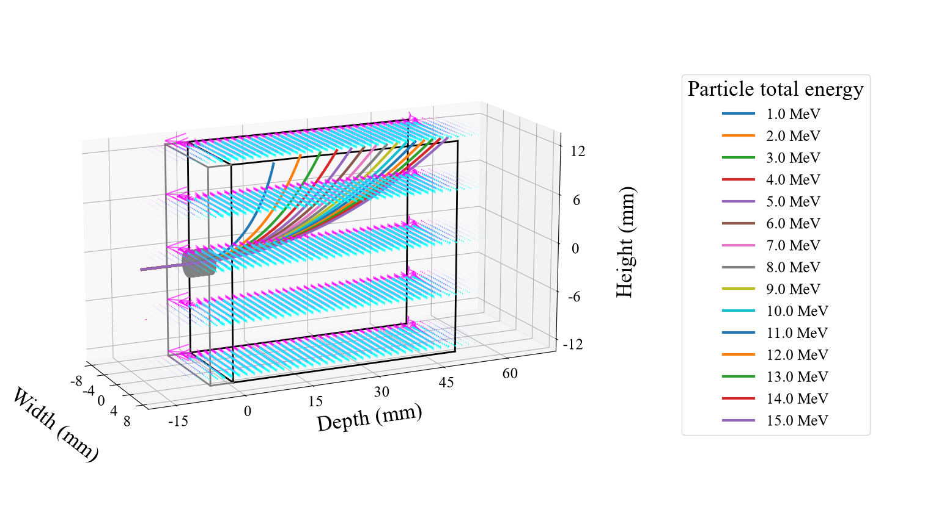
Representative numeric field or potential result stored with the project.
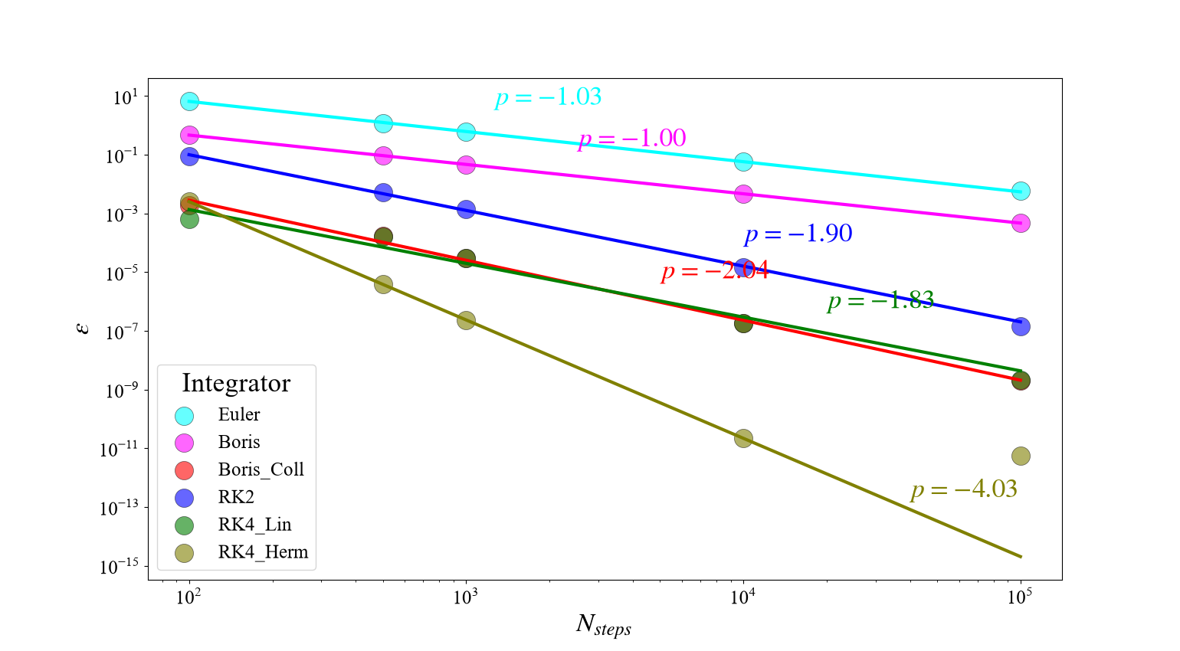
Representative comparison of numerical integrators with the analytic solution.
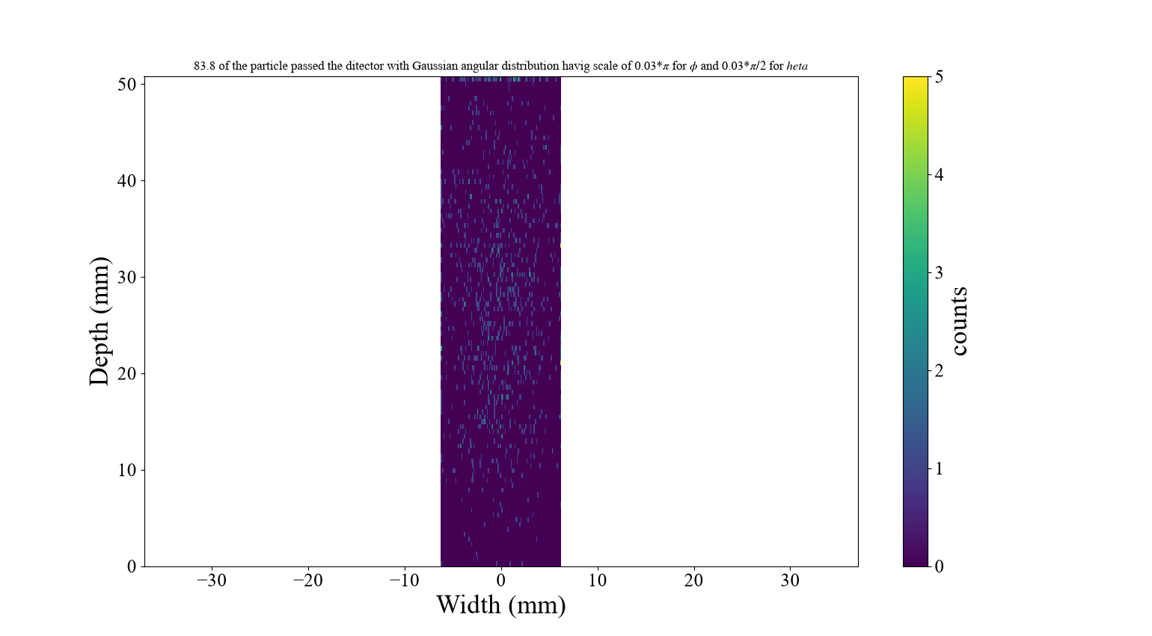
Representative synthetic real-beam detector distribution.

Validation Strategy
A defensible validation sequence is:
- verify energy-to-velocity conversion and $γ$ reconstruction;
- compare the uniform-field exit position with _analitic_sol_vel2dist;
- verify expected time orders on the smooth analytic field;
- compare linear and spline field interpolation on a fixed numeric grid;
- verify magnetic-only speed or $γ$ conservation;
- refine the numeric potential grid separately from the time step;
- repeat stochastic beam runs with a fixed seed;
- record all geometry, species, field, grid, and time parameters with every final figure.
Expected theoretical guidance is Euler order one, midpoint RK2 order two, classical RK4 order four for a sufficiently smooth right-hand side, and Boris order two when the field sampling and staggering are consistent. Boundary reconstruction and field interpolation can limit the observed order even when the interior stepping formula has a higher formal order.

Implementation Notes and Limitations
- The spelling Analitic field, grid_interpulation, _exect_exist, and RK4_Hermit is part of the present program interface and must be used exactly unless the code is renamed consistently.
- The field model is built when Integrators is constructed or when _update_solution is called. Updating the parameter dictionary alone does not regenerate a numeric potential.
- The spline clips query coordinates to its tabulated domain. The numeric domain must therefore contain the complete trajectory region and fringe region of interest.
- Natural boundary conditions impose zero second derivative at the outer spline limits. The computational field domain should extend far enough that this is a reasonable approximation.
- Cubic splines may overshoot near genuine discontinuities. A physical Enge fringe is smooth, whereas an intentionally abrupt fringe=0 field should not be interpreted as a smooth physical transition.
- The numeric field is based on a two-dimensional scalar-potential calculation and is not a general three-dimensional electromagnetic solver.
- Beam simulations can be memory- and CPU-intensive because integrator objects and field grids are copied into worker processes.
- Saved result figures are evidence of particular configurations; exact reproducibility additionally requires the parameter values, random seed, source version, and dependency versions.

Maintenance checks
When modifying the project, check the following paths together:
- both magnetic and electric interpolation paths;
- both analytic and numeric field construction branches;
- pinhole limits and body limits in every exit reconstruction method;
- scalar and array forms of energy input;
- single-process and multiprocessing execution;
- all enabled if True experiment blocks in main.py.

Quick-Start Checklist
- Install NumPy, Matplotlib, SciPy, and Joblib.
- Open main.py and set geometry, particle, and field parameters.
- Enable one field-initialization block.
- For numeric fields, select "Linear" or "Spline" and a $2^{k}+1$ grid.
- Enable the required experiment block and disable unrelated blocks.
- Rebuild the field after changing field-defining parameters.
- Run python main.py from the Final directory.
- Save the figure together with its parameter set and random seed.
- For convergence claims, inspect successive Richardson orders rather than relying only on one global fit.

Minimal Programmatic Example
import numpy as np
from spectrometer.Experiment import Experiment
from spectrometer.integrators import Integrators
experiment = Experiment(
height_mm=26,
width_mm=12.5,
depth_mm=50.8,
shield_mm=5,
yoke=0,
pinhole_dia_mm=3,
R0_mm=np.array([0.0, -10.0, 0.0]),
q_eng_MeV=np.array([0.0, 3.0, 0.0]),
m_kg=9.109e-31,
q_C=-1.602e-19,
Bx0_T=0.5,
Ex0_Vm=0.0,
fringe=1,
sharp_edge=1,
N_steps=1600,
CFL=0.05,
solution="Numeric Field",
Nx_p=129,
Ny_p=129,
grid_interpulation="Spline",
)
params = experiment._evaluate_exp_paramas()
integrator = Integrators(params)
R_mm, v_ms, gamma = integrator._RK4_Hermit()
print("Exit position [mm]:", R_mm[-1])

Natural Cubic Spline API
from spectrometer.custom_spline_2D import NaturalCubicSpline2D
# field.shape must be (len(y_axis), len(x_axis))
spline = NaturalCubicSpline2D(x_axis, y_axis, field)
# Scalar query -> scalar field-component value
field_at_particle = spline(x_particle, y_particle)
# Broadcast-compatible arrays -> array of field-component values
field_along_path = spline(x_positions, y_positions)
Internally, P_tag_tag_fun solves for natural-spline second derivatives and Params_finder converts them to $α,β,γ,η$. These functions are exposed primarily to make the derivation transparent; normal simulation code should construct NaturalCubicSpline2D and call the resulting object.

