UI Design

CSE327 SECTION: 05

**Group 1**

1. Faria Naznin -1931198042
2. Md. Touhidur Rahman – 2011873042
3. Aman Bin Azad Nafiz – 2011173642
4. Khalid Al Hassan - 1821505630

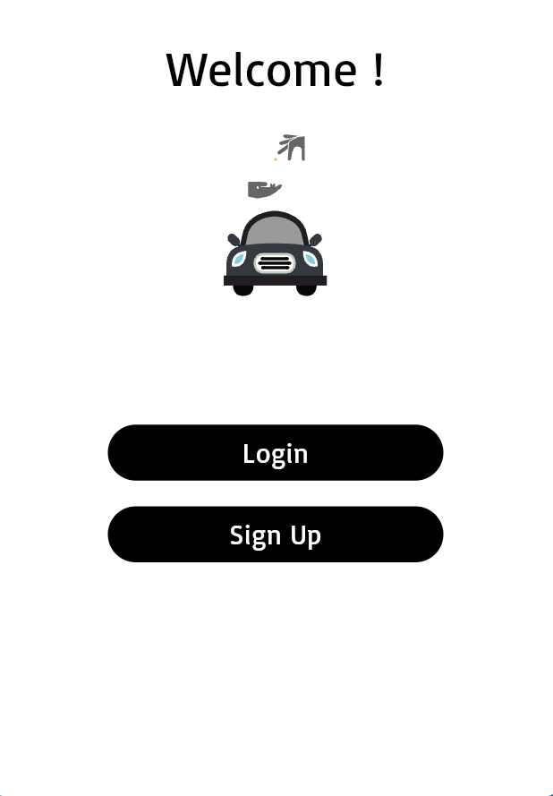

User will See this Login or Sign-Up view when he opens the app.

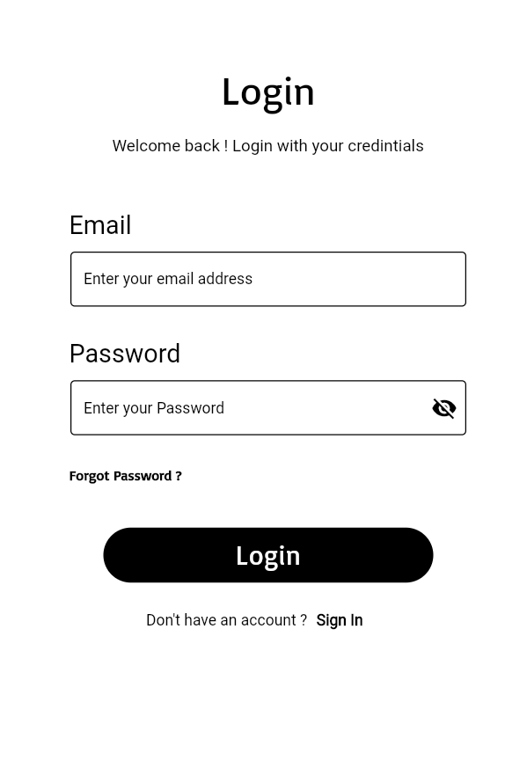

If the user is registered, he can login to the system by using proper credentials.

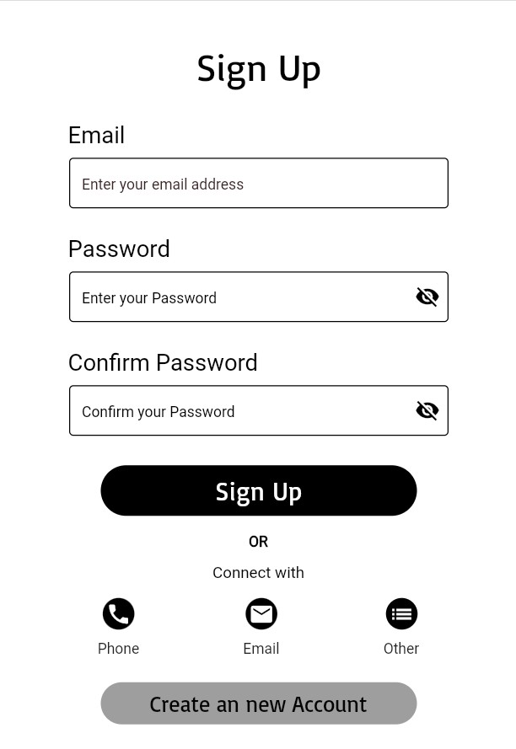

If the user is not registered to the system he can register.

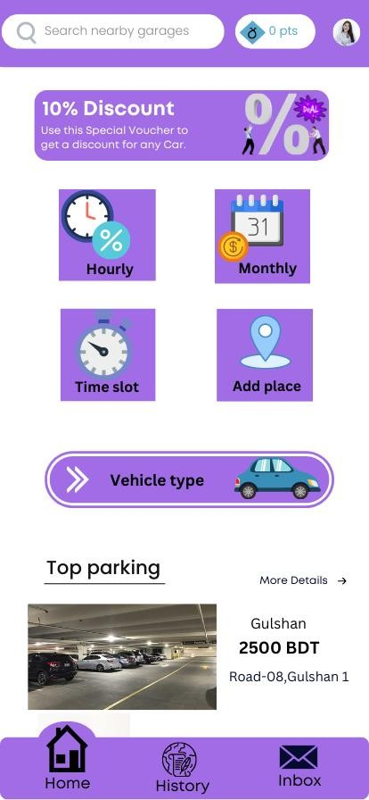

User Can search for garage and see other features on home page.

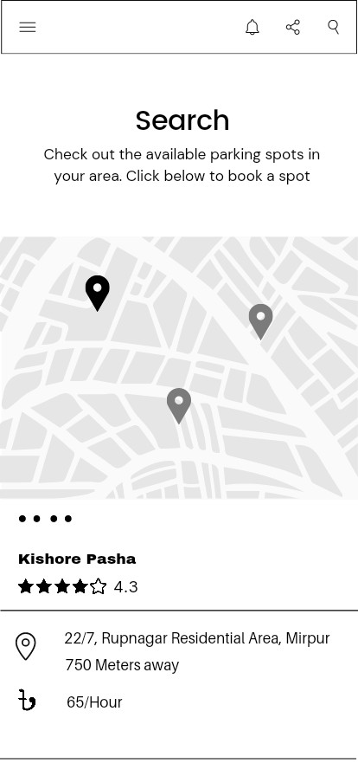

User can see available garage’s details.

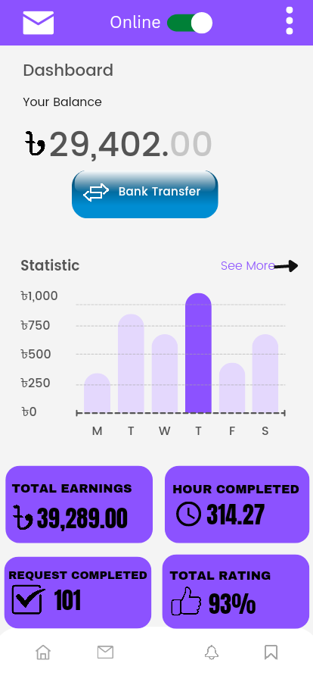

Garage owner can see his information on dashboard.