I. HTML Paragraphs
HTML Horizontal Rules: <hr>
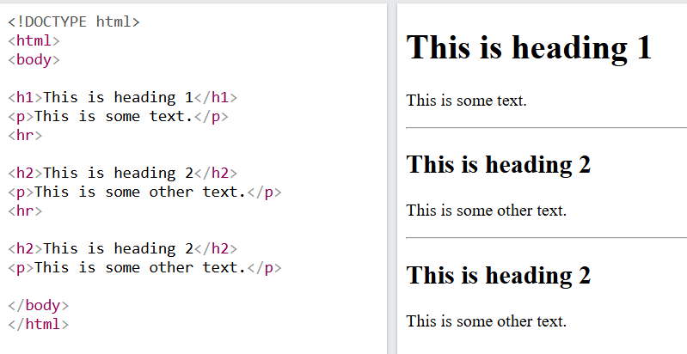
HTML Line Breaks: Use <br> if you want a line break (a new line) without starting a new paragraph:
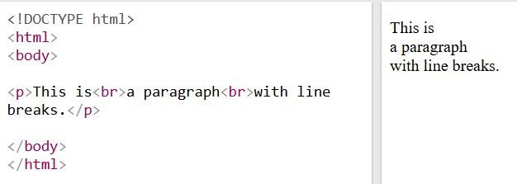
HTML <pre> Element: nếu dùng <p></p> như bình thường sẽ không xuống dòng
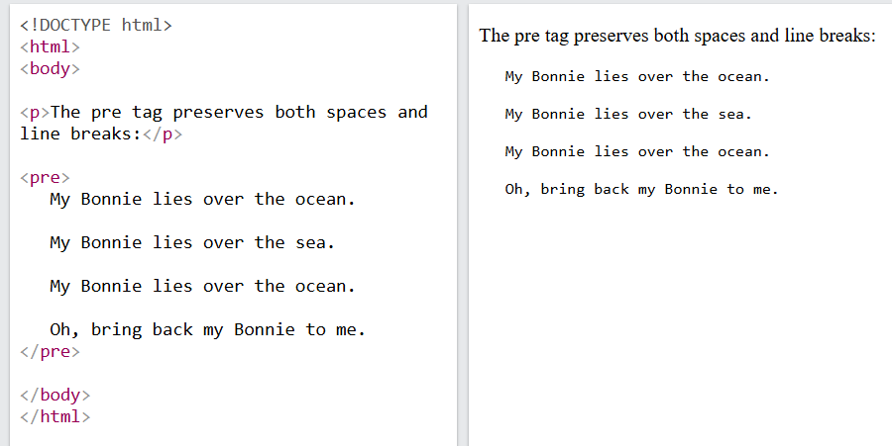

II. HTML Style Attribute
<tagname style="property:value;">
Background Color
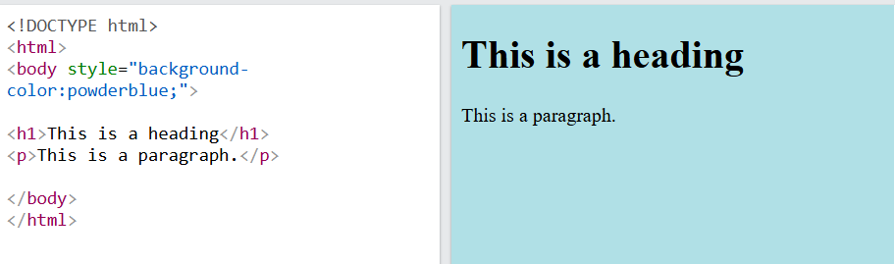
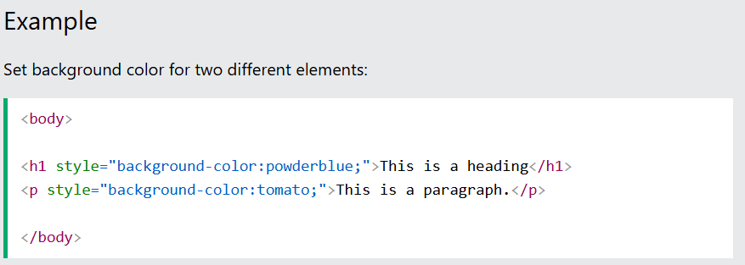
Text Color
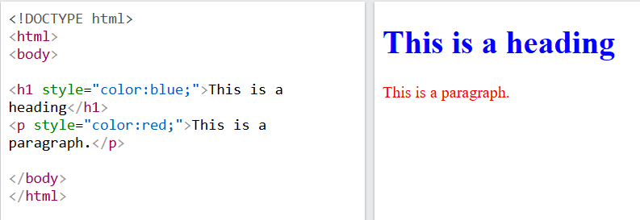
Fonts
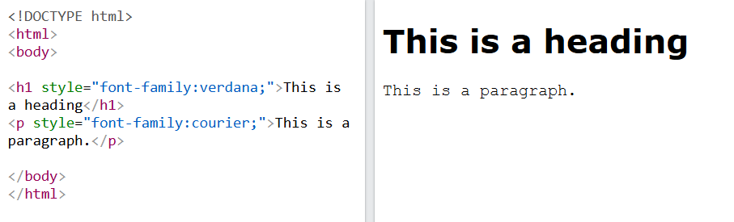
Text Size
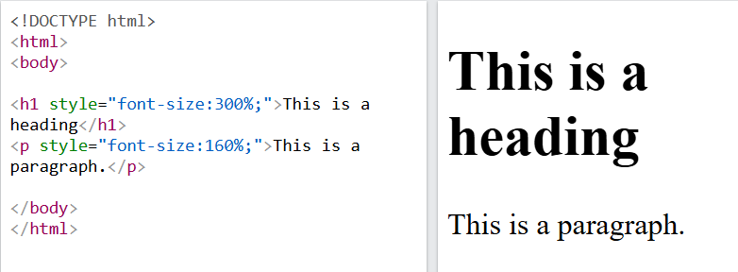
Text Alignment
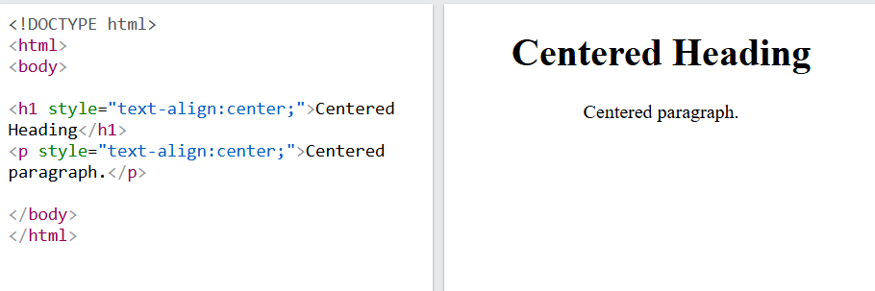
III. HTML Text Formatting
HTML <b> and <strong> Elements
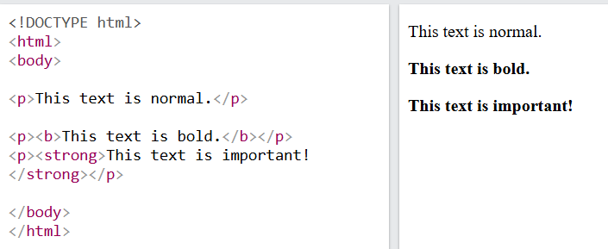

HTML <i> and <em> Elements
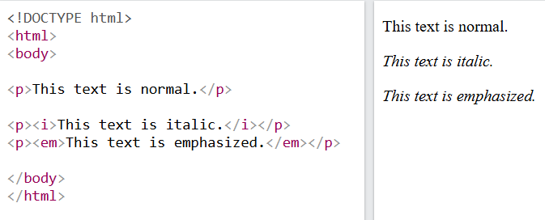
HTML <small> Element
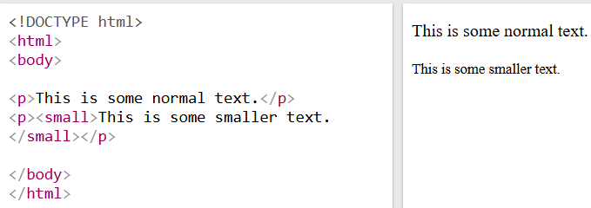
HTML <mark> Element
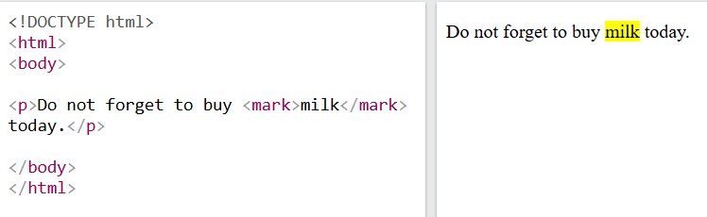

HTML <del> Element:
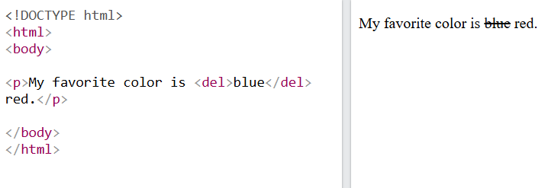
HTML <ins> Element: defines a text that has been inserted into a document. Browsers will usually underline inserted text:
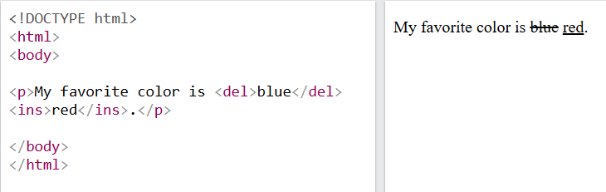
HTML <sub> Element
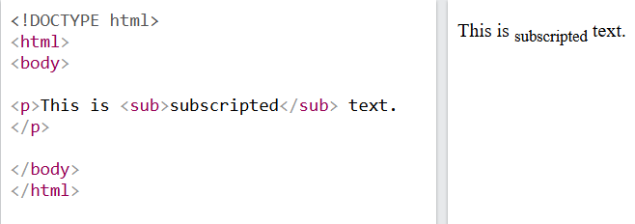

HTML <sup> Element
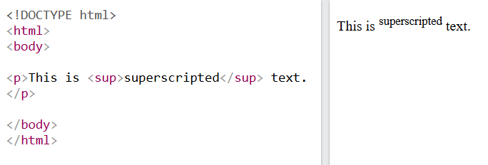

IV. HTML Lists
Unordered HTML List: An unordered list starts with the <ul> tag. Each list item starts with the <li> tag.
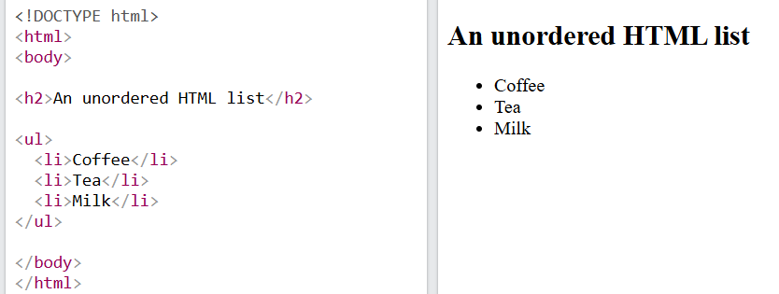
Ordered HTML List: An ordered list starts with the <ol> tag. Each list item starts with the <li> tag.
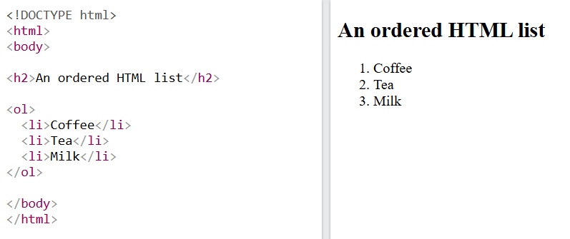

HTML <dl> Tag
