**Test Sort App**

How to use:

1. Put the txt file in C:\ with filename names.txt
2. Open solution file : ConsoleApp1.sln
3. 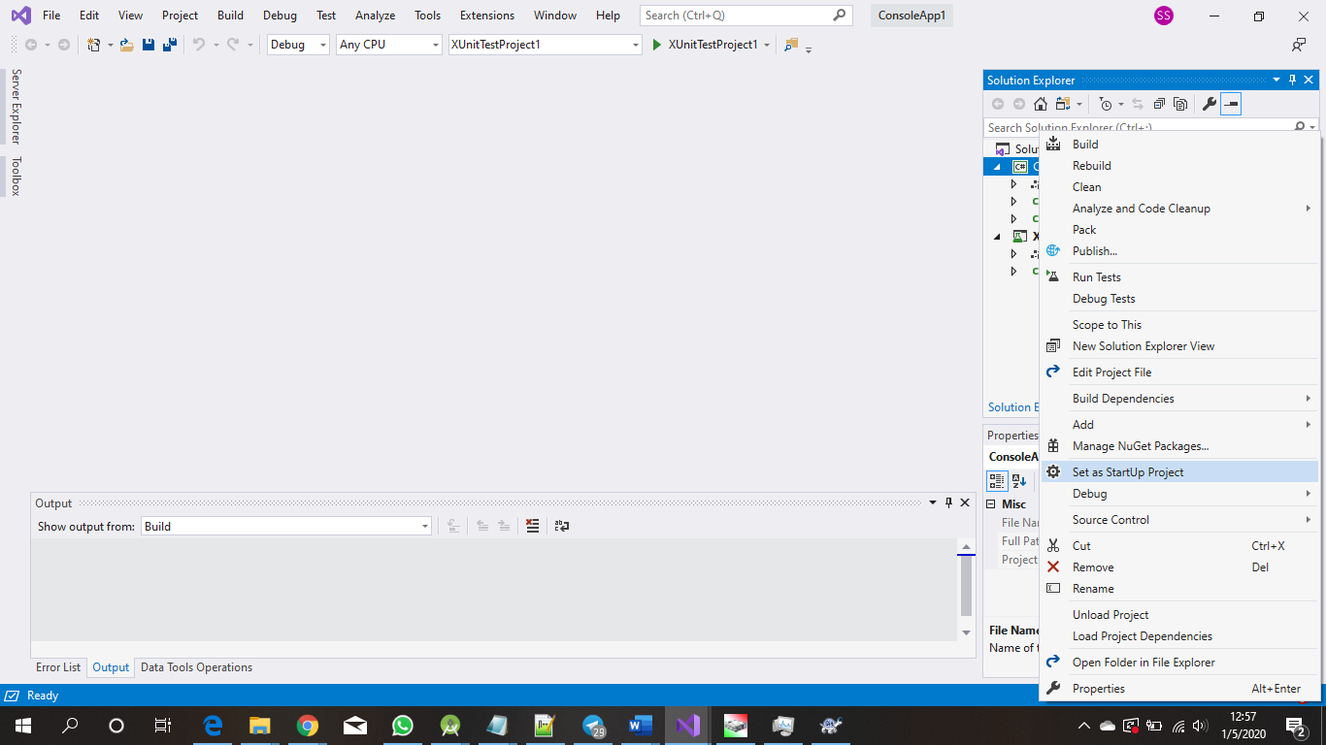
4. Right click ConsoleApp1. Then Click Set as StartUp Project.
5. 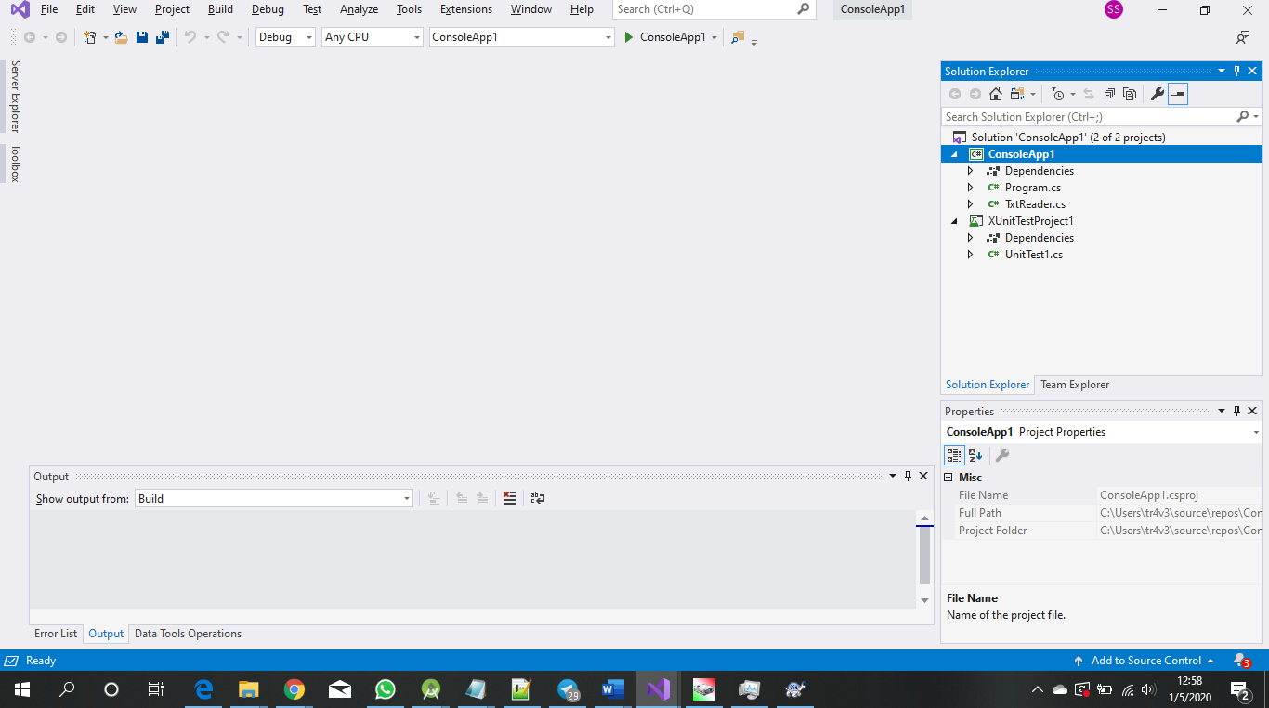
6. Click the green arrow with text consoleapp1
7. 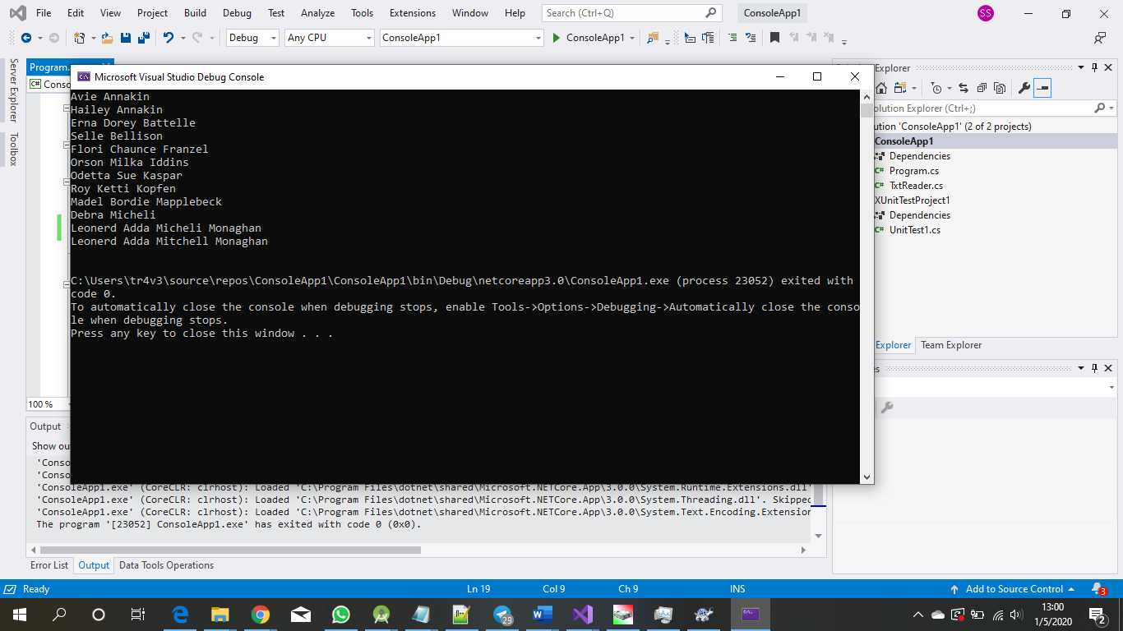
8. The console will show and print the sorted name
9. Check the file contains the sorted name at C:\sorted-names-list.txt