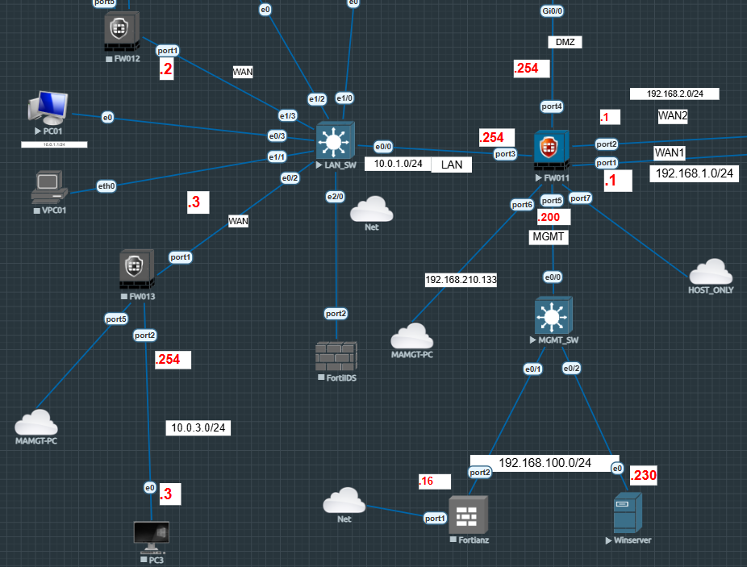

Passive Authentication AD:
To create an FSSO agent connector in the GUI: Go to Security Fabric > External Connectors. Click Create New. In the SSO/Identity section, click FSSO Agents Windows AD.

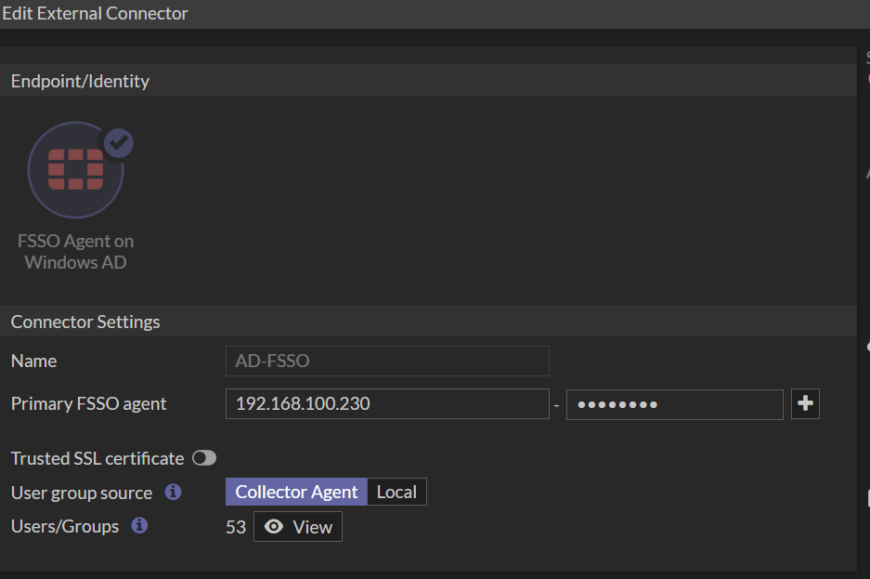
.
Map AD Group to FortiGate Group:
Go to User & Authentication > User Groups. Click Create New. Enter a name for the group in the Name field. Set the Type to Fortinet Single Sign-On (FSSO). Add the FSSO Groups as members Click OK.
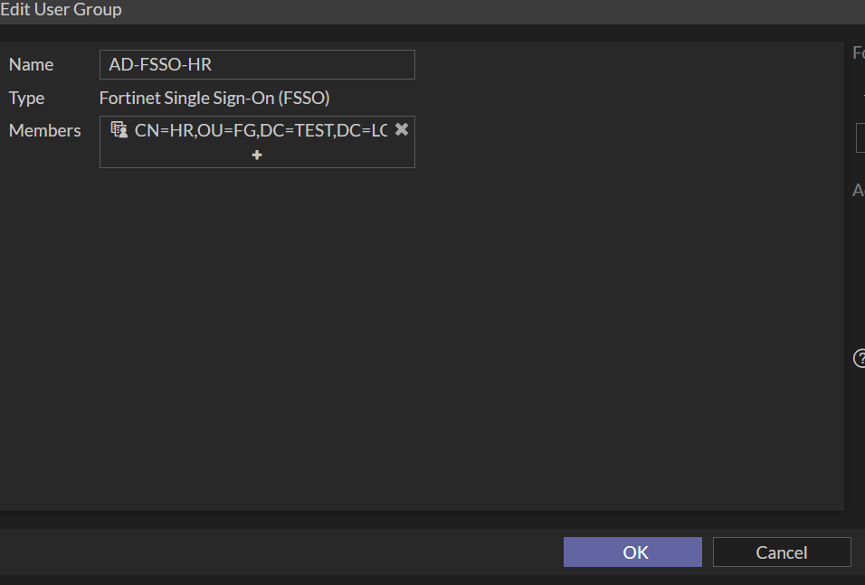

Add AD Groups to Policy:
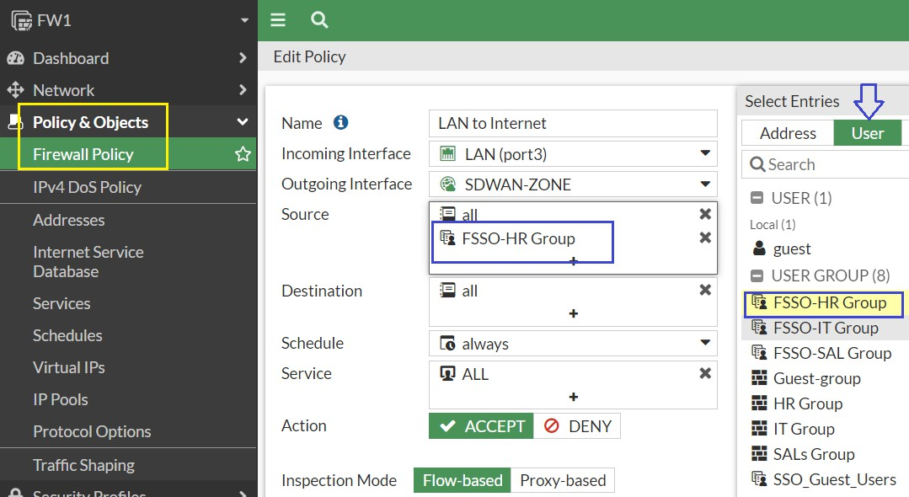
To add the FSSO groups directly to a firewall policy: Go to Policy & Objects > Firewall Policy. Click Create New. Click in the Source field. In the Select Entries pane, select the User tab. Select the FSSO groups.

Verification and Testing:
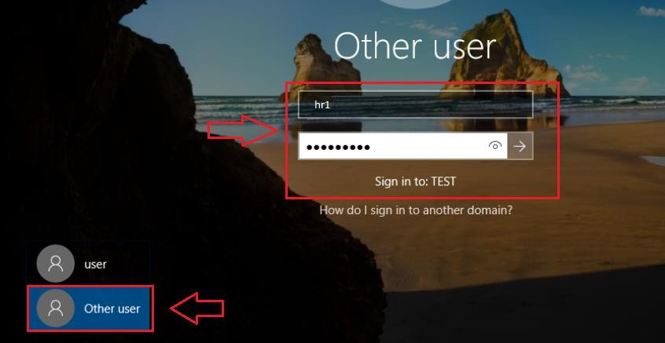
For verification and Testing First make sure LAN Systems already join to Active Directory.

