Project Report: OpenCTI Configuration and Integration with External Threat Feeds and FortiGate Firewall

Project Overview
The objective of this project was to deploy and configure OpenCTI (Open Cyber Threat Intelligence platform) to collect, manage, and operationalize threat intelligence from multiple external sources. The project involved integrating threat intelligence feeds from AlienVault OTX, VirusTotal, and AbuseDB/IP reputation services, and configuring FortiGate Firewall to consume actionable intelligence for network defense.

Tools and Technologies
- OpenCTI: Cyber Threat Intelligence platform for collecting, analyzing, and sharing threat intelligence.
- External Threat Feeds:
  - AlienVault OTX: Open Threat Exchange for shared threat indicators.
  - VirusTotal: File, URL, domain, and IP threat intelligence.
  - AbuseDB/IP: Database for malicious IP addresses and domain reputation.
- FortiGate Firewall: Network security appliance to block and monitor malicious traffic.
- Supporting Tools: Docker, Python, OpenCTI Connectors, STIX/TAXII standards.

Results
- OpenCTI successfully ingests data from AlienVault OTX, VirusTotal, and AbuseDB/IP.
- Threat indicators are normalized and stored in STIX 2.1 format.
- FortiGate Firewall receives actionable threat intelligence:
  - Malicious IPs blocked automatically.
  - Malicious domains flagged.
- Demonstrated end-to-end threat intelligence lifecycle from ingestion → analysis → enforcement.

OPENCTI

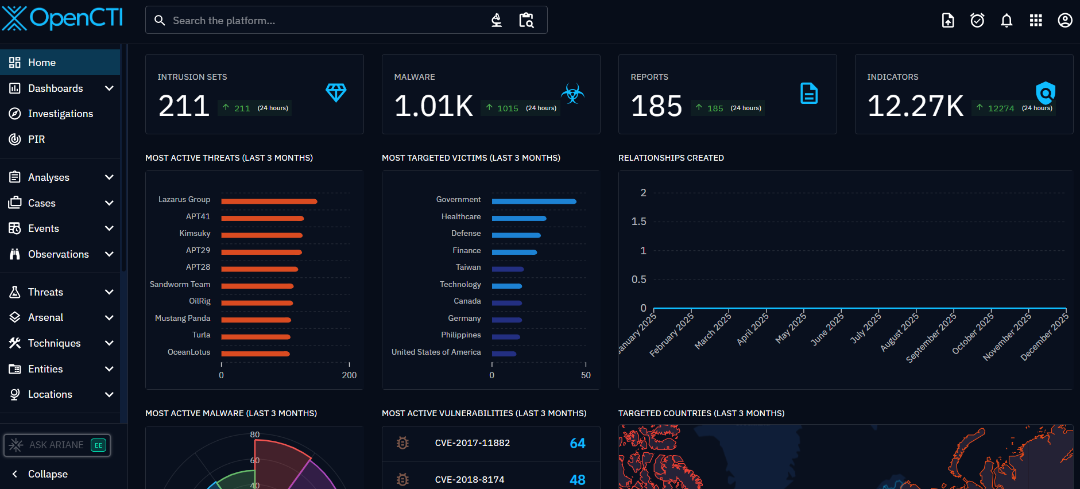

FortiGate Firewall
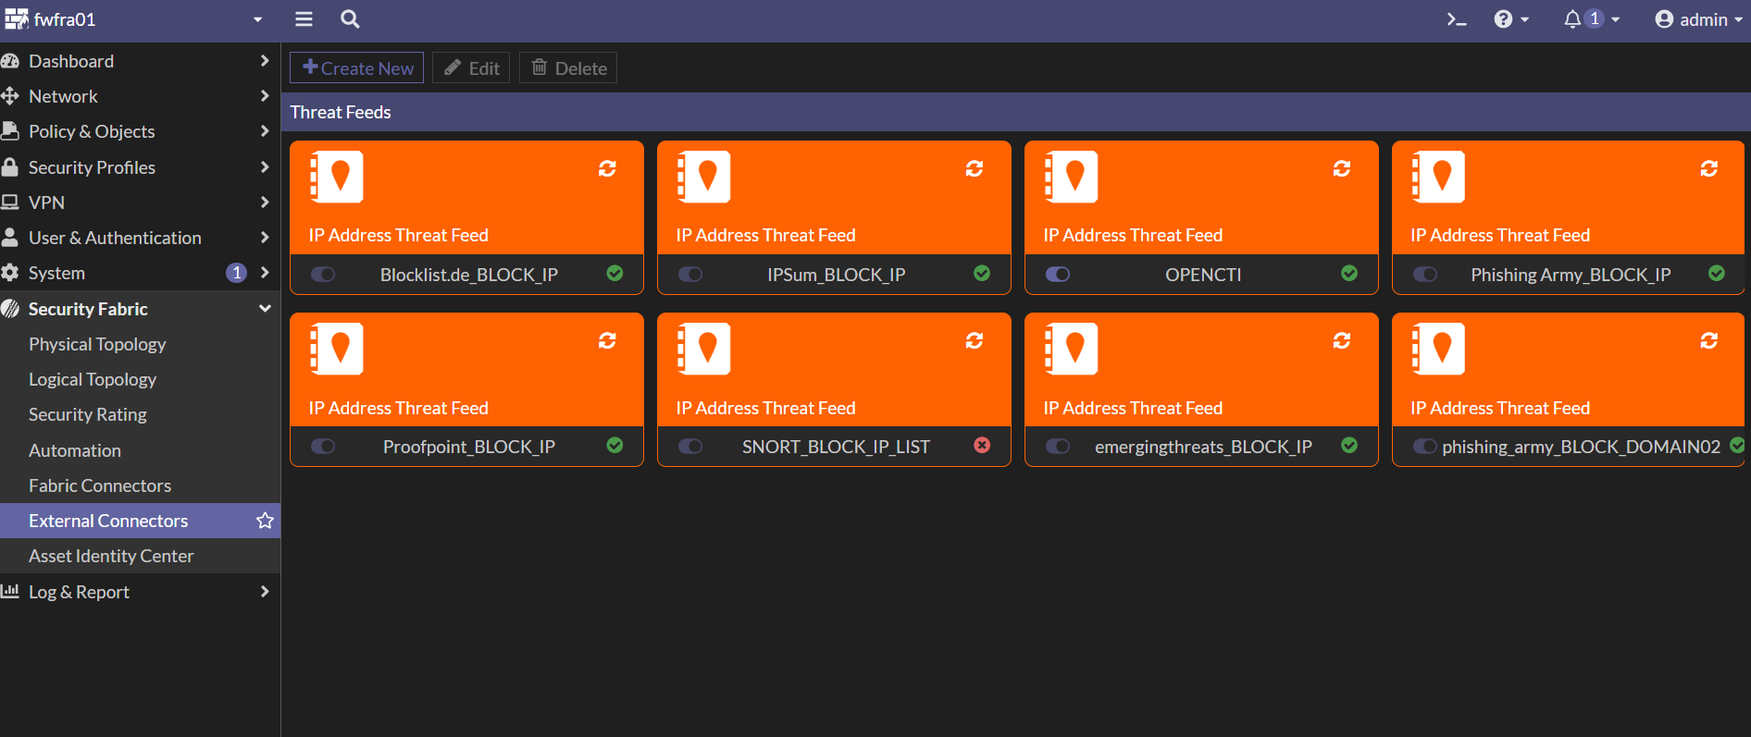

FortiGate Firewall Policy
