Design and Configuration of DDoS Protection Policy on FortiGate with DDoS Analysis Using Wireshark

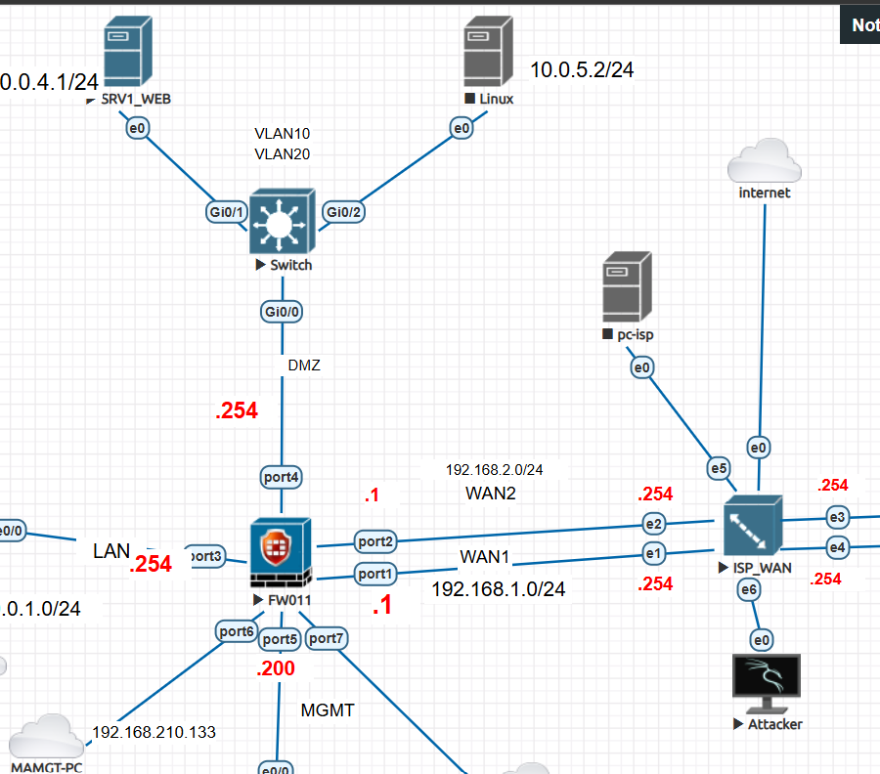

Design and Configuration of DDoS Protection Policy on FortiGate
Go to Policy & Objects > IPv4 DoS Policy. Select the Create New in the top left side of the right window. It will open new IPv4 DoS Policy windows. Enter a name for the policy. Set the Incoming Interface parameter by using the drop-down menu to select a single interface. Set the Source Address parameter by selecting the field with the "+" next to the field label. Set the Destination Address parameter by selecting the field with the "+" next to the field label. Set the Services parameter by selecting the field with the "+" next to the field label. Set the parameters for the various traffic anomalies.

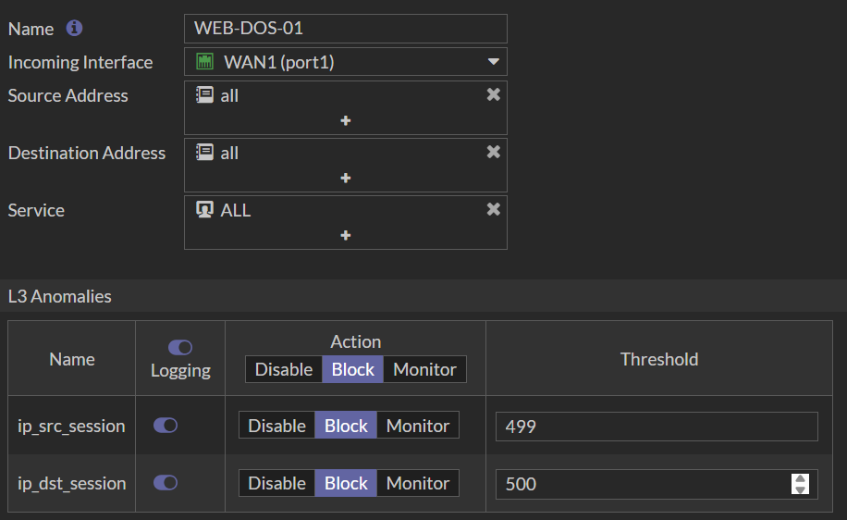

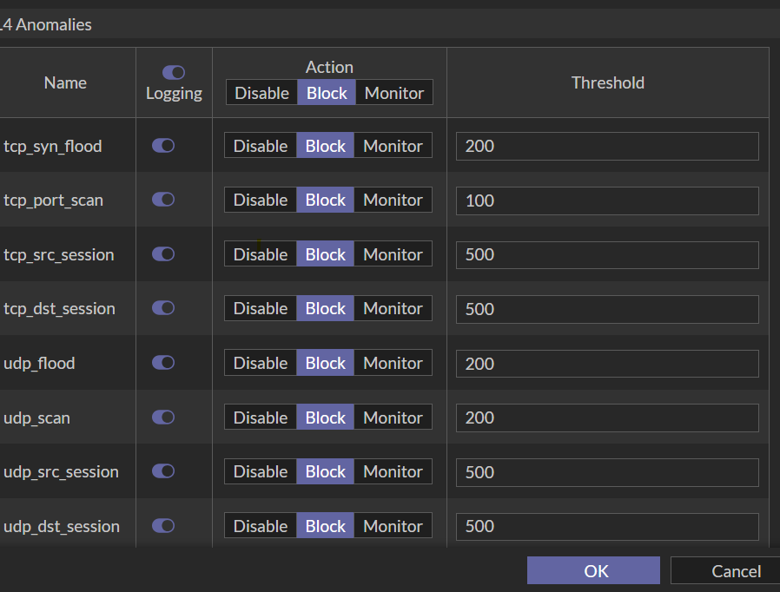

# Web server

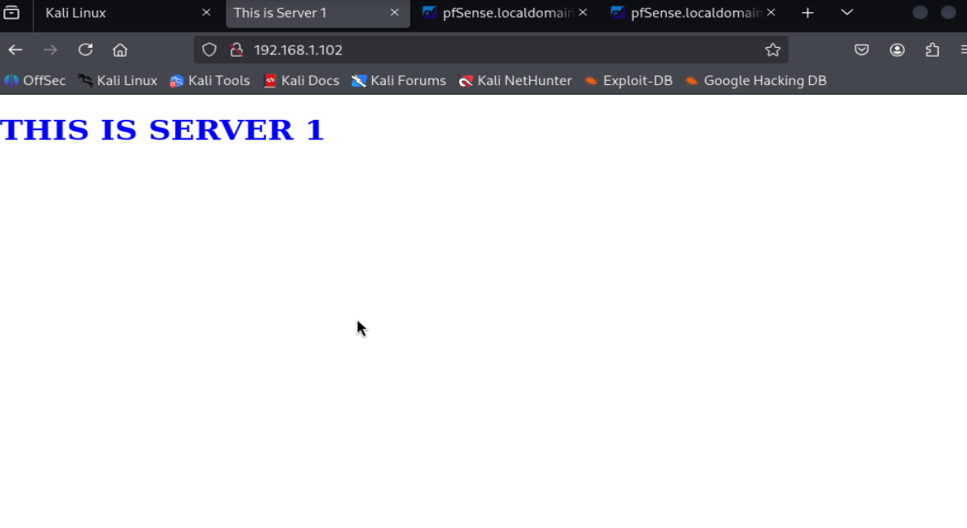

Firewall Testing with Hping3

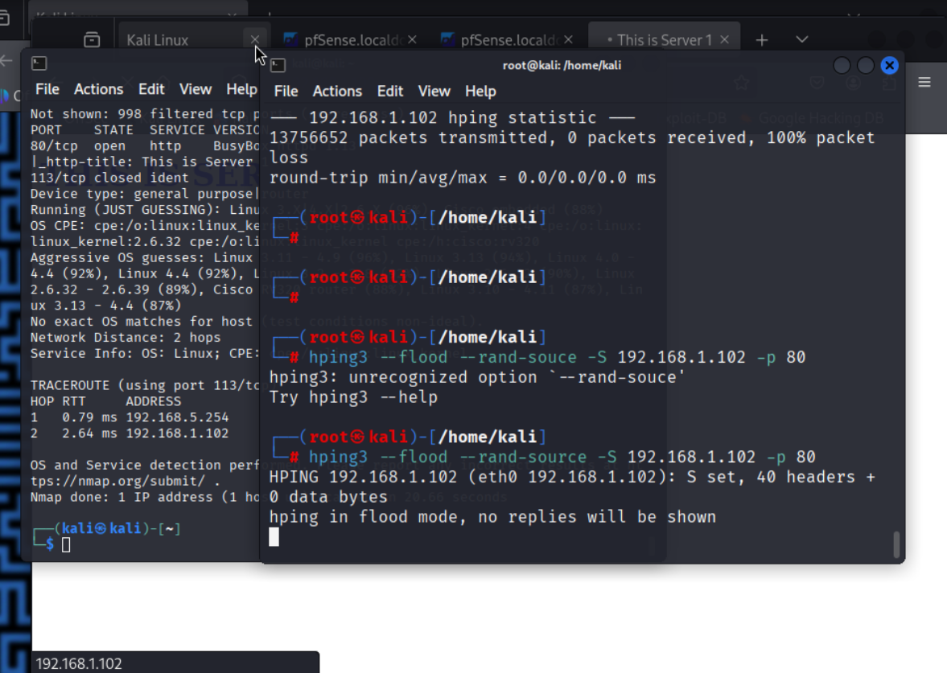

#DOS
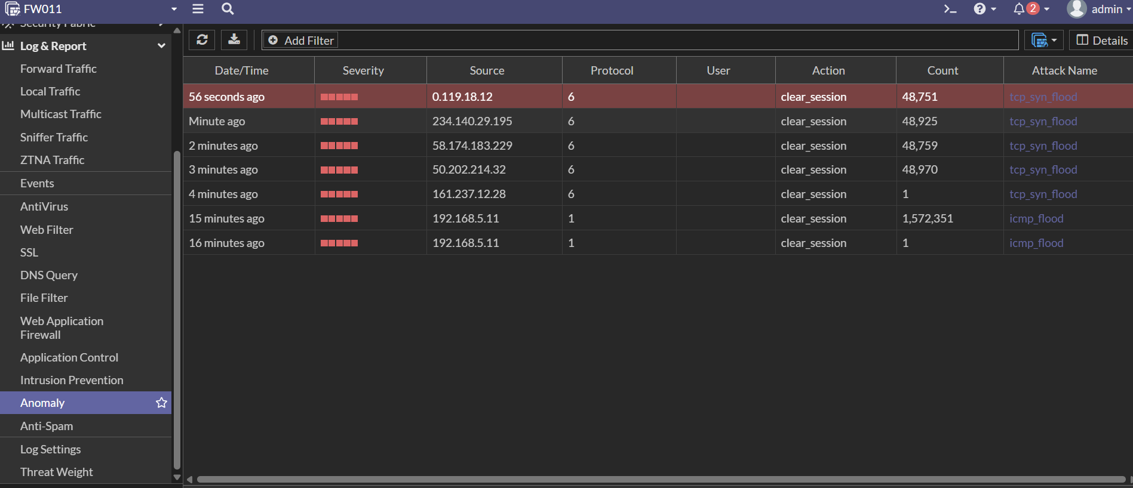

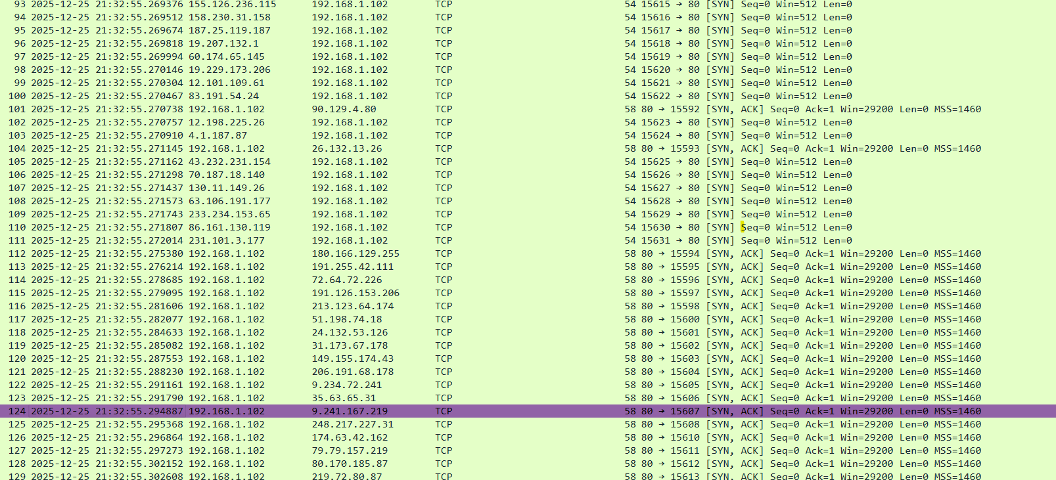

DoS Policy Configuration and Testing

