Suricata IDS Integration with Wazuh SIEM

Overview
This project integrates Suricata IDS with Wazuh SIEM to centralize network intrusion alerts, improve visibility, and support faster incident detection and response.

Scope
- Enable Suricata EVE JSON logging
- Ingest Suricata alerts into Wazuh
- Create basic Wazuh decoders and rules

Architecture
Network Traffic → Suricata IDS → eve.json → Wazuh Agent → Wazuh Manager → Wazuh Dashboard

Key Objectives
- Centralized monitoring of IDS alerts
- Correlation of network and host events
- Improved security visibility

#lab

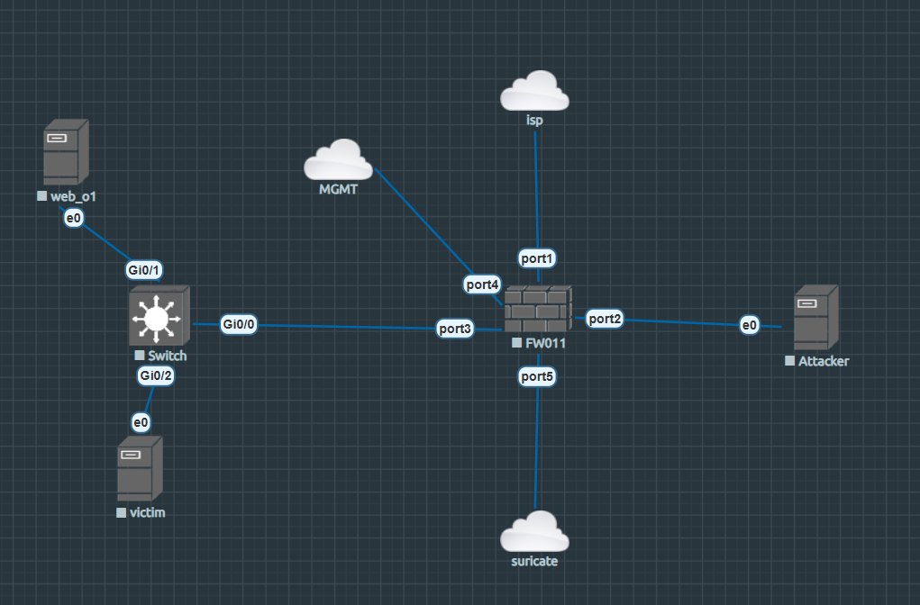

#suricata alerts
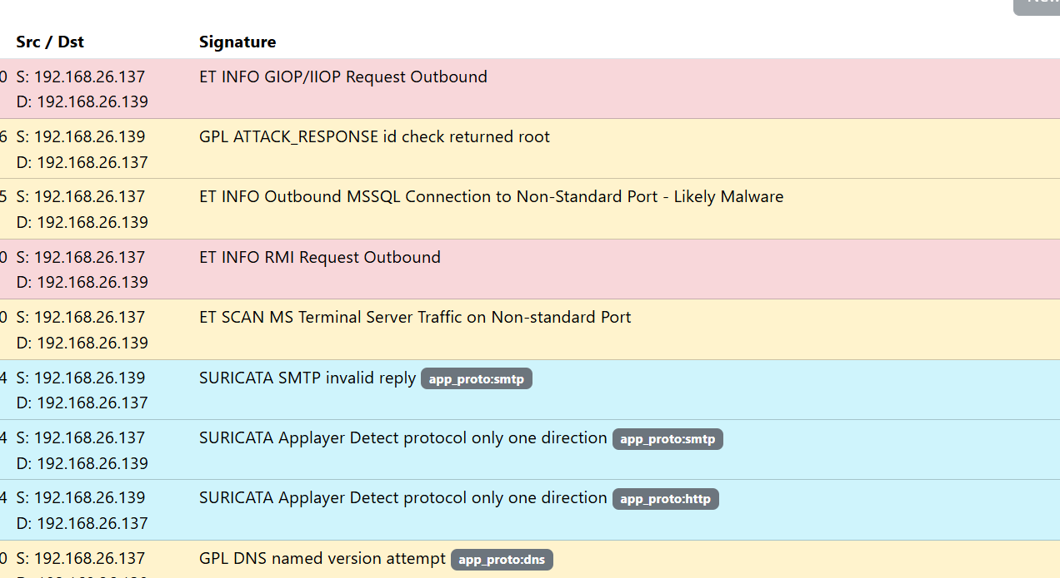

#SIEM–NIDS integration




