**Solution to Lab 2**

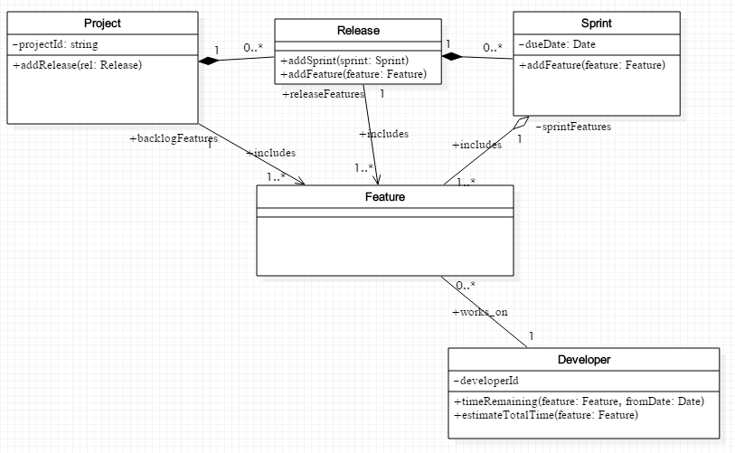

NOTES:

1. Notice that many of the attributes listed in the solution to Lab 1 have been removed. For instance, the List<Release> backlogFeatureList that used to belong to Project is not present. This is because the association from Project to Release already implies that this attribute is present, so it does not need to be explicitly named in the list of attributes
2. A Project has a composite relationship with Release and Release has a composite relationship with Sprint – the strong whole-part relationship holds in this case.
3. The association between Feature and Developer, and also the association between Feature and Sprint, is two-way. Therefore, when these classes are implemented in Java, we will need to see references to each class in the other class – in both cases.
4. We have introduced a developerId in the Developer class – this is because we need to have a way to identify a developer who will be assigned a feature; at this point, we do not know the specifics of the data that will be maintained about a Developer, so we specify only an id.
5. We have not created a class for Project Manager. There is only one such manager and we do not keep information about him. His role is only as an actor on the system.