Purpose
The purpose of the application is for tracking scores when shooting rounds of sporting clays.

Sporting clays is a sport where a squad of up to 5 shooters moves around a course from station to station. It is typical for a course to have between 8 and 15 stations and shooting all of them is called a round of sporting clays.

At each station the shooters take turns. A turn typically consists of 5 to 12 targets – it varies depending on the course setup and layout.

At a station, the targets in each turn are thrown either one or two at a time but never more than 2 at a time. When the first shooter has taken their turn, the next shooter will take their turn at the same set of targets.

For illustration, the squad arrives at station 6. Station has 7 targets for the shooter, thrown as a single, then a single, then a single, then a pair and then a final pair. Shooter 1 may steps up and shoots at that sequence of targets. Then shooter 2 would take their turn at the same sequence, etc.

The app tracks the number of “hits” by each shooter at each station.

Finally, because shooters pay for each target thrown and because sometimes targets break coming out of the thrower, the app needs to allow for tracking of “breakage” at each station – targets that shooters did not have a chance to shoot at.

Data Structure
The final data structure is up to you, but I have uploaded a PDF file that represents how I would build this in a database. The PDF file is: drawDB_ClayAppDiagram.pdf

- There would be a table where the application stores courses. This is considered master data.
- There would be a table where the application stores a list of shooters. This is considered master data.
- The main table would be one where you set up a round of clays by storing the course, the number of stations and what shooters (up to 5) are in each squad. This is transactional data; the round is essentially the header record for a transaction.
- The stations table would store the information about each station in the round.
- For each station, a table called Targets would store a shooter id and how they performed on up-to 12 targets at each station. Each target column would store one of four values (Hit / Miss / NotApplicable / Null).

Even though I have diagrammed this as a database, the storage of data should be local on the phone. This app should be usable when there is no data connection available from the phone to the internet as clays courses are often remote with poor cellular signal.

Design Flow
I have designed this flow around several screens that are mocked up and described below.

Screen 1 - The Home Screen
Example:
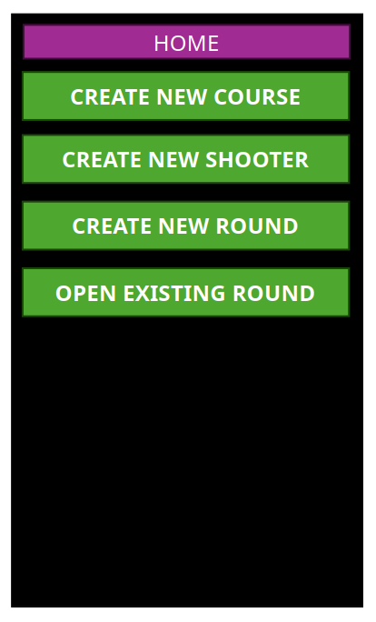
The app would open by default to this screen.

On this screen would be four actions a user can take:
- Create New Course
Pressing this would allow the user to create a new course in the “courses” table. That layout and function are further described below.
- Create New Shooter
Pressing this would allow the user to create a new shooter in the “shooters” table. That layout and function are further described below.
- Create New Round
This would allow the user to create a new round. That layout and function are further described below.
- Open Existing Round
This would allow the user to open an existing round that had previously been created. That layout and function are further described below.

Screen 2 – Create New Course
Example:
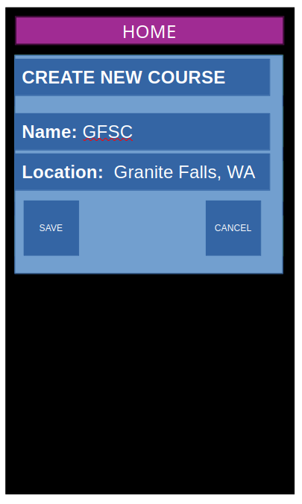
If the user presses the “Create New Course” button on the home screen then this layout would open. It would allow the user to enter the name of a course and the location of the course. Both of these are text fields and should be entered with the system’s standard keyboard.

The user could either save that course or cancel.

Saving the course would store that information in the “courses” table and then return to the home screen.

Cancel would not save the information and would return to the home screen.

The “home” button at the top would return to the home screen without saving (essentially the same as cancel).

Screen 3 – Create New Shooter
Example:
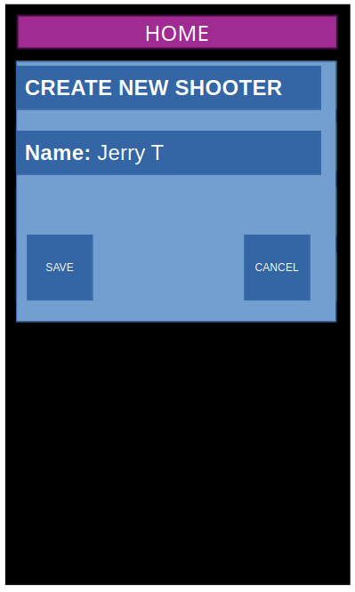
If the user selects “Create New Shooter” from the homepage, they are presented with a text field to enter a shooter name using the system’s keyboard.

Pressing “Save” would add the shooter to the “shooters” table in the database. Shooter names must be unique – if the shooter already exists then the data should not save and the user should be prompted to change the name and retry the transaction.

Pressing “Cancel” returns to the home screen without saving the data.

The “home” button at the top would return to the home screen without saving (essentially the same as cancel).

Screen 4 – Create New Round
Example:
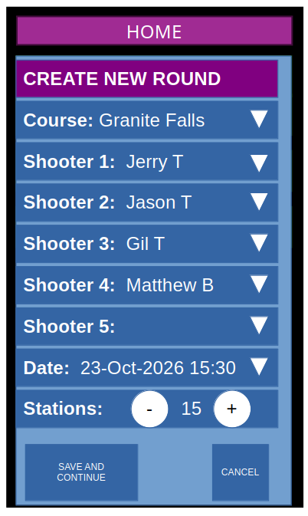
If the user selects “Create New Round” from the home screen, they would be presented with this screen.

A drop down would allow them to select a course name from the “courses” table. The drop down should be in alphabetical order. A course selection is required.

Five drop downs would allow the user to select a value from the “shooters” table. The drop down should be in alphabetical order. Only shooter 1 is required. They do not have to be unique.

A field would allow the user to select the date and time of the round. Date and time are required. The field would default to the current date and time the user opened the screen. The drop down should open a calendar/time picker widget similar to other applications with this.

A field should allow the user to specify the number of stations in the round. It should default to 15. Rather than make the user type numbers, buttons to increase and decrease the value are presented. Pressing these would increment or decrement the value by 1.
Pressing “Save” would add the data to the “rounds” table in the database. Course name and date/time must be unique and, if not, the user should get an appropriate error message and be allowed to correct the data. Once a successful save is done, the user would be taken to the “stations” screen (described later in this document) with this as the active round.

Pressing “Cancel” returns to the home screen without saving the data.

The “home” button at the top would return to the home screen without saving (essentially the same as cancel).

Screen 6 – Open Existing Round
Example:
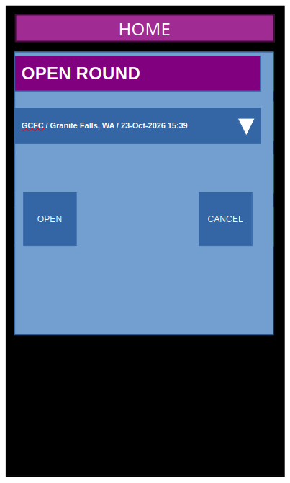
Pressing “Open Existing Round” from the home screen would present the user with the ability to choose a record that exists in the “rounds” table. The selection box is a drop down. The drop down shows a concatenation of the round’s course name, location and date/time, separated by slashes. The drop down is sorted by date, with the most recent round being at the top of the list. The most recent round is presented as the default when the user opens the screen.

Pressing “Open” takes the user to the “stations” screen (described later in this document) with this as the active round.

Pressing “Cancel” returns to the home screen.

The “home” button at the top would return to the home screen without saving (essentially the same as cancel).

Screen 7 – Stations
Example:
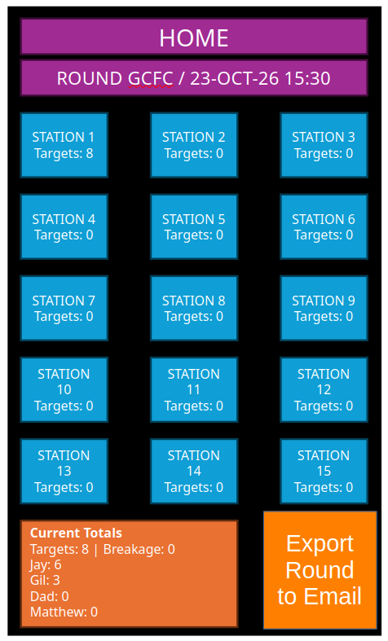
When the user enters a “round” they are presented with this interface. The title bar on the screen displays “ROUNDS” plus the name of the course and the date/time for the active round.

There is a grid of boxes, one for each station in the round. Pressing one of the station buttons will take the user to the screen for that individual station (described later in this document). The button shows the station number and the number of targets at that station.

There is a dialogue box at the bottom that shows the current scores. It will show the total number of targets in the round (i.e. the sum of the targets on each station) and the total number of hits recorded for each shooter in the round.

There is a button that will export the round results to an email. This functionality is described later in this document.
Pressing the “Home” button at the top of the screen would take the user back to the home screen.

Screen 8 – Individual Stations
Example:
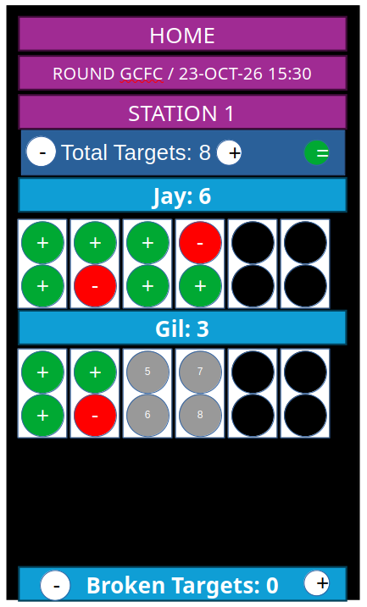
This is the interface the user would be presented with when selecting an individual station. The title bar at the top displays the station number.

A selection bar allows the user to set the number of targets at the station. Rather than entering text, there are buttons that allow the user to increment or decrement the value by 1 with each press. The default value for a station, when first opened and no results have been recorded, is 10 targets. The number of targets must be between 1 and 12. Another button allows the user to confirm the number of targets at the station. (The example shows a green equals sign – but something like a check mark might be more appropriate.)

Below that is a section for each shooter in the round. The section starts with a bar showing their name and the number of current hits they have at this station Below that is a grid of circles. The grid allows for recording the results on each target for a shooter. The grid functions as follows:
- When the grid first loads, there are up-to 12 grey circles that have a number in them. A grey circle indicates a “null” value for a target (not a hit, not a miss). Each circle represents a target, with the numbering as follows:
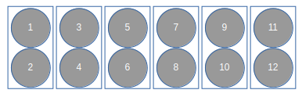
- Only the number of possible targets is shown for each shooter, based on the value for the total targets. Targets not needed are set to a black circle that can not be changed by touching it and in the data these are recorded as “not applicable” targets. The circles are always activated in pairs. For example:
  - Total Targets = 1 or Total Targets = 2
The first pair is active:
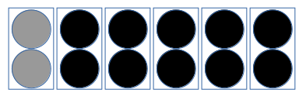
If the total targets is 1 – the user can record the result in either active circle. The other would just remain “null” (grey).
  - Total Targets = 3 or Total Targets = 4
The first 2 pairs are active:
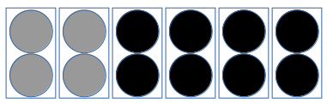
If the total targets is 3 – the user can record the result in any active circle, leaving one as grey (null).
  - Etc.
- Touching a grey target circle once turns it to a green circle with a “plus” icon. This records a a hit in the data tables for that target.
- Touching a green target circle once turns it to red with a “minus” icon. This records a miss in the data tables for that target.
- Touching a red target circle once turns it back to grey with the correct number as the icon. This is recorded as a null target in the data tables.

Data is recorded into the tables as the user changes the value of each target. There is no “save” or “cancel” button on this screen.

The title bar for each shooter shows their name and current number of “hits” they have at this station.

The order that the shooters are presented depends on the station number. Shooters rotate who takes the first turn at each station. For example, if the squad consists of shooters A, B and C then at each station:
- Station 1 order would be: A, B, C
- Station 2 order would be: B, C, A
- Station 3 order would be C, A, B
- Station 4 order would be A, B, C
- Station 5 order would be: B, C, A
- etc.

At the bottom of the screen, after the shooters, is a bar that allows the user to record the number of broken targets at each station.

Pressing the “home” bar at the top of the screen takes the user back to the “home” screen.
Pressing the “round” bar at the top of the screen takes the user back to the “stations” screen for the current round.

Email Round Results
On the “rounds” page is a button that allows users to email results for that round.

If the user presses this button, it would open an outgoing message in their default mail client with a subject and body populated with the results from that round. Using the standard mail functionality, users could add “To” addresses to the draft and then send the email.

I have attached email_example.txt file as a sample.
- The subject line is “Scores From “ and then concatenate the name and location of the course, then the date/time of the round.
- The body consists of:
  - A header showing the course name, location and the date/time of the round. It also shows the total number of stations and then the total targets (the sum of the available targets at each station for that round).
  - A section for each shooter showing their name and then, indented beneath that, their total score (total number of hits for the round). Following that is data for each station:
    - The total number of hits for that station concatenated with a slash and then the total targets at the station.
    - Two lines that show the result for each target. This represents the grid for each target and an “X” represents a hit, a “O” represents a miss and a dash represents a null. Not applicable targets are ignored.

Other Notes
- The example pictures in this specification are crude and ugly. The colors are terrible. Use good UI design rules and make the application look professional. Make sure buttons are correctly sized for easy presses with user’s fingers. Allow the user to scroll the screen, if necessary, to use the application.
The only guidelines are:
  - It should have a “dark” base theme (black backgrounds).
  - The app is used outside in often sunny environments – so choose colors that show well in this environment.
  - Text size should be as large as possible and be legible.
  - Hit targets should show “green” and missed targets should show “red”, as described in that section.
- This application should be built so that it is usable on either Android or iPhone operating systems.

