Supervised Learning
William Tidwell
Computer Science
Georgia Institute of Technology
Atlanta, GA, USA
trace.tidwell@gatech.edu

Abstract—The purpose of this project is to explore techniques used in supervised learning. Five classification algorithms – decision tree, neural network, boosting, support vector machine, k-nearest neighbors – are implemented on two different datasets. A description of the problem and an analysis of the results are included for each dataset.
Keywords—decision tree, neural network, boosting, support vector machine, k-nearest neighbor

Introduction
I first learned the phrase, "There is no such thing as a free lunch," in tenth grade economics. Simply put, it means one cannot get something for nothing. As I began studying machine learning, I learned that the phrase was also used in reference to algorithms, with much the same meaning. It means that no one algorithm is inherently better than another for solving a given problem. Each problem must be considered on an individual basis, and prior knowledge must be applied in order to achieve optimal results. In the case of machine learning, one cannot just select "the best" algorithm to solve a problem and expect to have long-term success. An important part of knowing which algorithm to select is domain knowledge, or experience in the field in which one is working. After having spent considerable time in a certain field or solving certain problems, one begins to have an understanding of which algorithms perform well and which do not, as well as how best to implement the algorithms. In this assignment, we will begin exploring different algorithms and techniques used in supervised learning with the goal of starting to develop some domain knowledge or, at the very least, being exposed to some of the problems faced in machine learning.

Algorithms

Decision Tree with Pruning
A decision tree (DT) is a representation of a discrete-valued target function. Instances are classified by sorting them down the tree from the root to a leaf node. The leaf node is what classifies the instance. Each node along the way represents a decision, with the goal of eventually deciding how to correctly classify an observation. For my implementations, the hyperparameters I chose to optimize are described below. The split criterion is used to determine the quality of the split, and the options are Gini Impurity and Entropy. The Gini Impurity measures the probability that an element will be labeled incorrectly if assigned a label based on the probability distribution of the labels in the set. Entropy is a measure of information gain, which measures the impurity of a collection of samples. Splitter is the method used to choose the split at each node, where best is the best choice and random is the best random choice. Max Depth defines how many levels a tree can have. Min Samples to Split is the minimum number of samples required to split a node. Min Samples per Leaf is the minimum number of samples required to be a leaf node. A split will only happen if this number of leaves remain as children on both the left and right branches. Finally, Max Features for Split defines the maximum number of features to consider when looking for the best split.

Support Vector Machine
A Support Vector Machine (SVM) is a classification algorithm that maps features into an high-dimensional space, such that the features can be separated by a hyperplane. To find the best SVM, I tuned the following hyperparameters: the kernel function, C, Coef0, and shrinking. The kernel function is a way of mapping features from one dimensional space to another (often higher) one. A linear kernel maps features to a linear space, the sigmoid kernel applies the hyperbolic tangent to the features, and the RBF kernel is an exponential transformation. C is a penalty parameter of the error term, and coef0 is a constant term used in the sigmoid kernel function. Shrinking is whether to use the shrinking heuristic.

K-Nearest Neighbors
The next algorithm tested is k-Nearest Neighbors (kNN). K-Nearest Neighbors is an example of instance-based learning, and it is considered a "lazy learner." kNN uses a distance metric to determine how close together or far apart observations are to one another. When a previously unseen observation is to be classified, the k most similar observations are found, based on the distance metric. The hyperparameters tested are outlined here. k-Neighbors refers to the number of neighbors to be considered when classifying new observations. The uniform option weights all points evenly, while the distance option weights points by the inverse of their distance, meaning that closer points have greater influence. The different algorithms used to compute the nearest neighbors are the Ball Tree, KD Tree, and Brute Force. Finally, the value of P is the power parameter of the Minkowski distance (where 1 is Manhattan distance and 2 is Euclidean distance).

Boosting
Boosting belongs to the class of ensemble learners. Ensemble learning works by finding a collection, or ensemble, of hypotheses and combing their predictions. Boosting works by assigning weights to each observation and then iteratively updating them as new hypotheses are found. To find the optimal boosting model, I tuned the loss function, number of estimators, subsample, and the minimum number of samples to split. The loss functions used are deviance, which is used for logistic regression, and exponential, which employs the AdaBoost method. Since boosting is robust to overfitting, I tried multiple values for the number of estimators, or hypotheses to be included in the ensemble. Normally the entire dataset is used for fitting each hypothesis, but it is possible to fit a hypothesis on only a subsample of the data, and I tested different values for this. Finally, I tested the minimum number of samples required to split a node and classify and instance.

Neural Network (NN)
Neural networks are a robust approach to approximating real-valued, discrete-valued, and vector-valued target functions. They are made up of one or more hidden layers of neurons. The neurons in the different layers are connected and parameterized by weights, which are then optimized during the training of the model. For the neural networks, I chose to optimize the number and size of the hidden layers, the activation function, the learning rate, and the solver. The hidden layers I tested ranged from a single layer with 8 neurons to 2 layers with 128 neurons each. I tested the logistic, or sigmoid activation function, the hyperbolic tangent activation function, and the Rectified Linear Unit, or ReLU activation function. Types of learning rates used were constant, inverse scaling, and adaptive. Finally, I used Stochastic Gradient Descent (SGD) and Adam (Adaptive Momentum) optimizers to update the weights of the model.

Methodology
For each of the datasets, I followed roughly the same methodology. I will outline the general steps taken here and go into specifics in the sections on the individual datasets when necessary. I started by inspecting the datasets for missing values, outliers, or errors. Luckily, the two datasets were pretty clean from the start. Next, I split the data into training and test sets, with 85% of the data going to the training set, and the remaining 15% going to the test set. Hyperparameter tuning and model training was done on the training set, and final model evaluation was done on the test set. For hyperparameter tuning, I performed a grid search over the specified parameters using 3-fold cross-validation. I chose 3-fold cross-validation because it seemed like a good compromise to obtain most of the benefits of cross-validation while not be so large as to being prohibitively timely. Once the optimal set of hyperparameters were found, they were saved, and the training and validation learning curves were found. To create the learning curves, the dataset was split 10 times into 80% training data and 20% test data. Then, subsets of the data with sizes 20%, 40%, 60%, 80%, and 100% were trained on each split. A score for the training and test sets was calculated, and the mean and standard deviation over the 10 splits was calculated. These numbers were used in plots for the learning curves. Again, the 10-fold split and percentages were chosen to ensure the testing was robust and less prone to error introduced by the distribution of the data but also to minimize the time spent training the model.
To evaluate the model, I first plotted the Receiver Operating Characteristic (ROC) curve. The ROC plots the True Positive Rate against the False Positive Rate for different thresholds. From the ROC curve, the area under the curve (AUC) can be calculated. AUC is the probability that a classifier will rank a randomly chosen positive instance higher than a randomly negative one. It is another way of evaluating how well a model truly distinguishes classes. An AUC of 0.5 means the model is no better than chance.
Next, a confusion matrix was calculated. A confusion matrix takes the form shown in Table I where True Positive was predicted true and is true, False Positive was predicted true and is false, false negative was predicted false and is true, and true negative was predicted false and is false.
- Confusion Matrix
 | Actual Positive | Actual Negative
Predicted Positive | True Positive | False Positive
Predicted Negative | False Negative | True Negative

Along with the confusion matrix, I calculated accuracy, precision, recall, and F1 scores. Accuracy is the total number of correct predictions divided by the total number of observations. Precision is the number of true positives divided by the total number of positive predictions. Recall is the number of true positive divided by the total number of actual positives. The F1 score takes the harmonic mean of the precision and recall and can be particularly useful with imbalanced datasets. I chose to include the additional metrics because one of the datasets is imbalanced, and accuracy alone is not always the best measure of the performance of the model in highly imbalanced datasets.
Considering the purpose of the assignment, it seems worth mentioning that most of the decisions I made about how to solve the problem with each algorithm were fairly arbitrary. That is to say, I have little domain knowledge, and, therefore, I am not properly equipped to truly decide which hyperparameters to tune and which values to select as options. I have some knowledge about how the algorithms work and some experience using them, but I came into the assignment mostly ignorant on how to solve these specific problems. I tried to make choices based on the knowledge I have, and I have done my best to justify those choices and analyze the results of those choices.

EEG Eye State

Description of Problem
The first dataset I chose to analyze is the EEG Eye State Dataset. The data was recorded during one continuous EEG measurement lasting 117 seconds. A camera was used to detect the eye state, and the status of the eye (open/closed) was added to the dataset. There are 14 features, each corresponding to a value recorded during the EEG, and there are 14,980 observations, each representing an EEG measurement. There were 8,257 negative labels and 6,723 positive labels, so the dataset is pretty balanced at about a 55/45 split. The objective is to predict whether the eye is open or closed based on the EEG measurement data. I chose this dataset because it reminded me of research being done on "Phrase-level communication with brain signals" by Thad Starner. Using fMRI, individual signs and phrases of American Sign Language can be distinguished. They are hoping to teach ALS patients sign language before they get fully locked-in, and then interpret those signs from brain signals using a brain-computer interface (BCI). More recently, experiments began to try to detect brain signals when attempting to clench certain parts of the body. This breakthrough could allow communication with ALS patients who are already locked-in. While I think their research is probably a bit more advanced than detecting eye state, the similarities are there, and I was curious to see how well I might be able to make predictions based on brain readings.

Decision Tree with Pruning
In order to ensure that the decision tree was pruned, the algorithm was first run to completion to determine the depth of the tree, which was 25. The values of the hyperparameters I chose to optimize are shown in Table II below.
- EEG DT Hyperparameter Tuning
Hyperparameter | Options
Split Criterion | Gini, Entropy
Splitter | Best, Random
Max Depth | 15, 20
Min Samples to Split | 5, 10, 25
Min Samples per Leaf | 2, 5, 10
Max Features for Split | Sqrt(n), Log2(n), None

The optimal hyperparameters were determined to be entropy for measuring split quality, a maximum depth of 20, choosing the best split at each node, using all features when splitting, requiring 5 samples to split a node, and requiring 2 samples to be a leaf node.
After determining the optimal hyperparameters, the model was retrained to find the training and validation learning curves, shown in Figure I below. Something interesting to note is that the training score increases after adding more samples and then essentially plateaus. When plotting learning curves, it is common to see the training score decrease and validation score increase as more data is added. The underlying intuition is that, with fewer samples, it is easier for the model to correctly fit or even overfit the data. My first thought when seeing the training score learning curve was that the model was overfitting the data. However, seeing the validation score continually increase as more data is added seems to indicate the model is generalizing better with more data. Perhaps this could be the result of pruning the tree, and in that attempt to avoid overfitting, we selected a tree that is suboptimal for the given data.
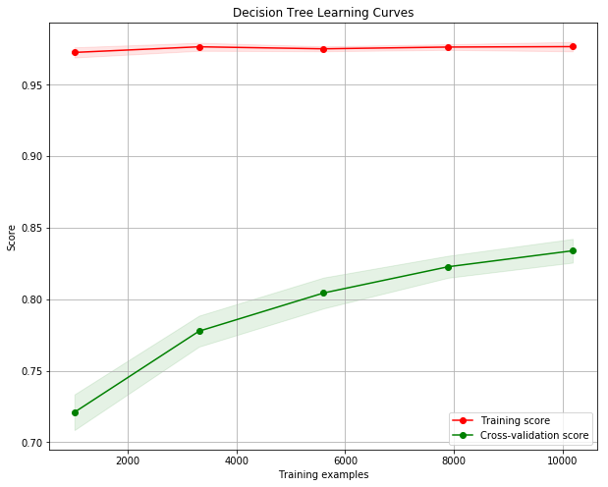
- EEG DT Learning Curves
Next, I plotted the Receiver Operating Characteristic (ROC) curve for the test data. Figure 2 below shows this plot. From the figure we can see that the area under the curve (AUC) is 0.85, which means the model is better than random, but there is still room for improvement.
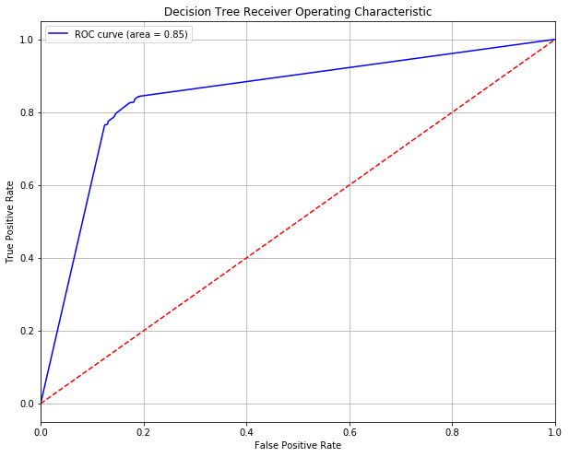
- EEG DT Receiver Operating Characteristic
The next step was to compute the confusion matrix, shown in Table III below, and then the accuracy, precision, recall, and f1-score. The accuracy of the model was 0.8291, the precision was 0.8058, the recall was 0.7975, and the F1 score was 0.8017. Though the accuracy of <83% is not great, the decision tree did perform well in terms of the precision and recall, meaning the incorrect answers were pretty evenly distributed and the algorithm did not incorrectly label only positives or only negatives.

- EEG DT Confusion Matrix
 | Actual Positive | Actual Negative
Predicted Positive | 776 | 197
Predicted Negative | 187 | 1087

Support Vector Machine
To find the best support vector machine model, I tuned the hyperparameters outlined in Table IV below. The optimal hyperparameters for the SVM were determined to be the RBF kernel, a C value of 1, a Coef0 of 0, and shrinking set to False.
- EEG SVM Hyperparameter Tuning
Hyperparameter | Options
Kernel | Linear, Sigmoid, RBF
C | 1.0, 0.75, 0.5
Coef0 | 0.0, 0.1, 0.25
Shrinking | True, False

The model was trained on the optimal hyperparameters and generated the learning curves seen in Figure 3 below. What is interesting about this plot is how closely the training and validation scores track one another, especially after the first iteration. Both scores are pretty constant, which would seem to indicate that the model generalizes well with only 40% of the data. However, the bounds seem to tell a different story, as both are very wide. I think this is because some of the smaller subsets are not truly representative of the actual distribution of data. The model fits some of them very well and others not well at all. However, as we increase the size of the data, the chance of drawing a sample that is not representative of the overall distribution decreases, and we see more consistency in the performance of the model. My guess is that, due to the nature of the hyperplane being fitted, SVMs are particularly susceptible to variations in underlying distribution of the data.
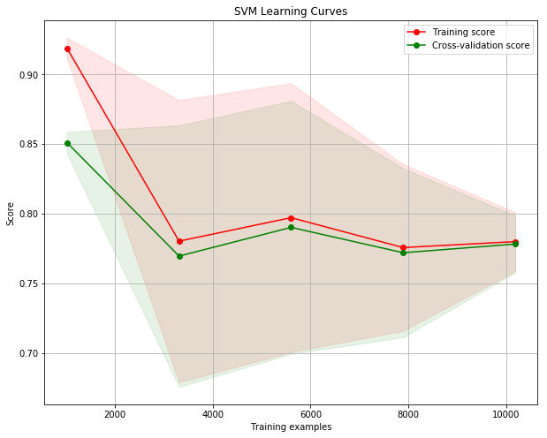
- EEG SVM Learning Curves
The ROC curve for the SVM can be seen in Figure 4 below. The AUC is 0.88, which is better than the decision tree, but there are still too many observations being incorrectly classified.
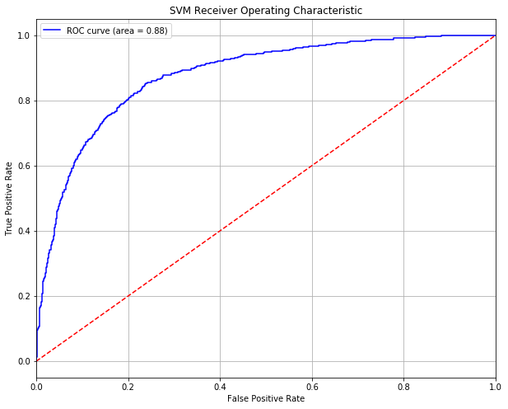
- EEG SVM Receiver Operating Characteristic
The confusion matrix for the SVM is found in Table V. From these numbers, we can determine that the model has an accuracy of 0.7919, precision of 0.8309, recall of 0.6514, and a F1 score of 0.7304. Though the AUC was better than the decision tree, the accuracy and F1 score were both worse. This is primarily due to the decrease in True Positive count and large increase in the False Positive count. Based on the learning curves and the poor metrics, I do not think I would trust an SVM on this dataset.
- EEG SVM Confusion Matrix
 | Actual Positive | Actual Negative
Predicted Positive | 634 | 339
Predicted Negative | 129 | 1145

k-Nearest Neighbors (kNN)
The values of the hyperparameters shown in Table VI were used to tune the k-Nearest Neighbors model. The optimal hyperparameters were shown to be 3 neighbors, p = 2 (meaning the distance metric was the Euclidean distance), the Ball Tree algorithm, and weighting the points by inverse distance.
- EEG kNN Hyperparameter Tuning
Hyperparameter | Options
k-Neighbors | 3, 5, 7
Weights | Uniform, Distance
Algorithm | Ball Tree, KD Tree, Brute Force
p | 1, 2, 3

The learning curves for the kNN model are shown in Figure 5. It quickly becomes evident that kNN is nearly perfect on the training data and that, as the size of the data increases, so does the validation score, reaching almost 97%.
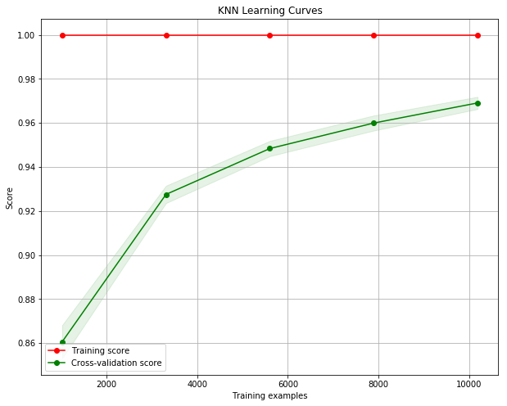
- EEG kNN Learning Curves
Next, we take a look at the ROC curve and the AUC, shown in Figure 6. As is to be expected with such a high validation score, the AUC is 0.99, meaning the model nearly perfectly classifies all observations in the test set.
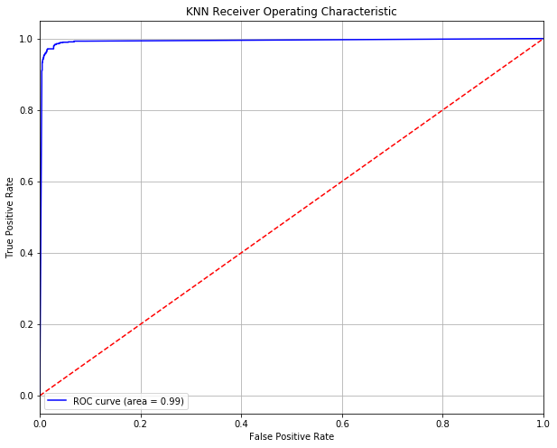
- EEG kNN Receiver Operating Characteristic
Table VI below shows the Confusion Matrix for the kNN model. We can see that it only incorrectly classified 63 out of 2,247 observations, and those were almost evenly divided between False Positives and False Negatives. This resulted in an accuracy of 0.9720, a precision of 0.9643, a recall of 0.9712, and an F1 score of 0.9677.

- EEG kNN Confusion Matrix
 | Actual Positive | Actual Negative
Predicted Positive | 945 | 28
Predicted Negative | 35 | 1239

Boosting
The boosting algorithm was trained using the hyperparameters outline in Table VIII below. The optimal configuration was found to be deviance for loss, 0.8 for minimum samples to split, 500 estimators (or hypotheses), and a subsample rate of 1.0.
- EEG Boostiing Hyperparameter Tuning
Hyperparameter | Options
Loss | Deviance, Exponential
Number of Estimators | 10, 50, 100, 500
Subsample | 0.5, 0.75, 1.0
Min Samples for Split | 0.8, 0.9, 1.0

The boosting learning curves are shown in Figure 7. These curves exhibit what I think is considered "normal" behavior, in that the training score decreases while the validation score increases as more data is added. It looks as though the training score is still decreasing and the validation score may have plateaued. It would be interesting to see how additional data changed the performance of the model.
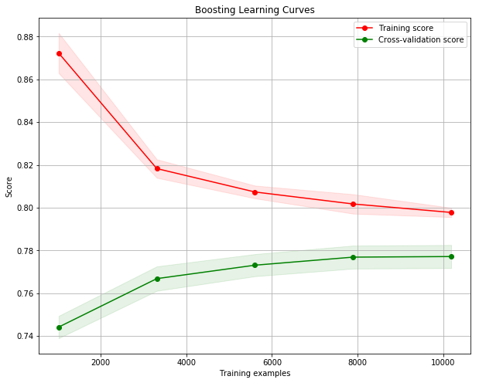
- EEG Boosting Learning Curves
The ROC curve and the AUC metric are shown in Figure 8. The AUC of 0.85 is right in line with the decision tree and just a bit lower than the SVM.
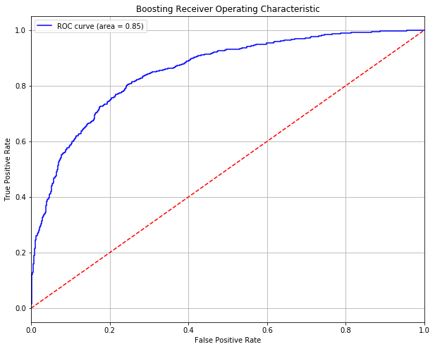
- EEG Boosting Receiver Operating Characteristic
Table IX contains the confusion matrix which was used to calculate the various scoring metrics. The accuracy of the model was 0.7770, the precision was 0.7616, the recall was 0.7060 and the F1 score was 0.7328. The model is not great, but the results are very consistent. Perhaps more hypotheses would help properly classify more examples.
- EEG Boosting Confusion Matrix
 | Actual Positive | Actual Negative
Predicted Positive | 687 | 286
Predicted Negative | 215 | 1059

Neural Network (NN)
The last algorithm trained on this dataset was a neural network. The hyperparameters tuned and their possible values can be seen in Table X. For this dataset, a neural network with two hidden layers, each with 128 neurons was selected. The activtion function is the ReLU, the learning rate was kept constant, and the Adam optimizer was used.
- EEG NN Hyperparameter Tuning
Hyperparameter | Options
Hidden Layer Sizes | 8x1 – 128x2
Activation Function | Logistic, Tanh, ReLU
Learning Rate | Constant, Inverse Scaling, Adaptive
Solver | Adam, SGD

The learning curves of the neural network are shown in Figure 9. We can see that the difference in the training and validation scores remains pretty constant for all numbers of samples, and the two track together throughout. They both appear to still be increasing, so I once again wonder if more data or a longer training time might be necessary to cause things to level off.
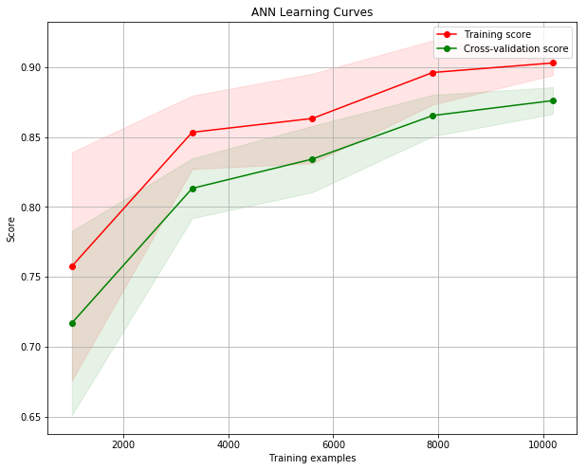
- EEG NN Learning Curves
Figure 10 shows the ROC curve and AUC value of 0.94 for the neural network. This is much better than the decision tree, SVM, and boosting models, but it's still not quite as good as kNN.
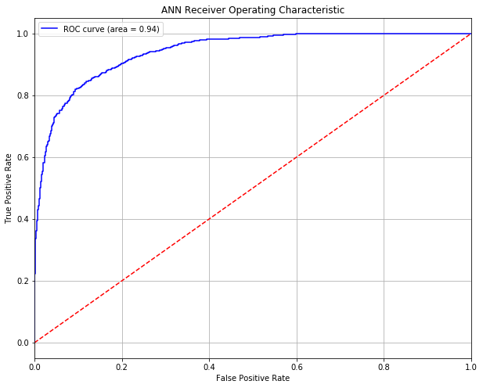
- EEG NN Receiver Operating Characteristic
The confusion matrix for the neural network is shown in Table X. The accuracy was 0.8629, the precision was 0.8389, the recall was 0.8458, and the F1 score was 0.8424. Second only to the kNN model, the neural network outperforms all other models on all metrics.
- EEG NN Confusion Matrix
 | Actual Positive | Actual Negative
Predicted Positive | 823 | 150
Predicted Negative | 158 | 1116

Analysis
For this dataset, the kNN model was clearly the best performer, followed by the neural network, and then the decision tree, boosting, and SVM, which all had similar performances. What I find most interesting about the kNN model is that is a relatively simple one. Only three neighbors were used, Euclidean distance was the metric, and the neighbors were weighted by inverse distance. For the neural network, I would be interested to know how large the network could grow while still seeing improvements that are generalizable. I wonder if the decision tree performance could be improved by eliminating some or all of the pruning. With boosting, similar to the neural network, it would be interesting to see how many hypotheses could be added before results stagnated or the model was overfitted. I also find it fascinating that such a simple model can be used to predict body part movements based on brain waves. If the non-invasive brain-computer interface technology continues to advance, maybe we will soon have a solution for people who have lost the ability to communicate.

Bank Marketing

Description of Problem
The second dataset I chose to analyze is the Bank Marketing Dataset. Though there was nothing particularly interesting about the dataset itself that drew me towards it, I decided on it because I thought it would provide a good comparison of how the algorithms perform on different datasets. In particular, the dataset has about the same number of features as the EEG Eye State dataset, but it has about triple the number of observations. It also has a quite a few categorical features, while the other one is purely numeric. It is also imbalanced, whereas the other was not. So, I wanted to see if the curse of dimensionality came into play, and how categorical features and label imbalance might make the algorithms perform differently. The Bank Marketing dataset has 17 features (10 numeric, 7 categorical) and 41,118 observations. 36,548 observations belong to one class and only 4,640 belonging to the other. The data was gathered during a marketing campaign for a Portuguese bank, and the goal is predict whether a client would subscribe to a bank term deposit. Features include age, education level, marital status, number of times contacted, previous outcomes, and various market indices.

Decision Tree with Pruning
Similar to the previous dataset, I first grew the decision tree to completion to determine the maximum depth of the tree, which was 33. The values of the hyperparameters used for tuning can be found in Table XII. The optimal hyperparameters were determined to be entropy for measuring split quality, a maximum depth of 25, choosing the best random split at each node, using all features when splitting, requiring 5 samples to split a node, and requiring 10 samples to be a leaf node. That the minimum samples being so high could have something to do with the dataset being so imbalanced.

- Bank Marketing DT Hyperparameter Tuning
Hyperparameter | Options
Split Criterion | Gini, Entropy
Splitter | Best, Random
Max Depth | 15, 20
Min Samples to Split | 5, 10, 25
Min Samples per Leaf | 2, 5, 10
Max Features for Split | Sqrt(n), Log2(n), None

From the learning curve in Figure 11, we can see that the training score seems to oscillate while the validation score increases with increasing data.
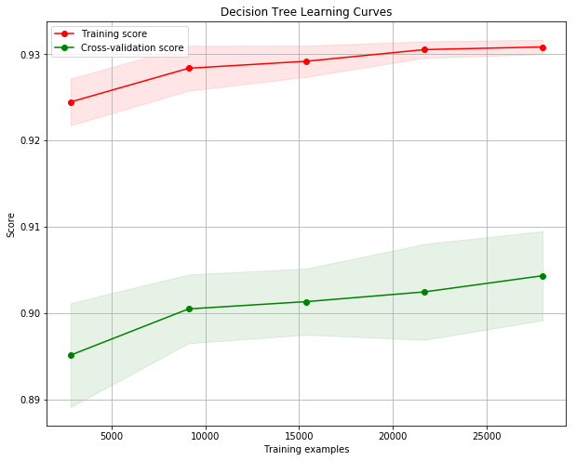
- Bank Marketing DT Learning Curves
This decision tree has an AUC of 0.90 as demonstrated in the ROC curve from Figure 12.
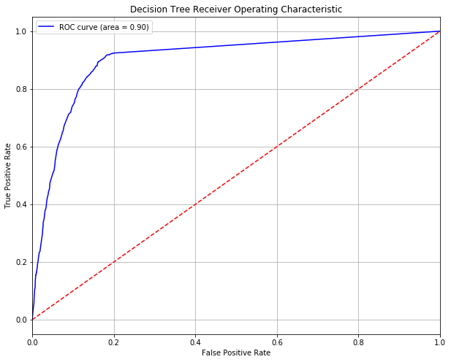
- Bank Marketing DT Receiver Operating Characteristic
The confusion matrix is shown in Table XIII. The accuracy is 0.9021, but the precision and recall are only 0.5807 and 0.4749, respectively, resulting in an F1 score of 0.5225. Here we get our first glimpse at how the imbalance of the dataset can really affect the predictions and the corresponding metrics. Even though the accuracy is >90%, over half of the positive predictions the model made were wrong. This is an excellent demonstration of why additional metrics are useful and why one should rarely, if ever, rely on a single metric to evaluate a model.
- Bank Marketing DT Confusion Matrix
 | Actual Positive | Actual Negative
Predicted Positive | 331 | 366
Predicted Negative | 239 | 5243

Support Vector Machine
The SVM was tuned using the parameters and values detailed in Table XIV. The optimal configuration used the RBF kernel, used a C-value of 0.75, and set shrinking to True.
- Bank marketing SVM Hyperparameter Tuning
Hyperparameter | Options
Kernel | Linear, Sigmoid, RBF
C | 1.0, 0.75, 0.5
Coef0 | 0.0, 0.1, 0.25
Shrinking | True, False

Once the optimal parameters were found and the model was retrained, the learning curves of the training and validations scores was generated. The SVM seems to be a little more stable on this dataset than on the EEG Eye State dataset, but the bounds on the validation scores never seem to narrow. It is worth pointing out that the scale on the y-axis is rather narrow, and even with the seemingly large bounds, roughly 65% of the validation scores are between 0.907 and 0.916.
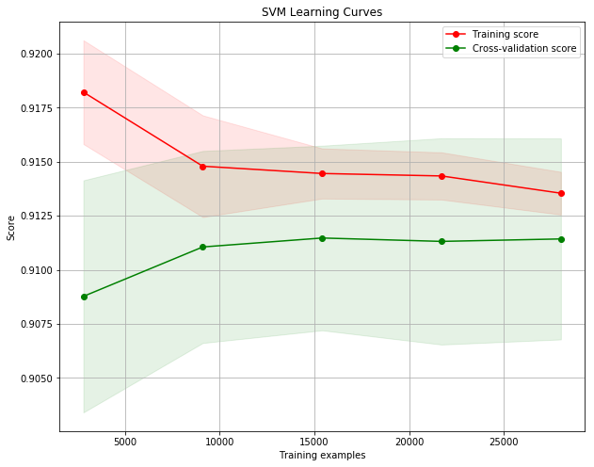
- Bank Marketing SVM Learning Curves
Next, we plotted the ROC and calculated the AUC, which can be seen in Figure 14. From the figure we can see that the AUC is 0.87, which is slightly worse than the decision tree.
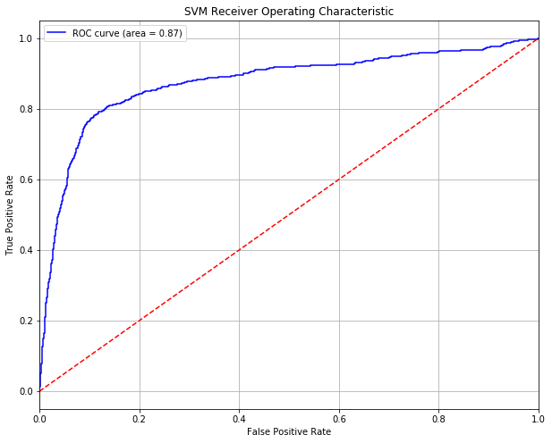
- Bank Marketing SVM Receiver Operating Characteristic
The next step was to populate the confusion matrix and to calculate the metrics. The accuracy was 0.9089, the precision was 0.6384, the recall was 0.4433, and the F1 score was 0.5233. Once again the accuracy is very high, while the precision, recall, and F1 score are all low. It's worth noting that, just like the decision tree, the False Positive count is higher than the True Positive count.
- Bank Marketing SVM Confusion Matrix
 | Actual Positive | Actual Negative
Predicted Positive | 309 | 388
Predicted Negative | 175 | 5307

k-Nearest Neighbors
To tune the kNN model, the hyperparameters and values outlined in Table XVI below were used. The optimal configuration was the model with k-neighbors set to 7, p=3 (meaning the power of the Minkowski distance was 3), uniform weights, and the Ball Tree algorithm for finding neighbors.
- Bank Marketing kNN Hyperparameter Tuning
Hyperparameter | Options
k-Neighbors | 3, 5, 7
Weights | Uniform, Distance
Algorithm | Ball Tree, KD Tree, Brute Force
p | 1, 2, 3

Upon completion of the grid search, the model was trained with the optimal hyperparameters and learning curves were generated. Figre 15 below has the learning training and validation learning curve for the kNN model. We can see that both the training score and validation score continue to increase until perhaps plateauing at the last iteration. Since kNN stores all observations and uses them each time a prediction is made, it kind of makes sense that both scores would increase, at least to a certain point, as more data is available.
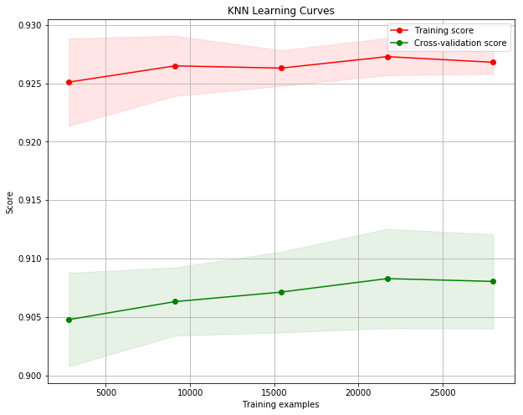
- Bank Marketing kNN Learning Curves
The ROC curve was then plotted and the area under the curve was found. The AUC of 0.89 is right in the middle of the AUC's of the other two models.
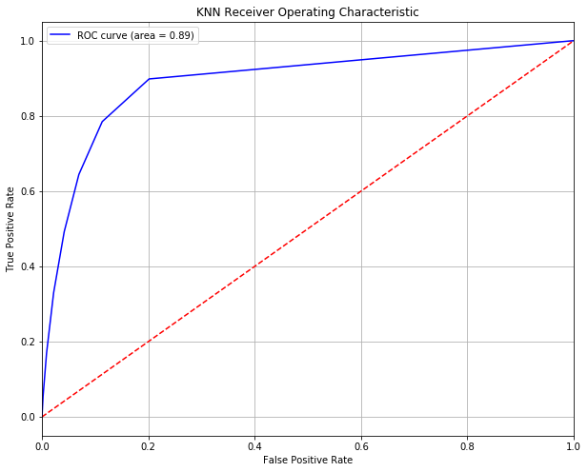
- Bank Marketing kNN Receiver Operating Characteristic
The last step was to build the confusion matrix and calculate the metrics. Accuracy came in at 0.8475, with a precision of 0.3795, a recall of 0.5538, and an F1 score of 0.4504. Even though the ROC is only slightly less than for the decision tree, the underlying metrics are worse than both other models across the board. Something to note here is that, even though this is the first model with a True Positive count higher than the False Positive count, its accuracy is still relatively low because of its high False Negative count.
- Bank Marketing kNN Confusion Matrix
 | Actual Positive | Actual Negative
Predicted Positive | 386 | 311
Predicted Negative | 631 | 4851

Boosting
Table XVIII shows the hyperparameters and their values that were compared in the grid search. For the Bank Marketing dataset, the best boosting model was one using deviance for loss, 100 hypotheses or estimators, a subsample of 0.5, and a minimum of 5 samples to split. The subsampling rate is interesting, because it means the hypothesis was only fit on half the data each. Given the massive class imbalance, this might make sense.
- Bank Marketing Boostiing Hyperparameter Tuning
Hyperparameter | Options
Loss | Deviance, Exponential
Number of Estimators | 50, 100, 500, 1000
Subsample | 0.5, 0.75, 1.0
Min Samples for Split | 2, 5, 10

After determining the optimal hyperparameters, the model was retrained to find the training and validation learning curves, shown in Figure 17 below. The boosting curves once again look pretty standard. The validation score seems to level out once all the data is included, which indicates the model was a good fit.
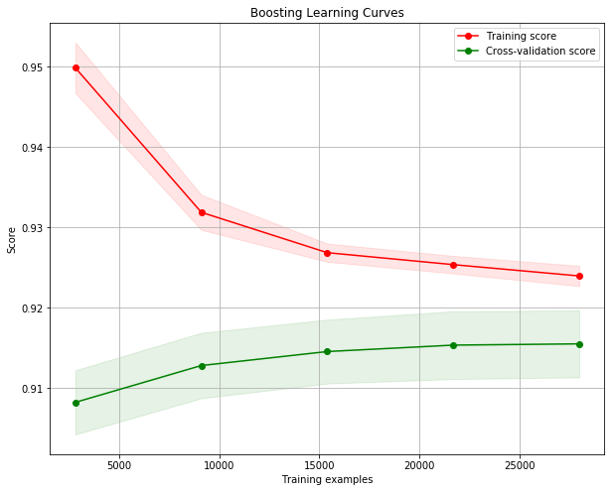
- Bank Marketing Boosting Learning Curves
The ROC curve was plotted next and can be seen in Figure 18. The AUC is 0.95, which is the highest we have seen on this dataset so far, indicating boosting might be the best fit here.
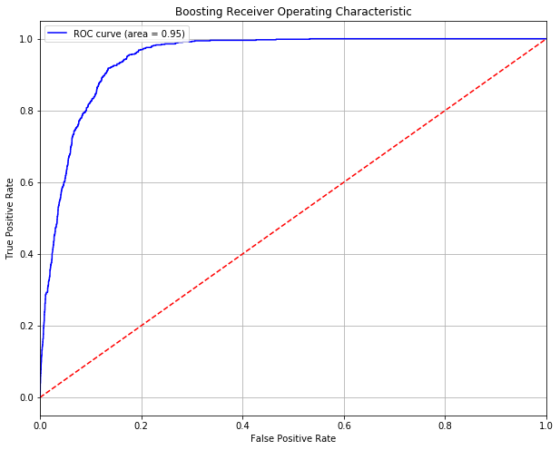
- Bank Marketing Boosting Receiver Operating Characteristic
We will once again take a look at the confusion matrix to see if the promising AUC aligns with the rest of the metrics. The accuracy is 0.9142, the precision is 0.6371, the recall is 0.5567, and the F1 score is 0.5942. This is still far from good, but it is the best overall model for the Bank Marketing dataset. The boosting model predicted nearly the same number of True and False Positives as the kNN model, but the False Negative count is greatly reduced, resulting in better overall performance.
- Bank Marketing Boosting Confusion Matrix
 | Actual Positive | Actual Negative
Predicted Positive | 388 | 309
Predicted Negative | 221 | 5261

Neural Network
The neural network was tuned using the parameters and their respective values from Table XX. In the end, a neural network with two layers consisting of 8 and 32 neurons was trained. The logistic activation function was used, the learning was adaptive, and the Adam optimizer was used.
- Bank Marketing NN Hyperparameter Tuning
Hyperparameter | Options
Hidden Layer Sizes | 8x1 – 128x2
Activation Function | Logistic, Tanh, ReLU
Learning Rate | Constant, Inverse Scaling, Adaptive
Solver | Adam, SGD

The learning curves from Figure 19 were generated using the newly trained model on progressively more data. These look incredibly similar to the curve above from the boosting model, and we will see that the additional metrics are also very similar. It actually appears as though the validation score is still increasing. Perhaps some different configuration or, once again, more data is necessary to fit the data properly.
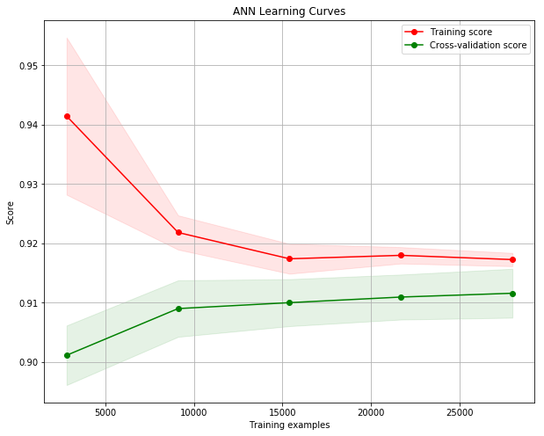
- Bank Marketing NN Learning Curves
Figure 20 shows the ROC curve and AUC of 0.94. This is only slightly worse the AUC for the boosting model, and it is still considerably better than those of the other three models.
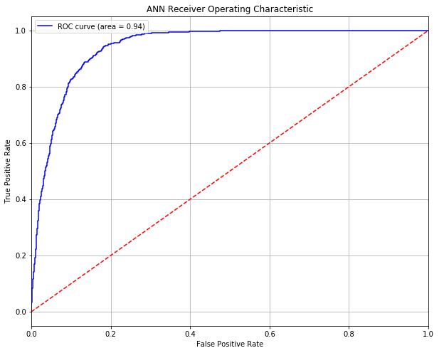
- Bank Marketing NN Receiver Operating Characteristic
Finally, we computed the confusion matrix and the metrics. The accuracy 0.9121, the precision was 0.6356, the recall was 0.5179, and the F1 score was 0.5708. The neural network was similar to the boosting model. Its correctness on the positive predictions was slightly worse, while its correctness on negative predictions was only slightly better, thus resulting in comparable overall scores.

- Bank Marketing NN Confusion Matrix
 | Actual Positive | Actual Negative
Predicted Positive | 361 | 336
Predicted Negative | 207 | 5275

Analysis
For this dataset, the boosting model and neural network performed the best, while the other three all lagged behind. Since the optimal boosting model actually did not use maximum number of possible hypotheses, I am not sure how much more could be done to improve its performance. However, as is often the case with the neural network, it would be interesting to see how additional configurations, particularly with more nodes and layers, might perform against this baseline. For the decision tree I would once again with the amount of pruning being done to try to do a better job of finding the balance between over- and underfitting. As for the SVM and kNN models, I think they just might not be very good models for this dataset. Considering that nearly 89% of the observations in the total dataset and the test dataset were negative, none of these algorithms performed very admirably. Were I to continue exploring this dataset, I would also look into feature engineering, perhaps looking to create more meaningful features from the existing ones or getting rid of features that seem meaningless or redundant.

Conclusion
There are a few things I would like to point out that I found interesting between the datasets. The first is that the optimal hyperparameters for each of the models was different for each dataset. One decision tree used the best split while the other used the best random split. Both SVMs used the RBF kernel, but one used shrinking and the other did not, and they both had different values for C. Both kNN models used the Ball Tree algorithm, but one used 7 neighbors, uniform weights, and p=3, while the other used 3 neighbors, distance-based weights, and p=2. Both boosting models used deviance for loss, but one used 100 hypotheses and sampled 50% of the data while the other used 500 hypotheses and sampled 100% of the data. Finally, both neural networks used the Adam optimizer, but one used ReLU activations, a constant learning rate, and 2 hidden layers with 128 neurons each, while the other used sigmoid activations, an adaptive learning rate, and hidden layer sizes of 8 and 32 neurons. On the first dataset, kNN was far and away the best performer, with an accuracy on a balanced dataset of over 97%. On the second dataset, boosting and the neural network were comparable at 91% accuracy but still pretty bad overall considering the 89%/11% class imbalance. I think if nothing else this was a great exercise in proving that there really is no such thing as a free lunch. None of these algorithms is bad, and none of them is good. Each of them performs well in certain situations and poorly in others. This is why domain knowledge is so important. It takes working with these algorithms and solving problems to get a feel for when to try a certain approach.

