Docker ps -a:
This command displays all Docker containers on your computer, including running containers, stopped containers and containers that have exited.

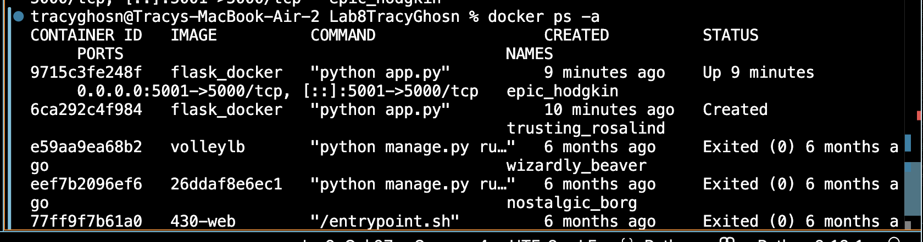

Docker stop:
This command stops a currently running Docker container gracefully. The container remains stored in Docker but is no longer running.

Docker logs:
This command displays the logs generated by a Docker container. It allows developers to monitor application activity, view server messages, identify errors, and troubleshoot problems.



