Installed required libraries:

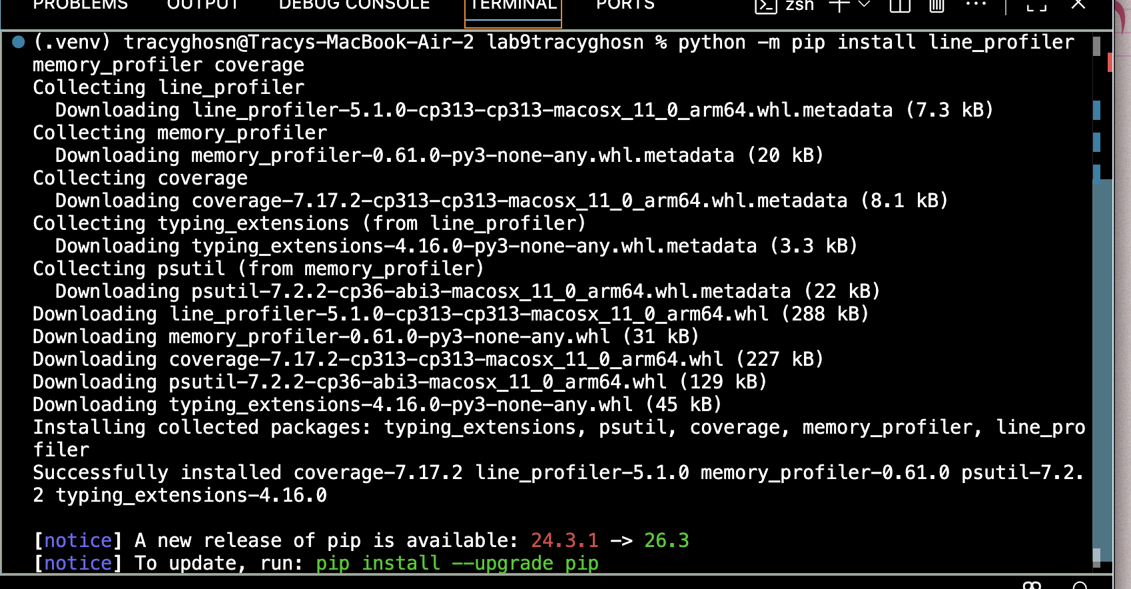

Command to run profiler.py ran in seconds:

Using cProfile:
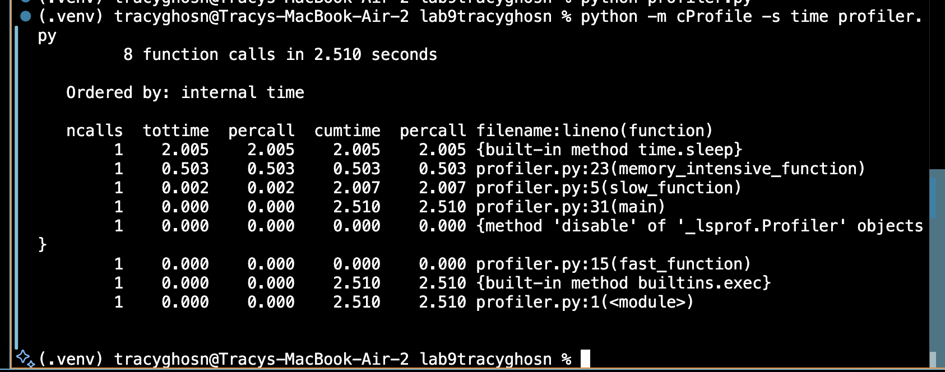
This command runs program and displays the execution time of each function.

- slow_function() takes approximately 2 seconds because of time.sleep(2). Sleep part of the slow function.
- memory_intensive_function() performs more iterations, making it computationally expensive and takes about 0.503 seconds.
- fast_function() executes much faster (almost no measurable time) because it only performs 100 iterations.
- main(): Takes 2.510 seconds because it executes all three functions.
The profiling results help identify which functions consume the most execution time. Slow takes the most time, the most prominent bottleneck function of the program.
python profiler_lineprofiler.py
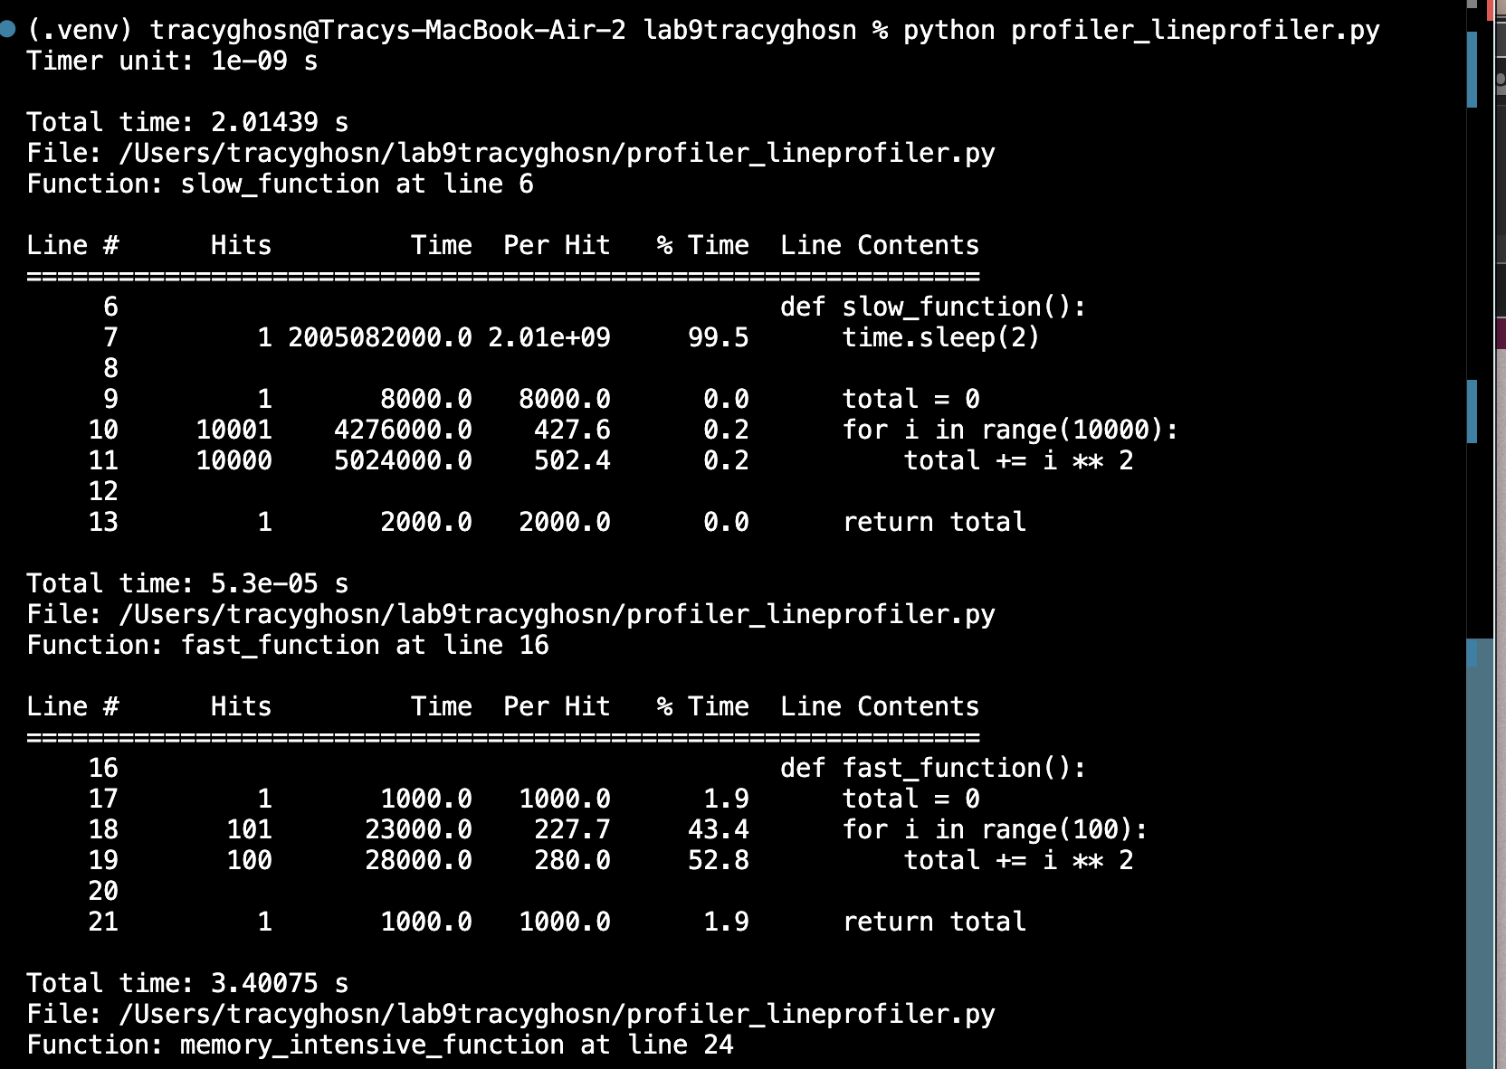
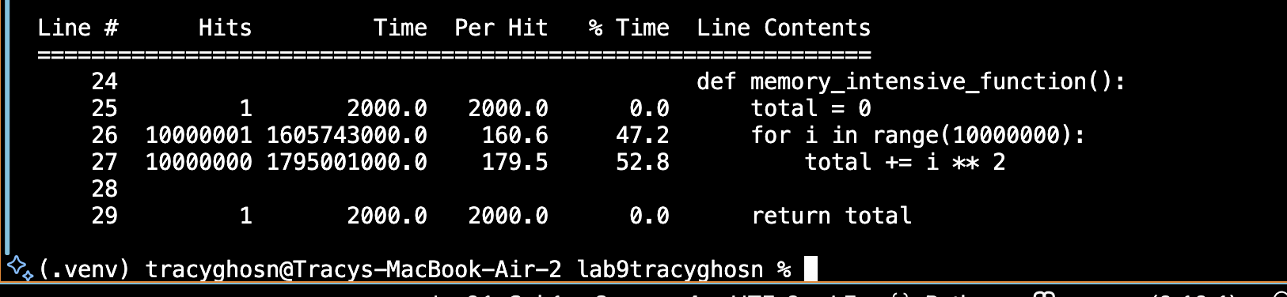

Line Profiler Analysis – Before Optimization
The line_profiler tool was used to analyze the execution time of individual lines in the Python program.
The slow_function() took approximately 2.01439 seconds. The results showed that the time.sleep(2) statement accounted for approximately 99.5% of its execution time.
The fast_function() took approximately 0.000053 seconds because it only performs 100 iterations, making it very efficient.
The memory_intensive_function() took approximately 3.40075 seconds under line profiling. Its loop and square calculation operations consumed nearly 47% and 53%, respectively.
The results indicate that memory_intensive_function() is the main computational bottleneck, while slow_function() spends most of its time waiting.
Line profiling helped identify the exact lines that consume the most execution time and provides useful information for future optimization.
Difference between cProfile and Line profiling:
The execution time reported by line_profiler is higher than the execution time reported by cProfile because line_profiler introduces additional overhead while monitoring individual lines of code.
In my experiment, memory_intensive_function() took approximately 0.503 seconds according to cProfile, whereas line_profiler reported approximately 3.401 seconds.
This difference occurs because line_profiler repeatedly measures the execution of individual lines inside the loop, which executes 10 million iterations. The additional monitoring work increases the measured execution time.

Now memory profiler:
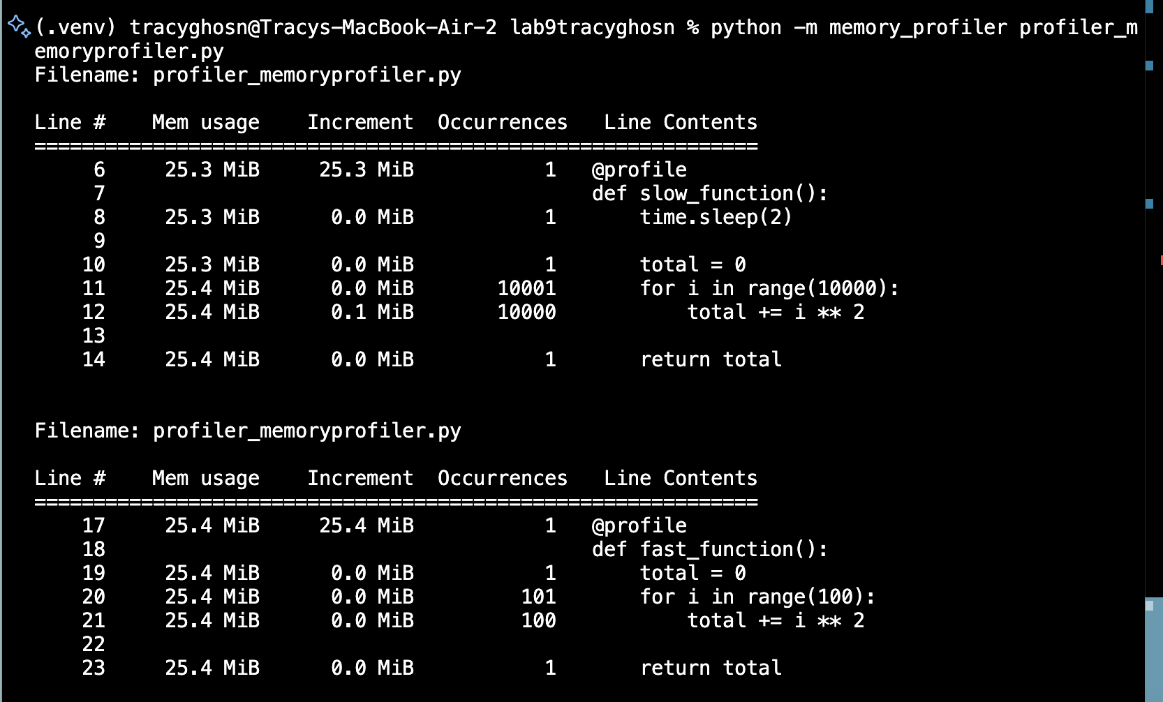
Taking more time for the computationally expensive iteration with 10 million iterations
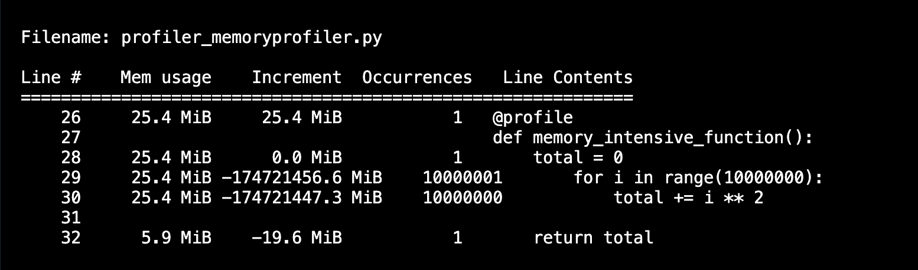
The memory profiler successfully analyzed all three functions: slow_function(), fast_function(), and memory_intensive_function().

1. slow_function()
- The function started using approximately 25.3 MiB of memory.
- The time.sleep(2) instruction did not cause any noticeable memory increase.
- The loop executed 10,000 iterations.
- Memory usage increased by approximately 0.1 MiB during the calculation.
- The function finished at approximately 25.4 MiB.
Its memory usage remained almost constant throughout execution (a small increase throughout).

2. fast_function()
- The function started at approximately 25.4 MiB.
- It executed a loop of 100 iterations.
- No noticeable memory increase occurred during the calculations.
- The function finished at approximately 25.4 MiB.
The function uses very little memory. Its memory consumption remained stable.

3. memory_intensive_function()
- The function started at approximately 25.4 MiB.
- It executed 10,000,000 iterations.
- The memory profiler displayed extremely large negative increments during the loop, followed by a final memory reading of approximately 5.9 MiB.
The large negative memory increments are not realistic measurements of memory released by the function. The function itself only stores one variable, total, rather than creating a large data structure because of its high number of iterations. Therefore, it does not actually require a large amount of additional memory.
Analysis:
The memory profiler showed that increasing the number of computational iterations does not necessarily result in increased memory consumption. The memory-intensive function performed 10 million iterations but maintained approximately constant memory usage because it only stored a running total rather than retaining every calculated value. This demonstrates that memory usage depends more on the amount of data stored than on the number of computations performed.

Coverage test:

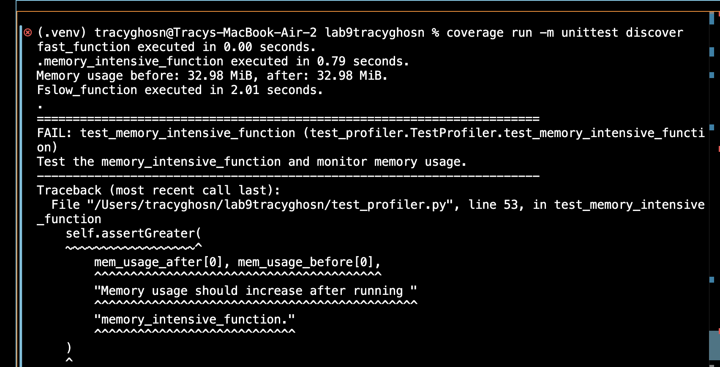
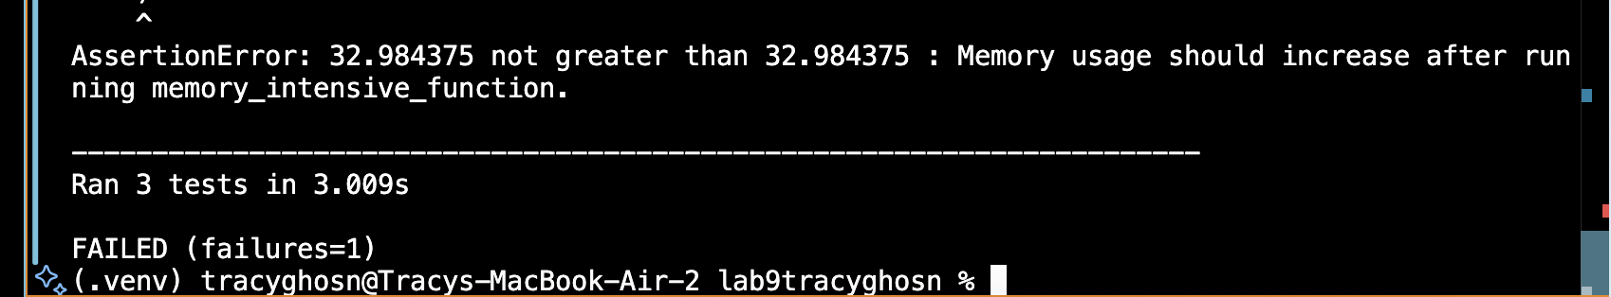

Coverage report:
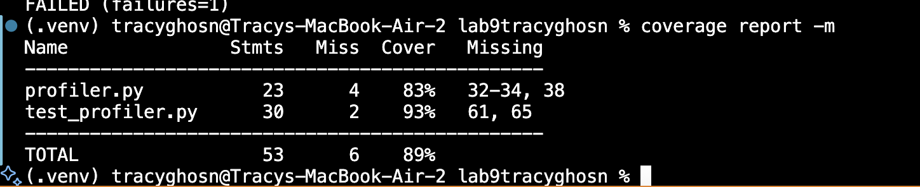

Code Coverage Analysis
After running the test suite using coverage run -m unittest discover, the coverage report showed an overall code coverage of 89%.
The profiler.py file contained 23 executable statements, of which 19 were executed, resulting in 83% coverage. Four lines (32,33,34 and 38) were not executed. These lines belong to the main program execution section, which was not called during the individual unit tests.
The test_profiler.py file contained 30 statements, of which 28 were executed, resulting in 93% coverage. Lines 61 and 65 were not executed because the test discovery mechanism runs the test methods directly rather than calling the file's main() function.
Overall, 47 out of 53 statements were executed, giving a total coverage of 89%.
The results show that the unit tests successfully exercised most of the program's functionality. However, some lines related to the main execution sections were not covered.
Additionally, two tests passed while the memory usage test failed because memory consumption remained unchanged before and after the function execution. This failure did not prevent coverage from collecting execution data.

Html:
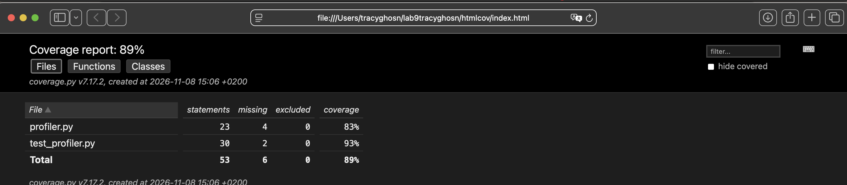

Optimization:
After changing fast function to optimized fast function:
def optimized_fast_function():
"""Return the sum of squares from 0 through 99 without a loop."""
n = 100
return n * (n - 1) * (2 * n - 1) // 6

I reran the profilers to check the optimization:

Cprofile:
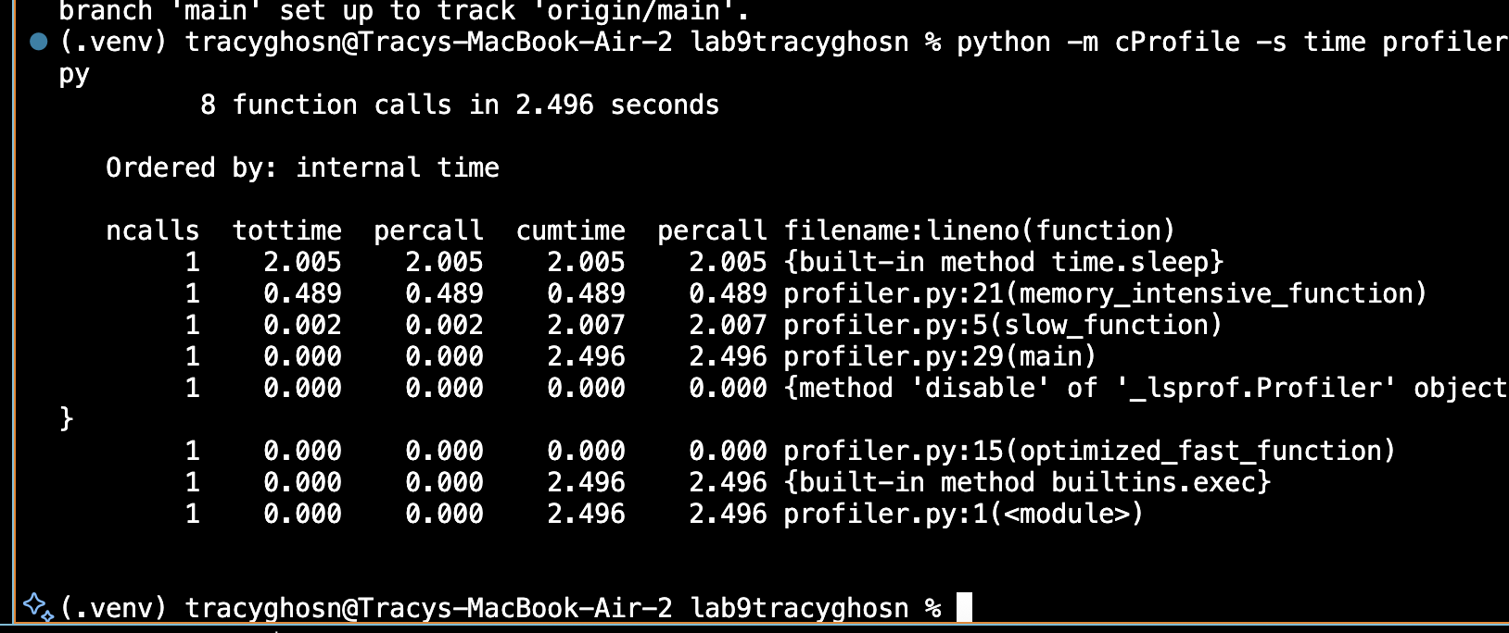
Still negligible time like before.

Line profiler:

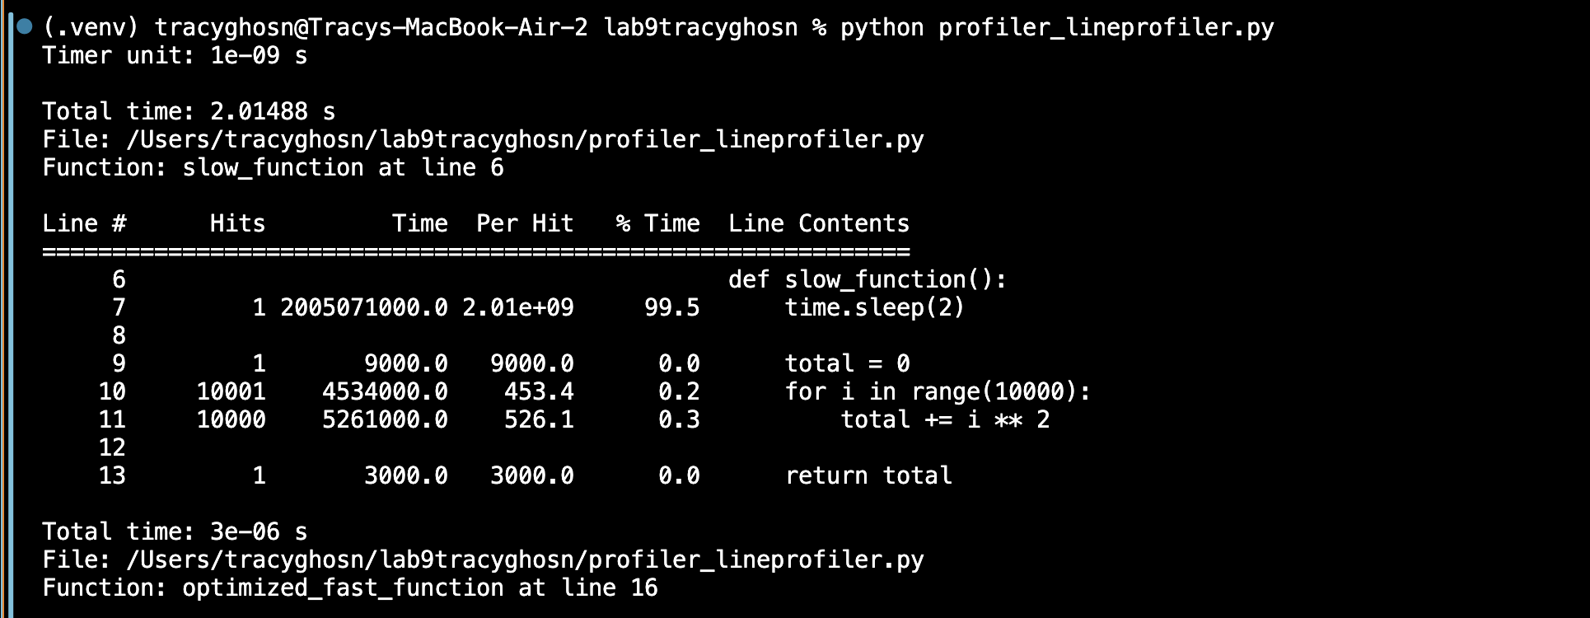

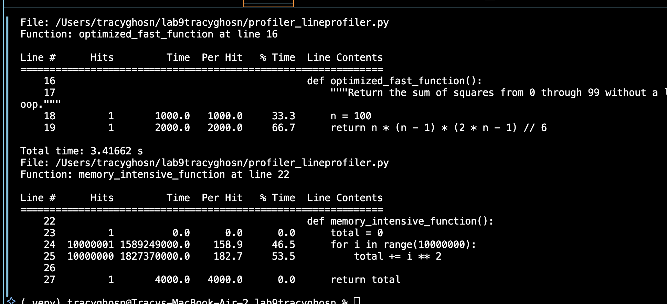

The optimized function uses a mathematical formula to calculate the sum of squares instead of executing a loop 100 times. This reduces the number of operations. The total program time also decreased, although the improvement is relatively small because slow_function() still takes approximately two seconds.

Memory profiler:

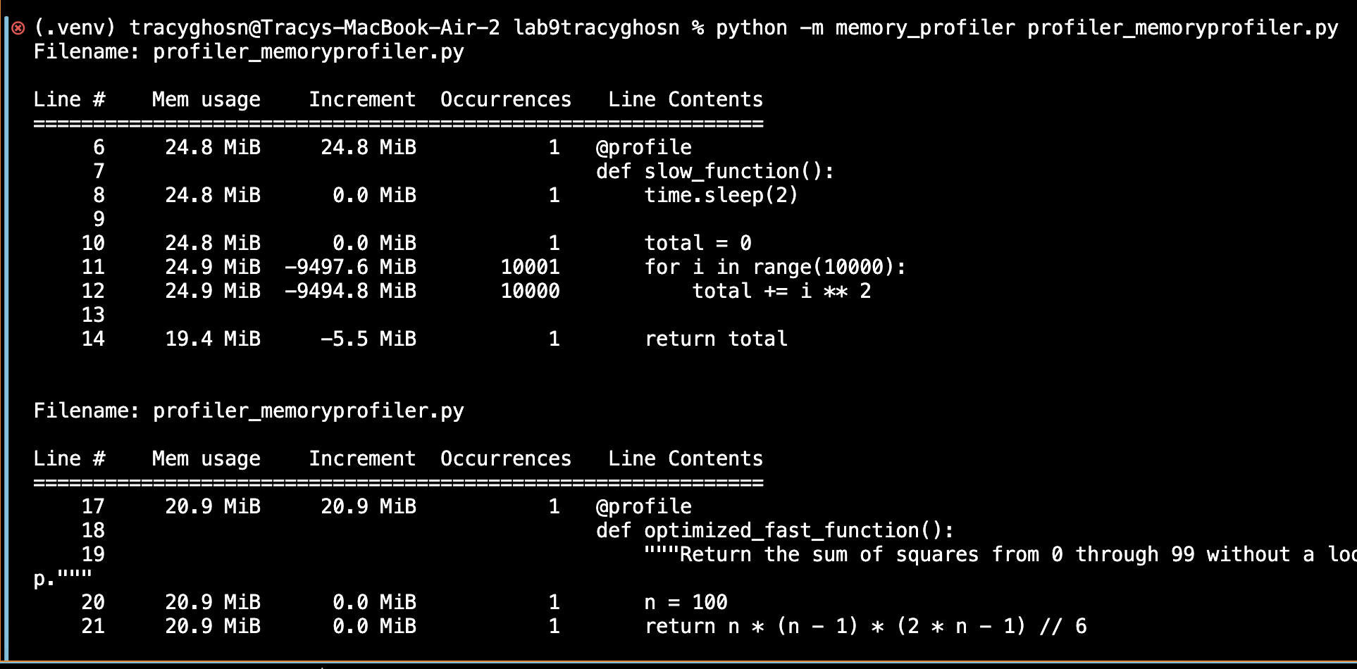
Before optimization, the fast function used approximately 25.4 MiB of memory. After optimization, the optimized fast function reported approximately 20.9 MiB.
This suggests a reduction of approximately 4.5 MiB in the reported memory usage. The optimized function uses a mathematical formula instead of repeatedly executing a loop, reducing the amount of intermediate computation
My strongest result is the mathematical optimization. It changes the calculation from a loop with 100 iterations to a constant-time formula, O(1) instead of O(n).

Coverage:
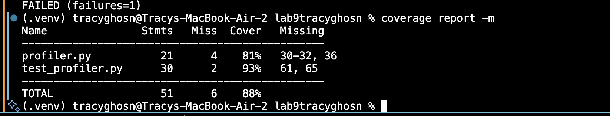

Before optimization, the project achieved 89% code coverage, with 53 statements and 6 missing statements.
After optimization, the project achieved the same coverage percentage of 89%.
This shows that the optimization did not reduce code coverage. The optimized function still produces the expected result, while using a direct mathematical formula instead of a loop.
Therefore, the optimization improved the computational approach while maintaining the same code coverage.
The test suite calls the functions, but not the main() entry points. In the coverage report, these show under missing in both before and after.

