
GENEVIEVE App™
KENNEL & CATTERY SAFETY, WELFARE
AND OPERATIONS TRIAL PROPOSAL
A proposed six-week controlled pilot for cats and dogs

Prepared by Tracey Kennedy | Founder, GENEVIEVE App™
Prepared for: [KENNEL / CATTERY NAME] • Date: [INSERT DATE] • Version: Draft 1
Purpose: to test whether one connected management dashboard and employee mobile workflow can reduce duplicated administration, strengthen safety and handovers, and return more staff time to direct animal care.
Revision note for Tracey: All bracketed text is intended for you to edit before sending. The proposed pilot conditions can be changed after discussion with the trial facility.

1. Executive summary
GENEVIEVE App™ Cats & Dogs Care Command is a proposed connected safety, welfare and operations program for boarding kennels, catteries, pet resorts and combined cat-and-dog facilities. It is designed to place the facility’s daily priorities in one view and connect management with attendants completing rounds, care tasks, custody handovers and optional transport work.
The system does not replace experienced staff, veterinary judgement, emergency services, workplace procedures or legal obligations. Its purpose is to make approved information easier to find, reduce repeated data entry, identify overdue or high-risk work, and create a clearer evidence trail.
Core proposition: less time searching, rewriting and chasing tasks; more time available for calm handling, welfare observations, enrichment, cleaning, medication safety, owner communication and individual animal needs.

2. The operational problem
- Many facilities rely on a mixture of booking software, paper care sheets, whiteboards, text messages, verbal handovers, spreadsheets and separate incident forms.
- Important information can be repeated in several places or may be difficult for the person standing in front of the animal to access quickly.
- Managers may spend time confirming whether rounds, medication, feeding, cleaning, owner updates or pickup arrangements were completed.
- When an incident occurs, records may need to be collected from several people and systems.
- Cat and dog needs are different, but generic workflows can overlook species-specific signals such as cat appetite, litter output, hiding, handling tolerance, dog reactivity, gate crowding, play style and heat risk.

3. The proposed solution
The trial would use one linked program with four controlled views:
View | Purpose
Management Command Dashboard | Current facility state, cats and dogs in care, bookings, rounds, alerts, rooms, care tasks, incidents, staff, stock, transport and emergency command.
Employee Mobile Rounds App | Assigned rounds, species-specific checklists, care tasks, notes, amber/red escalation and SOS.
Transport / Driver App | Optional pickup and delivery chain of custody, crate/restraint, temperature, ventilation, handover and final vehicle sweep.
Owner Portal Demonstration | Only approved animal information, updates and pickup-authorisation requests.

4. Proposed trial functions
Module | What the trial tests
Bookings and intake | Cat- and dog-specific profiles, vaccination evidence, owner permissions, emergency contacts, feeding, medication, allergies, behaviour, medical and authorised-pickup information.
Drop-off and pickup | Identity checks, condition records, belongings and medication counts, named employee acceptance, authorised collector checks and custody audit.
Kennels and cat suites | Occupancy, quiet/medical/isolation areas, temperature, humidity, gates/doors, cleaning state and placement warnings.
Preventative placement | Explainable room assessment. Dog rules consider reactivity, movement, play and heat; cat rules consider escape control, hiding, litter, noise and separation from dogs.
Care and health tasks | Feeding, medication, welfare, physiotherapy, grooming, veterinary appointments and timed employee assignments.
Live employee rounds | Dog and cat checklists with direct observations, progress, notes and manager escalation.
Stock and expiry | Food, medications, PPE, cleaning products and emergency supplies with low-stock warnings.
Transport option | Vehicle, equipment, identity, custody, temperature, ventilation, water, medication and no-animal-left check.
Staff and WHS | Shift status, first-aid training indicators, two-person controls, hazard and near-miss reporting, duress and lone-worker concepts.
Emergency command | Scenario activation, animal headcount, cat/dog separation, staff actions, owner/vet communications, evidence and recovery tasks.
Incident and audit | Factual records, immediate controls, responsible manager, alerts, corrective actions and exportable audit data.
Owner communication | Facility-approved updates and pickup-authorisation requests with restricted visibility.

5. Expected operational benefits to test
The proposal does not guarantee a fixed saving. The pilot is intended to measure whether the facility achieves improvements in the following areas:
Area | Potential trial outcome
Time | Less duplicate entry, faster handovers, easier task verification and more immediate access to animal instructions.
Animal welfare | More consistent species-specific rounds, clearer priorities and earlier escalation of changes.
Staff safety | Visible handling warnings, two-person controls, incident and near-miss reporting, and clearer emergency roles.
Owner service | More structured check-in/out, approved updates and clearer custody handovers.
Cost control | Lower avoidable stock wastage, fewer missed or late tasks, reduced administrative rework and better capacity visibility.
Evidence | Time-stamped records for internal review and for the facility’s authorised advisers, insurer or regulator where appropriate.

6. Proposed six-week pilot
Stage | Activity
Before week 1 | Map the facility’s existing process; nominate trial users; confirm data, privacy, WHS and incident boundaries; configure cats, dogs, rooms, tasks and forms; capture baseline measurements.
Week 1 | Training and controlled start. Use the system alongside existing records until the facility authorises a change.
Weeks 2–3 | Daily use in selected areas. Weekly review of usability, missed information, staff workload and safety concerns.
Weeks 4–5 | Refine forms and alerts; test pickup, transport (if offered), incident and emergency demonstrations; compare baseline measures.
Week 6 | Final observations, staff and management feedback, owner-service feedback if approved, data export and results report.
After pilot | Decide whether to stop, revise, extend or plan a secure production implementation. Trial data is returned/exported and handled under the agreed pilot terms.

7. Measures of success
- Average minutes spent on an animal-welfare round
- Daily minutes spent rewriting or transferring records
- Average check-in and pickup time
- Number of late, missed or unverified care tasks
- Time required to prepare shift handover
- Number of incidents and near misses recorded and followed up
- Stock shortages, expiry or avoidable wastage identified
- Overtime associated with administration or handovers
- Staff confidence that they can find the correct animal information
- Management confidence that priority work is visible
- Estimated staff time redirected to direct animal care
- Usability, privacy, safety and workflow problems requiring correction

8. Responsibilities during the trial
GENEVIEVE App™ / Tracey | Trial facility
• Configure the agreed demonstration | • Retain control of animal-care, staffing, emergency and legal decisions
• Provide initial training and reasonable trial support | • Nominate an authorised manager and trial users
• Document requested changes and known limitations | • Maintain all required licences, policies, insurance, training and existing safety procedures
• Protect information supplied for the trial under the written pilot agreement | • Use fictional/de-identified information until secure production controls are approved
• Provide an end-of-trial findings summary | • Report errors, risks and incidents immediately and stop use where unsafe

9. Privacy, employee monitoring and data security
The current package is a static demonstration and is not approved for real personal, medical, employee, payment or incident data. A production pilot using real information should not begin until the parties agree on secure hosting, accounts, permissions, data location, backups, retention, incident response, access/correction and deletion requirements.
- Collect only information reasonably necessary for the agreed kennel or cattery function.
- Give owners and employees clear notices about what is collected, why, who can see it and how long it is retained.
- Use role-based access so attendants, managers, drivers and owners see only what they need.
- Use employee location, cameras or activity monitoring only after the facility confirms applicable laws, consultation and notices.
- Never use camera monitoring as a replacement for physical welfare rounds.
- Do not use real payment data in the static demo.
- Agree on data export and deletion when the pilot ends.

10. Animal welfare, WHS, insurance and legal position
GENEVIEVE App™ is proposed as a decision-support and record-keeping tool. The facility remains responsible for animals in its charge, workplace health and safety, local council approvals, incident notification, workers’ compensation, transport, privacy, employment obligations and insurance. The facility’s veterinary, legal, WHS, privacy, council and insurance advisers should review any production trial.
Important: the program must never delay emergency action, veterinary attention or required external notification. In a life-threatening emergency, call 000 and follow official directions.

11. Proposed pilot terms for discussion
- Pilot site: [INSERT FACILITY AND LOCATION]
- Pilot term: six weeks from [DATE] to [DATE]
- Pilot functions: [SELECT AGREED MODULES]
- Commercial terms: [NO-CHARGE DEVELOPMENT PILOT / AGREED FEE / OTHER]
- Staff users: [NUMBER AND ROLES]
- Animals and areas included: [SPECIFY]
- Trial data: [FICTIONAL / DE-IDENTIFIED / APPROVED REAL DATA UNDER SECURITY AGREEMENT]
- Confidentiality: neither party publicly names the other or publishes results without written approval
- Intellectual property: each party keeps its pre-existing IP; trial feedback and product-development treatment to be confirmed in writing
- Liability and insurance: to be reviewed and agreed before operational use
- Stop-work right: either party may pause the trial immediately if a safety, privacy or operational risk is identified
- End of pilot: export, return, deletion and continued-access arrangements to be agreed

12. Current live-demo limitations
- The supplied demo is static and stores changes in the browser.
- It can demonstrate management and employee views updating between tabs in the same browser.
- It is GitHub and Vercel compatible and requires no npm build.
- It does not yet provide secure real-time synchronisation between separate physical phones.
- It does not include production authentication, server audit timestamps, encrypted database storage, backups, payment processing or formal integrations.
- Those functions require a separate production build and security review.

13. Proposed next steps
1. Tracey reviews and edits this draft.
2. Identify one suitable independent kennel, cattery, pet resort or combined facility.
3. Hold a 30–45 minute demonstration and discovery meeting.
4. Map the facility’s existing forms and daily process.
5. Prepare a written pilot agreement and risk/privacy checklist.
6. Run a staff demonstration using fictional animals.
7. Only after approval, begin the controlled pilot and measurements.

14. Suggested short pitch
GENEVIEVE App™ connects the facility’s bookings, cats and dogs, rooms, care tasks, employee rounds, custody handovers, incidents and emergencies in one system. Staff record work where it happens, while management can see which animal, room, task or hazard needs attention first. The purpose is to reduce duplicated administration and missed communication so more valuable staff time can be directed to safe, individual animal care. I am seeking one facility to help test and improve it through a measured six-week pilot.

15. Questions to finalise before sending
☐ Which facility will receive the proposal?
☐ Will the pilot be free, discounted or paid?
☐ Will it include dogs only, cats only or both?
☐ Will transport be included or switched off?
☐ Will the first pilot use fictional/de-identified information only?
☐ Which functions are essential for the first six weeks?
☐ What support can Tracey provide during the trial?
☐ What may the facility keep or use after the pilot?
☐ Can results be used anonymously in future pitches?
☐ Which business contact details should appear on the cover?

16. Official reference notes for adviser review
- Queensland duty of care for animals
- WorkSafe Queensland — animal handling
- WorkSafe Queensland — incident notification
- WorkCover Queensland — insurance
- OAIC — securing personal information
- OAIC — workplace monitoring and surveillance
- Queensland Animal Care and Protection Act 2001
These references are a starting point only. The trial facility must confirm the requirements that apply to its exact location, council, services, workforce and insurance arrangements.
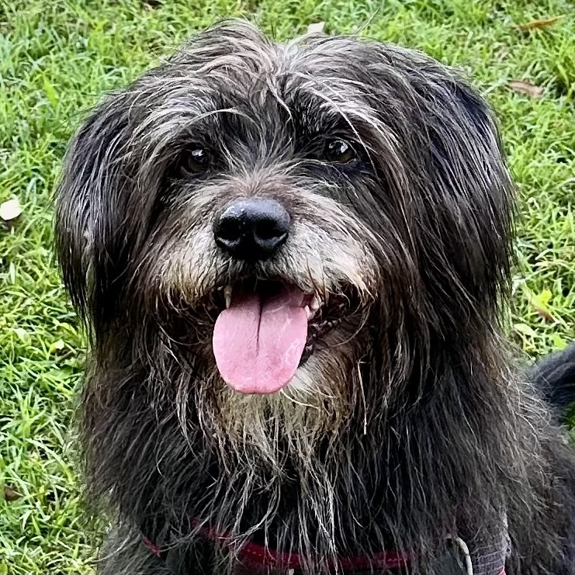
Keeping every cat, dog and person safer — while returning time to care.
Tracey Kennedy | GENEVIEVE App™ | [EMAIL] | [PHONE] | [WEBSITE]

