GENEVIEVE App™
IP MASTER RECORD AND DRAFT PATENT SPECIFICATION

Configuration-Driven, Evidence-Gated Operational Intelligence, Accountability and Human-Controlled Mechanical Safety Systems

Inventor / Applicant: Tracey Kennedy
Jurisdiction focus: Australia
Preparation date: 22 July 2026
Document status: Confidential working draft for patent-attorney review

IMPORTANT
This document is a comprehensive invention-record and drafting foundation. It is not a guarantee of patentability, validity, freedom to operate, or acceptance by IP Australia. A registered Australian patent attorney should conduct prior-art searching, determine inventorship and ownership, select filing strategy, and settle the final claims before filing. Broadly combining unrelated products in one claim set can trigger a lack-of-unity objection; therefore this record deliberately discloses multiple invention families while identifying a proposed unifying core and recommended separate mechanical filings.

1. Executive protection strategy
The recommended strategy is a layered portfolio rather than one “everything patent”. The master record preserves the full technical story, dates, variants and links between inventions. Patent applications should then be filed around technically coherent invention families, supported by trade marks, registered designs, copyright, confidential know-how, contracts and invention-assignment records.
- Core platform patent family: configuration-driven event ingestion, role-capability routing, evidence gates, timed escalation, immutable accountability and cross-industry overlays.
- Mechanical safety-device patent families: each mechanically distinct apparatus should receive its own disclosure and, where justified, its own provisional application (for example smart waste bagging, smart furniture, dispensing, sealing, lifting, grooming or sanitation devices).
- Registered designs: protect the visual appearance of physical products, enclosures, stations, furniture and interfaces where appearance is commercially important.
- Trade marks: protect GENEVIEVE App™, division names, product names, logos and other origin indicators.
- Copyright and trade secrets: protect source code, drawings, specifications, databases, manuals, UI artwork, rule libraries, pricing logic and undisclosed manufacturing details.
- Contracts: use NDAs, contractor IP assignments, employee invention clauses, manufacturing confidentiality, licence terms and ownership records.
A standard patent can protect a new and inventive device, method or process for up to 20 years, subject to statutory requirements and ongoing fees. Computer-related inventions may be patentable where the claimed substance is a technical innovation rather than merely an abstract scheme. Mechanical devices are expressly among the types of subject matter that may be protected.

2. Filing architecture and unity plan

2.1 Proposed unifying inventive concept
The broad unifying concept is a configurable operational safety system that converts heterogeneous physical or digital events into capability-matched human or machine actions, enforces timed escalation and evidence prerequisites, controls or supervises connected mechanical devices, and creates a tamper-evident accountability history that prevents unresolved matters from being silently closed.

2.2 Invention families disclosed in this master record
Family | Working title | Technical focus
A | Accountability Core | Event classification, named ownership, timed GREEN-AMBER-RED-CRITICAL-GOVERNANCE escalation, acknowledgement, evidence-gated closure and append-only history.
B | Capability-Based Routing | Routing an event to an authorised person or responder based on competency, availability, location, jurisdiction and severity rather than to a generic recipient.
C | Cross-Industry Configuration Engine | Reusable core with configuration packages for animals, health, education, construction, emergency services, homes, parks, inventory and other sectors.
D | Connected Mechanical Control | Human-controlled or automated devices with interlocks, sensor feedback, remote supervision, local fail-safe operation and audit evidence.
E | Smart Waste Bagging and Collection | Automatic bag supply, fill/odour sensing, sealing, tying, deployment and worker-safe collection.
F | Interactive Smart Furniture | Touch/tablet surface, wireless power, device integration, pop-up screens, safe beverage recesses, audio and permissioned shared display.
G | Asset and Inventory Safety | Stock sensing, replenishment alerts, hazardous-item mapping, expiry and emergency responder visibility.
H | Animal Compatibility and Location | Behavioural compatibility, geospatial presence, alerts, check-in and safer interaction management.
I | Emergency and Responder Coordination | Colour-coded incidents, nearest capable responder selection, command-centre visibility, handover and verified resolution.

2.3 Recommended filing sequence
- Immediately preserve this document, source repositories, dated drawings, prototypes, test records and witness records as confidential evidence of development.
- Before any new public disclosure, have a patent attorney review the existing provisional applications and map what is already supported by their specifications.
- File a core-platform provisional only for genuinely new matter not already disclosed, or file an updated/new provisional where necessary; do not assume new material can be backdated into an earlier filing.
- File separate provisional applications for mechanically distinct devices when each has its own structure, operation and inventive contribution.
- Within 12 months of each provisional filing, decide whether to file an Australian standard application, a PCT international application, or both, claiming only the priority actually supported by the provisional disclosure.
- Use registered designs before public release of distinctive physical appearances, and preserve trade secrets for manufacturing tolerances or algorithms that are difficult to reverse engineer.

3. Invention record and provenance

3.1 Inventor declaration worksheet
Legal name of each inventor: ____________________________________________________________
Residential address (not for public circulation): ____________________________________________________________
Applicant/owner entity: ____________________________________________________________
Date each inventive concept was first conceived: ____________________________________________________________
Who contributed to each claimed technical feature: ____________________________________________________________
Whether any contractor, collaborator, clinician, developer or manufacturer contributed: ____________________________________________________________
Existing assignment or employment obligations: ____________________________________________________________
First disclosure, demonstration, sale, offer, publication or online deployment date: ____________________________________________________________
Related provisional/standard/PCT application numbers: ____________________________________________________________
Funding, grant, university or third-party rights: ____________________________________________________________
Inventorship is based on contribution to the inventive concept, not merely ownership, funding, testing or following instructions. Do not omit a genuine inventor or list a person who did not contribute to the claimed invention.

3.2 Evidence register
Record ID | Date | Item | Creator | Location/hash | Confidential? | Related family

4. Draft patent specification

4.1 Title
CONFIGURATION-DRIVEN EVIDENCE-GATED OPERATIONAL INTELLIGENCE SYSTEM WITH CAPABILITY-BASED ROUTING, ACCOUNTABILITY ESCALATION AND CONTROL OF CONNECTED MECHANICAL DEVICES

4.2 Technical field
The disclosure relates to computer-implemented operational safety, event processing, distributed control, human-machine interfaces, Internet-of-Things devices, workflow accountability, incident response, mechanical actuation, condition monitoring and auditable governance. Particular embodiments relate to configurable platforms deployed across multiple industries and to physical devices controlled or supervised by the platform.

4.3 Background
Conventional safety and workflow systems often record an incident or send a message but do not reliably determine who is competent and available to act, require positive acknowledgement, escalate according to elapsed time and changing risk, preserve an immutable history, or prevent closure without objective evidence. Separate systems commonly exist for each industry, causing duplicated configuration, inconsistent escalation and fragmented records. Physical equipment may also be controlled locally without a unified accountability record, or remotely without adequate interlocks and fail-safe behaviour.
There is therefore a need for an improved technical architecture that receives events from diverse physical and digital sources, evaluates them using configurable rules and evidence gates, routes actions to capable authorised recipients, supervises connected equipment, escalates unresolved matters, and stores a tamper-evident record suitable for operational, safety, insurance and governance review.

4.4 Summary of invention
In one aspect, a system comprises event interfaces, a configuration store, a processing engine, a capability registry, an escalation engine, an evidence service, a notification service, a device-control gateway and an append-only audit store. The processing engine normalises a received event, identifies an applicable rule package and determines a required action. The capability registry identifies one or more eligible actors or devices by matching requirements including competency, authority, availability, proximity and jurisdiction. The escalation engine changes an operational state according to acknowledgement, evidence, elapsed time and risk. The evidence service prevents closure unless prescribed evidence has been received and verified. The audit store preserves event, assignment, acknowledgement, handover, actuation, evidence, escalation and closure records.
In another aspect, a connected mechanical apparatus includes a user control, sensors, a controller, one or more actuators, safety interlocks and a communications interface. The controller permits an actuation only when local safety conditions and remote or local authorisation conditions are satisfied, records feedback proving completion or failure, and triggers escalation when the actuation is incomplete, unsafe or overdue.
In further aspects, the connected apparatus is a waste bagging station, dispensing station, smart furniture system, lifting or deployment apparatus, grooming apparatus, sanitation device, storage device, charging surface, access-controlled cabinet, or other human-operated or semi-automated device.

4.5 Brief description of drawings
FIG. 1 illustrates overall system architecture.
FIG. 2 illustrates timed escalation ladder.
FIG. 3 illustrates role-capability routing.
FIG. 4 illustrates mechanical device control architecture.
FIG. 5 illustrates smart waste bagging apparatus.
FIG. 6 illustrates interactive smart furniture platform.
FIG. 7 illustrates cross-industry configuration overlay.
FIG. 8 illustrates evidence-gated closure workflow.
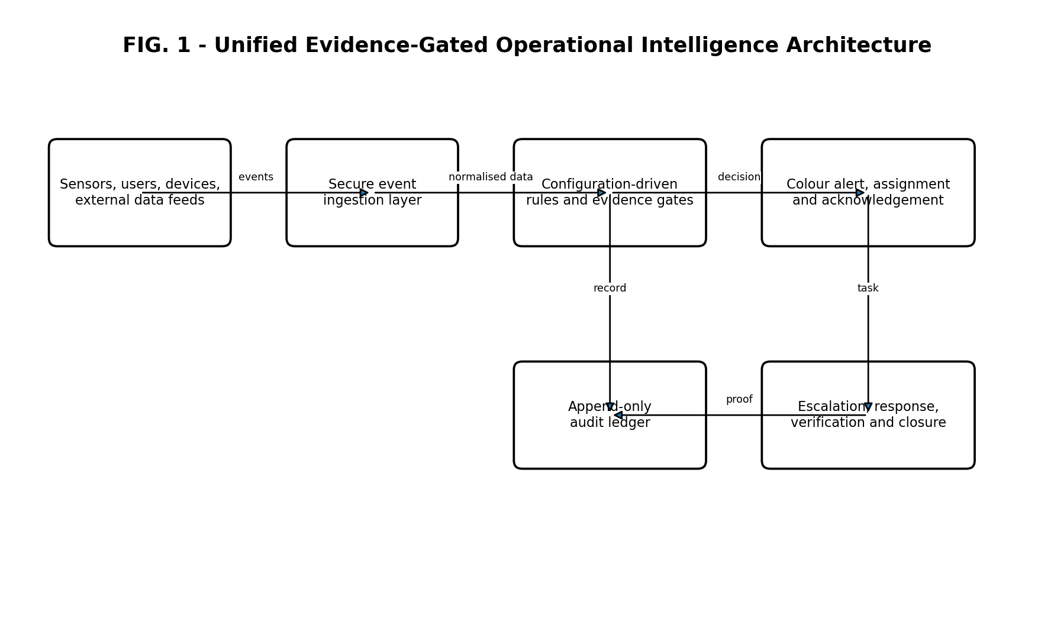
FIG. 1
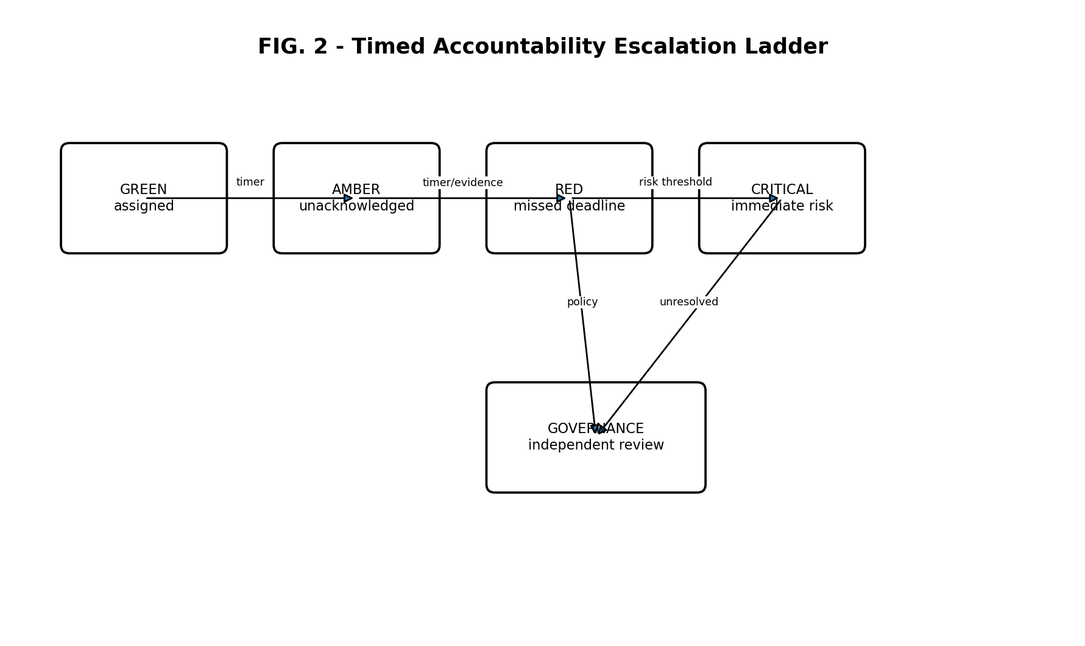
FIG. 2
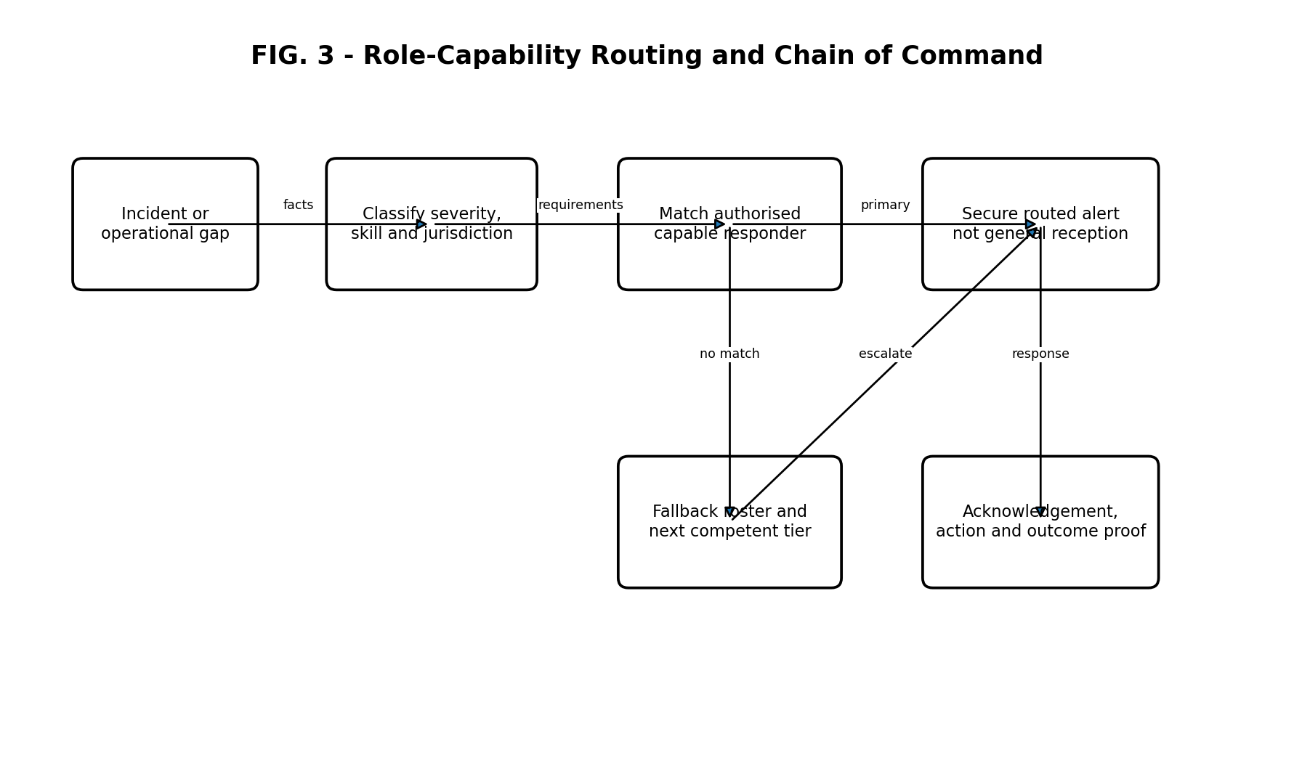
FIG. 3
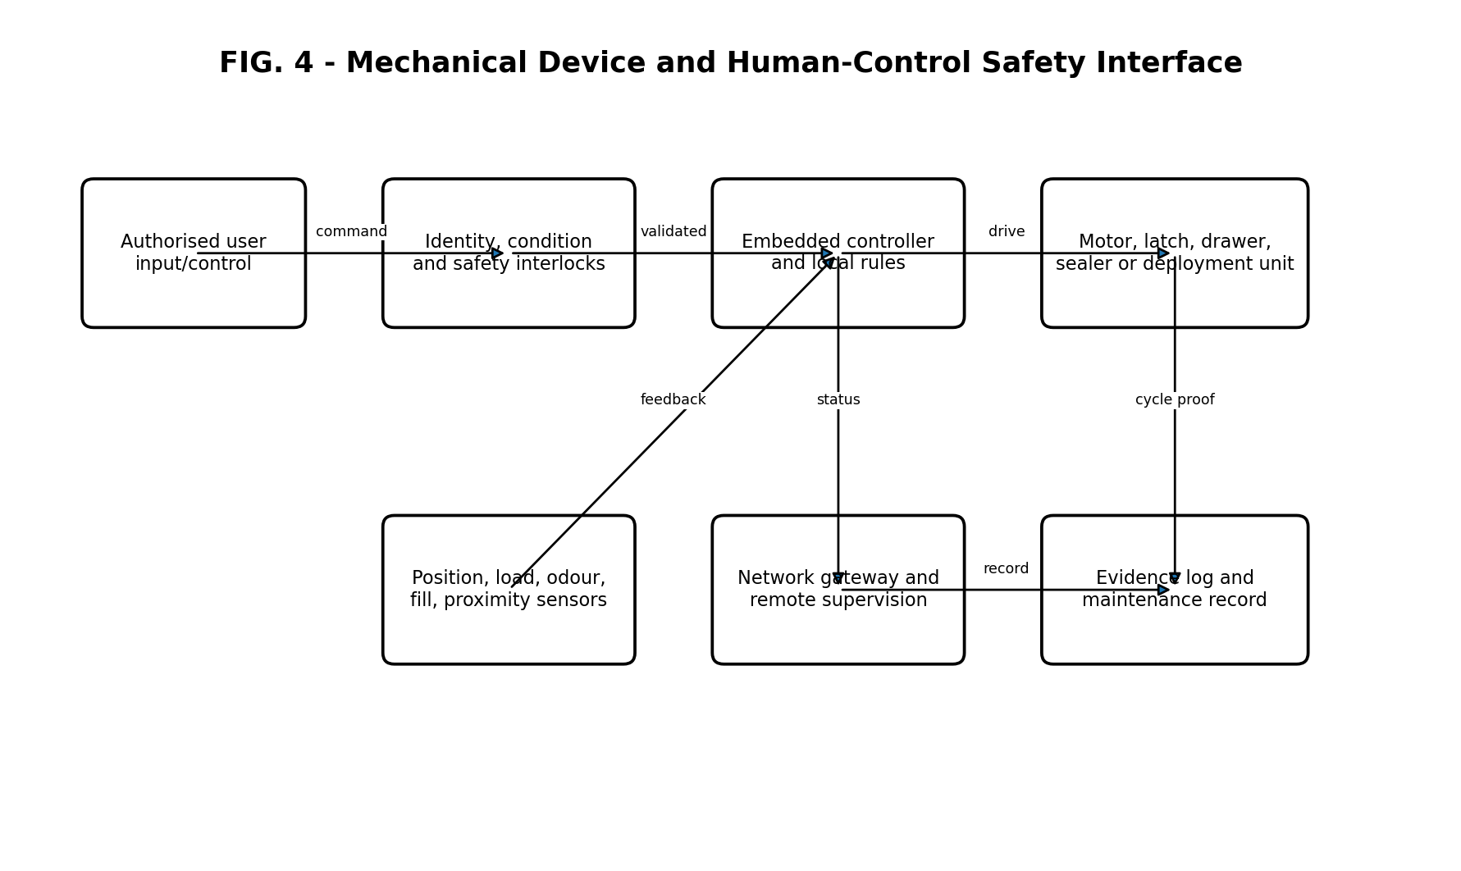
FIG. 4
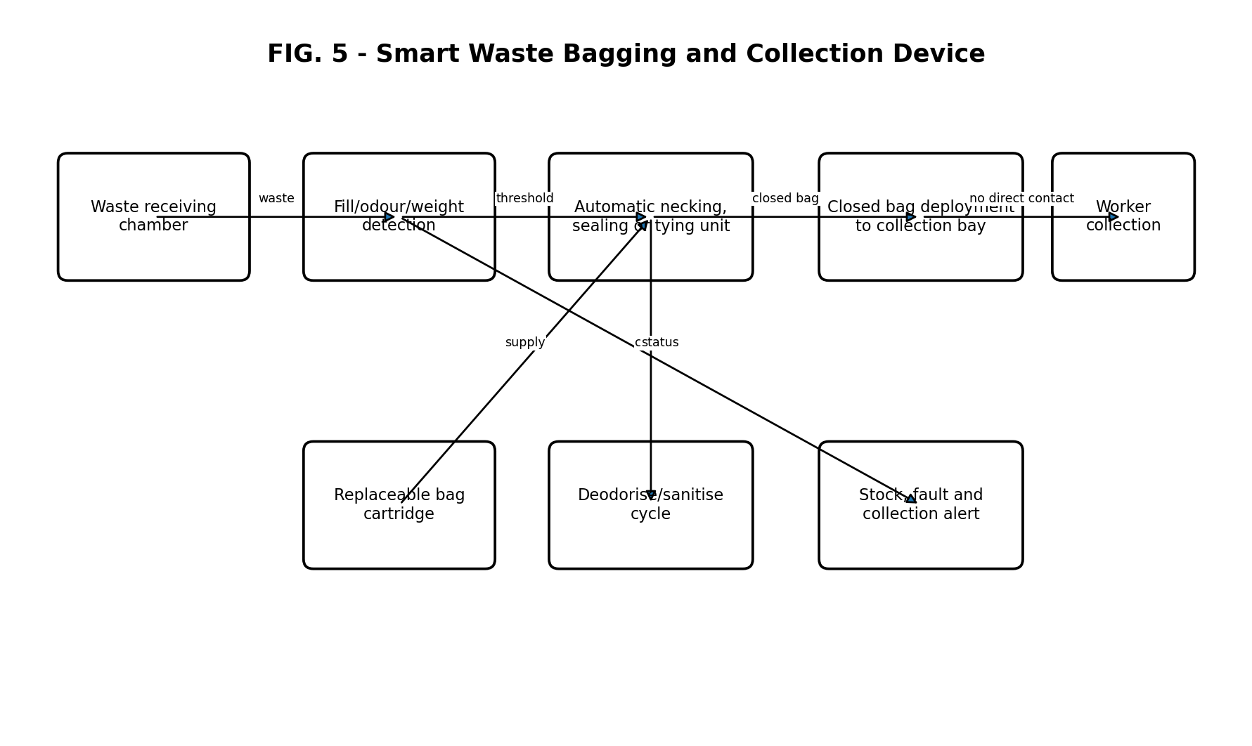
FIG. 5
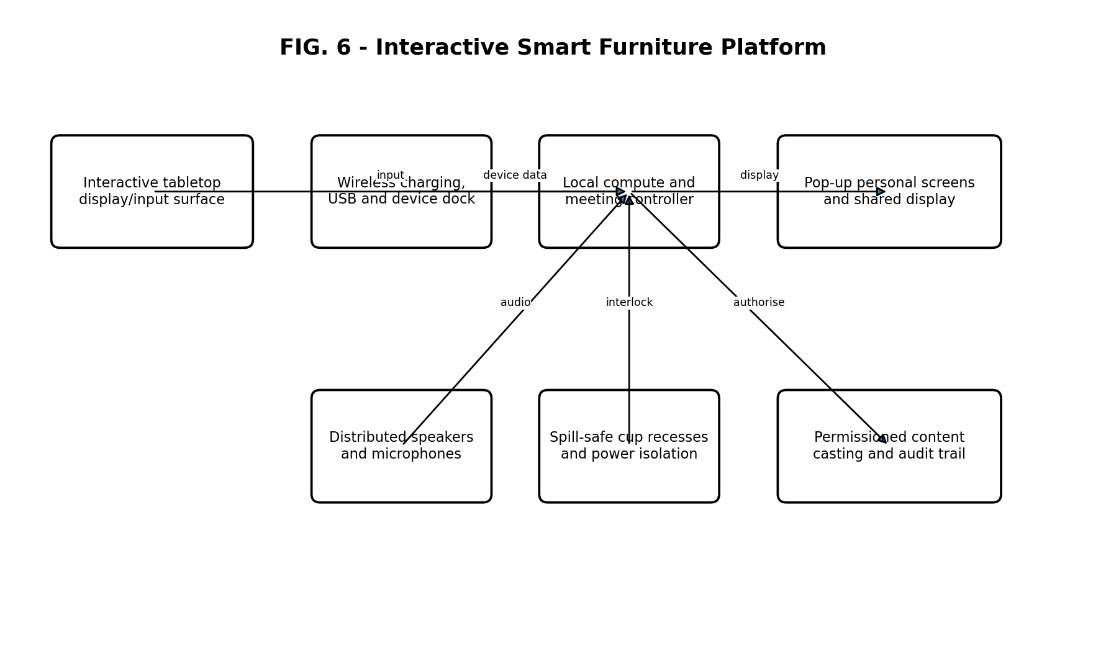
FIG. 6
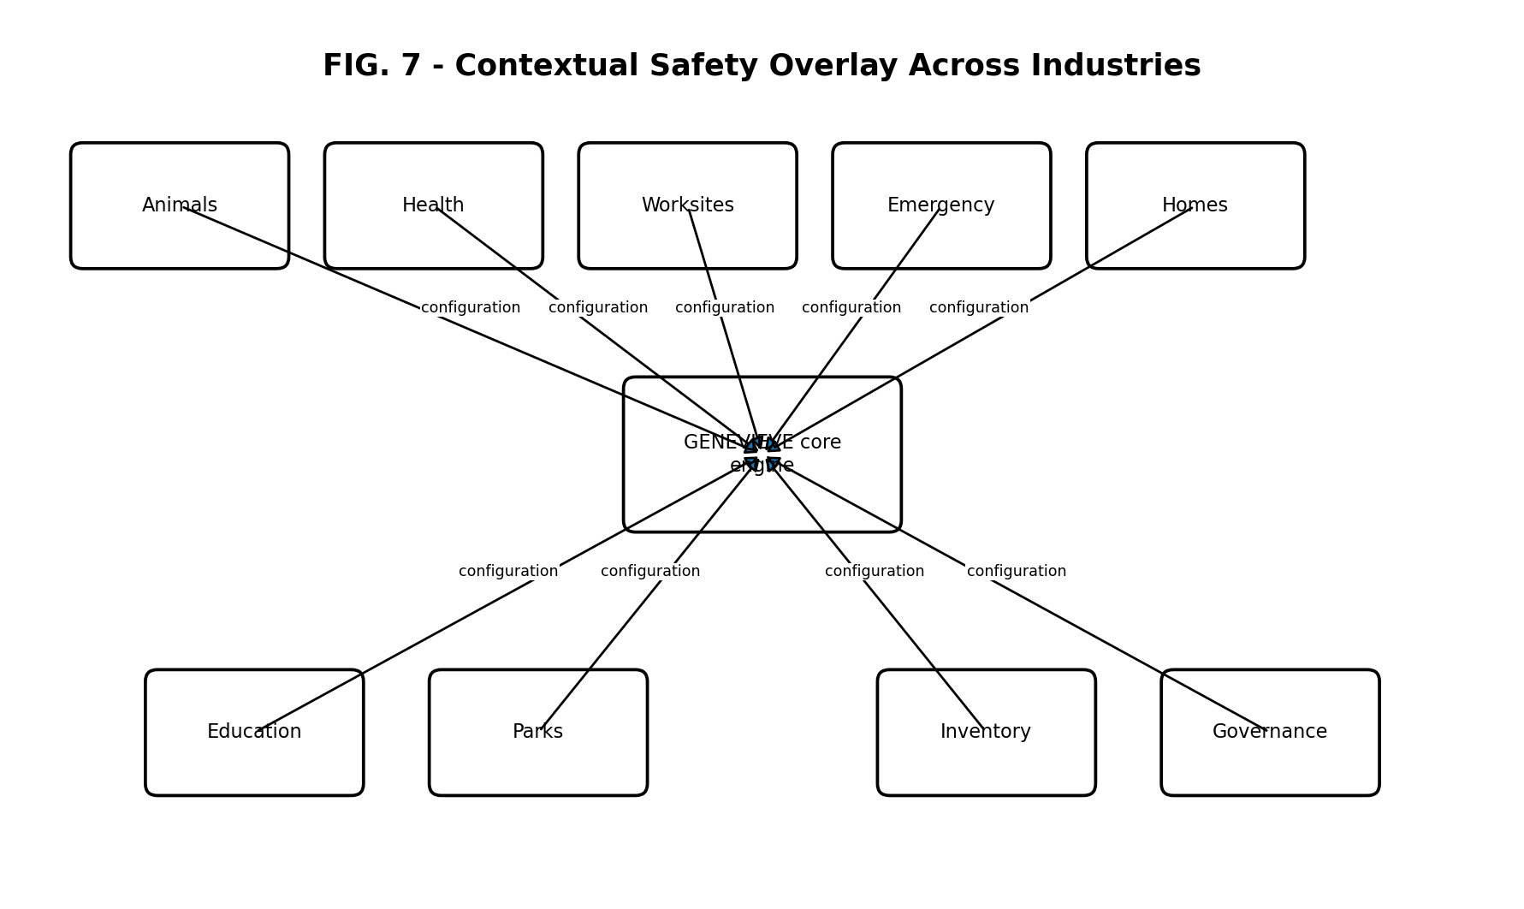
FIG. 7
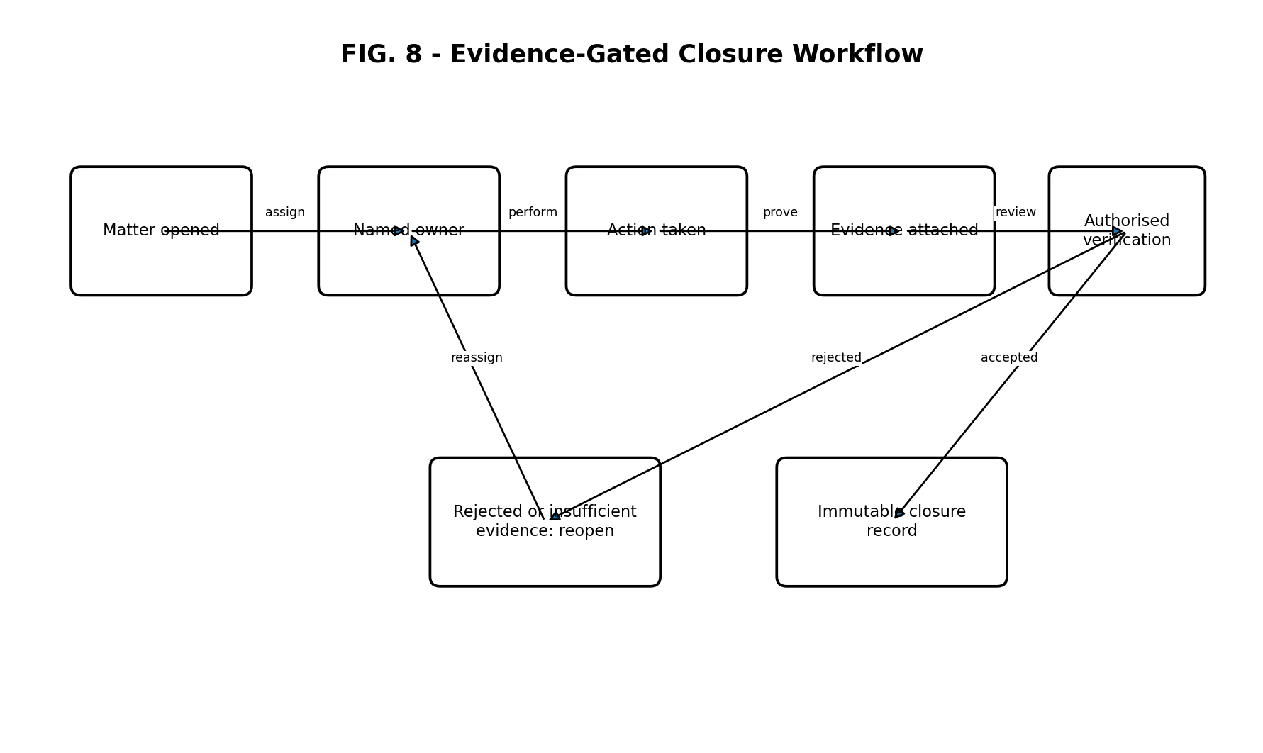
FIG. 8

4.6 Detailed description

Event acquisition and normalisation
Events may be generated by a user interface, wearable, mobile device, environmental sensor, camera-derived metadata, access-control system, stock sensor, mechanical limit switch, load cell, odour sensor, weather feed, roster system, clinical workflow, public report or emergency service feed. An event adapter converts source-specific data into a common event object containing an identifier, time, location, source, subject, event type, measured values, confidence, attachments, permissions and integrity metadata.

Configuration-driven rules
A configuration package defines event classes, thresholds, risk levels, mandatory fields, responsible role types, capability requirements, acknowledgement periods, escalation intervals, evidence requirements, closure authority, notification channels and connected-device actions. A configuration package can be selected according to organisation, site, industry, legal jurisdiction, subject type, equipment type or operating mode without changing the core executable engine.

Capability registry and routing
The capability registry stores competency, certification, authority, roster status, workload, location, equipment, language, conflict, availability and jurisdiction attributes. A routing score or constraint solver excludes ineligible recipients and selects a primary and fallback actor. Sensitive clinical, emergency or safeguarding matters may be routed only to designated competent roles and not to reception or unauthorised personnel. Where no eligible actor acknowledges, the event is escalated to the next competent tier or governance role.

Timed escalation and accountability
Each matter is assigned a named owner and an operational state. A GREEN state represents assigned and within response time; AMBER represents approaching or missed acknowledgement; RED represents missed action threshold or elevated risk; CRITICAL represents immediate or severe risk; and GOVERNANCE represents independent oversight, unresolved systemic failure or mandated review. State changes may depend on time, severity, sensor values, repeat history, non-response, failed actuation, evidence quality or policy.

Evidence-gated closure
Closure conditions are machine-evaluated. Examples include an image, signed checklist, sensor return to safe range, geotag, supervisor approval, completed handover, maintenance reading, seal confirmation, receipt, digital signature or responder report. The system rejects closure where required evidence is missing, inconsistent, outside tolerance or supplied by an unauthorised actor. Rejected closure returns the matter to an active state and records the reason.

Append-only audit and integrity
Records are stored as immutable or append-only entries. Each entry can include a prior-record hash, timestamp, actor identity, device identity, action type, before/after state and evidence reference. Corrections are appended rather than overwriting earlier records. The system can export a chronological evidence package for authorised review while applying role-based access and privacy controls.

Connected mechanical device control
A device controller receives a requested operation and checks a safety state including guard position, user presence, load, proximity, obstruction, power condition, consumable availability and emergency-stop status. A command may require local user confirmation, remote authorisation, two-person approval or a prescribed sequence. The controller drives one or more actuators and receives sensor feedback. Failure to achieve the expected state within tolerance causes safe stop, local indication, remote alert and escalation. Offline operation uses locally cached rules and synchronises evidence when communication returns.

Waste bagging embodiment
A waste apparatus comprises a receiving chamber, bag cartridge, bag-opening mechanism, fill or weight sensor, odour sensor, necking mechanism, heat seal, tie, clip or equivalent closure mechanism, cutting mechanism, sanitising or deodorising module and closed-bag collection compartment. On reaching a threshold or receiving an authorised command, the apparatus isolates the waste, closes and separates the bag, moves the sealed bag into a worker-accessible collection region and deploys a fresh bag. Interlocks prevent worker access to moving or hot components. Consumable levels, faults, odour, collection status and service cycles are reported to the platform.

Interactive furniture embodiment
A furniture apparatus includes an interactive display surface, touch or stylus input, wireless charging zones, wired data and power ports, local compute, speakers, microphones, one or more retractable personal displays, a shared display interface, spill-detection or power-isolation features and protected beverage recesses. A participant can create or annotate content privately and selectively cast the content to a shared display. Device pairing, presentation rights and meeting records are permission controlled. Retractable mechanisms include obstruction and pinch detection.

Cross-industry overlays
The same engine may load distinct configuration packages for animal behaviour and location, psychological practice safety, construction weather coordination, police patrol safety, ambulance or emergency response, childcare, aged care, hospitals, education, parks, facilities, inventory, hazardous material visibility, disaster evacuation, homes and workplaces. Each overlay changes vocabulary, permissions, thresholds, capabilities, evidence and device integrations while retaining the common event, escalation and audit architecture.

Security and privacy
Security controls may include encryption in transit and at rest, device certificates, least-privilege access, multi-factor authentication, data minimisation, consent and authority records, jurisdictional data residency, emergency break-glass access, immutable access logs, retention schedules, pseudonymous identifiers and separation of tenant data. Safety-critical device commands may be signed and nonce-protected to prevent replay.

Best presently contemplated method
The presently preferred implementation uses a multi-tenant cloud service with local edge gateways for connected devices. Rules are represented as versioned configuration objects. Events are normalised into a common schema and written to an append-only event stream. A policy engine evaluates eligibility and state transitions. A relational store maintains organisation and capability data, while object storage holds evidence. Device gateways use mutually authenticated messaging and preserve a local safe-state rule set. Every change to a rule package is versioned and linked to the matters processed under that version.

4.7 Example operational sequences

Example 1 - staff crisis in a psychological practice
- A crisis event is entered or detected.
- The engine classifies the event and identifies clinical competency and authority requirements.
- Reception and non-qualified roles are excluded.
- The alert is routed to the designated competent clinician or crisis lead and requires acknowledgement.
- Non-response changes the state from GREEN to AMBER and then RED, routing to the next competent tier.
- Actions, handovers and evidence are recorded.
- Closure is prevented until the required clinical and operational evidence is verified.

Example 2 - mechanical bag sealing
- A fill, weight or odour threshold is reached.
- The controller verifies the collection bay is closed, guards are engaged and consumables are available.
- The bag is necked, sealed and separated.
- Sensors confirm seal completion and transfer to the collection compartment.
- A fresh bag is deployed.
- A cycle record is sent to the audit ledger; a failed confirmation causes a safe stop and maintenance escalation.

Example 3 - weather-based multi-party coordination
- A weather event or threshold is received for a worksite.
- The rules identify affected tasks, dependencies and organisations.
- Authorised contacts are selected by role and current project assignment.
- A coordinated cancellation, delay or safety instruction is issued with acknowledgement tracking.
- Unacknowledged critical dependencies escalate to project leadership.
- The complete communication and decision history is preserved.

5. Draft claim set - core platform
The following claims are drafting proposals only. Final claims must be settled against the prior art and the exact support in each priority document.
1. A computer-implemented operational safety system comprising: one or more event interfaces configured to receive event data from a plurality of heterogeneous physical or digital sources; a configuration store containing a plurality of versioned rule packages; a capability registry containing capability and authority attributes for human actors and connected devices; a processing engine configured to normalise the event data, select an applicable rule package and determine a required response; a routing engine configured to select at least one eligible responder or device by applying mandatory capability constraints to the capability and authority attributes; an escalation engine configured to transition the event through a plurality of operational states according to at least acknowledgement status, elapsed time and risk; an evidence service configured to prevent closure of the event until prescribed evidence conditions are satisfied; and an append-only audit store configured to record assignments, acknowledgements, escalations, actions, evidence and closure, wherein an unresolved event cannot be removed from active accountability without an auditable authorised disposition.
2. The system of claim 1, wherein the plurality of operational states comprises a normal assigned state, an approaching or missed acknowledgement state, a missed action or elevated-risk state, an immediate-risk state and a governance-review state.
3. The system of claim 1 or 2, wherein the routing engine excludes a recipient lacking a prescribed clinical, safety, trade, emergency, safeguarding or jurisdictional competency.
4. The system of any preceding claim, wherein the routing engine selects a primary responder and at least one fallback responder according to availability, proximity, workload, authority, equipment or jurisdiction.
5. The system of any preceding claim, wherein the evidence conditions comprise at least one of a sensor reading, image, geolocation, digital signature, checklist, supervisor approval, responder report, maintenance reading, handover record or device completion signal.
6. The system of any preceding claim, wherein rejection of submitted closure evidence automatically reopens or maintains the event in an active state and records a rejection reason.
7. The system of any preceding claim, wherein each audit entry includes integrity data linking the entry to a preceding audit entry.
8. The system of any preceding claim, wherein a selected rule package is specific to an organisation, site, industry, jurisdiction, subject type or equipment type while the processing engine remains common across a plurality of industries.
9. The system of any preceding claim, further comprising a device-control gateway configured to transmit an authorised command to a connected mechanical apparatus and receive sensor feedback indicating completion, failure or unsafe condition.
10. The system of claim 9, wherein failure to receive expected feedback within a prescribed tolerance causes a safe-state command and escalation to an eligible human responder.
11. The system of claim 9 or 10, wherein the connected mechanical apparatus continues safety-critical local operation using a cached rule set during a communications outage and later synchronises an evidence record.
12. A computer-implemented method comprising receiving an event; normalising the event into a common event schema; selecting a versioned configuration package; identifying response capability requirements; excluding actors and devices that do not satisfy mandatory requirements; assigning the event to a selected eligible actor or device; measuring acknowledgement and response time; escalating the event according to time and risk; receiving action evidence; machine-evaluating the evidence against closure conditions; and writing an append-only event history that preserves any rejection, reassignment or escalation.
13. The method of claim 12, further comprising generating an authorised review package containing a chronological sequence of objective facts, assignments, alerts, missed deadlines, handovers, actions and evidence.
14. A non-transitory computer-readable medium comprising instructions which, when executed, cause one or more processors to perform the method of claim 12 or 13.

6. Draft claim set - connected mechanical apparatus
15. A safety-controlled mechanical apparatus comprising: a user control interface; one or more condition sensors; one or more actuators; a controller; a safety interlock; and a communications interface, wherein the controller is configured to receive a requested mechanical operation, permit the requested mechanical operation only when a sensed local safety condition and an authorisation condition are satisfied, drive the one or more actuators, receive completion feedback, generate an evidence record representative of the operation, and cause a safe stop and escalation when the completion feedback fails to satisfy an expected condition within a tolerance.
16. The apparatus of claim 15, wherein the authorisation condition comprises identity, role, competency, two-person approval, remote approval, local confirmation or a combination thereof.
17. The apparatus of claim 15 or 16, wherein the condition sensors include at least one of a position sensor, load sensor, proximity sensor, obstruction sensor, odour sensor, fill sensor, temperature sensor, guard sensor or consumable sensor.
18. The apparatus of any of claims 15 to 17, wherein the controller stores a local rule set enabling safe operation during loss of network connectivity.
19. The apparatus of any of claims 15 to 18, wherein the evidence record includes a requested operation, user or device identity, pre-operation sensor state, actuator command, post-operation sensor state, outcome and timestamp.
20. The apparatus of any of claims 15 to 19, wherein the apparatus is selected from a waste handling apparatus, dispensing apparatus, lifting apparatus, retractable furniture apparatus, grooming apparatus, sanitation apparatus, access-controlled storage apparatus or charging apparatus.

7. Draft claim set - smart waste bagging apparatus
21. A waste handling apparatus comprising a waste receiving chamber; a replaceable bag supply; a mechanism configured to support an open bag in the chamber; at least one fill, weight or odour sensor; a closure assembly configured to neck and close a filled bag; a separation mechanism configured to separate the closed bag from unused bag material; a transfer mechanism configured to move the closed bag to a collection region; a controller configured to initiate a closure cycle in response to a threshold or authorised command; and at least one guard or access interlock preventing access to a hazardous moving or heated component during the closure cycle.
22. The apparatus of claim 21, wherein the closure assembly comprises a heat seal, tie, clip, adhesive, twist closure or combination thereof.
23. The apparatus of claim 21 or 22, further comprising a sanitising or deodorising module operated after separation of the filled bag.
24. The apparatus of any of claims 21 to 23, wherein the controller verifies closure completion using force, position, temperature, optical, pressure or continuity feedback before permitting transfer to the collection region.
25. The apparatus of any of claims 21 to 24, wherein a fresh bag is automatically deployed after transfer of the closed bag.
26. The apparatus of any of claims 21 to 25, wherein consumable status, collection status, odour status, fault state and maintenance status are transmitted to an external accountability platform.

8. Draft claim set - interactive smart furniture
27. An interactive furniture apparatus comprising a tabletop having an interactive display and input region; a plurality of participant positions; at least one device charging region at each of a plurality of participant positions; a local computing system; at least one retractable participant display; an interface to a shared display; and a permissions controller configured to receive participant content at the tabletop or retractable participant display and selectively transmit the participant content to the shared display in response to participant authorisation.
28. The apparatus of claim 27, further comprising distributed speakers and microphones integrated below or around the tabletop.
29. The apparatus of claim 27 or 28, further comprising a spill-protected beverage recess and a power-isolation sensor associated with the beverage recess.
30. The apparatus of any of claims 27 to 29, wherein the retractable participant display comprises an obstruction or pinch sensor that stops or reverses movement.
31. The apparatus of any of claims 27 to 30, wherein annotations entered on the interactive display are stored as private participant content until a permission input is received.
32. The apparatus of any of claims 27 to 31, wherein charging, pairing, content casting, display movement and meeting actions are recorded in an audit history.

9. Abstract
A configurable operational safety system receives events from heterogeneous physical and digital sources, normalises the events, applies versioned industry or site rule packages, routes required actions to capability-matched authorised humans or connected devices, and enforces timed acknowledgement and response escalation. Closure is prevented until prescribed evidence has been received and verified, and an append-only audit history preserves assignments, alerts, missed deadlines, handovers, device operations, evidence and outcomes. A connected mechanical apparatus includes local sensors, interlocks, actuators and a controller that permits an operation only when safety and authorisation conditions are satisfied, records completion feedback and causes safe stop and escalation on failure. Embodiments include automated waste bagging and collection equipment, interactive smart furniture, dispensing, lifting, grooming, sanitation and storage apparatus, and cross-industry safety overlays for animals, health, workplaces, education, emergency response, parks, homes and inventory.

10. Mechanical invention disclosure schedule
Complete one schedule for every physical product before filing. Do not rely on a product name alone; disclose the actual structure, arrangement, motion, sensors, materials, dimensions, interlocks, control sequence, alternatives and best method.
Product/invention name:
________________________________________________________________________________
________________________________________________________________________________
Problem solved:
________________________________________________________________________________
________________________________________________________________________________
Existing products and their shortcomings:
________________________________________________________________________________
________________________________________________________________________________
Essential physical components:
________________________________________________________________________________
________________________________________________________________________________
How components are connected:
________________________________________________________________________________
________________________________________________________________________________
Sequence of operation:
________________________________________________________________________________
________________________________________________________________________________
Human controls:
________________________________________________________________________________
________________________________________________________________________________
Automatic controls:
________________________________________________________________________________
________________________________________________________________________________
Sensors and feedback:
________________________________________________________________________________
________________________________________________________________________________
Safety interlocks and fail-safe state:
________________________________________________________________________________
________________________________________________________________________________
Power source:
________________________________________________________________________________
________________________________________________________________________________
Network/offline behaviour:
________________________________________________________________________________
________________________________________________________________________________
Consumables:
________________________________________________________________________________
________________________________________________________________________________
Materials and approximate dimensions:
________________________________________________________________________________
________________________________________________________________________________
Manufacturing method:
________________________________________________________________________________
________________________________________________________________________________
Cleaning and maintenance:
________________________________________________________________________________
________________________________________________________________________________
Alternative mechanisms:
________________________________________________________________________________
________________________________________________________________________________
Best presently known embodiment:
________________________________________________________________________________
________________________________________________________________________________
Prototype date and test results:
________________________________________________________________________________
________________________________________________________________________________
Public disclosure date:
________________________________________________________________________________
________________________________________________________________________________
Inventors for this device:
________________________________________________________________________________
________________________________________________________________________________

11. Product-to-IP portfolio map
Product | Protection layers | Patent family | Immediate record needed
GENEVIEVE Accountability Core | Patent, copyright, trade secret | Family A-C | Keep rule schema, source code and security methods confidential.
Dog Park / animal compatibility | Existing/new patent review, trade mark, copyright | Family H plus core | Map against existing provisional patent 2026903465 and any later filing.
Psychological practice safety | Core patent configuration, copyright, confidentiality | Family A-C | Keep clinician-ready program separate from staff practice-flow program.
Police/ambulance/SES dashboards | Core patent configuration, copyright, security know-how | Families A-C and I | Do not disclose sensitive operational details publicly.
Smart waste bagging stations/bins | Separate mechanical provisional, design registration, trade mark | Families D-E | Prepare engineering drawings and test data.
Interactive boardroom/coffee tables | Separate mechanical provisional and registered designs | Families D-F | Protect retractable screens, spill safety and integrated interaction.
Stock Sense | Core/asset patent family, copyright, database rights, trade secret | Family G | Document sensor and hazard-mapping embodiments.
Grooming/body shaver devices | Separate mechanical provisional and designs | Family D | Need specific mechanisms and safety interlocks.
Weather coordination platform | Core patent configuration and copyright | Families A-C | Emphasise technical dependency mapping and acknowledgement.
Emergency response and evacuation | Core patent and security know-how | Families A-C and I | Document geospatial and responder-routing improvements.

12. Confidentiality and disclosure controls
- Mark all invention documents “Confidential - Patent Pending” only after a relevant patent application has actually been filed; before filing use “Confidential - Unpublished Invention”.
- Do not publish enabling technical details, drawings, source code or demonstrations before filing without attorney advice.
- Use signed NDAs before discussions with developers, engineers, manufacturers, investors, clinicians, councils or partners.
- Require written assignment of all IP created by contractors or collaborators, including code, CAD, drawings, documentation and improvements.
- Maintain a disclosure log recording recipient, date, material disclosed, NDA status and purpose.
- Keep each repository and document version time-stamped; preserve hashes and backups.
- Do not state that a patent is granted when only a provisional application has been filed.

13. Pre-filing attorney checklist
- Confirm current applicant and ownership structure, including whether the applicant should be Tracey Kennedy or an IP holding entity.
- Confirm every inventor for each proposed claim set and obtain signed assignments where applicant and inventor differ.
- Review all existing filings and create a priority-support chart mapping each claim feature to exact paragraphs and drawings.
- Conduct novelty and inventive-step searches for the core engine and each mechanical device.
- Decide which claim groups satisfy unity and which require separate provisional or standard applications.
- Redraft computer-implemented claims so the technical contribution is explicit: event normalisation, device integration, secure control, sensor feedback, fail-safe operation and tamper-evident records.
- Add detailed engineering drawings for every mechanical embodiment, including sectional views, exploded views, actuator paths, guards, sensors and maintenance access.
- Confirm the best method known at filing and disclose alternatives sufficient to support broad claims.
- Check privacy, medical, safety, radio, electrical, machinery and consumer compliance separately; a patent does not provide regulatory approval or freedom to operate.
- Create a 12-month deadline calendar for every provisional application and a public-disclosure hold point.

14. Current Australian drafting requirements noted
For a standard patent, the specification must include a title, description and at least one claim. A complete specification must disclose the invention clearly and completely enough for a skilled person to perform it and must disclose the best method known to the applicant. Drawings are filed separately from the description and claims. Claims must relate to one invention only or a group linked by a single inventive concept. A provisional application is a priority-preserving first step but does not itself become an enforceable patent and must be followed by a complete application within the relevant period if protection is to continue.

15. Official source notes
- IP Australia, “Provisional patent applications” (accessed 22 July 2026).
- IP Australia, “How to apply for a standard patent” (accessed 22 July 2026).
- IP Australia, “What computer-related inventions can be patented” (accessed 22 July 2026).
- IP Australia Patent Manual, section 5.6.3.2, claims directed to a single invention (unity).
- IP Australia Patent Manual, section 5.6.7.2, clear and complete disclosure.
- IP Australia Patent Manual, section 5.6.7.5, best method.
- IP Australia Patent Manual, section 5.3.2.3, drawings to be provided separately.
- IP Australia, “What are patents?” (devices, methods and processes; standard patent term).

16. Sign-off and continuing update record
I declare that this document is intended to record inventions and development information accurately. I understand that dates, inventorship and disclosure history must not be fabricated or backdated.
Inventor signature: ____________________________________________
Name: ____________________________________________
Date: ____________________________________________
Witness signature: ____________________________________________
Witness name: ____________________________________________
Date: ____________________________________________

Revision log
Version | Date | Author | Changes | Evidence added
1.0 | 22 July 2026 | Draft prepared for Tracey Kennedy | Initial master record and draft specification | Eight conceptual drawings

REVISION 4 — IP AUSTRALIA FILING ARCHITECTURE
GENEVIEVE App™ Ecosystem Protection Record
Prepared for Tracey Kennedy | 22 July 2026 | Confidential pre-filing working draft

17. Critical filing position: the ecosystem cannot lawfully be compressed into one unlimited patent
A patent does not protect a broad business vision, a brand, every future variation, or an entire commercial ecosystem merely because the products share the GENEVIEVE name. Patent claims must define a patentable invention or a group of inventions linked by a single inventive concept and must be supported by enough technical detail for a skilled person to perform what is claimed.
The legally stronger structure is a coordinated patent family under one controlled GENEVIEVE IP portfolio. The portfolio can share common terminology, architecture, evidence and licensing control, while separate applications protect distinct inventive concepts. This avoids a unity objection, unsupported claims, accidental loss of priority and a specification so broad that it becomes difficult to obtain or enforce.
This Revision 4 therefore treats the existing master record as the central evidence and ownership record, while allocating inventions to filing families. It must not be represented as an IP Australia filing receipt, granted right, legal guarantee or attorney opinion.
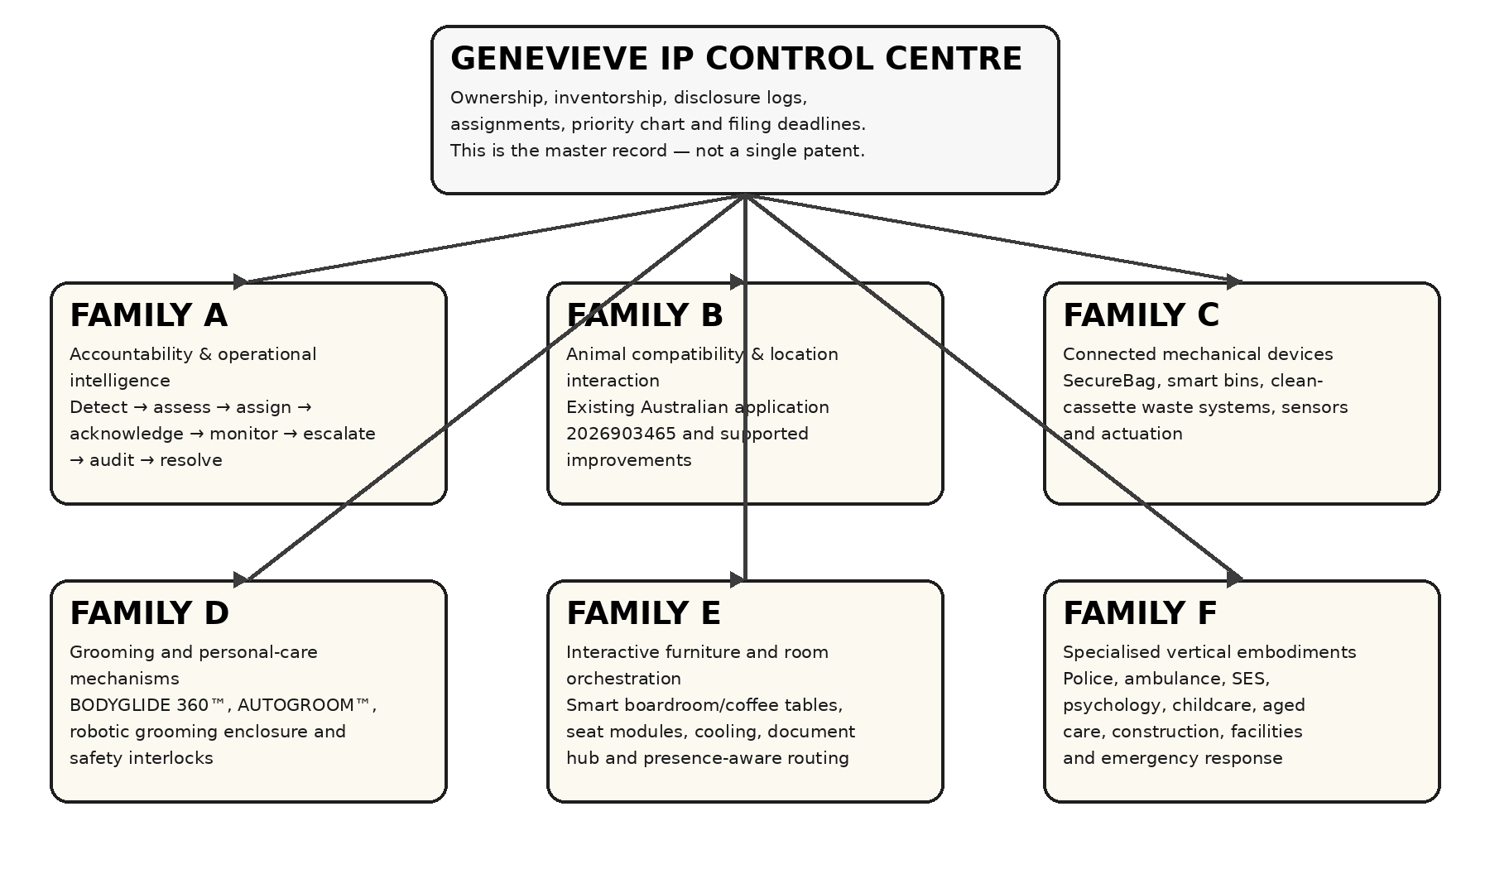
FIG. 14 — Recommended GENEVIEVE coordinated IP-family architecture.

18. Portfolio-wide protection matrix
Asset group | Primary protection | Required action
GENEVIEVE App™ name; GA emblem; Tree and Roots emblem | Trade marks + copyright evidence | File word and logo marks separately where appropriate; preserve locked masters and provenance.
Accountability Core; escalation; acknowledgement; immutable action history | Patent family A + copyright + trade secrets | Claims must focus on technical event handling, routing, controls, data integrity and system operation—not an abstract management rule.
Animal social compatibility and location interaction | Existing patent family B | Map every improvement to application 2026903465 before asserting priority.
SecureBag™, bag stations, smart bins, sealed waste handling | Patent family C + design rights | Separate functional mechanisms from appearance; create sectional and exploded drawings.
BODYGLIDE 360™, AUTOGROOM™, robotic body-grooming systems | Patent family D + design rights | Protect attachment recognition, collection, interlocks, body mapping, guarded motion and cleaning dock where novel.
Smart boardroom and coffee tables | Patent family E + design rights + software copyright | Protect room/device orchestration and any genuinely new mechanism; use design rights for the distinctive physical appearance.
Police, ambulance, SES, psychological practice, childcare, aged care, construction, facilities and emergency systems | Patent family F or supported embodiments of A | Only separate where a distinct technical contribution exists; industry labels alone do not create patentability.
Dashboards, code, UI assets, manuals, diagrams and deployment packages | Copyright + confidential information + contractual control | Retain source history, hashes, access logs and written IP assignments.
Business ideas, pricing, licensing structures and market plans | Confidential information + contracts | Not patentable merely as business ideas; protect through NDAs, access controls and carefully drafted agreements.

19. Filing Family E — Smart Boardroom and Interactive Furniture System
Proposed title: Integrated Interactive Furniture System with Presence-Aware User Authentication, Coordinated Peripheral Control, Zoned Thermal Management and Adaptive Meeting Orchestration

Technical field
The invention relates to interactive furniture, distributed human-machine interfaces, room automation, secure identity-based session control, peripheral orchestration, environmental sensing, thermal management and adaptive operation of meeting spaces.

Inventive concept to be assessed
A modular table coordinates seat occupancy, identity verification, personal display deployment, document and presentation routing, environmental controls, cooling zones, power distribution, peripherals and audit records through a local orchestration controller. Facial recognition is used only as one authentication factor, with liveness detection, consent, local encrypted templates, a non-biometric fallback and role-based access. Adaptive performance changes are tested in a controlled update pipeline and are not permitted to rewrite safety limits or install uncontrolled self-modifying code.

Proposed independent claim — system
1. An interactive furniture system comprising: a table body having a plurality of participant positions; a participant interface associated with each participant position; at least one occupancy sensor; at least one identity-verification sensor; a local orchestration controller in communication with the participant interfaces, the occupancy sensor and a plurality of controllable table or room devices; and a non-transitory memory storing instructions which, when executed, cause the controller to detect occupancy at a participant position, obtain an identity-verification input subject to an authorised consent policy, determine a user identity or invoke a fallback authentication pathway, establish a role-limited session at the participant interface, route user-specific content and control permissions to the occupied participant position, coordinate at least one peripheral or environmental device according to the session, and write a tamper-evident event record of authentication, routing and control actions.

Proposed independent claim — thermal architecture
2. A thermal-management system for interactive furniture comprising a plurality of thermally separated equipment zones including at least an electronic-interface zone and a refrigeration or temperature-control zone; respective temperature sensors associated with the zones; controllable air-moving or heat-transfer devices; filtered intake and exhaust paths arranged to limit transfer of heated exhaust into a participant working region; and a controller configured to regulate the devices independently according to sensed temperatures, acoustic limits and electrical load, and to perform staged load shedding when a temperature or power threshold is exceeded.

Proposed independent claim — controlled adaptive improvement
3. A computer-implemented method of adapting operation of an interactive meeting environment, the method comprising collecting consented operational telemetry; separating identifiable meeting content from equipment-performance telemetry; generating a proposed configuration change using a rules engine or trained model; evaluating the proposed change against safety constraints, privacy constraints, compatibility tests and a rollback criterion in a sandbox environment; requiring automated approval within a predefined low-risk class or human approval for a higher-risk class; deploying a signed configuration package to one or more table controllers; monitoring post-deployment performance; and automatically rolling back the configuration package when the rollback criterion is met, while preserving an append-only audit history of the proposal, approval, deployment and outcome.

Illustrative dependent claim subjects
- 3D facial sensing or another biometric modality combined with liveness detection and a PIN, passkey, card or mobile-device fallback.
- Biometric templates stored locally in encrypted form and deleted or disabled according to a configurable retention and consent policy.
- A retractable personal display module that deploys after seat authentication and retracts on logout, emergency stop or obstruction detection.
- Presence-aware routing that transfers a document, whiteboard object or presentation stream to the interface corresponding to the authenticated user’s current seat.
- A central document module comprising print, scan, copy and electronic fax or secure digital transmission functions, with job release limited to an authenticated participant.
- Defined wireless charging zones with foreign-object detection, thermal monitoring and automatic power reduction.
- Spill-isolated cup docks with drainage paths, temperature control and shutdown on liquid ingress or abnormal temperature.
- Modular hot-swappable seat bays with service isolation, device identity and automatic configuration on replacement.
- Beamforming microphones, echo cancellation and separation of microphone and loudspeaker zones.
- Environmental response based on carbon dioxide, volatile organic compound, humidity, temperature, occupancy or air-flow data.
- A local edge mode that continues core meeting functions during internet loss and synchronises authorised records when connectivity returns.
- A fleet dashboard that monitors health, servicing, firmware or configuration versions and unresolved faults across multiple tables.

20. Safety and legal constraints for facial recognition and adaptive updates
- Facial recognition must not be the only way to use the table. Provide passkey, PIN, access card or administrator-assisted login.
- Use explicit organisational authority and a documented privacy basis before enrolling faces. Display a clear notice and provide a practical opt-out.
- Store a mathematical template rather than ordinary photographs where technically possible; encrypt it, restrict access and define deletion and retention rules.
- Use liveness detection and anti-spoofing controls. Do not silently infer sensitive traits, emotions, health status, race or productivity from a person’s face.
- The system may learn preferences and equipment-performance patterns, but it must not autonomously remove safety controls, expand its own permissions, change retention rules, alter biometric policies or install unsigned executable code.
- Updates should follow propose → test → approve → sign → deploy → monitor → rollback, with the GENEVIEVE Accountability Core recording ownership, acknowledgement, missed actions and unresolved faults.

21. Evidence still required before filing broad enforceable claims
- A complete product inventory with one evidence ID per invention, including the inventor, first conception date, contributors, disclosure history and repository or file location.
- For each mechanical product: dimensioned orthographic views, sectional views, exploded views, actuator or material path, sensor positions, guards, maintenance access and at least one buildable embodiment.
- For each software family: architecture diagrams, data flows, event schemas, security boundaries, failure states, offline operation, test results and source-control history.
- A claim-to-support chart identifying the exact paragraphs, figures and evidence that support every element of every proposed claim.
- Prior-art searches for the common platform and separately for SecureBag/waste systems, grooming devices, interactive furniture, biometric login, adaptive update control and any other distinct mechanism.
- Signed assignments from every developer, engineer, designer or collaborator whose contribution could make that person an inventor or copyright owner.
- Confirmation of the exact priority and filing status of application 2026903465 from the official IP Australia record; placeholders must not remain in any filed specification.
- A registered patent attorney’s unity, entitlement, patentability, amendment and filing-route review before submission.

22. IP Australia-ready document set to produce
- Master confidential invention and ownership register (this document, continuously updated).
- Separate provisional or complete specification for each filing family that passes unity and patentability review.
- Claims beginning on a separate page, numbered sequentially and supported by the description.
- Separate formal drawing sheets using consistent reference numerals and no promotional wording.
- Abstract for each complete specification.
- Applicant, inventor and entitlement schedule; assignments where required.
- Priority-support schedule for every claim that relies on an earlier filing.
- Public-disclosure and NDA log.
- Design-right image sets for the visible appearance of selected physical products.
- Trade mark filing schedule for the GENEVIEVE App™ word mark, GA emblem, Tree and Roots emblem and selected product names.

23. Updated official drafting notes — checked 22 July 2026
- IP Australia states that a provisional application establishes a priority date but provides no enforceable patent protection; a standard or PCT application generally must be filed within 12 months to retain that priority.
- IP Australia’s specification guidance requires a description that enables reproduction and describes the best method; standard applications require claims that are clear, concise, single-sentence, technically focused and supported by the description.
- Claims should define one invention or inventive concept. More than 20 claims attract additional fees.
- Design rights protect the overall visual appearance of a tangible product, not how it works, a business concept, software graphics or a logo.
- Trade marks can protect words and logos; IP Australia notes that businesses commonly register the words and logo separately to maximise protection.

24. Revision 4 declaration and status
This revision adds a coordinated filing-family strategy and a draft claim framework for the Smart Boardroom and Interactive Furniture System, including facial recognition, controlled adaptive improvement, integrated document handling and zoned thermal management. It does not state that these claims are novel, granted, filed or legally enforceable. Novelty, inventive step, entitlement, unity, support and filing strategy require professional review and official searches.
Inventor review and corrections: ______________________________________________
Tracey Kennedy signature: ______________________________ Date: ______________
Witness / patent attorney review: _______________________ Date: ______________

