Taber International, LLC was established in 2006 and since has been a leader in the field of combustion optimization and advanced process control. Taber, together with Griffin Open Systems, focuses on creating next generation software and optimization applications targeted to the process industries using an open systems business model, allowing for rapid inclusion of great ideas and practices, regardless of source. Through collaboration with numerous academic universities and the U.S. Department of Energy, Taber is the cutting-edge of efficiency and operational improvement capabilities for power generation and other process industries. Today, Taber continues to pride themselves on providing exceptional quality optimization solutions realizing top-level performance customized to the unique needs of each application, process, and customer.

Taber’s optimization system deployments within the Griffin AI Toolkit™ repeatedly realize multiple system-wide benefits, all in real-time through closed-loop control. All that’s needed is activation by an operator, and the system automatically does the rest, adapting to the changing conditions of each moment to make the system run the best it can. 100% of our 40+ installations are still in active use reflecting high customer satisfaction.

**Real-Time Visible   
Logic Pathways**

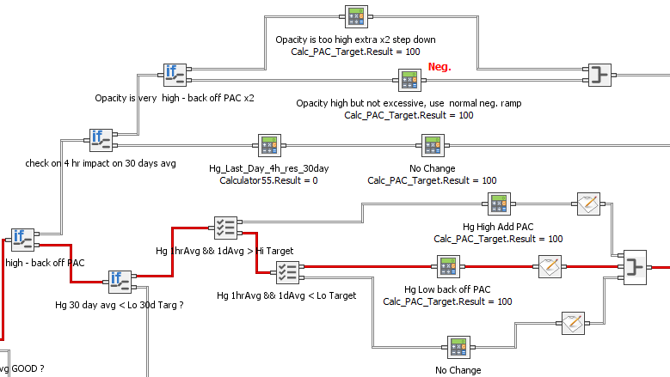

**Specially tailored applications can be developed in response to the immediate needs of the most challenging situations experienced by engineers and**

**operators, from adapting to variable load operation to reducing**

**additive consumption and slagging. These tailored applications**

**developed in real-time on-site have helped to decrease**

**high tube metal temperatures by more than**

**80%, increasing unit longevity, and saved**

**more than $1,000,000 every year**

**in chemical additives for**

**emissions control**

**at deployed**

**sites.**

Common observations include sustained efficiency improvements of >0.7%, emission rate reductions of 20 – 30% or more, and overall system consistency and reliability benefits. Further, systems outside of the combustion process can benefit from optimized process control. Cooling towers have been made to run 5% more efficiently, steel mill product quality control improved, and many other processes enhanced. ANY process with inputs and outputs can benefit from Taber’s optimization applications to more effectively achieve key process objectives using self-learning and adaptive methods.

Contact us at Taber today or visit out partner’s website to explore the vast potential for closed-loop optimization across your system and process.

[info@taber-intl.com](mailto:info@taber-intl.com) | www.taber-intl.com

[www.griffinopensystems.com](http://www.griffinopensystems.com)