**Taber International**

**System Platforms, Dashboards, and Data Analytics**

Taber International offers clients fully customized system platforms and dashboards with integrated data analytics. These systems are designed to meet the requirements of each unique process and system where they are deployed, drawing upon the experience and objectives of those who will interface with the system regularly to ensure their needs and functionalities are realized.

***Dashboards***

Developed dashboards can represent all forms of information, including numeric, text, comments, visualizations, graphics, trends, and pictures. Taber works with the client to connect many disparate sources of information and provide a centralized location for all relevant and important information to be easily accessed. By connecting directly to these data sources, any updates to the data are automatically represented within the dashboard without any additional effort by the client.

*Example dashboard showing real-time equipment measurements, work order reports, and calculated costs*

A centralized platform to visualize a system and process from end-to-end can provide dramatic improvements to operations, maintenance, and overall efficiency through enhanced transparency and understanding of flow and bottlenecks within the system.

*Example dashboard showing real-time vibration measurements and predicted value probabilities*

***Analytics Platform***

Behind the scenes, the Dashboarding system is populated by an advanced analytics platform and toolkit, The Griffin AI Toolkit®. This environment is a no-code/low-code development platform providing numerous advanced process control and database management capabilities in an easy-to-use and intuitive interface. The toolkit is an open system, meaning that other available methods, algorithms, and components can be seamlessly integrated to provide additional functionality.

*No-code / low-code programming environment showing live logic execution and values*

The Griffin AI Toolkit® software platform is extremely versatile, providing the capability to perform complex analytics as well as closed-loop process control, real-time notifications and reports using a variety of channels (email, Microsoft Teams, Slack, Web APIs, etc.), and controlling and managing artificial intelligence procedures.

Numerous communication protocols are supported, including OPC UA, OPC DA, Modbus, MQTT, OSI PI, MS SQL, and Web APIs. The variety of supported communications methods makes the platform a ubiquitous system for integrating with many different process areas and technical systems.

***Artificial Intelligence & Advanced Components***

In addition to basic arithmetic and decision making, the Griffin AI Toolkit® and Taber’s applications employ numerous artificial intelligence algorithms and other advanced components. These include artificial neural networks (ANN), dynamic neural networks such as long-short term memory (LSTM) and gated-recurrent unit (GRU) networks, support vector machine/regression (SVM and SVR), random forest (RF), reinforcement learning (RL), particle swarm optimization (PSO), genetic algorithm (GA), as well as integrated python and java script programming, HTTP requests and posts, data filtering and normalization, and others. The ability to easily and seamlessly utilize these advanced methods in a visual programming environment allows for simple deployment and unmatched integration performance.

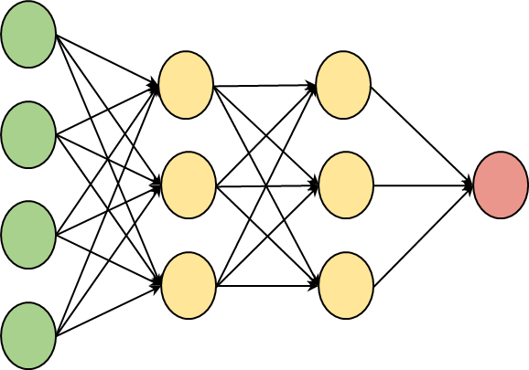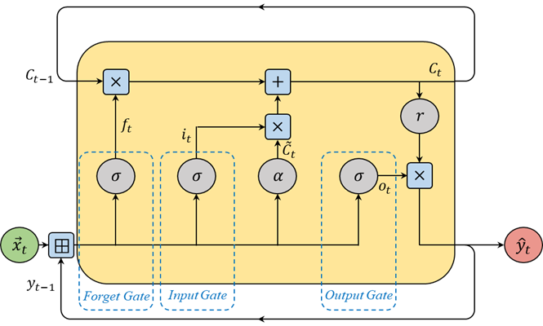

*Artificial Neural Network (ANN) Structure Long-Short Term Memory (LSTM) Structure*

*Particle Swarm Optimization Solution Identification Visualization*

***Customizable and Adaptable***

Taber’s systems deployed within the Griffin AI Toolkit® are fully customizable to the needs of the client. These applications have been successfully used within projects ranging from a focus on reducing emission rates in power utilities to capturing and representing financial and maintenance information from discrete hardware monitoring programs. The flexibility ensures that the Taber approach can address any system, and the adaptability ensures that these systems will remain applicable and beneficial for years into the future.

For more information about Taber’s services, please visit [www.taber-intl.com](http://www.taber-intl.com), and for information on the Griffin AI Toolkit® platform, please visit [www.griffinopensystems.com](http://www.griffinopensystems.com).