**Product Enhancement & Value Maximization   
by applying Computational Intelligence**

Domain expertise and specific, expert knowledge are often the difference between mediocracy and excellence. The ability to provide expertise and knowledge as part of a product adds substantial value to the product, driving sales and increasing revenue streams. The incorporation of specific domain expertise to general products and tools seems counter-intuitive as this limits the interested market, or it requires substantial installation and man-hours, eliminating profits.

Fortunately, the Griffin AI Toolkit offered by Griffin Open Systems provides the ability to ***rapidly enhance products and maximize value to the customer*** through the use of its proprietary computational intelligence tools and platform. ***Advanced artificial intelligence*** methods in a ***simple, no-code environment*** facilitate ***swift knowledge acquisition*** of any measured process in real-time and enables basic products and tools to offer optimized performance, leading to improved processes and functionality. This application of ***adivarent control*** is a valuable addition to any system. By enabling basic products and tools to ***learn*** about their environment and the process they are operating within, they can ***provide valuable insight*** to inform control systems to optimize the process to ***improve efficiency, reduce capital costs, enhance quality, and many other objectives***.

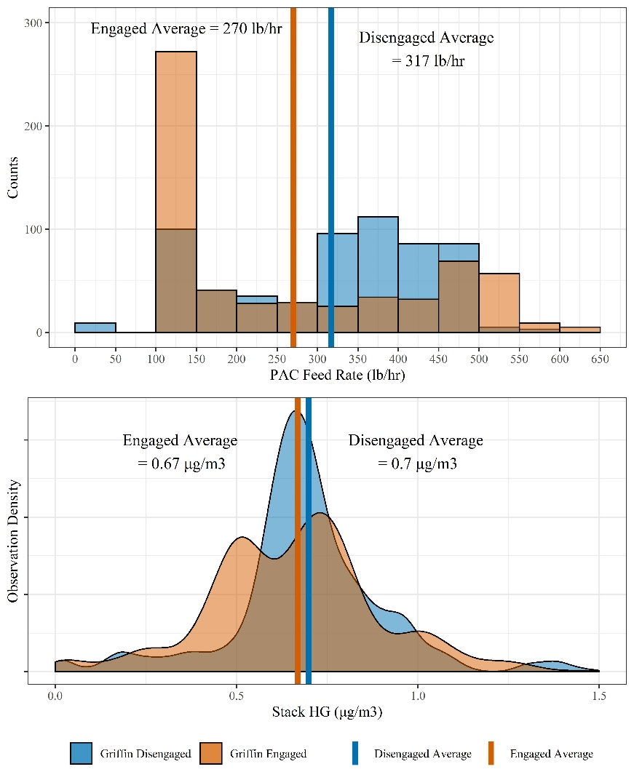Consider the following example. Continuous Emissions Monitoring Systems (CEMS) are common pieces of equipment on many industrial processes used to quantify the amount of various chemical species in a stream. In its basic form, it provides a continuous readout of values to a recording system, and otherwise does little else. However, the CEMS system is excellently positioned to learn about the upstream process and provide knowledge and insight to improve that process as it learns to relate its measured outputs to performance. An ***existing CEMS system*** measuring combustion products outfitted with the Griffin AI Toolkit has learned to use measured mercury and powdered activated carbon (PAC) levels to ***reduce PAC consumption by 15%*** on average while ***maintaining and even reducing mercury emissions***. The value of CEMS equipment to the overall system has been significantly increased as it has reduced operating expenditures on PAC feedstock. For this application, the optimization capability provided by the intelligent CEMS tool has become a valued, integral component of the overall system, and is relied upon by operations.

In practice, there exist many such components in numerous process environments that, at face-value, appear as non-essential or unwarranted expenditures as they provide little benefit to the overall process. By incorporating the ability to learn the process and provide further performance benefits such equipment becomes necessary and begins to see widespread use and application, equating to high sales and large revenue streams for your company.

If you provide a tool or component that you feel would be aided by becoming intelligent, we at Griffin Open Systems look forward to aiding you in quickly enhancing your product and maximizing its value through the Griffin AI Toolkit. Please contact us at [_______@griffinopensystems.com](mailto:_______@griffinopensystems.com) or visit us at [www.griffinopensystems.com](http://www.griffinopensystems.com) to learn more about our many solutions today!