***Combustion Optimization using   
AI and Knowledge Capture***

The highly complex and sensitive nature of combustion makes it one of the most challenging systems to control in a thermal power plant. Taber’s Combustion Optimization System (COS) built in the Griffin AI Toolkit™ platform recognizes that all units are distinct and ***custom builds each application*** to meet the specific needs of every unique unit.

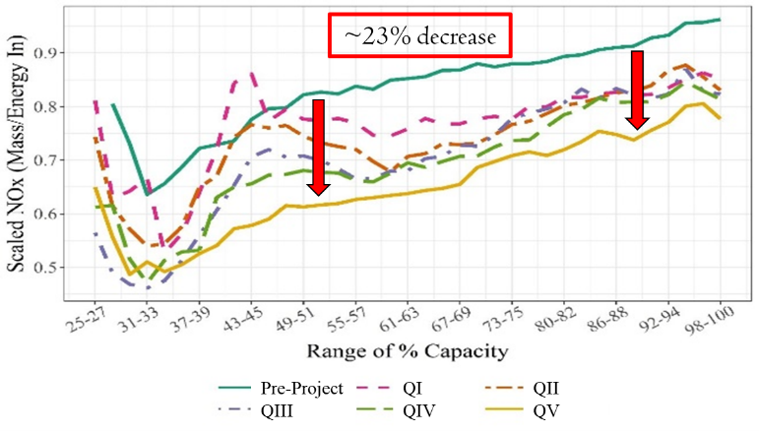Through a combination of artificial intelligence (AI) and expert knowledge capture, bias control logic in the COS

provides consistent process ***improvements that increase over time*** with the system’s self-learning and self-adapting capabilities.

Taber’s COS systems have successfully improved ***NOx 20%+***, ***CO 45%+***, ***heat rate 0.7%+***, ***tube metal temperature alarms 80%+***, ***steam temperature control 5°***, ***opacity violations 95%+***, and numerous other metrics, many at the same time on a single unit.

Combustion is the heart of the thermal power plant, and improvements there extend plant-wide. Increase the capability and control of your combustion process today by contacting   
[info@taber-intl.com](mailto:info@taber-intl.com), and learn more about the unique software platform at [www.griffinopensystems.com](http://www.griffinopensystems.com).