***Taber Cooling Tower Optimization using the Griffin AI Toolkit***

Cooling towers are an integral piece of equipment for many processes, from power generation to food processing. Such systems which utilize fans to create draft (both forced and induced) can use a substantial amount of power, representing higher operating costs or decreased operating efficiency. ***Opportunity exists to reduce power consumption of the cooling tower through optimal on/off cell selection or adjusting cell fan speeds for variable frequency drives (VFDs) equipped fans motors.*** Many systems having this capability operate on the assumption that all cells in the system have identical operating efficiency and run all fans within the system at identical speeds to achieve a given temperature setpoint. Often this is not the case, and individual cell efficiency varies greatly from fan to fan and can also change based on load, weather conditions, and other circumstances, as shown to the right.

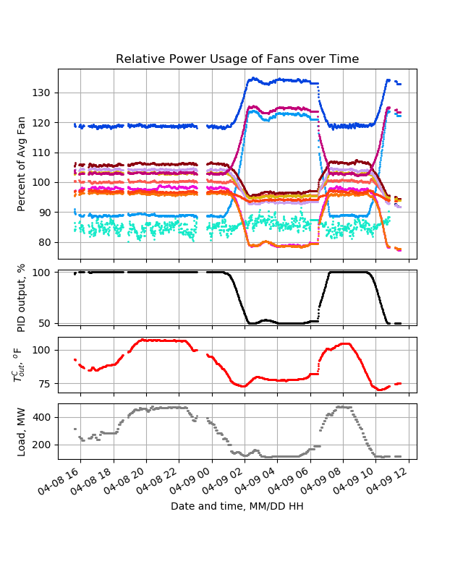

Griffin Open Systems’ new Cooling Tower Optimization application can ***significantly reduce power consumption*** while achieving similar or even ***improved process performance*** through Adivarent Control***. A power consumption reduction capability of 5–10%*** has been demonstrated on a 12-cell induced draft evaporative cooler at a large electric power plant, shown below.

Installation of Griffin Open Systems’ AI platform and cooling tower optimization application is quick and simple, requiring ***less than one week*** after internal control system changes are in place. Necessary I/O points are minimal, needing ***less than 50 I/O points*** depending on system size and scope. After a short AI learning and exploratory period (typically 2 – 3 weeks), ***benefits*** *of the optimization system can be expected to be seen* ***within one month of install***.

We at Taber International look forward to aiding you in achieving optimal performance of your cooling towers as well as all systems within your process. Please contact us at [sales@taber-intl.com](mailto:sales@taber-intl.com) and learn more about the Griffin AI Toolkit by visiting [www.griffinopensystems.com](http://www.griffinopensystems.com) to see more about our many solutions today!