***PAC Injection & Mercury Optimization using the Griffin AI Toolkit***

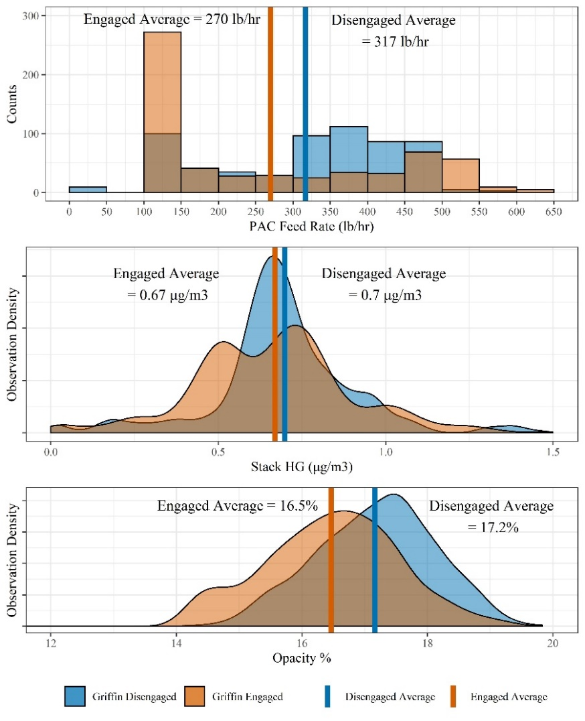The minimization of mercury (Hg) emissions is a high priority for many coal-burning processes in order to meet environmental limits. A common mercury removal method injects powdered activated carbon (PAC) shortly after combustion to adsorb mercury from the flue-gas stream. PAC injection, however, can be expensive and have detrimental effects on other aspects of the system, primarily exit gas stream opacity out the stack. It is preferable to inject only the minimum necessary amount of PAC to lower mercury below limits while not wasting PAC material and inflating opacity measurements. Common PAC injection control systems operate very slowly due to the nature of the adsorption process and the extremely low concentrations of mercury; however, the effects of injection can rapidly raise opacity, often beyond acceptable limits, requiring manual corrective actions. This often creates a cycle of control movements which culminate in the entire process performing inefficiently. ***There exists an opportunity to intelligently balance priorities and optimize PAC injection rates to remove mercury while controlling opacity with minimal PAC usage.***

Griffin Open Systems’ Hg PAC Optimization application ***successfully prioritizes multiple objectives in real-time*** to achieve optimal performance of your system while respecting all process limits. Through an advanced method of prioritization, long- and short-term objectives of multiple parameters are considered and respected, leading to ***overall improved performance***. These ***methods are*** ***easily extended to other processes and objectives***.

***In less than one week*** and ***utilizing minimal I/O***, up to a ***15% – 20% reduction in PAC injection*** is achievable, while ***lowering the occurrence of high opacity*** and maintaining ***similar or improved mercury emissions.*** The ***cost savings in PAC purchases alone exceeds $500,000*** for this single application.

We at Griffin Open Systems look forward to aiding you in achieving optimal performance of your PAC injection system as well as all systems within your process. Please contact us at [sales@taber-intl.com](mailto:sales@taber-intl.com) or learn more about the Griffin AI Toolkit™ at [www.griffinopensystems.com](http://www.griffinopensystems.com) and our many other solutions today!