Validation
Input: 100 0.2 4
Console output:
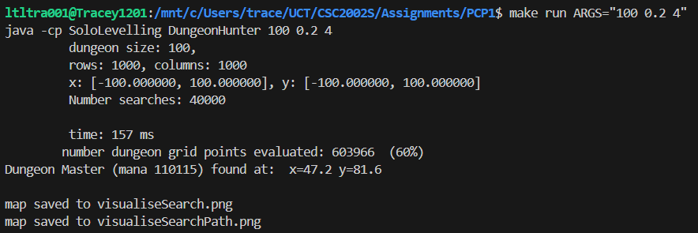
Figure 1: Serial Program Output
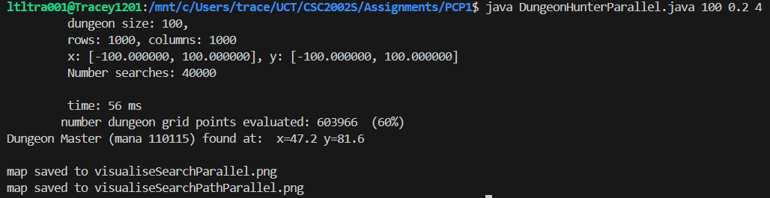
Figure 2: Parallel Program Output
Beyond Compare results
Picture Compare
Produced: 2025/08/17 12:18:13

Left file: C:\Users\trace\UCT\CSC2002S\Assignments\PCP1\visualiseSearch.png
Right file: C:\Users\trace\UCT\CSC2002S\Assignments\PCP1\visualiseSearchParallel.png
1000000 same pixel(s)

Input: 200 0.2 4
Console output:
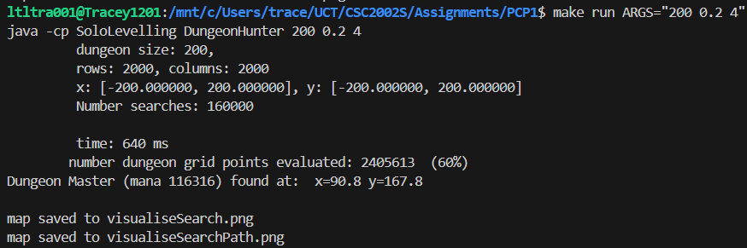
Figure 3: Serial Program Output
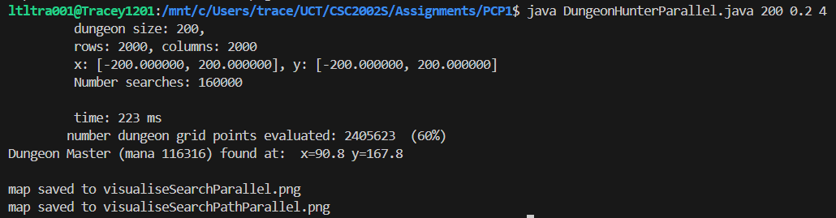
Figure 4: Serial Program Output
Picture Compare
Produced: 2025/08/17 12:31:09

Left file: C:\Users\trace\UCT\CSC2002S\Assignments\PCP1\visualiseSearch.png
Right file: C:\Users\trace\UCT\CSC2002S\Assignments\PCP1\visualiseSearchParallel.png
4000000 same pixel(s)

