Fact Sheet Collection Assignment

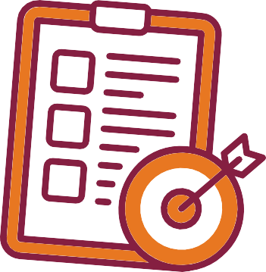

You’re part of a professional team on a technical communication project. Traci is your manager in this fictional workplace scenario.

You and your group will write a collection of fact sheets to teach your client’s employees about usability, document design, and accessibility.

**Your Role in This Project**

This assignment helps you: Communicate complex info visually. Write for real audiences.

Collaborate on document design. Practice accessible communication.

**Why This Project Matters**

Write your report for your client and their employees to use as they revise and improve their organization’s website.

Use a respectful, professional tone that’s appropriate for external workplace communication.

**Know Your Audience**

**Letter of Transmittal:** One-page letter with project overview **Title Page:** Collection Title, Prepared for, & Prepared by **Table of Contents:** List all fact sheet titles and authors

**Fact Sheets:** One 2-page fact sheet for each group member, which:

* Focuses on 1 principle (e.g., alt text or heading use).
* Includes clear examples from the chosen website.
* Uses in-text citations with full references at the end of the sheet.
* Includes 3 or more visual elements that demonstrate the principle.

**What to Include**

**Success Tips**

Coordinate as a team for a consistent look. Include examples from your chosen website. Check your sheet’s accessibility and usability. Cite your sources clearly and accurately.

**How You’ll Be Graded**

See the rubric on the assignment page for full criteria.

You will receive an **individual** grade for the collection.

Check the assignment page for details on assignment dates.

Copyright © 2025 Traci Gardner. Licensed under a Creative Commons Attribution-NonCommercial Share-Alike 4.0 International License. Created on [Canva.com](https://Canva.com/).