**Technical Description of a Microwavable Rice Cooker**

A microwavable rice cooker is a small container with two lids that is used to quickly cook rice in the microwave. This is an alternative to traditional rice cookers that might require a source of power and take longer to cook. The main container of the rice cooker is a wide cylinder and there are two lids that cover the opening.

**The Main Container**

The main container of the rice cooker is a plastic, dark gray cylinder. The paint is not completely matte, as there is some gloss due to lighting, but the plastic is not very reflective. There are two protruding parts at the lip of the container. The protrusions have a swiveling piece of plastic that swivels 90 degrees upwards and are used to latch and hook onto the outer lid to secure it in place. The latches themselves are slightly indented to make it more comfortable to hold and easier to grip. The lip at the top of the rice cooker body extrudes out about a centimeter. The container widens about two centimeters down from the top of the container to allow the inner lid to fit neatly inside.

**The Inner Lid**

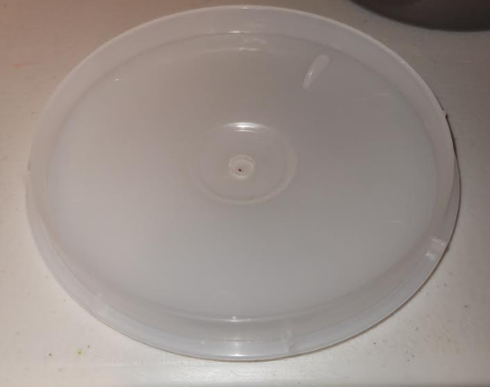The inner lid of the rice cooker is a translucent, white disk with a diameter just slightly less than the diameter of the main body. There is a small, circular opening a little smaller in size than a dime. The disk slopes downward from the outer edge to the inner circle. There is a raised two-centimeter tall “wall” that is one centimeter in from the outer edge of the lid. Outside the inner hole is another raised part of the lid in the shape of a circle. The inner lid fits inside the main container with the “wall” face up. The hole allows steam to escape as the rice is being cooked.

**The Outer Lid**

The outer lid has two different designs on both sides of it. The bottom of the lid also has the same raised wall as the inner lid. However, in the center, there is now a raised section that allows steam to vent out of it. There is a raised flat cylinder that is about six centimeters wide and three centimeters tall. On the side of this cylinder are three slits for the steam to escape through. On top of this cylinder is another raised wall that matches the diameter of the circle around the center hole of the inner lid. The edge of the lid also has two protruding pieces of plastic that are slightly angled to allow the hooks of the main container to latch on and secure the lid in place. The top side of the outer lid has a crater with the same diameter as the cylinder on the underside. In line with the two protruding hooks and over the crater is the handle of the A picture containing indoor, wall, white, toilet
**outer lid. This lets the user hold the rice cooker after the lid has been secured.

**Conclusion**

The microwavable rice cooker is a simple, easy-to-use container that allows the user to quickly cook rice. There are three main parts to the container, and they all fit tightly together and are secured in place by hooks. There are many other types of microwavable rice cookers, but this is what one can expect to see from a budget model.