# Using a Can Opener: A Step-by-Step Guide

Still using knives to open your metal cans? Not after reading this quick guide. A can opener is a faster, easier, and safer way to open up your canned products, but without some instruction it can be a pretty daunting task! All it takes is two hands, a can opener, and 3 seconds of your time. Let’s get you started.

## Icon Description automatically generatedWarning

The edges of the can lid and the cutting blade of the can opener are sharp and can cause cuts. Be careful how you handle the sharp edges.

## Things you will need

1. A can opener
2. A can
3. Countertop or flat surface

## Instructions for opening your can

1. Retrieve your can opener and the canned product you are looking to open.
2. Lay out your can opener and can in front of you on a flat surface, as shown in the image below.  
   A picture containing indoor, floor

   Description automatically generated
3. Pick up your can opener by the rubber or plastic handle and separate the two handles to open the can opener, and remember to watch out for the blade!

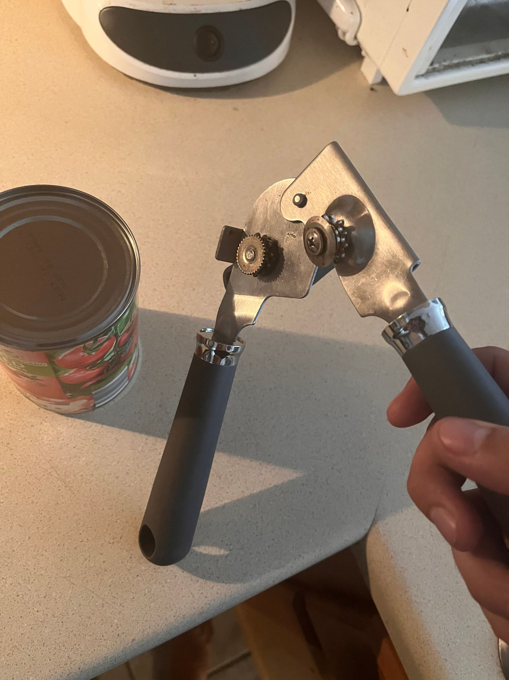

1. Find the small indent on the top part of the canned product, which is along the edge of the can. Line up the circular blade of the opener with this indent.

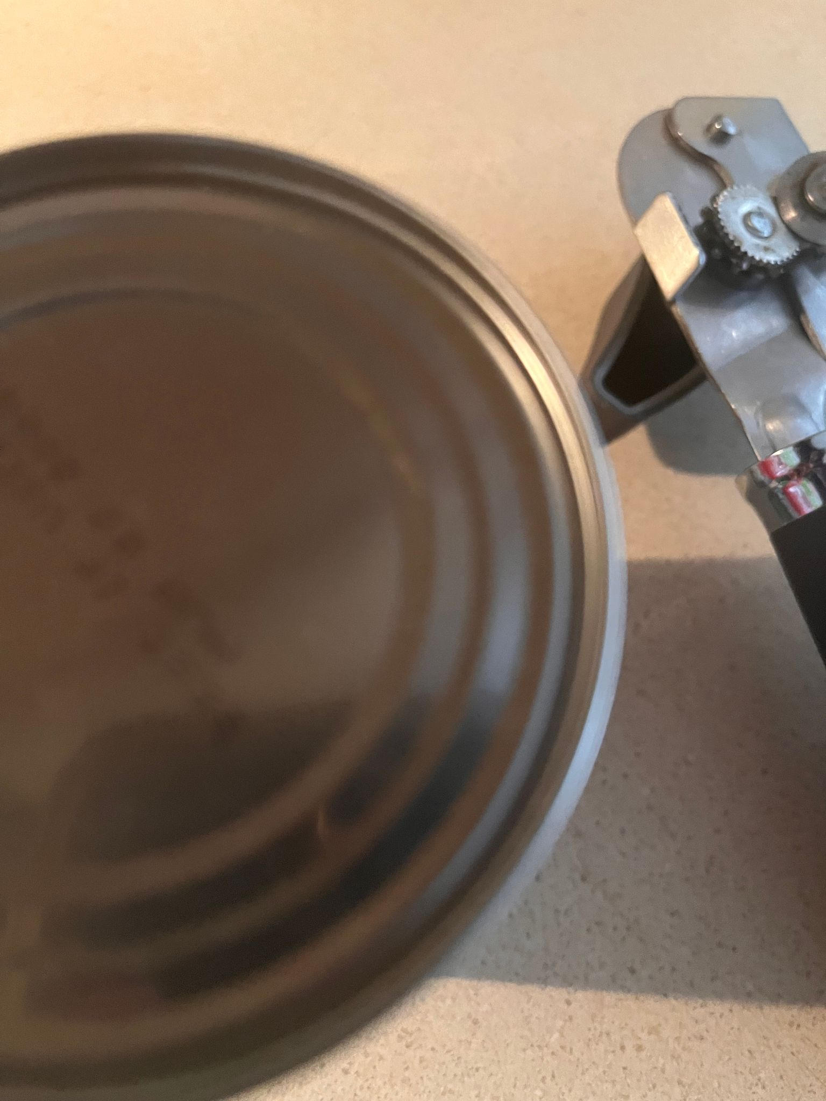

1. Move the handles together to close the blade down onto the can and keep the opener in a firm position. Squeeze with a small amount of force to ensure the opener stays on track

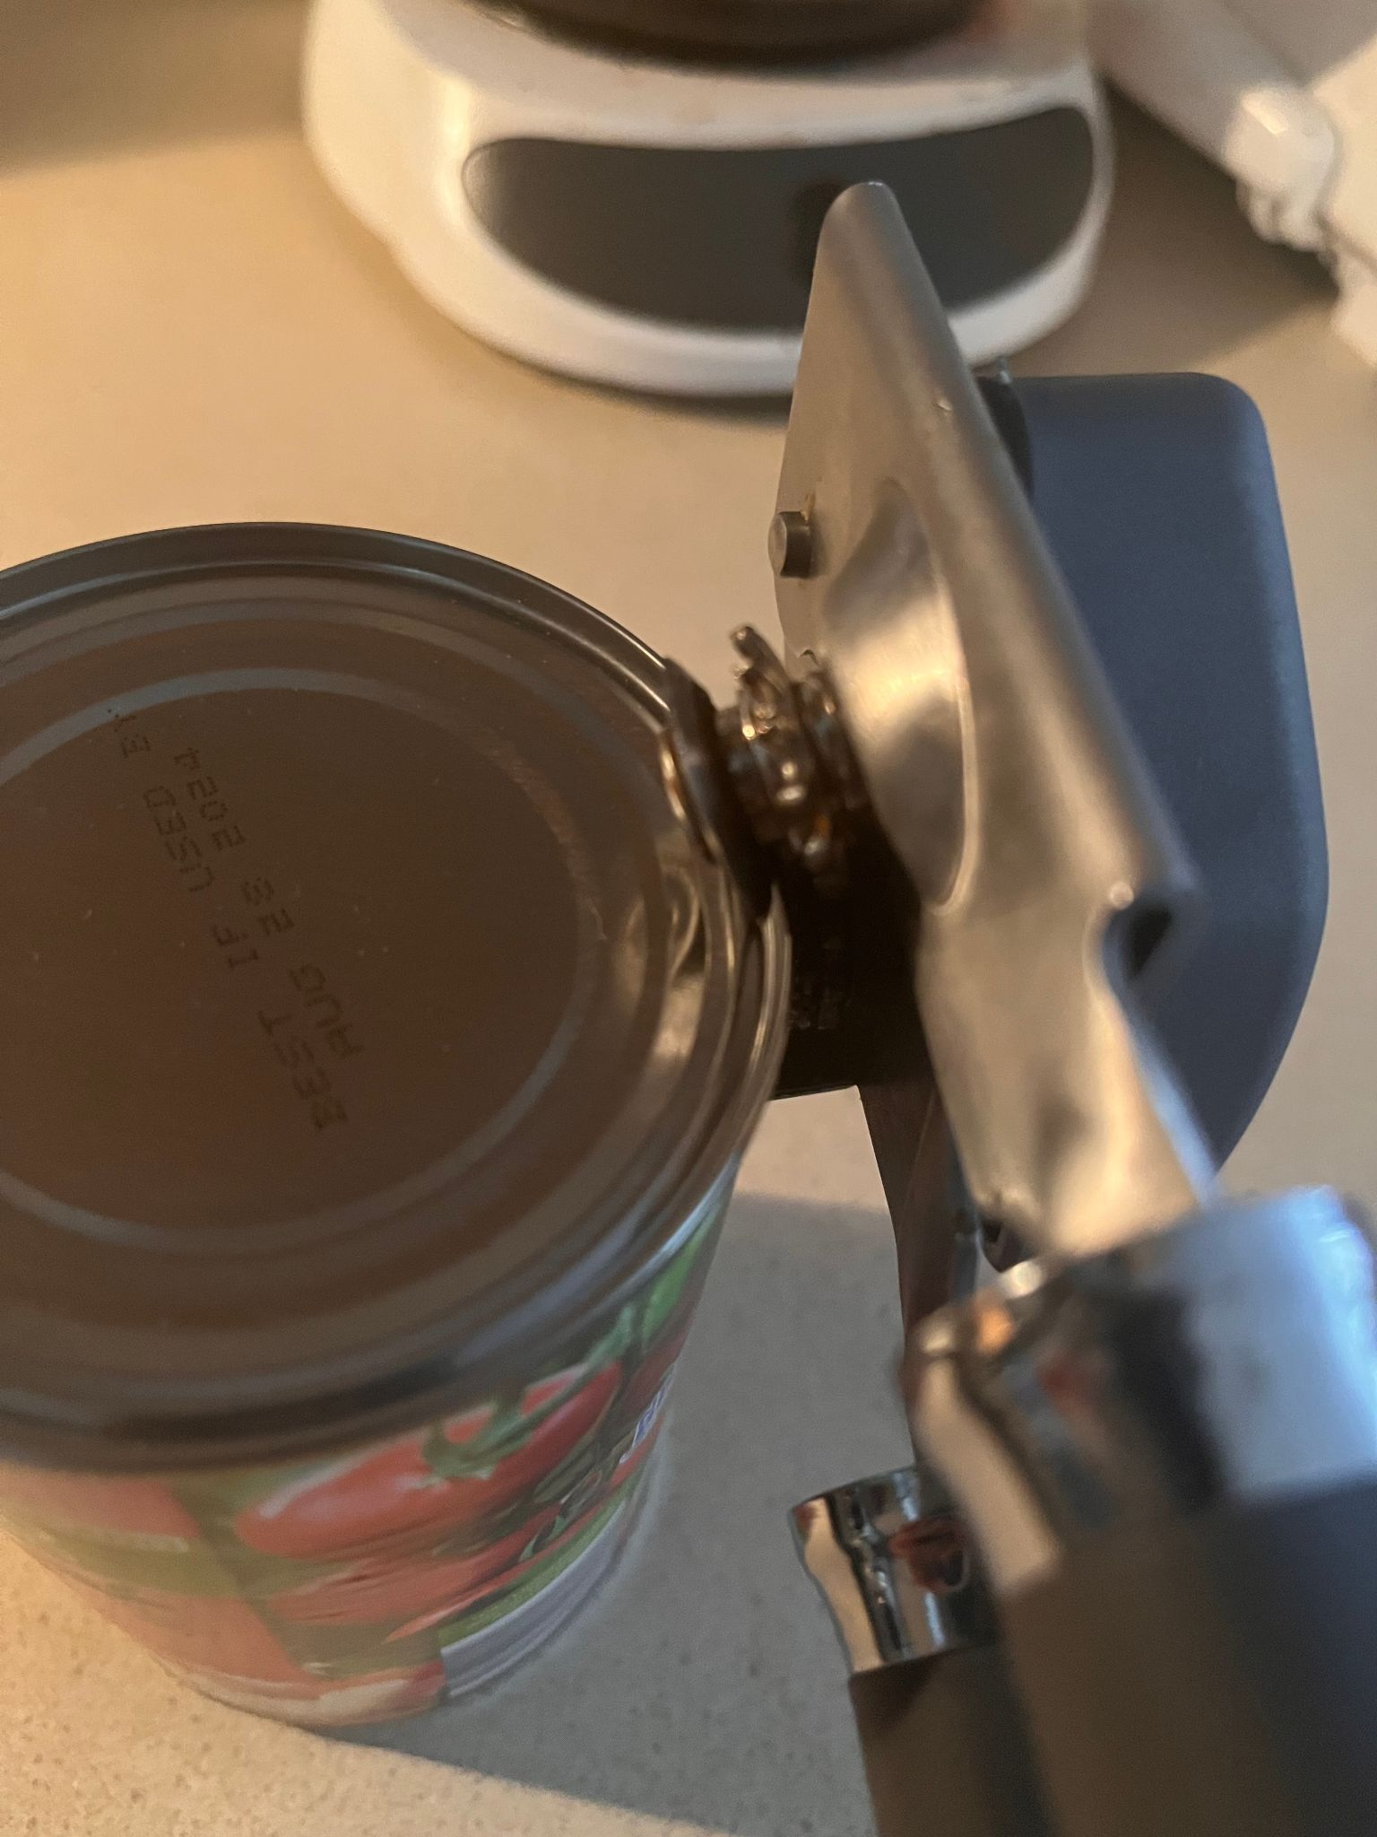

1. Twist the lever on the other side of the opener away from you, the can opener will rotate the can for you and cut open the lid, allow the can to spin but maintain control of the opener.

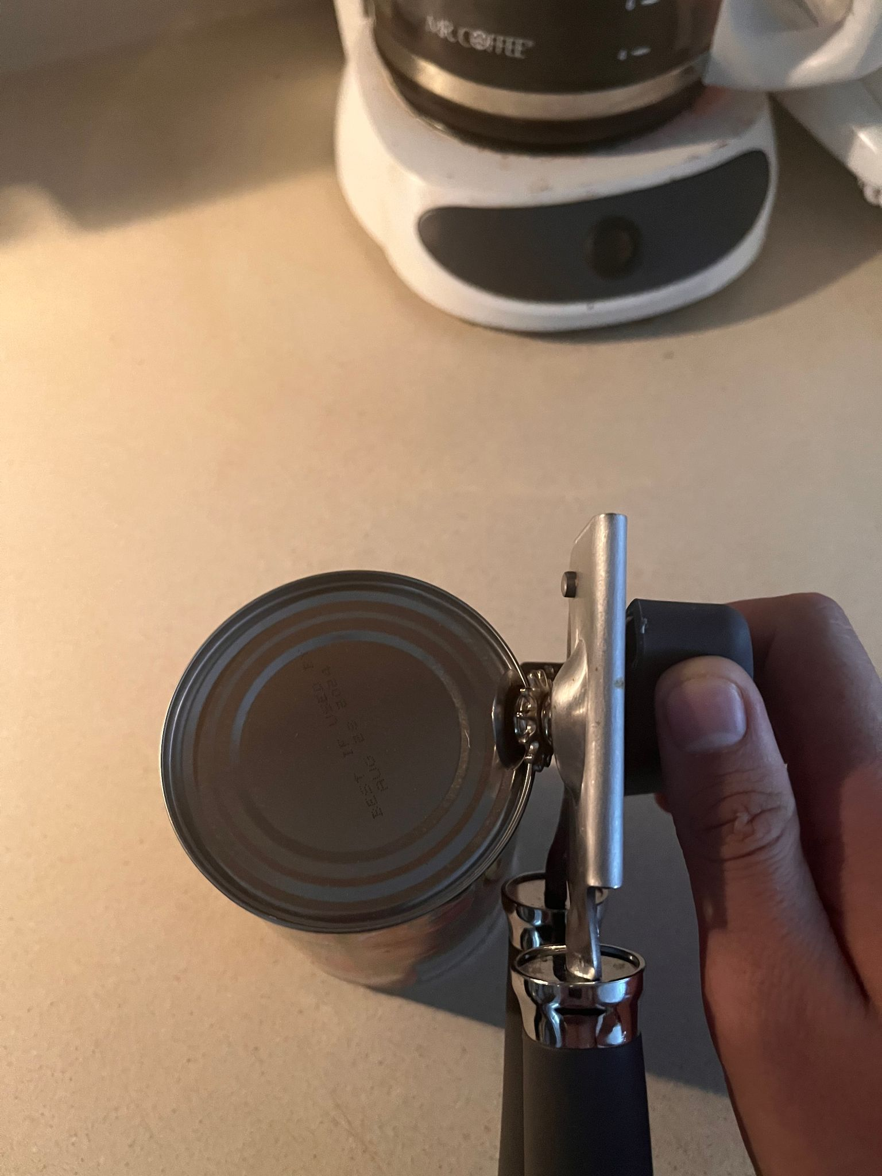

1. Once the can has twisted 360 degrees the entire lid will be removed from the can. Be careful when removing the lid as it can be sharp. Sometimes a fork can be used to pick up the sharp lid.
2. Enjoy the contents of your can and have a great day!

## Conclusion

A can opener is a necessary kitchen tool for any chef, stay at home parent, or really anybody that has to eat and wants some Chef Boyardee every once in a while. These steps will only get easier the more you use the can opener and are a much safer alternative to using a knife or other sharp tool.