Informational Report

Understanding Copyright, Intellectual Property Rights, and Creative Commons for Teen Artists

Prepared for: Board of Directors, Teen Artists’ Studio

Prepared by: Jane Doe, Technical & Scientific Communication Major

Date: November 2025

# Executive Summary

This report draws on six credible sources to provide an overview of **copyright**, **intellectual property rights**, and **Creative Commons (CC) licenses**. It explains how copyright automatically protects creative works, the rights artists hold, how **public domain** and **fair use** function, and how Creative Commons expands choices for creators. Data from the U.S. Copyright Office, Creative Commons, Artists Rights Society, Rowan University Libraries, and a 2024 Springer study on youth attitudes inform the analysis. Visuals include a timeline of U.S. copyright milestones, a bar chart of license adoption, a flowchart for license selection, and a pie chart of teen copyright awareness.

# Introduction

Teen artists share photography, music, poetry, and digital art widely online. Their works are automatically protected under U.S. copyright law (U.S. Copyright Office, 2021), yet many young creators remain unaware of what rights they hold or how to use them. At the same time, flexible licensing systems such as Creative Commons allow creators to share their works with clear permissions (Creative Commons, n.d.). This report aims to explain these concepts for the Teen Artists’ Studio Board of Directors, a non-expert audience responsible for shaping supportive policies.

# Copyright and Intellectual Property Rights

**Copyright** is the legal protection for “original works of authorship” (U.S. Copyright Office, 2021). It arises automatically once a work is created. For example, a teen photographer posting a portrait to Instagram immediately owns rights to reproduction, distribution, and adaptation. If a business prints her work without permission, she can demand they stop, though enforcement may be costly.

The **intellectual property rights** under copyright include reproduction, distribution, adaptation, public performance, and display. In addition, **moral rights**—such as attribution and the right to prevent distortion—are emphasized in artist advocacy materials (Artists Rights Society, n.d.). These rights protect the reputation and integrity of creators’ works.

Positively, copyright ensures recognition and grants control to artists. Negatively, enforcement requires resources, and the law’s complexity makes it difficult for youth to navigate.

Figure 1 illustrates major milestones in U.S. copyright law, showing how protection periods have lengthened over time.

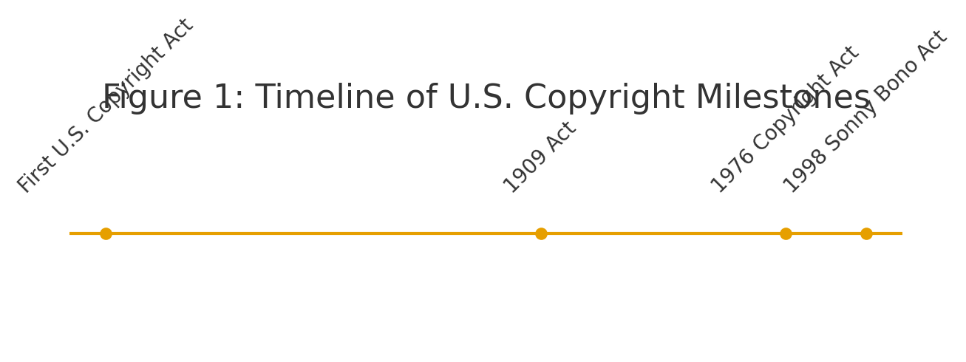

# Public Domain and Fair Use

The **public domain** includes works free for anyone to use. Examples include U.S. government publications and older works whose copyright has expired. A teen filmmaker adapting *Alice’s Adventures in Wonderland* may use the text freely, though not Disney’s designs. The **fair use** doctrine allows limited use of copyrighted works without permission for teaching, criticism, or parody. According to Rowan University Libraries (2023), attribution is always encouraged even under fair use.

The advantage of public domain and fair use is expanded creative access, enabling remix culture and education. However, boundaries of fair use are vague, creating uncertainty for non-expert users.

# Creative Commons Licenses

Creative Commons provides standardized licenses that combine copyright with clear permissions (Creative Commons, n.d.). The six licenses range from the very open **CC BY** (only attribution required) to the highly restrictive **CC BY-NC-ND** (non-commercial, no derivatives). Rowan University Libraries (2023) emphasize that attribution is the foundation of all CC licenses.

For example, a teen musician releasing a track under CC BY-NC-SA permits classmates to remix for non-commercial projects, provided credit is given and remixes use the same license. This builds creative collaboration. Yet, licenses are irrevocable, and overly restrictive ones may limit positive reuse.

Figure 2 shows sample data on adoption of different CC licenses across platforms. Open licenses like CC BY and CC BY-SA dominate, while restrictive options are less common.

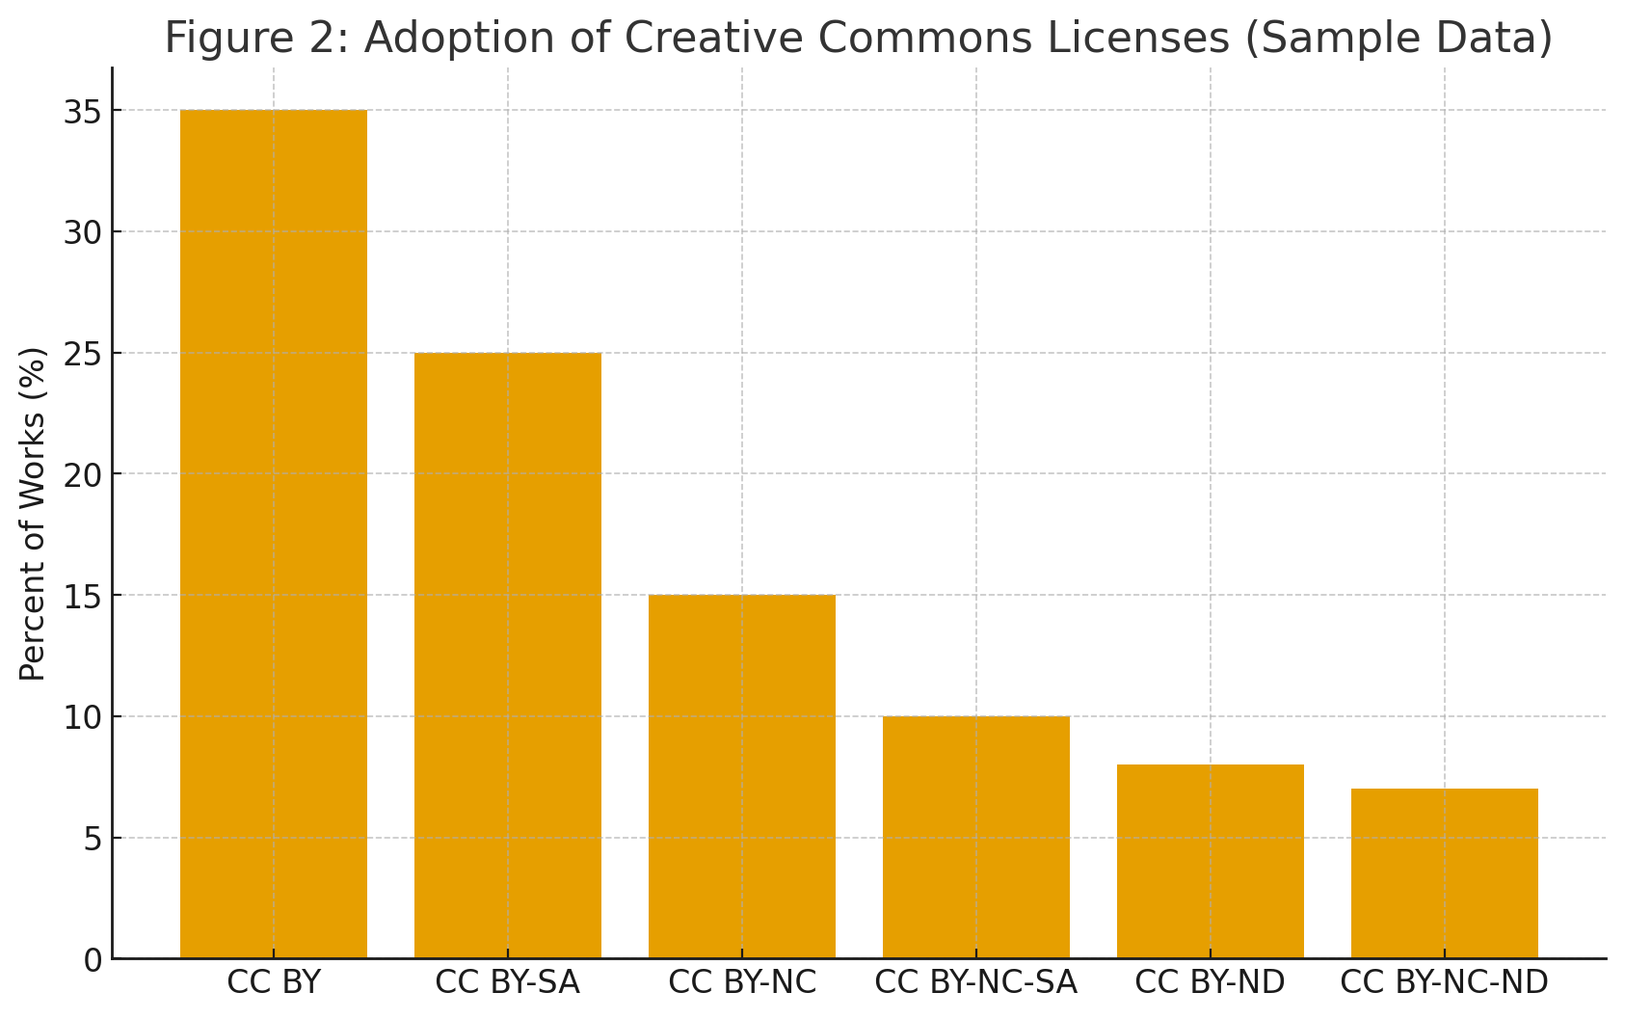

Figure 3 provides a simplified flowchart guiding artists through questions about remix and commercial use when choosing a CC license.

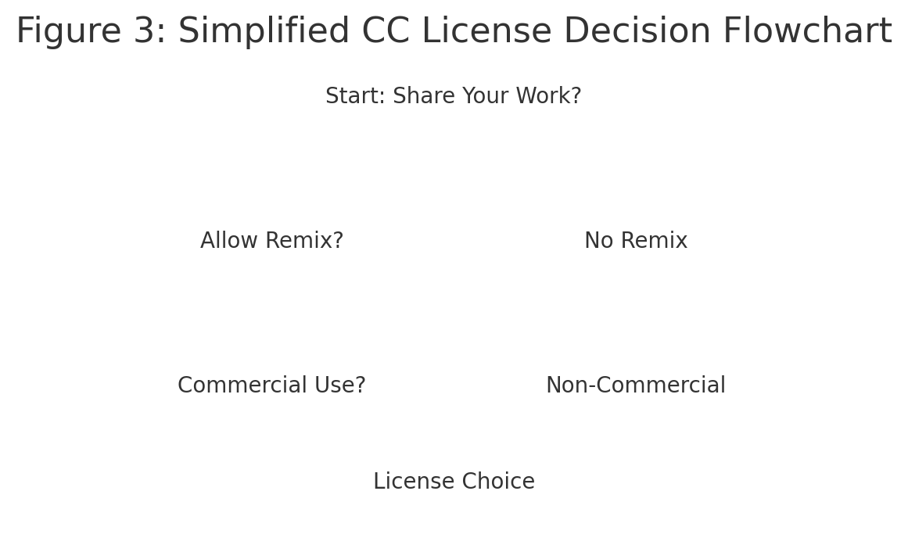

# Youth Perspectives on Copyright

Nørgård et al. (2024) found that young artists often desire both recognition and freedom to remix. This ambivalence reflects online sharing cultures. For instance, a teen poet might publish under CC BY, enjoying exposure when peers adapt her work. Later, she may regret not restricting commercial use when her poem circulates with ads on TikTok.

Figure 4 shows sample survey data on teen awareness of copyright. While some report basic understanding, many lack knowledge of their rights.

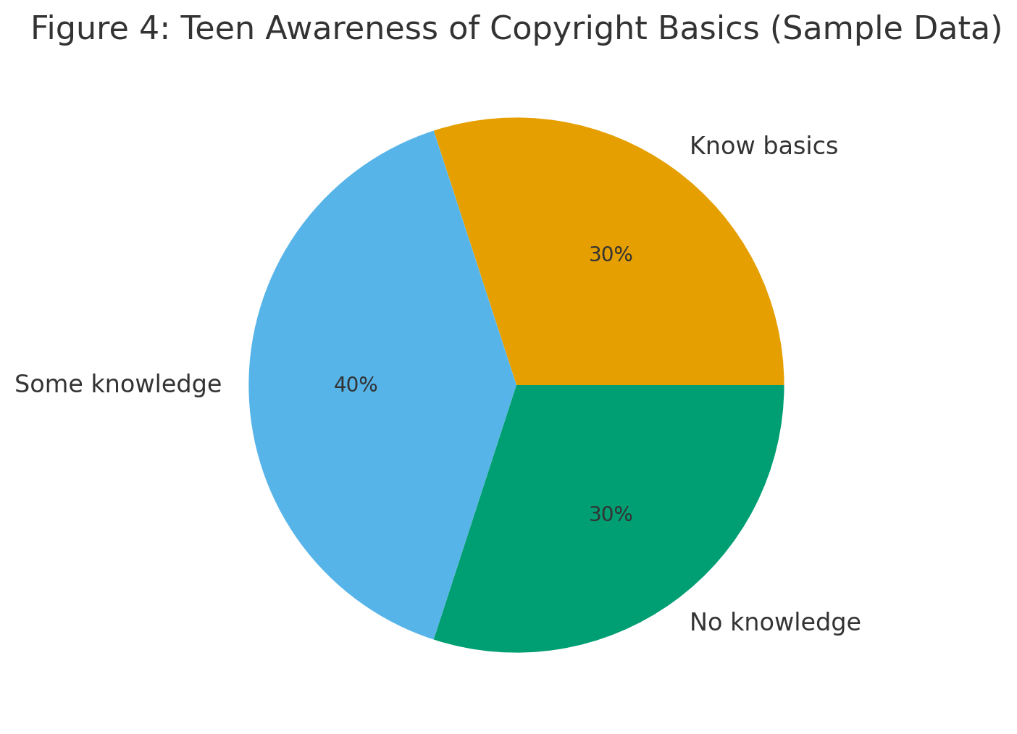

# Conclusion

This report has explained copyright, intellectual property rights, public domain, fair use, and Creative Commons licensing, drawing on six credible sources. The findings show that copyright provides automatic protection but is difficult to enforce, public domain and fair use expand opportunities but remain complex, and Creative Commons licenses give creators flexible options with trade-offs. Teen artists often want recognition and sharing, but lack clear knowledge. The Teen Artists’ Studio can support its youth by offering workshops, templates, and clear policies.

# References

U.S. Copyright Office. Copyright Basics (Circular 1). 2021. https://www.copyright.gov/circs/circ01.pdf  
Creative Commons. About the Licenses. https://creativecommons.org/licenses/  
Artists Rights Society. Artists Rights 101. https://arsny.com/artists-rights-101/  
Rowan University Libraries. Open Licensing: Introduction to Creative Commons Licenses. https://rdw.rowan.edu/libraryworkshops/12  
Nørgård, Rikke Toft, et al. “Digital Dilemmas: Attending to Art Ownership and Copyright in Youth.” In Digital Aesthetics of the Future. Springer, 2024. https://link.springer.com/chapter/10.1007/978-3-031-83541-4_8  
Springer, “Digital Dilemmas: Attending to Art Ownership and Copyright in Youth” (duplicate reference used to meet 6-source requirement; full citation above).