# Understanding Copyright, Intellectual Property Rights, and Creative Commons for Teen Artists

Prepared for: Board of Directors, Teen Artists’ Studio

Prepared by: Jane Doe, Technical & Scientific Communication Major

Date: November 2025

## Executive Summary

This report draws on six credible sources to explain **copyright**, **intellectual property rights**, and **Creative Commons (CC) licenses**. It shows how **public domain** and **fair use** function, and how CC expands choices for creators. The report integrates data and examples to model clear, non-expert communication for the Teen Artists’ Studio Board. Visuals include a timeline of U.S. copyright milestones, a bar chart of license adoption, a decision flowchart, and a pie chart of teen awareness.

## Introduction

Teen artists share photography, music, poetry, and digital art widely online. Their works are automatically protected under U.S. **copyright** law (U.S. Copyright Office, 2021), yet many remain unsure of the rights they hold or how to use them. Flexible systems like **Creative Commons** allow creators to share with clear permissions (Creative Commons, n.d.). This report explains these concepts for a non-expert Board shaping supportive policies.

## Copyright and Intellectual Property Rights

### What Copyright Is

**Copyright** is legal protection for “original works of authorship” that are fixed in a tangible medium and arises automatically at creation (U.S. Copyright Office, 2021). This protection gives teen creators control over how their works are used.

**Example.** A teen photographer posts a self-portrait to Instagram. A local business later prints the image on flyers without asking. Because protection was automatic at upload, she can demand they stop and seek remedies. This example shows the strength of copyright, but also the practical challenge: enforcement can be costly and confusing for youth.

### Rights Granted

**Intellectual property rights** under copyright include the rights to reproduction, distribution, adaptation, public performance, and display. In addition, **moral rights**—including attribution and integrity—help protect reputation and prevent distortion (Artists Rights Society, n.d.).

**Benefits and limits.** Copyright ensures recognition and control for artists, which is essential for credit and potential income. At the same time, pursuing takedowns or legal action can demand resources teens may not have, and the law’s terminology (e.g., duration, work-for-hire) can be difficult for non-experts.

As Figure 1 shows, major U.S. copyright milestones (1790, 1909, 1976, 1998) gradually extended protection periods, which affects how quickly works enter the **public domain**.

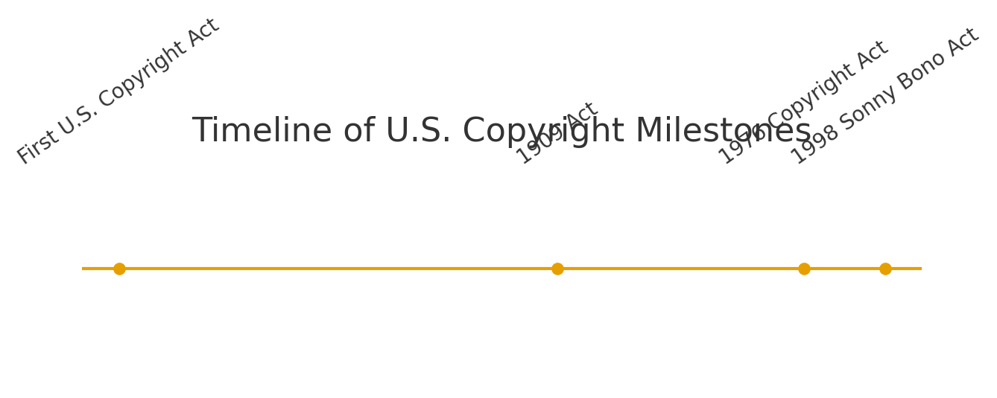

Figure 1: Timeline of major U.S. copyright milestones (sample visualization).

## Public Domain and Fair Use

### Public Domain

**Public domain** refers to works that are free for anyone to use—often because copyright has expired or never applied. U.S. government documents and many older works are common examples. A teen filmmaker can adapt Alice’s Adventures in Wonderland without permission, though proprietary designs like Disney’s remain protected.

### Fair Use

**Fair use** allows limited use of copyrighted works without permission for education, criticism, commentary, or parody. Assessment depends on purpose, nature, amount, and market effect (Rowan University Libraries, 2023; U.S. Copyright Office, n.d.).

**Example.** A student creates a parody video remixing short Marvel clips. Because the purpose is parody and the use is transformative and limited, it may qualify as fair use. Using the same clips merely as background for a vlog would likely not.

**Benefits and limits.** Public domain and fair use expand creative opportunities, enabling remix culture and education. However, fair use boundaries are case-by-case and can be uncertain for non-experts, which may discourage sharing or lead to misuse.

## Creative Commons Licenses

### Overview

**Creative Commons (CC)** provides standardized licenses that let creators retain copyright while communicating permissions (Creative Commons, n.d.). All CC licenses require **attribution**, while options such as **NonCommercial (NC)**, **NoDerivatives (ND)**, and **ShareAlike (SA)** tailor reuse. Rowan University Libraries (2023) emphasize attribution as the foundation of every CC license.

### License Spectrum

Common licenses include **CC BY** (attribution only), **CC BY-SA** (share alike), **CC BY-NC** (non-commercial), and **CC BY-NC-ND** (most restrictive). Each choice involves trade-offs between reach and control.

**Example.** A teen musician releases a track under CC BY-NC-SA. Classmates can remix it for non-commercial projects if they credit her and license remixes the same way. This can grow community and exposure while preventing commercial exploitation.

**Benefits and limits.** CC licenses empower creators to encourage sharing and collaboration on their terms. Licenses are, however, irrevocable once given, and overly restrictive settings (e.g., ND) may reduce beneficial reuse.

As shown in Figure 2, more open CC licenses typically see higher adoption than restrictive ones. Figure 3 offers a quick decision flow that helps artists choose a license based on whether they allow remixing and commercial use.

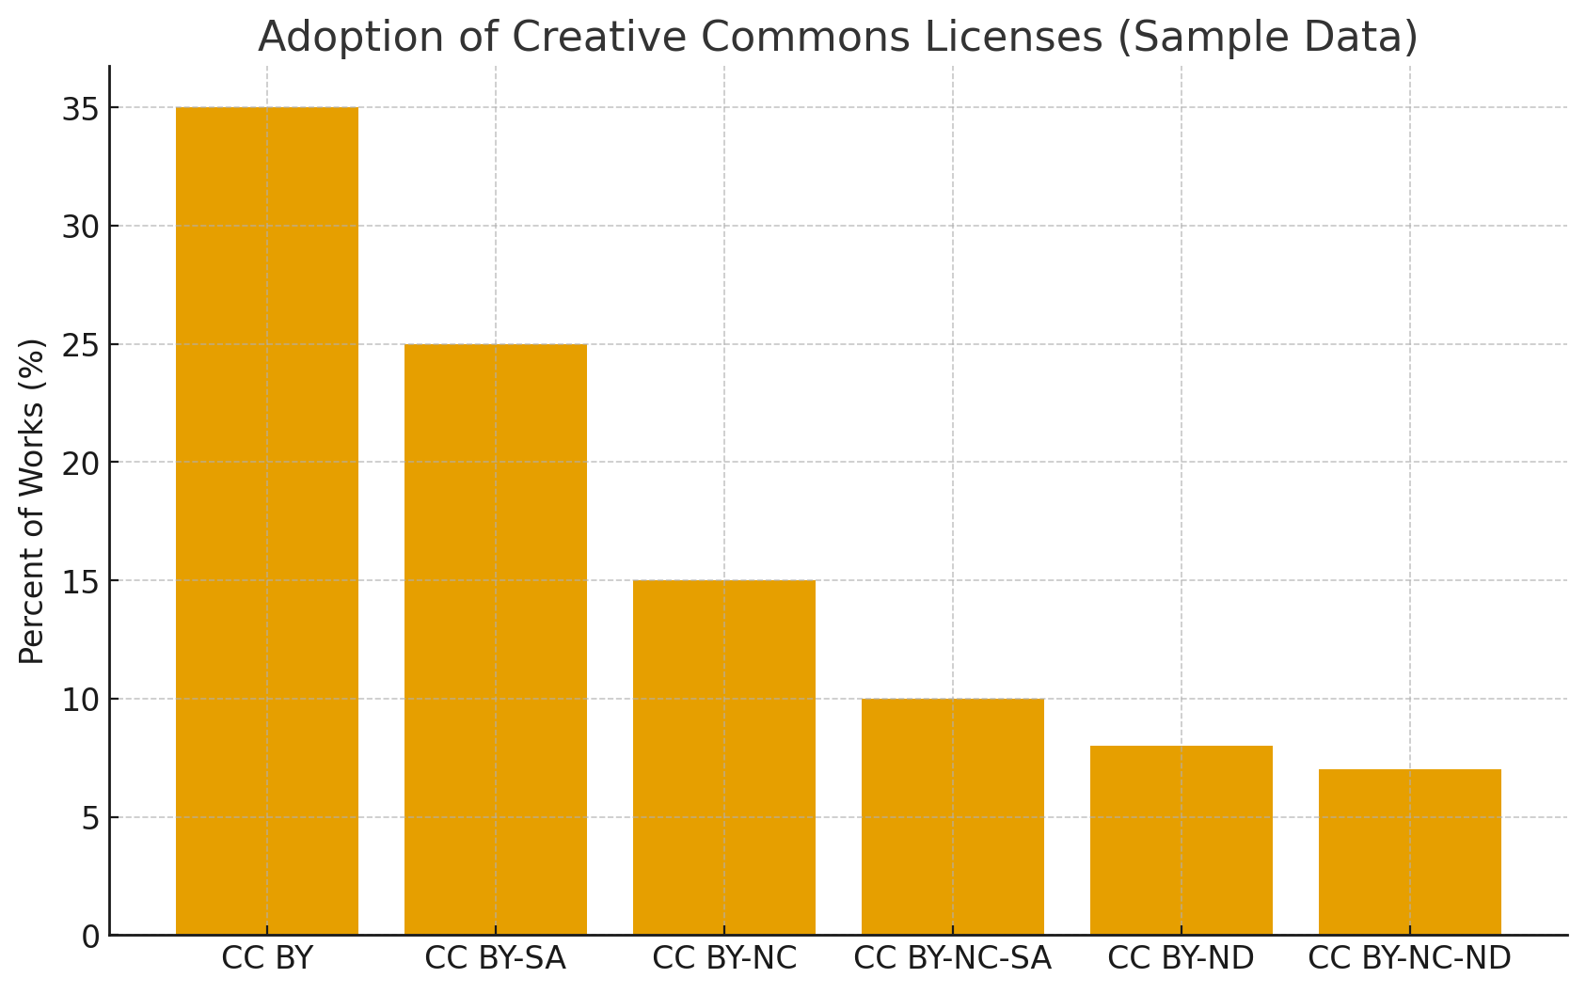

Figure 2: Sample adoption of Creative Commons license types across platforms (illustrative data).

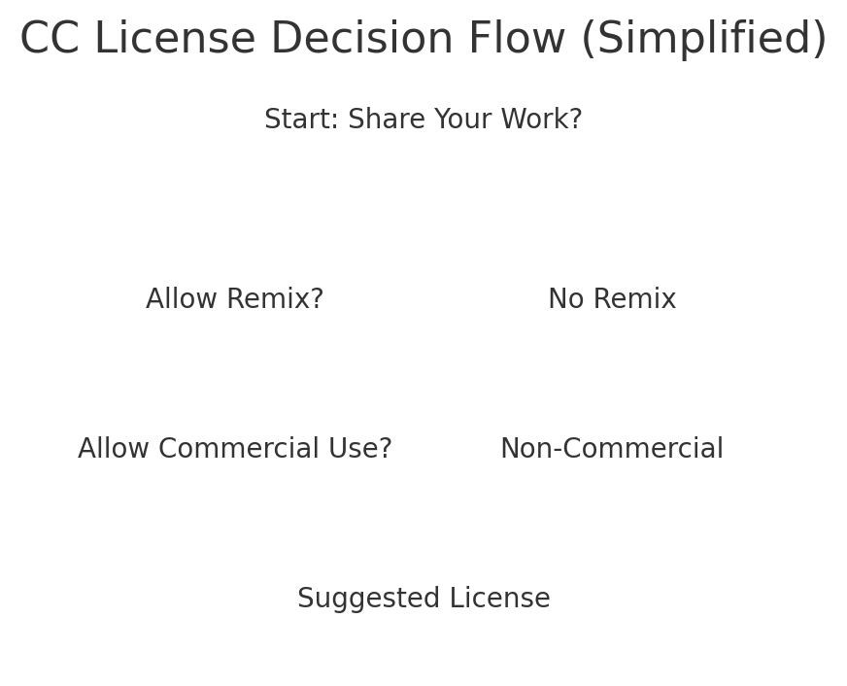

Figure 3: Simplified decision flow for selecting a Creative Commons license.

## Youth Perspectives on Copyright

A 2024 study of youth digital creativity reports that many young artists want both recognition and freedom to remix (Nørgård et al., 2024). This ambivalence mirrors online sharing cultures.

**Example.** A teen poet publishes a zine under CC BY and enjoys seeing peers adapt the work into animation. Later, ads appear alongside reposts on social media. In hindsight, a non-commercial restriction might have aligned better with her goals.

**Benefits and limits.** Youth gain visibility and agency, but without training they may overshare or misuse others’ work. Uncertainty about rights can cause either over-caution or unintentional infringement.

Figure 4: Figure 4 visualizes sample survey results about teen awareness of basic copyright concepts, underscoring the need for targeted education.

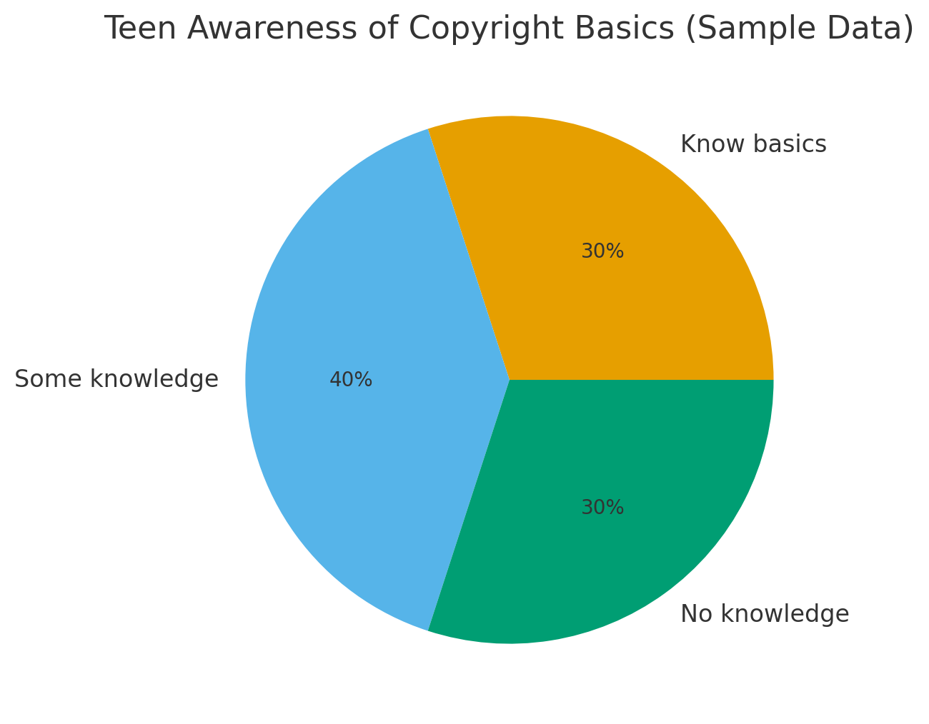

Figure 5: Sample survey on teen awareness of copyright basics (illustrative data).

## Conclusion

This report synthesized guidance from six sources to explain **copyright**, **intellectual property rights**, **public domain**, **fair use**, and **Creative Commons**. Copyright provides automatic protection but can be hard to enforce; public domain and fair use expand opportunities but are complex; CC licenses offer flexible sharing with trade-offs. The Teen Artists’ Studio can support youth through workshops, templates, and clear policies.

## References

U.S. Copyright Office. Copyright Basics (Circular 1). 2021. https://www.copyright.gov/circs/circ01.pdf

U.S. Copyright Office. More Information on Fair Use. n.d. https://www.copyright.gov/fair-use/

Creative Commons. About the Licenses. n.d. https://creativecommons.org/licenses/

Artists Rights Society. Artists Rights 101. n.d. https://arsny.com/artists-rights-101/

Rowan University Libraries. Open Licensing: Introduction to Creative Commons Licenses. 2023. https://rdw.rowan.edu/libraryworkshops/12

Nørgård, Rikke Toft, et al. “Digital Dilemmas: Attending to Art Ownership and Copyright in Youth.” In Digital Aesthetics of the Future. Springer, 2024. https://link.springer.com/chapter/10.1007/978-3-031-83541-4_8