# Understanding Copyright, Intellectual Property Rights, and Creative Commons for Teen Artists

Prepared for: Board of Directors

Teen Artists’ Studio

Maroon + Orange Digital

1872 Drillfield Drive

Blacksburg, VA 24060

Prepared by: Jane Doe

Technical & Scientific Communication Major

Department of English

Virginia Tech

Blacksburg, Virginia

Date: November 14, 2025

## Executive Summary

This report explains the legal concepts of copyright, intellectual property rights, and Creative Commons (CC) licenses for the Board of Directors of **Maroon + Orange** Digital’s Teen Artists’ Studio.

The document shows how public domain and fair use function, and how CC expands choices for creators. The explanations highlight how these legal tools protect creative work and provide ways to share and remix creative works. Additionally, the details demonstrate how these protections sometimes create limitations for artists, writers, and digital makers.

**The works teens create in the Teen Artists&rsquo; Studio come into being with automatic, legal copyright protections that ensure others cannot copy, reuse, or distribute these compositions without the permission of the artist. The document shows how public domain and fair use function, and how CC expands choices for creators beyond the basics of copyright. The explanations highlight how these legal tools protect creative work and provide ways to share and remix creative works.**

### Key Findings

* Copyright protection is automatic once a work is created, but enforcement can be costly and confusing.
* Intellectual property rights include economic benefits such as selling and licensing an artist’s work and protections that provide attribution requirements.
* Public domain and fair use support free creativity, but fair use can be ambiguous and context-specific, making it hard for artists to understand what they can and cannot share and remix.
* Creative Commons licenses allow flexible sharing, yet choices can unintentionally restrict how art circulates.
* Teen artists often feel torn between wanting recognition and wanting to remix freely.

By understanding these opportunities and challenges, the Board can determine how to support the artists who use the Studio.

## Introduction

This report explains intellectual property rights systems—including copyright, fair use, public domain, and Creative Commons licenses—as they apply to the creative work of writers, artists, and other makers.

Teen artists create music, poetry, digital art, and more during their residency in **Maroon + Orange** Digital’s Teen Artists’ Studio. Their works are automatically protected under U.S. copyright law (U.S. Copyright Office, 2021), but many of these artists-in-residence are unaware of their ownership rights.

Likewise, they are frequently unfamiliar with Creative Commons licenses (Creative Commons, n.d.), which can allow them to maintain ownership while still allowing flexible options for sharing. The purpose of this report is to explain how these intellectual property rights are used, how they can protect artists’ works, and the advantages and challenges of using the different systems.

Members of the Board of Directors of **Maroon + Orange** Digital’s Teen Artists’ Studio can use this report to decide how to support the members of the Teen Artists’ Studio.

This report has been written for the Board of Directors of the **Maroon + Orange** Digital’s Teen Artists’ Studio—community members, graphic artists, and business executives, but not legal experts.

They need:

* Clear definitions of copyright and Creative Commons.
* Explanations of rights already held by teen artists.
* Comparison of CC license options (with visuals like a table).

The report will emphasize clarity, use of visuals, and concise executive-style summaries.

**Element 3: Intended Audience**

Identify your audience and explain why this report is useful for them. You don’t have to name individuals, but you should describe the group you’re writing for (such as city officials, university administrators, first-time parents, high school students, or the general public). This shows that you understand who you’re writing for and what their needs might be.

**Example:**This report is written for city council members who are considering whether to expand e-scooter access in local neighborhoods.

**Element 4: Scope or Focus**

If your topic is broad, your introduction should also explain what specific aspects your report will cover. What will it include—and just as important, what *won’t* it include?

**Example:**While the report discusses general trends in scooter use, it focuses on programs in mid-sized U.S. cities with populations between 100,000 and 500,000.

## Discussion

### What Is Copyright?

**Copyright** is “a form of protection provided by the laws of the United States to the authors of ‘original works of authorship’ that are fixed in a tangible form of expression” (U.S. Copyright Office, 2021).

It gives creators rights of reproduction, distribution, adaptation, performance, and display. Moral rights, such as attribution and integrity, further protect reputation (Artists Rights Society, n.d.).

Example: A teen photographer posts a self-portrait online. A local business uses it without permission. She can demand they stop, but pursuing action may be costly.

Benefits: ensures recognition and control. Limits: enforcement can be difficult for youth.

t and Intellectual Property Rights

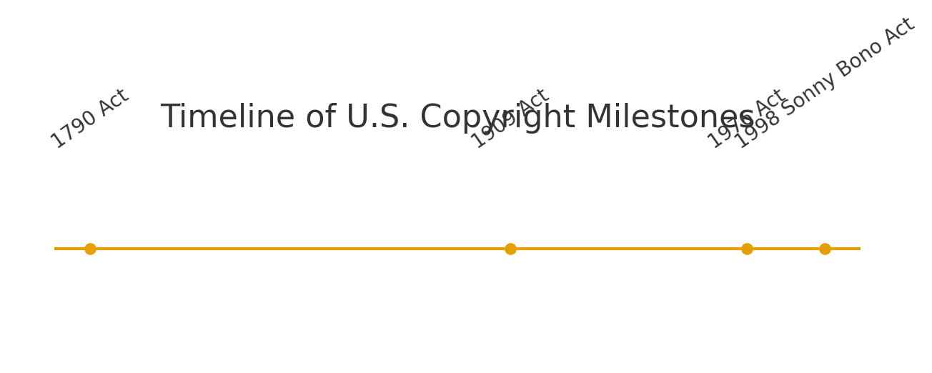

Figure 1: Timeline of major U.S. copyright milestones.

### Public Domain and Fair Use

The public domain includes works free for anyone to use.

People can adapt ideas and characters the fiction novel *Alice’s Adventures in Wonderland*, but not Disney’s designs for the movie. Fair use allows limited use without permission for education, parody, or criticism (Rowan University Libraries, 2023).

Example: A parody video remixing Marvel clips may qualify as fair use; using the clips as background would not.

Benefits: expands cultural access and remix. Limits: boundaries are vague and judged case by case.

### Creative Commons Licenses

Creative Commons (CC) licenses let creators retain copyright while granting permissions. All require attribution, but vary in allowing remixing, derivatives, or commercial use (Creative Commons, n.d.; Rowan University Libraries, 2023).

Example: A teen musician uploads a track under CC BY-NC-SA. Classmates may remix non-commercially if they give credit.

Benefits: flexible and collaborative. Limits: licenses are irrevocable and restrictive terms may reduce exposure.

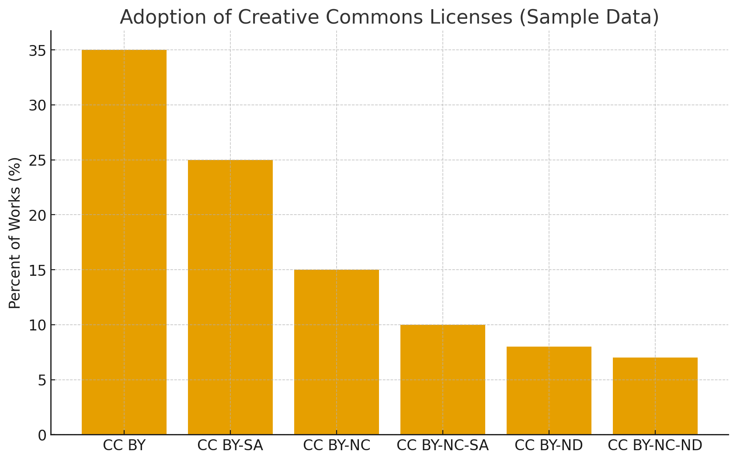

Figure 2: Sample adoption of Creative Commons license types.

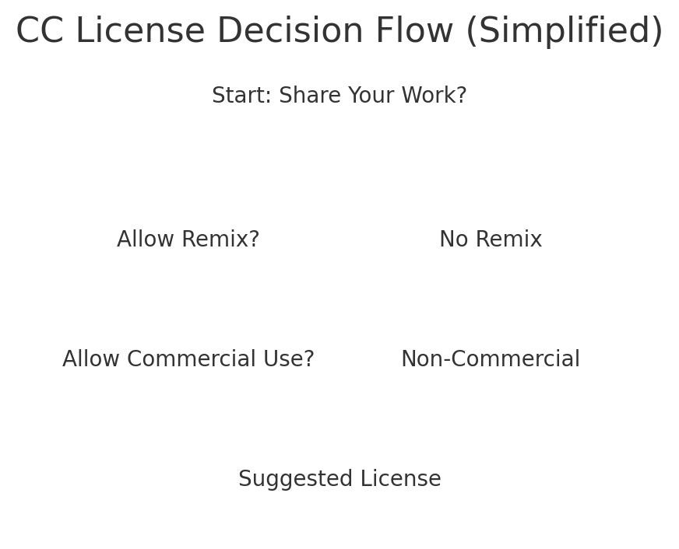

Figure 3: Simplified decision flow for selecting a Creative Commons license.

### Youth Perspectives

Research shows teens often want both recognition and remix freedom (Nørgård et al., 2024). This reflects digital sharing cultures.

Example: A teen poet publishes under CC BY. She enjoys remixes but regrets not limiting commercial use when her poem appears in ad-supported videos.

Benefits: visibility and community engagement. Limits: risk of oversharing, misuse, or discouragement due to unclear rules.

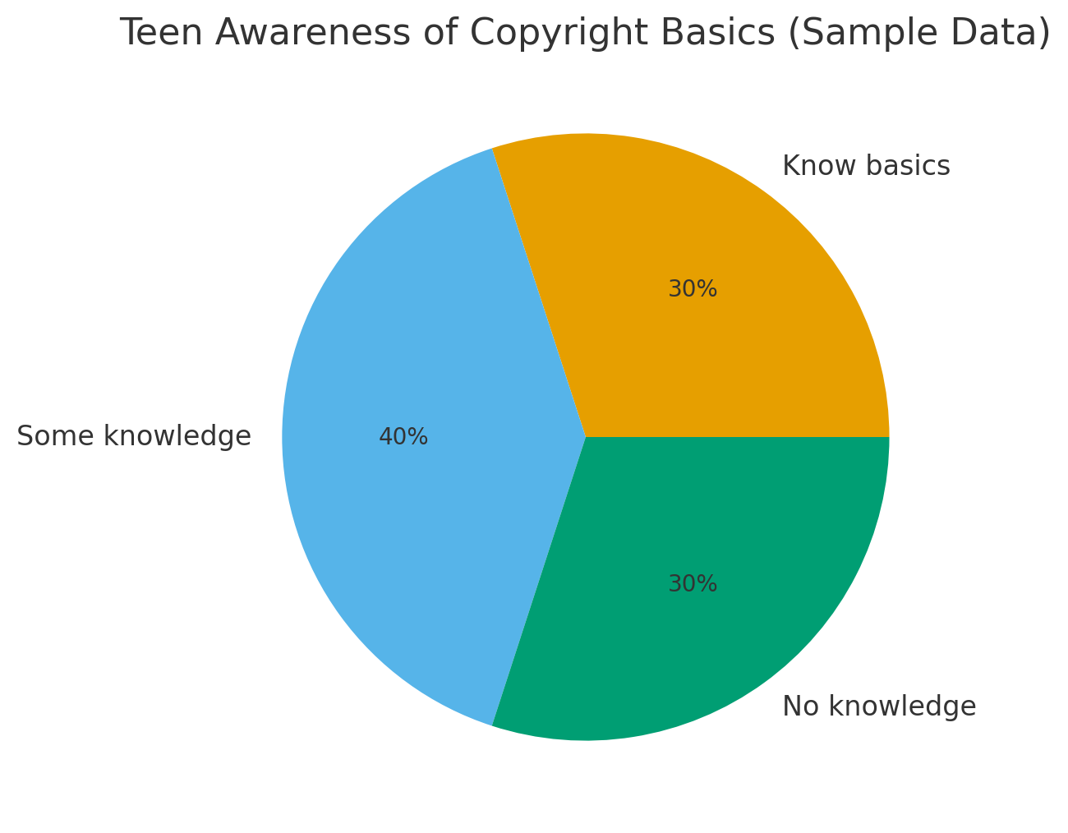

Figure 4: Sample survey of teen copyright awareness.

## Conclusion

This report explained copyright, intellectual property rights, public domain, fair use, and Creative Commons licensing. It integrated examples, visuals, and six credible sources. Key points: copyright is automatic but complex; public domain and fair use expand access but are uncertain; Creative Commons licenses empower creators but require careful choice. For the Teen Artists’ Studio, the opportunity lies in offering education, templates, and policies to help young artists make informed choices.

## References

U.S. Copyright Office. Copyright Basics (Circular 1). 2021. <https://www.copyright.gov/circs/circ01.pdf>

U.S. Copyright Office. More Information on Fair Use. n.d. <https://www.copyright.gov/fair-use/>

Creative Commons. About the Licenses. n.d. <https://creativecommons.org/licenses/>

Artists Rights Society. Artists Rights 101. n.d. <https://arsny.com/artists-rights-101/>

Rowan University Libraries. Open Licensing: Introduction to Creative Commons Licenses. 2023. <https://rdw.rowan.edu/libraryworkshops/12>

Nørgård, Rikke Toft, et al. “Digital Dilemmas: Attending to Art Ownership and Copyright in Youth.” In Digital Aesthetics of the Future. Springer, 2024. <https://link.springer.com/chapter/10.1007/978-3-031-83541-4_8>