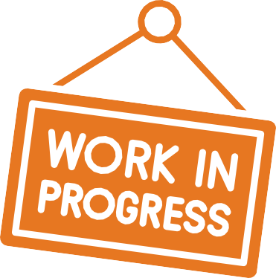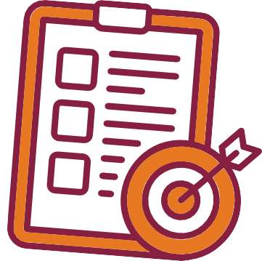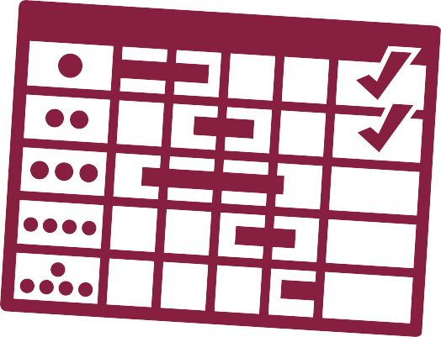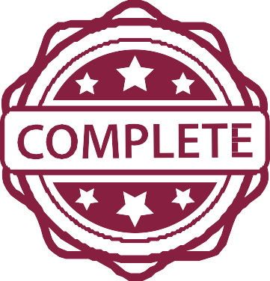

**Progress Report Assignment**

**Your Role in This Project**

You’re working as part of a professional team on a technical communication project. Traci is your manager in this fictional workplace scenario.

You and your group will write a progress report to update your manager (Traci) on your progress on the Recommendation Report or Fact Sheet Collection.

This assignment helps you:

Practice workplace-style writing. Reflect on progress and planning. Communicate with your team.

Identify and respond to challenges.

**Why This Report Matters**

Write your report for Traci, your manager in this scenario. Convince her your group is making progress and will do a great job on the Recommendation Report.

Use a respectful, professional tone that’s appropriate for internal workplace communication.

**Know Your Audience**

**What to Include**

**Memo Headers:** To, From, Date, Subject

**Introduction:** Purpose statement and overview of your progress on the Recommendation Report OR the Fact Sheet Collection

**Work Completed:** What’s done so far (specifics!)

**Work Scheduled:** What’s left and updated Gantt Chart

**Conclusion**: Draw ideas together and provide contact info

See the [Annotated Progress Report Template](https://canvas.vt.edu/courses/205859/pages/annotated-progress-report-template) for more details.

**Success Tips**

Clear and objective tone

Specific details: names, dates, tasks Honest reflection on progress Headings and lists for easy reading Focused on facts—not filler

Refer to the rubric on the assignment page for full grading criteria. Your group will receive one grade for the progress report.

Check the rubric before submitting to be sure your report is complete and effective.

**How You’ll Be Graded**

Copyright © 2025 Traci Gardner. Licensed under a Creative Commons Attribution-NonCommercial Share-Alike 4.0 International License. Created on Canva.com.