# Kinds of Work in the Course

Technical Writing ⚪ Fall 2022 ⚪ Traci Gardner

This course includes four kinds of work: Try-Its, Check-In Surveys, Full Drafts, and Self-Checks. A fifth category, Other Weekly Activities, covers less frequent work you do. All of these categories are submitted and assessed in Canvas to ensure [FERPA protection](https://docs.google.com/document/d/1E7bWUo4QbbEglPSfkj52LB5WhDIQGgAkQCvLcwYOv84/edit#heading=h.f0cj119358gg). Read more about each kind of work below.

## Try-Its

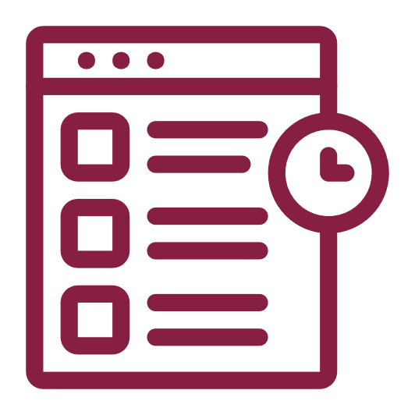Try-Its let you try a writing activity related to the week’s work or the current project without worrying about mistakes. Some activities ask you to write a short technical document. Others present you with scenarios or documents to analyze. All Try-Its are open book: you can use the textbook, Canvas, and your notes. Usually you have two Try-Its each week.

**Assessment for Try-Its**: As long as you put in provide a full response, your work will earn a Complete. Canvas marks these activities Complete automatically. I review them, and if I find you did not do the work, I will change the mark to Incomplete.

You cannot revise these activities if I mark them Incomplete. This situation rarely happens. When it has, it has often been that someone turned in work that was blank or skipped questions.

## Check-In Surveys

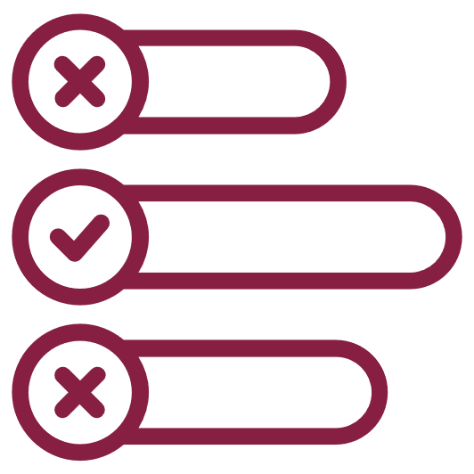Check-In Surveys are short activities that ask you to how you are doing in the course. I use your responses to customize the course. I may also share your responses with the class. The surveys can be multiple-choice, true-false, and short answer. There are no right or wrong answers. There is a Check-In Survey for each week of classes.

**Assessment for Check-In Surveys:** Canvas marks these activities Complete automatically. In most cases, I will only see the survey statistics and answers in summary. I won’t see your name with your answers. Your responses will not help or hurt you in the course (as long as you don’t skip the activity).

At times I may set Check-In Surveys so that they are not anonymous. I will indicate this change in the opening of the survey so that you know. In these cases, I am asking specific questions about your projects, and I want to be able to reply to you.

## Full Drafts

Full Drafts are the major projects in the course. You will compose full technical documents in specific genres, such as technical description, instructions, and reports. These activities are the most important in the course, and they have the strongest impact on your course grade. There are five Full Draft assignments in the course.

**Assessment for Full Drafts:** I compare your Full Draft to the rubric attached to the assignment in Canvas. Your Full Draft needs a Yes rating for all the criteria listed in the rubric to earn a Complete.

If your work does not receive a Yes for all the criteria, I mark it Incomplete. You can revise and resubmit Incomplete work as long as the Grace Period for Full Drafts is still open. This term, the Grace Period ends at 11:59 PM on Friday, December 2, 2022.

## Self-Checks

Self-Checks ask you to compare your working draft to the specifications for a Full Draft assignment to assess the status of your project. When you are able to mark all the criteria in the Self-Check as True, you are ready to turn in your Full Draft assignment. There are five Self-Checks in the course, one for each of the Full Draft assignments.

**Assessment for Self-Checks:** Canvas automatically marks your Self-Checks Complete. If you do not earn a 1 (Complete) on the survey, revise your Full Draft to meet the criteria you marked False. You can complete the checklist as often as you like while the Grace Period for Full Drafts is still open.

## Icon Description automatically generatedOther Weekly Activities

Other Weekly Activities are miscellaneous work that does not fit any of the four primary categories, such as the Syllabus Review and the presentation video during the first week of the course. Their frequency varies during the term. These activities fall primarily during the first week of the course.

**Assessment for Other Weekly Activities:** When possible, Canvas marks this work Complete automatically. Otherwise, I will mark the work manually.