Teamwork & Collaboration Guide  
for English 3764: Technical Writing

# Traci Gardner • Spring 2025

**Contents**

Your Access to this Course 2

Teamwork & Collaboration in This Course 3

How Groups Are Set Up 6

How Groups Will Connect 8

How to Support Every Group Member 9

What to Do When Something Goes Wrong 13

How Groups and Group Work Are Assessed 16

FAQs 18

Documentation 21

Bibliography 22

Copyright © 2024–2025 by Traci Gardner. Last updated January 13, 2025.

This document is offered under a [CC Attribution Non-Commercial-Share-Alike license](http://creativecommons.org/licenses/by-nc-sa/4.0/) 4.0 International License. Icons from The Noun Project Pro. Cover image: [Torg Bridge by Paul Kurlak on Flickr](https://flic.kr/p/epBEtT), used under a CC-By 2.0 license.

# Acknowledgements

I acknowledge the Tutelo/Monacan people, who are the traditional custodians of the land on which we work and live, and recognize their continuing connection to the land, water, and air that Virginia Tech consumes. I pay respect to the Tutelo/Monacan Nations, and to their elders past, present, and emerging. To learn more, visit the VT Library exhibit [The Land Speaks: The Monacan Nation and Politics of Memory](https://exhibits.lib.vt.edu/the-land-speaks/). You can also visit the [American Indian & Indigenous Community Center](https://ccc.vt.edu/index/aiicc.html) in 122 Squires Student Center.

I also acknowledge the enslaved Black people who lived and worked on the former plantation lands upon which Virginia Tech stands. These families include the Fractions, McNortons, and Saunders, as well as others. Read more about these families in the *Virginia Tech Magazine* article “[Family Tree](https://www.archive.vtmag.vt.edu/fall15/family-tree.html).”

# Your Access to this Course

Everyone needs special accommodation at some point because we all learn differently. I am happy to work with the [Services for Students with Disabilities (SSD) staff](http://www.ssd.vt.edu/) or directly with you to make sure that you have the support you need.

### **For anyone who needs extra time on assignments**

No problem. You can arrange whatever you need. If you need more time on a project, take the time you need. This course has a grace period that allows everyone extra time if needed. Check the [details on Due Dates & the Late Policy](https://tracigardner.github.io/TechComm/semester/2025-01-Spring/ShortGuide2TW-Spring25.pdf#page=6) for more details.

### **For anyone who needs a less-distracting environment**

You can arrange to do your work for this course any place that works for you. Since all work is done online and independently, you have complete control over where you work.

### **Providing documentation of special needs**

I generally do not require official documentation unless the university requires it for some reason. I do require that you let me know of any accommodation you need **during the first week of classes** so that I can make sure I arrange the support you need. I can only make accommodations for the future. I don’t have a time machine (oh, how I wish I did!), so I can’t apply them to past situations.

For anyone with official documentation:

Contact [Services for Students with Disabilities](http://ssd.vt.edu/students.html) (SSD) in 310 Lavery Hall ([map link](https://goo.gl/maps/rNDopPaCXok), above the Turner Place Dining Center) as soon as possible to ensure that you have the resources you need to participate in the class. The procedures and forms you need are also available on the SSD website.

For anyone without official documentation:

I know that the official testing can be expensive and time-consuming. Send me [a private message in Canvas](https://community.canvaslms.com/t5/Canvas-Basics-Guide/What-is-the-Inbox/ta-p/55) during the first week of classes that tells me what you need, and I will try to help.

# Teamwork & Collaboration in This Course

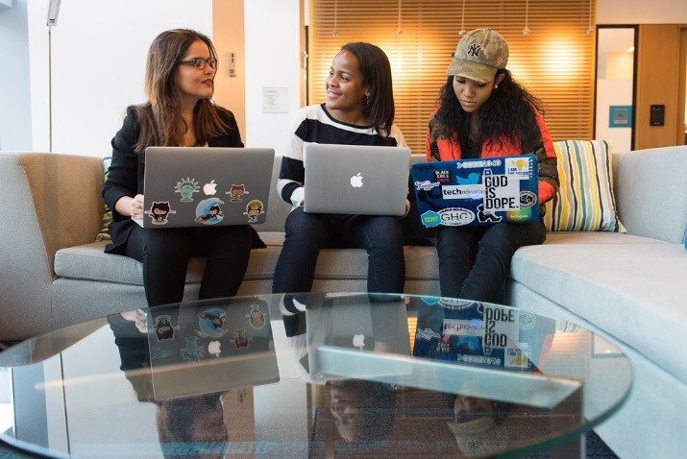You will complete projects individually and with a group in this course. Project management and collaborative writing comprise the majority of major projects you will do. Working successfully with your group, then, is crucial to doing well in the course.

Not only is collaboration important in this course, it is also significant in the workplace as well. Burnett, Cooper, and Welhausen (2013) report, “Collaboration is important because virtually all workplaces rely on group-based decision making and projects, often increasing creativity, productivity, and the quality of the process and product.”

Credit: [wocintech (microsoft) – 58 by WOCinTech Chat on Flickr](https://flic.kr/p/FsKTjm), used under a CC-BY 2.0 license

This guide focuses on what you need to know to collaborate successfully with the members of your group. Here you will find details on the following topics:

* How groups are set up.
* How you will connect with your group.
* What you can do to support the members of your group.
* What your group can do if something goes wrong.
* How your group projects and activities are assessed.

## Teamwork & Collaboration Goals

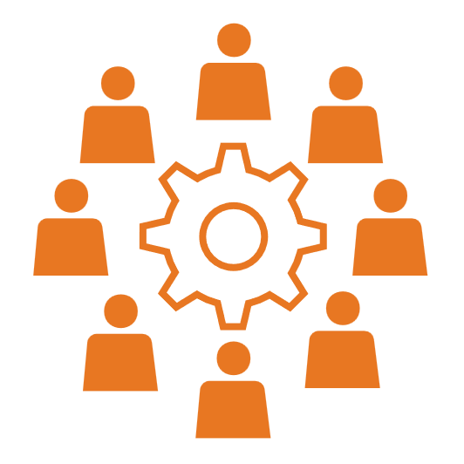While your group activities touch on all the goals for English 3764, they fit *Course Learning Objective (CLO) 4* most closely:

Practice team and collaborative work in all phases of project management: planning, researching, writing, revising, and presenting information; include genres associated with teamwork (e.g., meeting minutes, summaries, poster presentations; pitches).

CLO 4 gets at *what* the course focuses on in group writing tasks. You and your group will participate in those activities, and you’ll compose the listed genres of technical writing.

I still need to address *how* your group will collaborate. In the workplace, successful groups support every group member. They understand that taking care of one another ensures every group member can do their best work. Rice-Bailey and Chong (2023) identify strategies such as listening, paying attention to nonverbal skills, and practicing empathy as key to successful groups in the workplace and the classroom. In essence, groups excel when they cultivate caring and supportive interactions.

Based on the value of building such strong connections among group members, the *how* of group tasks in this class relies on a humane approach that focuses on empathy and kindness. Your group should build a community where everyone has a positive experience and where everyone in the group succeeds. The collaborative projects in this course require every group member to accomplish these goals:

* Bring your best skills and a positive attitude to the task.
* Be honest about where and when you need help.
* Work as a community to support one another.
* Ensure that everyone is included, heard, and successful.

Individual success isn’t the goal for group projects in this class. Your group should collaborate in ways that show you care about the team’s success. It should be evident that every group member wants everyone in the group to thrive and succeed.

## Individual vs. Group Projects

Before diving into specific collaboration procedures, I want to preview the kinds of projects you’ll write individually and those you’ll write with your group. Table 1 (below) outlines the projects and other work you’ll complete and the working methods you’ll use as you work on individual and group projects.

|  |  |  |
| --- | --- | --- |
|  | Individual Projects & Work | Group Projects & Work |
| Major Projects Involved | You will work individually on the first two Major Projects:   * Survey of Website Writing in Your Field * User Documentation Revision   You will also do individual work that contributes to your group projects, like writing a section of your proposal individually. | You will work with your group on the remaining three Major Projects:   * Group Proposal * Progress Report * Recommendation Report   You will combine work from everyone in the group to create one, unified document for each project. |
| Other Course Work | You will also work individually on many of the weekly activities and all the Self-Checks and Check-In Surveys. | You will work with your group on some Try-Its and in Group Discussions. Everyone in your group should contribute to these group activities. |
| Working Methods | You will write these projects on your own. You can consult with others for feedback, but all of the writing should be your own work. You may also share these projects with your group for feedback and advice. | You will write these projects as a group. Everyone in the group should contribute in a significant way to every group project. Your group can divide the work on each project in whatever way you agree on. |

Table 1. Individual vs. Group Projects and Work in Technical Writing

## How You’ll Collaborate

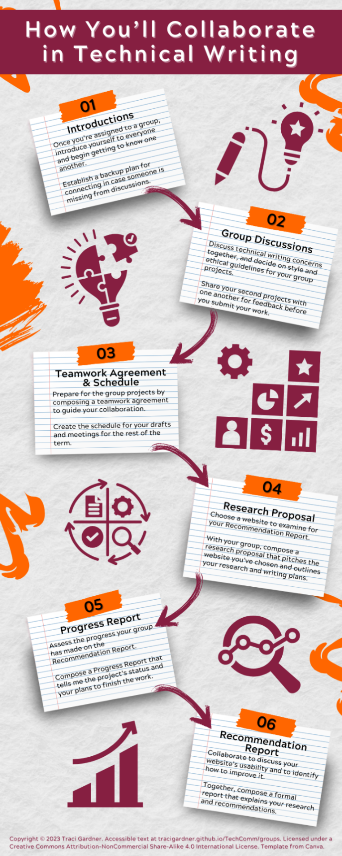Overall, you will collaborate in six primary ways this term, outlined below and in Figure 1 (on the left). In addition to the activities listed here, you will collaborate on some Weekly Activities, including Group Try-Its and Discussions.

Figure . How You'll Collaborate in Technical Writing

**01: Introductions**

Once you’re assigned to a group, introduce yourself to everyone and begin getting to know one another.

Establish a backup plan for connecting in case someone is missing from discussions.

**02: Group Discussions**

Discuss technical writing concerns together, and decide on style and ethical guidelines for your group projects.

Share your second projects with one another for feedback before you submit your work.

**03: Teamwork Agreement & Schedule**

Prepare for the group projects by composing a teamwork agreement to guide your collaboration.

Create the schedule for your drafts and meetings for the rest of the term.

**04: Research Proposal (Major Project)**

Choose a website to examine for your Recommendation Report.

With your group, compose a research proposal that pitches the website you’ve chosen and outlines your research and writing plans.

**05: Progress Report (Major Project)**

Assess the progress your group has made on the Recommendation Report.

Compose a Progress Report that tells me the project’s status and your plans to finish the work.

**06: Recommendation Report (Major Project)**

Figure 1. Hou You'll Collaborate in Technical Writing

Collaborate to discuss your website’s usability and to identify how to improve it.

Together, compose a formal report that explains your research and recommendations.

# How Groups Are Set Up

****In an asynchronous course like this one, groups are most successful when they have a shared time when everyone can meet and collaborate. In courses where everyone meets in a classroom on campus, it’s easy to arrange time to meet and work on your projects. You can all meet during the class period. In an asynchronous course like ours however, we can’t assume everyone will be available at the same time to work.

To set up your groups, I use a system that focuses on connecting people who all have similar open times in their schedules and who like to work in the same ways. I developed this system six years ago, and I’ve found that it eliminates the challenges that random group composition creates.

## Group Setup for Projects

**How I Decide on Groups:** I use details from the Student Information Form that you fill out during the first week of class. In your answers, you tell me when you are available to work and how you like to work (for instance, do you like to work ahead or do you prefer to work at the deadline?).

**Schedule for Group Setup:** I will set up groups after the second week of the course. There are two reasons for this schedule. First, everyone needs to submit the Student Information Form to give me the information I need to group people based on their availability. Second, Monday, January 27 is the last day to add, so I have to wait for any new students to fill out the Info Form.

**Group Size:** Your groups will include 4–5 members each. There may be a group with as many as 6 members, but I will do my best to avoid any groups with fewer than 4 members.

**Group Duration:** You will be in the same group for the entire semester so that you can develop strong teamwork strategies as you work on increasingly more difficult projects.

**Where to Find Your Group:** You’ll be able to connect with your Group in Canvas. See the Documentation section for more help.

**In Canvas**I’ll set up your groups using tools in Canvas. You will be able to find your Group by clicking the Groups button (shown in Figure 2) in the left Canvas toolbar. You’ll participate in Canvas Discussions and submit your group work in Canvas.

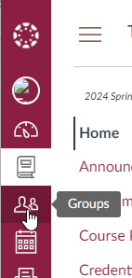

Figure 2. Main Canvas toolbar, showing the Groups button

# How Groups Will Connect

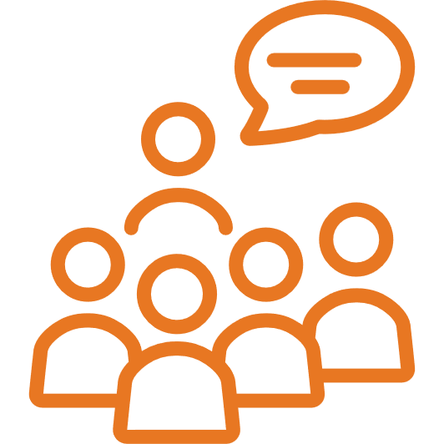When you first heard about the group projects in this course, you may have immediately wondered, “How will that work in an asynchronous course?”

It’s a good question, so I’ll outline how we’ll get everyone connected. You’ll find instructions for these tasks in Canvas after the second week of class. Your group will collaborate in your Canvas Group to complete the tasks below in Table 2:

|  |  |
| --- | --- |
| Task | Description |
| Post contact info for group members | You’ll share contact information in a group Discussions post in Canvas. I will post a Discussions post for you to use for this task. |
| Set roles for each group member. | Your group will decide on roles people will fill, like a group leader and a technology specialist. These roles will ensure smooth collaboration. You can add more roles once you work on your teamwork contract, around Week 7. |
| Choose the tools you’ll use to collaborate. | Your group will consider the options for each way you collaborate and choose whatever fits your needs and access best. In some cases, there is a required tool to ensure ongoing access for everyone (including me).  **Shared Documents You Write**  You can work in Google Drive, Office 365, Dropbox, Box, or some other tool. . You can also create a Group Discussion in Canvas and then attach your documents to share them with your group. You can also [create a Group Discussion](https://community.canvaslms.com/t5/Student-Guide/How-do-I-create-a-discussion-in-a-group-as-a-student/ta-p/350) and then attach your documents to share them. Whatever you choose must be free and allow everyone in your group plus me to access the files easily. I recommend Google Drive or Office 365.  **Weekly Status Updates**  You’ll have basic weekly status updates in Canvas Discussions. Using one central tool means everyone in the group knows where to look for the most recent information.  **Meeting Space**  You can meet in person or online. Your whole group can meet, and you can also have smaller meetings with two or three people. I encourage you to use Zoom or Teams for online meetings.  **Communication Tools**  Basic communications take place in Canvas. You can also set up a GroupMe, Discord channel, or Google Group to if your group wants. You will still need to post basic information in Canvas to ensure everyone has access. |
| Create a team calendar for the rest of the term. | You’ll track meetings, group dates, and course dates (e.g., Target Due Dates, Checkpoint Deadlines) in [your group’s Calendar in Canvas](https://community.canvaslms.com/t5/Canvas-Basics-Guide/How-do-I-view-a-group-calendar/ta-p/617600). |

Table . First Tasks to Connect Group Members

# How to Support Every Group Member

Supporting one another is the number one goal for your group. You need to do your best to make sure everyone in the group can succeed. In this course and in the workplace, project management is all about working together, focusing on shared goals and backing each other up.

The guidelines on the next few pages provide strategies you can follow to create a positive space where group members lift one another to success through teamwork and unity. If the guidelines seem overwhelming at first, recognize that they boil down to two basic ideas: Be kind, and help when you can. The guidelines here outline specific ways you can put those ideas into action.

|  |  |
| --- | --- |
| **Begin by trusting one another.** Assume that everyone in your group has positive, supportive intentions. When someone says they will do something, believe that they will. Everyone in your group wants to do well in the course, just like you. By trusting one another, you start off positively and make it clear you’ll catch anyone who’s falling. |  |
| **Focus on each person’s success.** In the case of group projects, when every person on the team succeeds, the entire group succeeds too. As you collaborate, pay attention to the tasks that each person is doing, the progress they are making, and the challenges they are encountering. Do what you can to help one another meet the goals set for the group. |  |
| **Include everyone.** Every member of the group should be involved in the group’s discussions, decisions, and tasks. When everyone participates, everyone understands the work and why it’s being done. Your group needs to do the following:   * Make sure every member knows when and where meetings are being held. * Clearly discuss how the group is working on its goals. * Watch for people who aren’t adding ideas to the discussion and invite them into the conversation by asking them what they can add or what they think. |  |
| **Respect one another’s time.** Be on time for everything. That means you get to meetings on time, that you meet due dates and deadlines, and that you do what you say you’ll do when you say you’ll do it. For the entire group to continue moving toward its goals, timeliness matters. |  |

|  |  |
| --- | --- |
| **Update your group at least once every week, without fail.** By updating everyone each week in your group’s Discussions in Canvas, you make sure your group knows what you’re doing. Your group members should never be unsure where you are or what’s going on. Tell them clearly in your weekly status update. If something unusual comes up, jump back into the group Discussions and add the details. |  |
| **Listen closely.** Pay careful attention to what members of your group say when you meet or exchange messages. Consider how they are saying things (for instance, does their tone suggest they are confident, hesitant, or sarcastic?). Think about the unspoken (or unwritten) characteristics of their comments. When someone finishes sharing an idea, repeat what you heard and give them a chance to restate or rephrase anything that hasn’t come across clearly. |  |
| **Be forthcoming about challenges.** Be clear when something goes wrong or when something comes up. Let your group know as soon as you can if you’ll be late or if you won’t make a meeting. Tell them immediately if you can’t meet a due date or deadline. In addition, explain how you are addressing the challenges you’ve encountered. More importantly, ask for help if you need it. Let your group members know exactly what they can do to help you. |  |
| **Reach out to group members to make sure everything is okay.** If someone in your group mentions that they’re feeling stressful, not feeling well, or struggling in some other way, send them a private message that offers some words of encouragement and support. Not sure what to say? Just ask how they’re doing and let them know you hope things are improving. Have some free time? Offer to meet for coffee so you can catch up on how things are going. |  |
| **Lend a hand when someone asks for help.** Nothing can feel worse than asking for help and hearing nothing. If someone asks the group for help, jump in and offer whatever you can. Even if you can’t help immediately, you can let them know that you hear them and will help when you can. Be sure that you are specific in talking about what you can do and when you can do it. |  |
| **Be aware of campus and community resources.**  The help a group member needs may have nothing to do with our class or the projects you’re working on. The [Learner Support section](https://docs.google.com/document/d/1rUieHepzcXxULuZwRKDCjvvwgi-x5xo1k_bYE-Z3o-4/edit?tab=t.0#heading=h.6110tjwof89b) in the Course Policies Manual lists resources that can help with food insecurity, mental well-being, personal safety, and more. If you or someone in your group needs help, please take advantage of these resources. |  |
| **Offer to chat with a group member.** Sometimes people just need to talk an idea through to figure out what to do next. Other times, they may want to vent to someone facing a similar situation. Even if you aren’t sure how to help someone, you can offer to listen by inviting them to join you on Zoom. Audio or video won’t work? Try a text message, Canvas message, or email message. |  |
| **Leverage group strengths.** Each person brings different skills and capabilities to the group. That’s one of the reasons that groups are so valuable: Members combine their strengths to achieve goals that no individual group member can. When you decide on group roles and writing tasks, consider which member has the skills and strengths that are best suited for the job. If you have a special skill yourself, offer to teach others what you know. |  |
| **Protect one another’s privacy**. You and group members will share private information, possibly including your email address and phone number, with your group. You may also share personal information about your life, family, and friends. Treat all personal information as confidential. Do not post it publicly or share it with those outside the group. |  |
| Safety WarningThere are exceptions: If you think someone is in danger, is a victim of violence or abuse, or may harm themselves, use the resources on the [How to support a friend page](https://safe.vt.edu/support_a_friend.html) to help them. In an emergency, call 911 immediately. | |
| **Provide constructive criticism.** When you review one another’s work, focus on how to improve what someone else has written. Your goal should be formative, not summative feedback. Here’s a quick explanation of the differences between the two ways of providing feedback: **Formative Feedback**  * Focuses on comments that help form and improve the project. * Provides advice on how to proceed. * Points out where the reader is lost or has questions. * Avoids any judgment of quality.   A chef uses *formative assessment* when she tastes a dish while cooking to decide if she needs to add anything. She is considering how she can improve the dish. **Summative Feedback**  * Focuses on summary comments. * Makes judgments that relate to the quality of the finished product. * Happens when it’s too late to improve.   Diners use summative assessment when they taste the finished dishes and share their comments. The diners are judging the final quality of the dish. | Chef tasting a dishTwo people eating at a table |
| **Celebrate achievements.** Acknowledge group achievements and individual successes. Celebrate when you turn in a Major Project draft. Applaud one another when you earn a Complete. No need to stick to this course either. Did a group member do well in another course? That’s worthy of kudos too! No matter how small the successes are, take time to give a shout-out when things go well. |  |
| **Improve the process as you work.** As you finish tasks and accomplish your goals as a group, discuss what worked well and what can be improved. Practicing collaborative project management in the classroom now should prepare you for the workplace. The process of trying things out should be paired with close analysis to improve. Once you identify things you want to do better, adapt the strategies you use for future collaborations. |  |
| **Be kind.** Being kind extends beyond mere pleasantries. It involves having genuine confidence in the members of your group and trusting that they have faith in you. Catherine Denial, a professor at Knox College, describes being kind as believing people and believing *IN* people. By embodying these principles, you demonstrate your commitment to your group members. If you forget everything else, remember to be kind to your group members. |  |

# What to Do When Something Goes Wrong

No matter how kind and supportive your group is, something can go wrong and cause challenges as you collaborate to compose your Major Projects and complete other activities.

Keep in mind that your group’s success depends upon keeping everyone involved and on course. No business wants to lose employees because they didn’t have the support they needed. The same goes for this course. A group that loses a member doesn’t succeed. Focus on doing what you can to make sure every person gets what they need if something goes wrong.

## What to Do Before Anything Goes Wrong

Talking with your group about how to manage challenges before they arise will make sure you’re all prepared to take on whatever happens. We’ll do these two things to prepare your group.

******Adding contact details in Teams**The challenge I’ve seen most frequently in the past is when a member of a group is missing for several days. You’ll prepare for that situation by adding your contact information to a form in Teams. You’ll also include meeting dates and times on Calendar Pro in Teams.

**Agreeing on procedures in your Group Contract**When you create your group contract during Week 7, your group can set up specific procedures that you’ll follow if something goes wrong, such as how you’ll respond if a group member is sick and what you’ll do if someone is having difficulty finding research for their section of a document.

## What to Do If Something Goes Wrong for You

Two things matter the most if something goes wrong for you. First, be sure that you communicate with everyone who needs to know, specifically me and, if relevant, your group members. Second, ask for whatever help you need. Don’t be shy about it! These details suggest strategies for common situations you may encounter.

**Problems with the course or vt.edu websites, LinkedIn Learning, Teams, or Canvas**If something goes wrong with one of the websites we are using, don’t panic. I will fix it if I can. Otherwise, just wait until the university or outside provider fixes it (You can check [4Help](https://4help.vt.edu/) for updates). If necessary, I’ll adjust any due dates or expectations.

Check the Announcements in Canvas. I may have posted about a known issue already. If you don’t see an Announcement, send me an email about the outage, since I may not know there is a problem. If the issue will impact your group, update everyone in Teams or use whatever method you have agreed on. Keep working as you can until the situation is resolved.

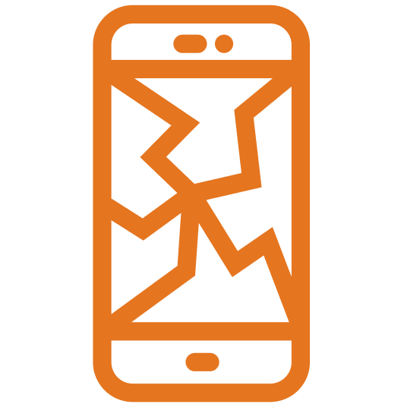**Problems with something in your world**If something goes wrong for you personally, send me an email message explaining the issue. Don’t be worried if I don’t respond immediately. It just means I’m not at my computer. If the issue will impact your group, update them as well.

After you contact me and (if necessary) your group, relax. We can come up with a solution. Things such as a broken phone or a change in your work schedule fall in this category. It may feel like a horrible situation, but we can work it out.

**Emergencies and the 911 policy  
I**f you have an emergency, first take care of any immediate danger. The safety of you, your family, and your friends is your most important priority in an emergency. Remember that we can fix anything we need to once you’re all safe.

When you can, email me and begin the subject of your message with “911.” For example, a subject line might be “911 Struck by Storm.” Give me the details in the message (e.g., The storm knocked out your power. Your work is going to be delayed until things are fixed). I give 911 messages priority and answer them ASAP.

I can contact your group for you if you want. Tell me in your email message what you’d like them to know. Otherwise, you can update your group yourself.

## What to Do If Something Goes Wrong for Someone Else

Your group may face situations where something goes wrong for a group member. People get sick. Work situations change. Accidents happen. People break bones and get concussions. Families (genetic and chosen) require attention and physical presence.Other classes have exams and deadlines. Basically, things happen—often at the worst possible time. Your group needs to be ready to deal with whatever comes up. This section outlines what you should do when such circumstances arise.

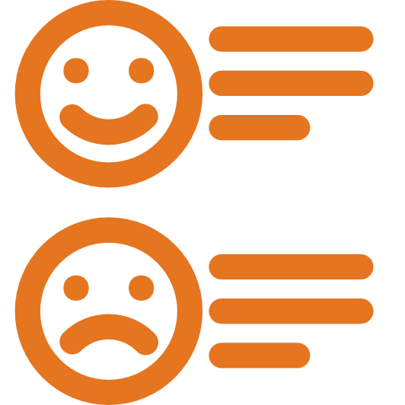**Assume the best, not the worst.**If a group member seems to disappear or doesn’t turn in their portion of an assignment, begin by assuming that they have best intentions, but something got in the way. Avoid jumping to the conclusion that the missing person is abandoning the group or expecting the other group members to carry them. Assume the best and move on to finding out what you can do to check on them and, if needed, to help them.

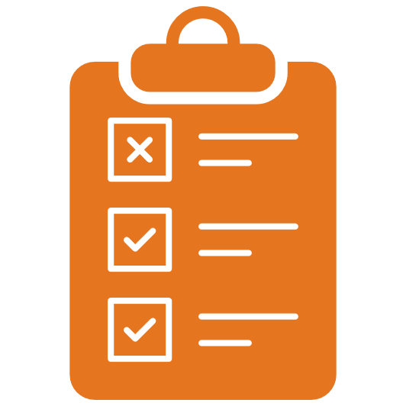**Check the weekly status updates.**Each week, every member of your group should post an update on Teams with details on anything unusual going on in their lives and any group work they’re contributing to. They may also include details on their individual work for the course as a kind of accountability tracker. Check these weekly status updates on Teams first if something seems to go wrong. The person may have already accounted for the situation by leaving the group a note in their update for the week.

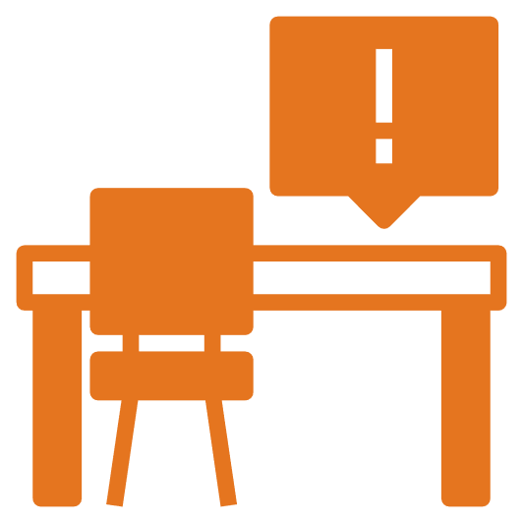**Try to find out why.**As I mentioned above, things happen to all of us—and we don’t always have time to let anyone know in advance. As a supportive group member, you can begin by reaching out to the group member in question. Ask what’s going on and what the group can do to help. At the same time, respect their privacy. It’s possible that they can’t or don’t want to tell you. They may be embarrassed or facing a sensitive situation. Getting everyone back on schedule matters more than the details of what went wrong.

**Take care of them.**Do what you can to help the group member. The Writing Center is a great resource if someone is having trouble with any part of the writing process, for instance. You’ll find more suggestions in the previous section, How to Support Every Group Member.

**Keep track of any challenges that group members face.**If someone is experiencing any conflicts or issues, be sure to document what’s going on and how you have worked to resolve the challenges. In the workplace, documentation can be a critical way of showing how you build community and support one another. In this class, you can use the notes in your Submission Wrappers, when you describe challenges and how you solved them.

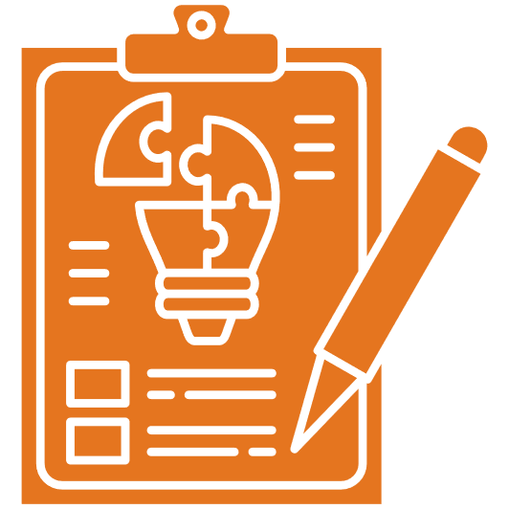**Address the situation with the rest of your group.**Once you know what’s going on, your group should be able to find a way forward. Maybe you need to adjust the work schedule or let me know that you need an extra day on an activity. Perhaps you need to have a working meeting where members write together. As much as possible, try to solve the problem as a group.

**Email me if you need help.**Finding your own way is a large part of what project management is about, but you’re still learning how the process works. I don’t expect you to know everything already—what would be the point of taking the course if you already knew everything?

If you need help, let me know. As a group, send me a message that answers the following questions:

* What’s your group’s name?
* What’s going on? Why does your group need help?
* What have you already done to try to solve the situation?
* What kind of help do you need from me?

Remember that the message should be from your whole group. It’s usually sent by the group leader, but it doesn’t have to be. Please do not send individual messages unless you have a private concern.

After I get your message, I’ll come up with some ideas on what to do next and send a reply. Remember that I reply in 24–48 hours OR on Mondays if your message comes in during the weekend.

# How Groups and Group Work Are Assessed

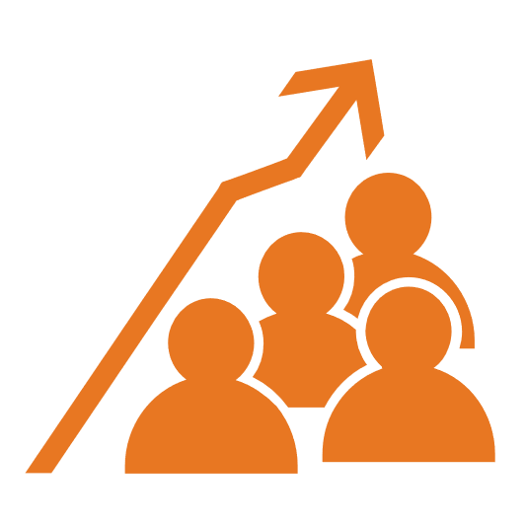Assessment is probably the stickiest challenge with group activities. Nearly everyone has had a bad experience with a group project in the classroom. Someone didn’t participate fully. Someone else had to pick up the slack. The group isn’t happy because one person brings down everyone else’s grade.

I have tried to design a system where that won’t happen. Here are some reasons why you can relax about your assessment:

* **This course does not use letter or number grades on projects and activities.**Your group projects are either Complete or Incomplete. The usual fear of losing points doesn’t apply. See the [How Assessment Works section](https://tracigardner.github.io/TechComm/semester/2025-01-Spring/ShortGuide2TW-Spring25.pdf#page=15) of the Short Guide for more details on the course assessment system.
* 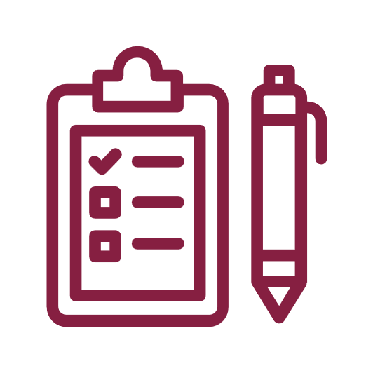**You know the assessment criteria in advance.**You have a rubric and other materials that tell you what you need to earn a Complete. As long as you contribute to the work and the activity meets the criteria, you’ll get your Complete.
* **You have opportunities for revision if you meet the Target Due Date or the Checkpoint Deadline.**As long as your group meets either the Target Due Date or the Checkpoint Deadline, you have “do-overs.” If something is missing from your project, you can check the feedback that I add to it, revise it as a group, and resubmit it.
* 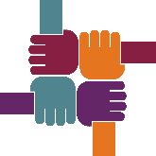**Supporting one another counts.**It’s more important that everyone is included in the group and contributes to the projects and activities than it is that you meet every tiny point in the rubric. As long as everyone participates and puts in their best effort, you’ll all be fine.

## What Groups Need to Do to Earn a Complete

To earn a Complete, your group needs to submit a document that meets the assignment criteria. If portions of the project or activity are missing or do not meet the requirements, the group will earn an Incomplete. The entire group is responsible for the contents of the report, which is why every person in the group should complete the Self-Check to make sure the document meets all of the criteria.

There isn't partial credit for sections of a document. In other words, individuals do not earn Completes for their sections. For instance, you do not earn a Complete for writing the introduction to your project. You and the rest of the group earn a Complete for the entire document.

## How Feedback Works for Individual Group Members

Everyone in a group usually receives the same mark. There are exceptions however when one or more group members does not contribute to a group task:

* Everyone who participates fully in the task earns a Complete on it.
* Any group member who does not participate or participates only minimally earns an Incomplete.

## How Revision and Resubmission Work for Groups

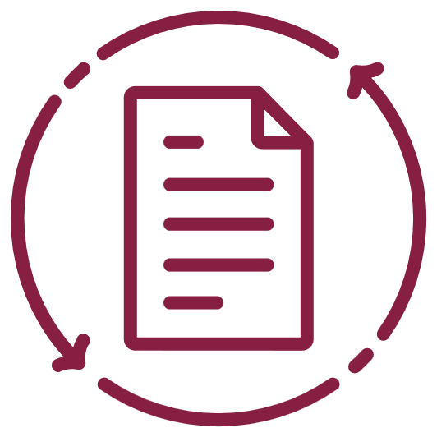If a group project or activity is Incomplete, the group can revise and resubmit as long as the end of the grace period has not passed. Everyone can participate, even a group member who didn’t originally add to the task.

Once a group has earned a Complete on an assignment, no one can contribute to it further. If a group member did not participate in the project or activity, they will earn an Incomplete, which is permanent. Complete work cannot be revised or resubmitted.

## Individual Work Cannot Be Substituted for Group Work

Unfortunately, you cannot complete the group projects individually. The group assignments in this course are part of the Project Management unit, which requires collaborative group work. These assignments are determined by the Director of Professional and Technical Writing, so I cannot change the expectation for group work to allow you to work individually.

# FAQs

This section includes answers to frequently asked questions about assessment and feedback, group meetings and collaboration, group projects, and potential challenges and disagreements.

## Assessment and Feedback

Do the group projects have an impact on our course grades?

Of course. You need to both participate fully in the group projects and earn a Complete on the group projects.

Will everyone in the group get the same grade?

The documents will either be marked Complete or Incomplete. Everyone in the group will usually receive the same mark. If the group project is Incomplete, the group can revise and resubmit as long as the end of the grace period has not passed.

Is there a group-member grading system?

This course has no grades other than the course grade at the end; therefore, there is no grading system. Group members will, however, be able to provide feedback on one another’s work.

How will poor or missing work from one group member impact the grade for the project?

Remember that documents are either marked Complete or Incomplete. Everyone in the group will receive the same mark. In the case of a group member who does not participate at all or participates only minimally, that person will receive an Incomplete.

## Group Meetings and Collaboration

Do we have to coordinate a time for meetings?

You can if you want to. Your group will decide how you want to meet and work together. Here are some tips:

* Create a shared Google calendar or use scheduling apps like Doodle or When2meet to find common meeting times.
* Be flexible and accommodating of one another’s schedules.
* Use online communication tools like Canvas Discussions, Zoom, or Slack if physical meetings are not possible.
* Assign a group member to be responsible for scheduling and reminders to keep everyone on track.

Will there be any mandatory meetings set up?

I will not set up mandatory meetings. Your group can however. The goal of the tasks is to learn about project management as it relates to collaborative writing. You need to make the decisions and evaluate how they work.

How does a group project work in an asynchronous course?

Your group can decide how to collaborate based on your schedules and what works best for you. You can meet in person or on Zoom. Your whole group can meet, and you can also have smaller meetings with two or three people. You can also use the resources in Canvas Discussions to connect.

How many times a week do you recommend for groups to meet?

I believe that groups will benefit from at least meeting once a week to arrange work, update one another, and address any challenges that come up. You can meet more than that if you want.

Are we able to adjust the work schedule and group assignments after?

Of course. Your group decides what kind of meetings and schedule work for everyone involved. You’re in control.

How will we contact group members?

You can choose whatever will work best for the members of your group. Your group can exchange email addresses, or you can connect in Canvas Discussions. If you want, you can exchange cell numbers so you can text one another or set up a GroupMe for your group.

How will the group share documents?

I recommend Google Drive, primarily because it is what I use the most. If you are used to sharing work with Office 365, that’s fine too. I just can’t help much with Office because I haven’t used it as much.

## General Questions about the Group Projects

How long will the group projects take?

You can check the Target Due Dates on the [Short Course Schedule](https://tracigardner.github.io/TechComm/semester/2025-01-Spring/ShortGuide2TW-Spring25.pdf#page=4) to see the amount of time for each.

Will the group collaborate on projects, or will we each write our own report?

Everyone will collaborate to write and submit a single document for each of the group projects and activities. For instance, your group will collaborate to write and submit a proposal.

What Major Projects will we write as a group?

The Proposal, Progress Report, and Recommendation Report are all group projects.

Will each group member have a specific page count to complete?

I won’t set up any page counts. I don’t set up page counts for the documents either. I give you a typical range that describes (but does not prescribe) the length. Length depends upon what you have to say, your document design, your use of graphics and illustrations, and other document elements.

How can we ensure work is evenly divided among group members?

* Set clear expectations at the beginning of the project. Discuss roles and responsibilities for each member, and make sure everyone agrees on their tasks.
* Communicate openly with your group. If you’re struggling or unable to contribute, discuss it with the group. If a member of the group is struggling, do what you can to support them. Rearrange tasks as a group if you need to.
* Track your group progress and responsibilities so it's clear who is doing what. You can keep a running list of accomplishments in a Canvas Discussion thread.
* Remember that the natural process of the work may mean that one person works more during one week than the others. For instance, the person who proofreads the entire document for consistency will have more to do at the end of the writing process.

## Group Challenges and Disagreements

What should groups do if a member does not respond to email or messages in Canvas?

Your group can decide on the general methods when you create your group contract during Week 7. You might send a text message to check on anyone who is missing, for example. Start by assuming everyone means well, and do what you can to get any missing member back on track.

When should we be concerned about a missing student?

If someone is missing for a day, I wouldn’t worry about it. Everyone has a bad day from time to time. If the person is missing a week or more, despite your attempts to get in contract, let me know.

How should groups deal with disagreements among members?

Your group should work together to resolve any disagreements, as you will do in the workplace. Return to your Group Contract, created during Week 7, and follow the procedure that you included there to resolve the issue. Remember that the goal is to keep everyone in the group on course and contributing to the tasks you have to complete.

# Documentation

You’ll use Canvas and Microsoft Teams to connect with your group. Your group will also choose a way to collaborate on written documents, usually Google Drive or Office365. For all these tools, [contact 4Help](https://4help.vt.edu/) if you have questions or need help troubleshooting an issue.

This section includes links to online documentation for these Canvas and Teams.

## Canvas Documentation

**Know what you can do as a group in Canvas.**Your group is all yours. You can add Discussions, Pages, and Files. You can add dates to your group’s Calendar. Here are links to the documentation:

* + [How do I view my Canvas groups as a student?](https://community.canvaslms.com/t5/Student-Guide/How-do-I-view-my-Canvas-groups-as-a-student/ta-p/281)
  + [How do I use groups as a student?](https://community.canvaslms.com/t5/Student-Guide/How-do-I-use-groups-as-a-student/ta-p/603040)
  + [How do I upload a file to a group?](https://community.canvaslms.com/t5/Student-Guide/How-do-I-upload-a-file-to-a-group/ta-p/278)
  + [How do I start a collaboration in a group?](https://community.canvaslms.com/t5/Student-Guide/How-do-I-start-a-collaboration-in-a-group/ta-p/438)
  + [How do I create a discussion in a group?](https://community.canvaslms.com/t5/Student-Guide/How-do-I-create-a-discussion-in-a-group/ta-p/350)
  + [How do I close a discussion for comments in a group?](https://community.canvaslms.com/t5/Student-Guide/How-do-I-close-a-discussion-for-comments-in-a-group/ta-p/376)
  + [How do I manage groups as a student group leader?](https://community.canvaslms.com/t5/Student-Guide/How-do-I-manage-groups-as-a-student-group-leader/ta-p/473)

**Check your Canvas Notifications settings.**To make sure that your group can get in touch with you, check the settings for your Canvas Notifications. Check this documentation:

* + [How do I manage my Canvas notification settings as a student?](https://community.canvaslms.com/t5/Student-Guide/How-do-I-manage-my-Canvas-notification-settings-as-a-student/ta-p/434)
  + [How do I add contact methods to receive Canvas notifications as a student?](https://community.canvaslms.com/t5/Student-Guide/How-do-I-add-contact-methods-to-receive-Canvas-notifications-as/ta-p/516)
  + [How do I add a text (SMS) contact method in Canvas as a student?](https://community.canvaslms.com/t5/Student-Guide/How-do-I-add-a-text-SMS-contact-method-in-Canvas-as-a-student/ta-p/411)

# Bibliography

Burnett, Rebecca E., Cooper, L. Andrew, & Welhausen, Candice A. (2013). What Do Technical Communicators Need to Know about Collaboration? In Johndan Johnson-Eilola & Stuart A. Selber (Eds.), *Solving Problems in Technical Communication* (pp. 454–478). The University of Chicago Press.

Denial, Catherine. (2019, August 15). A Pedagogy of Kindness. *Hybrid Pedagogy*. <https://hybridpedagogy.org/pedagogy-of-kindness/>

Rice-Bailey, Tammy, & Chong, Felicia. (2023). *Interpersonal Skills for Group Collaboration: Creating High-Performance Teams in the Classroom and the Workplace*. Routledge. <https://doi.org/10.4324/9781003285571>