Impact of AI on the Workplace



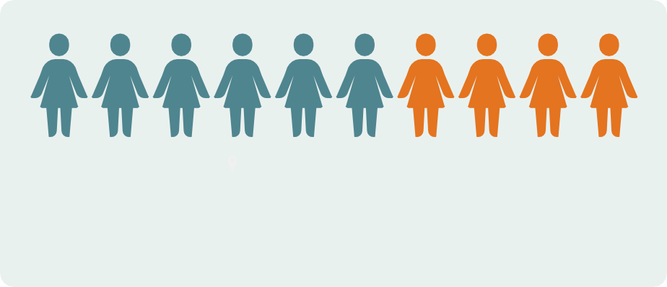

An [April 2023 Pew Research Survey](https://www.pewresearch.org/internet/2023/04/20/ai-in-hiring-and-evaluating-workers-what-americans-think/) found 6 in every 10 Americans (62%) said that AI would have a “major impact on workers generally”

75% of global knowledge workers already use AI, according to a [2024 Microsoft/LinkedIn study](https://assets-c4akfrf5b4d3f4b7.z01.azurefd.net/assets/2024/05/2024_Work_Trend_Index_Annual_Report_663d45200a4ad.pdf)

**Employees who use AI say it helps them . . .**

90%

Save time

85%

Focus on

their most important work

Be more

84% creative

**Employers say . . .**

**66%**

66% would not hire someone without AI skills

**71%**

71% would hire less-qualified people with AI skills over more-qualified people without them

**Sources**

Rainie, Lee, Monica Anderson, Colleen McClain, Emily A. Vogels and Risa Gelles-Watnick. (2023, April 20). AI in Hiring and Evaluating Workers: What Americans Think. Pew Research Center. [https://www.pewresearch.org/internet/2023/04/20/ai-](https://www.pewresearch.org/internet/2023/04/20/ai-in-hiring-and-evaluating-workers-what-americans-think/) [in-hiring-and-evaluating-workers-what-americans-think/](https://www.pewresearch.org/internet/2023/04/20/ai-in-hiring-and-evaluating-workers-what-americans-think/)

Microsoft, & LinkedIn. (2024, May 8). AI at Work Is Here. Now Comes the Hard Part (2024 Work Trend Index Annual Report). [https://www.microsoft.com/en-us/worklab/work-trend-index/ai-at-work-is-here-now-comes-the-hard-part](https://assets-c4akfrf5b4d3f4b7.z01.azurefd.net/assets/2024/05/2024_Work_Trend_Index_Annual_Report_663d45200a4ad.pdf)

[**Credits**](https://assets-c4akfrf5b4d3f4b7.z01.azurefd.net/assets/2024/05/2024_Work_Trend_Index_Annual_Report_663d45200a4ad.pdf)

[Infographic was created by Traci Gardner on](https://assets-c4akfrf5b4d3f4b7.z01.azurefd.net/assets/2024/05/2024_Work_Trend_Index_Annual_Report_663d45200a4ad.pdf) [canva.com](https://canva.com/)[. Photos created with Canva’s AI image generator.](https://assets-c4akfrf5b4d3f4b7.z01.azurefd.net/assets/2024/05/2024_Work_Trend_Index_Annual_Report_663d45200a4ad.pdf)

[**Transcript**](https://assets-c4akfrf5b4d3f4b7.z01.azurefd.net/assets/2024/05/2024_Work_Trend_Index_Annual_Report_663d45200a4ad.pdf)

Online at https://tracigardner/ai/impactonworkplace/