**Task and Audience Analysis Exercise**

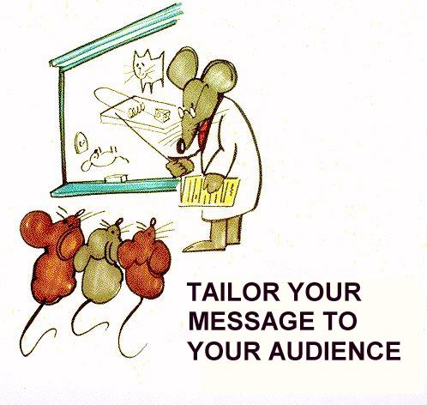

**Exercise 1: What to include? What to leave out?**

Table 1 contains a collection of details about a research project you have just completed on thunderstorms. Imagine that you're writing documents for each of the 5 following audiences:

**A. Your boss**

**B. Scientists**

**C. The general public**

**D. Politician**

**E. Students**

What information about thunderstorms might each ask you for? As you go down the list, write in the blank spaces in front of each detail the letter that correspond to the audiences that you think would find this detail most relevant. Consider what kind of document might contain that information for that audience.

**Table 1. Details About Your Research Project On Thunderstorms**

|  |  |
| --- | --- |
|  | The dollar damage caused by thunderstorms each year. |
|  | A literature review of previous research on thunderstorms. |
|  | Descriptions of calibration procedures for your instruments. |
|  | Some basic physics of how thunderstorms work. |
|  | How much your project costs. |
|  | A log of all your measurements during the whole project. |
|  | A list of everyone who worked on the project. |
|  | Specifications of a new instrument to measure hail size. |
|  | A new result showing a connection between lightning intensity and total rainfall. |
|  | A new result showing how to suppress hail. |
|  | New insights into the flow patterns around thunderstorms. |
|  | Procedures you used to avoid statistical biases in your data. |
|  | Your plans for further measurements. |
|  | Your recommendations for future research. |

## Exercise 2: Compare audience needs

What differences in purpose, content, and format would you need to consider in the following examples:

1) A report on Internet Privacy Issues for a new internet user

for an e-commerce website developer

2) Information on Lyme Disease for camping enthusiasts

for a family practice physician

for public health department

3) Food born diseases for a restaurant worker

for a health inspector training manual

4) Proposal for a new bus shelter design Mayor’s office

Contractor

Newspaper reporter

Use the schematic in Table 2 to determine what kind of document with what kind of content would be appropriate for the various audiences above.

**Table 2. Audience Analysis Schematic**

|  |  |  |
| --- | --- | --- |
| **4 categories of audiences** | **Examples/roles** | **Kind of information required:** |
| Laypeople | General public  Non-Specialists  General “users” |  |
| Executives | Decision Makers  (manage resources and people) |  |
| Experts | Advisors  (use their expertise to help decision makers) |  |
| Technicians | Implementers |  |

**Exercise 3: Task and Audience Analysis**

Compare these two tasks in terms of intended audience and purpose.

|  |  |  |
| --- | --- | --- |
|  | **End of term Course Evaluation** | **a Ratemyprofessor.com entry** |
| **Purpose** |  |  |
| **Audience** |  |  |
| **Author** |  |  |
| **What details would you include? What info would your audience expect?** |  |  |