Tracing Book

Started by Michel R. Dagenais, Ph. D.
February 2008
Contains contributions of other Tracing Wiki members
Table of Contents
Objective 3
Introduction 3
Application areas 4
Cluster of online servers 5
System monitoring 5
Embedded system 5
Data Providers 6
Source Level Instrumentation 6
Binary Instrumentation 13
Sampling 20
Emulation 21
Data collection and transfer 23
Data Collection 23
Data Analysis Tools 24
Data Visualization Frameworks 25
Introduction 25
Eclipse Framework 26
Intel VTune 28
LTTng Viewer 30
Tracealyzer 33
QNX Momentics 33
Visualizing System Latency 38
WindRiver Workbench 39
Zealcore System Debugger 43
Glossary 45
List of tracing world common terms 45

Objective
The objective of this document is to explain the underlying principles and techniques available for tracing and dynamic program analysis in general. It is thus both an introduction to the domain and a survey of the commonly used tools. Each important aspect of dynamic program analysis is examined to explain the various techniques available and most frequently used, as well as the cost (in memory and execution time) and benefits of each. The dynamic program analysis frameworks available and in common usage are presented and their performance, features and usability are discussed.

Introduction
Dynamic analysis consists in obtaining information at runtime to provide some interesting data for the users or developers either online or in a posteriori analysis. The main advantage of dynamic analysis is that it can theoretically access almost any information on the system behaviour while it is running in real life production conditions. In practice, the information collection does disturb the system execution, but the disturbance may in many cases remain extremely small, possibly negligible, with the proper use of efficient algorithms and techniques.
The complete dynamic analysis process may be decomposed in several aspects, a section being devoted to each.
Data providers are the basic mechanisms to access the needed data, for example by adding instructions to trace the execution of some program section, or by externally interrupting a program and sampling its program counter or other properties.
Data Collection and Transfer is the next step. The data that have been accessed must be written to a trace buffer, accumulated in a counter and later written to disk, or sent through the network. Once the data are available either through a file on disk or through a stream (pipe, socket) they can be read by analysis tools.
Data Analysis Tools can measure or identify a number of interesting properties or metrics, for example the state (of processes, CPUs or devices at any given time), the duration (of processes execution, disk requests) or the average (of CPUs or devices queue length) of some properties. The analysis tools may even detect patterns of interest (virtual memory thrashing, disk input/output bottleneck, frequent network retransmissions or timeouts).
The final component is the Data Visualization and Control Framework. This is where most of the user interaction normally takes place. Accordingly, while the other sections focus more on the underlying mechanisms, the section on frameworks examines in some depth the various frameworks currently available.

Application areas

A number of different application areas, usage categories and typical use cases, for monitoring and tracing, are detailed here.
Tracing and monitoring may be used for different reasons:
- traceability, documentation or control purposes;
- system understanding, debugging or tuning;
- system health monitoring;
- security and intrusion detection.
A trace can be generated and recorded on demand when the need arises, either for a random control or because a problem is suspected. It can also be generated continuously, in "flight recorder" mode, and only recorded on permanent storage when needed, because a problem is detected such as a crash, or for sampling purposes. It is also possible to continuously generate and record a trace.
A posteriori trace analysis is used to minimize the impact on the system under study. It can be performed on the same system, after the trace collection is finished, or on a different system. It is used to determine after the fact why the system was failing or was not performing as well as expected. Online trace analysis is usually performed on a separate computer, networked with the computers under study. This reduces the impact on the system under study by not running the data analysis framework on it. Online trace analysis provides a real-time or near real-time picture of the system behaviour, useful to detect security problems and intrusions in real-time, or to correlate the trace content with the perceived system state in real-time.
System tracing is ideally suited for the understanding, debugging and performance tuning of applications where several processes heavily interact with the operating system and with each other, or where the real-time behaviour is important. This includes:
- online servers with heavy interactions between several cooperating processes, the operating system, the network and the disks;
- embedded real-time systems for machine and vehicle control, cellular phones, or multimedia pocket computers;
- desktop computers running several cooperating processes for the graphical user interface, the window manager, the sound server, and the wireless network manager;
Systems running CPU intensive tasks, either a single system or a cluster with relatively infrequent interactions, may be analyzed with simpler profiling tools.
In the following sections, typical use cases for tracing and monitoring are described.

Cluster of online servers
When a cluster of online servers (file servers, web servers, telecom servers) is not performing well or encounters random failures, detailed execution traces are generated on each computer. The traces are either stored on disk continuously, or the trace buffers are filled in flight recorder mode and saved to disk only when encountering a problem or performing a specific performance test. The traces are then collected on a single computer and analyzed to understand the problem.

System monitoring
A critical system (battlefield support server) is instrumented to continuously generate a system trace at the lowest level. The system trace is sent on the fly to a monitoring system. The monitoring system checks the trace for evidence of abnormal behaviour, cyber attack or security intrusion. When something is detected, a human operator is alerted or corrective measures are activated.

Embedded system
An embedded system (high end cellular phone handset) is being debugged. An execution trace can be generated for the processes of interest and for a short duration (making a phone call, viewing a short video). The trace buffers are limited in size and there is no local disk. The tracing data are stored on flash memory or sent on the fly to a development host through a communication link, without additional hardware required.

Data Providers

Source Level Instrumentation

Source-level instrumentation may be classified as either automatic or manual.
For automatic instrumentation, special tools parse the source code and possibly generate a control flow graph, before adding instrumentation code at the specified locations (e.g. function entry or exit).
Manual instrumentation requires that the developers specify explicitly the instrumentation points inside their target application source code.
Static, source level instrumentation does not have the same constraints as dynamic binary instrumentation and thus allows the most flexibility for inserting low overhead instrumentation.

Automatically Inserted Instrumentation

Instrumentation code may be inserted automatically by the compiler, in the process of converting high level language functions into lower level intermediate or assembly code. The GNU Compiler Collection (gcc) provides a number of instrumentation compilation options. Automatic instrumentation is also possible using one of several source code parsing and transformation toolkits, available for various programming languages. Notable examples include TXL, and Javacc which is used by the Java Instrumentation Engine (JIE).

GCC compilation options

The GNU Compiler Collection, GCC, implements numerous options for debugging and instrumentation purposes. The instrumentation is typically oriented towards providing information for profiling and code coverage tools.
The compilation option -finstrument-functions automatically inserts tracepoints at every entry and exit of user-compiled functions. It is possible to prevent the insertion of tracepoints for some functions with the no_instrument_function attribute.
Two other compilation options, -ftest-coverage and -fprofile-arcs, tell the compiler to instrument the generated code to count the execution frequencies of each basic block and branch and write the results to a file upon exit. This file can later be analyzed with the associated tool, gcov, to print the source code along with the execution frequencies.
The overhead of instrumenting basic blocks and branches with counters is fairly small since it adds a single add instruction for every block or branch execution. As an example, the GNU compression program gzip was compiled with -ftest-coverage and -fprofile-arcs. It was executed to compress a 64 MB log file. It turned out that the instrumented gzip required 31.36 s of elapsed execution time rather than 28.16 s for the normal gzip.
The -pg compilation option is provided for sampling. It instruments function entries by adding a call to a function named mcount. This mechanism is used in the Linux kernel by the function tracer, Ftrace, by defining a special mcount function to trace function entries or measure the latency associated with each function called.

Manually Inserted Instrumentation

Manually inserted instrumentation is present in most large systems for logging or tracing purposes. Libraries exist to provide simple, single line, instrumentation statements in most programming languages, be they low or high level. For instance, the Linux kernel used printk statements from the very beginning, even though they are relatively low performance and not optimized for multi-processors or real-time.
Tracepoints are manually inserted at locations in the source code where significant events occur, which may help to understand the system behaviour for performance tuning, monitoring or troubleshooting.

High Level Languages Logging APIs

Besides the usual print statement, tracing or logging libraries are available for most high level programming languages such as Java (see also Java logging), .NET, and C++.

Java Logging API

The official release of JDK 1.4 came out in 2002 and included the Java logging API. This API provides a way to manually instrument Java source code for debugging purposes. The target application needs to create instances of Logger objects, and may assign for each a different Handler object. The logger object can set the Level of any log message, and this can be used to control logging output. Handler objects also have their own Level. Enabling logging at a given level filters out events at lower levels, recording events only at that level and higher. The levels in descending order are:
SEVERE, WARNING, INFO, CONFIG, FINE, FINER, FINEST.
Logging example:
Logger logger = Logger.getLogger(“xyz.abc”);
logger.log(Level.WARNING,“This is an example”);
Some of the already implemented handlers that can be assigned to a logger are:
- FileHandler, a simple file logger,
- MemoryHandler, a handler that buffers messages in a circular buffer in memory,
- ConsoleHandler, which publishes log records to System.err,
- SocketHandler, a simple network logging handler.
Other non-implemented Handlers can be developed by subclassing one of the provided Handlers. Typically, every handler will have a Formatter associated with it. The two standard Formatters included in J2SE are:
- the SimpleFormatter, which formats events into human-readable strings, and
- the XMLFormatter, which formats events into XML structured records.
The XMLFormatter is used by default.
A default configuration file (lib/logging.properties) contains properties for use by handlers and loggers (logger levels, size of the memory ring buffer...). This file is automatically read at startup by a LogManager object. Further modifications are possible by referring to the LogManager object.
The performance impact of logging on the execution time was studied with 4 scenarios:
- a simple loop without logging, 2279 ms;
- the same loop with a logging statement within the loop but at a severity level not currently logged, 2401 ms;
- the logging level of the statement is raised such that logging takes place in a memory-based circular buffer, MemoryHandler, 10054 ms;
- the memory-based circular buffer is replaced by a FileHandler and events are written to disk, 210442 ms.
The XMLFormatter was used by the FileHandler and gave better results than the SimpleFormatter. When using a FileHandler to log events directly to a file, an overhead of 0.208 ms per event is observed. On the other hand, the MemoryHandler induces a cost of 7.77 µs per event.

References
- Java 1.4.2 Logging Overview
- Java Logging Frameworks on Wikipedia

Low Level Logging APIs

While the basic principles of manual instrumentation are applicable to both high level applications and low level system software, the context, constraints and tradeoffs differ. The system software (e.g. Linux kernel, Xen hypervisor) is written in C, a great emphasis is placed on efficiency, and reentrancy and latency are important considerations.
Linux had from the very beginning the printk statement, not necessarily very efficient but simple and thus relatively robust. Over the years, several more structured frameworks were proposed for logging and tracing, from Event logger, evlog, to the Linux Kernel State Tracer, LKST, the Linux Trace Toolkit, LTT, the Driver Tracing Infrastructure, DTI (see also Driver Tracing Infrastructure), and the Linux Trace Toolkit next generation, LTTng.
The buffering mechanism from LTT, Relay, was included into the mainline Linux kernel in 2005. The source code instrumentation mechanism proposed by LTTng, Kernel Markers, was included into the mainline Linux kernel in 2008 and replaced by its direct descendant, Tracepoints, by the end of 2009. The LKST team is now collaborating with the SystemTap project on dynamic tracepoints. There seems to be general agreement that tracing is making its way into the mainline Linux kernel. However, it is taking a long time and the proposed systems have to convince that they represent the right tradeoff between simplicity, efficiency, low intrusiveness and low disturbance.

Driver Tracing Infrastructure

The Driver Tracing Interface, DTI, was initially designed to enable driver developers to log events in a circular flight-recording buffer. The typical usage model consists in extracting and analyzing the buffer content after a system crash, trying to pinpoint the source of the problem.
The Driver Tracing Interface enables passing debug data (per-CPU buffering) into user space using the existing Relay file system. The DTI API is architecture independent, and is usable in both user and interrupt contexts. A relay buffer is created for every CPU, and each buffer is subdivided into equally-sized sub-buffers. These sub-buffers are filled in a circular fashion. A user space client program (a logger) can consume a sub-buffer only when full, changing the latter's state to "consumed". If no consumed sub-buffers are available, the one containing the oldest data is overwritten.
The DTI Kernel API can be used to register new traces, set the corresponding sub-buffer size, write a formatted string or a buffer to the trace and set the trace level (e.g. debug level) from 0 to 6. The trace level is used to select which records to keep.
The driver writer needs to register a new trace by specifying its name and the sub-buffer size. This will generate a trace handle that can be used to log events. Binary tracing, printk-style logging and mixed tracing are supported, but it is up to the user to interpret the outcome. For each registered trace, the files data0, data1 ... data[max_cpus – 1] are created in the mounted debug filesystem. The content of each event record is as follows:
struct dti_even {
__u16 len;
__u64 time;
char data[0];
}
A trace formatting tool is provided to extract, sort and format the events from each per-CPU data file. Retrieving trace data from a crash dump is also possible by first locating the address of a special string stored in the trace structure, and then manipulating this address to locate another basic structure from which the buffers are retrieved. A major characteristic of DTI is that it provides early logging in the kernel, from the beginning of the start_kernel() init code.
The device drivers constitute the largest portion of the Linux kernel source code. Many drivers or subsystems need to be traced for performance analysis, troubleshooting and debugging. Already some of these subsystems come with ad hoc tracers for events like wireless connections or SCSI disks commands. The DTI project has not been very active lately. However, with the inclusion of the Kernel Tracepoints and Markers, there is now a mechanism in place to instrument the various device drivers.

Tracepoints and Markers

Tracepoints, and Markers (a tracepoint variant for directly generating LTTng events from a generic printf-like function call), are hooking mechanisms providing static instrumentation that can be enabled at runtime (dynamically) with very small footprint when disabled. This document describes both the Tracepoints and the Markers, and their implementation in the Linux kernel and ongoing implementation in Linux user space processes.
Tracepoints are a C-functions prototype based instrumentation mechanism meant to create a simple and flexible instrumentation API. The developers define instrumentation prototypes in include (.h) files which are then used in the C code. The prototypes definition include the use of preprocessor macros which add en entry in a table for each site where a tracepoint is used in the C code. This allows using the tracepoints at runtime. It is possible to connect a probe (a C function with an argument type list matching the tracepoint) to a tracepoint, and to activate the tracepoint. When an activated tracepoint is hit in the program, the connected probe is called and the execution continues when the probe returns. A naive implementation of tracepoints could result in code somewhat equivalent the following.
if (tracepoint_1_activated)
(*tracepoint_1_probe)(arg1, arg2);
In practice, several optimizations and enhancements are achieved. For instance, it is possible to connect several probes to the same tracepoint, and the various operations (probe connection, tracepoint activation) are thread safe. Furthermore, a faster immediate boolean value, instead of a global boolean variable, may be used to check the activation status. Other optimizations are also used such as using an unlikely branch, and placing the probe call setup instructions at the function end to improve instruction cache usage. Thus, as a first approximation, the cost of an inactive tracepoint is that of an if on a boolean variable, and the cost of an active tracepoint is that of the if plus a call to the connected probe through a function pointer.
One possible use for a tracepoint is to call a probe for tracing purposes. The probe will then use the received arguments to write an event to the trace buffers. The LTTng tracer provides two different APIs to write an event to the trace buffers. The first is based on a format string and a variable argument list. The format string is registered with LTTng at initialization time and written to a trace only once; it can later be retrieved from the trace metadata to help a tracer understand the event types. The variable argument list is accessed based on the format string and the individual arguments are efficiently written in binary form in the trace buffers. The second, lower level but more efficient, API lets the probe reserve space for an event and write each argument in binary form directly in the trace buffers.
Markers are very much like Tracepoints, except that they declare a format string and export the data through a variable argument list. There is a small overhead associated with variable argument lists and the associated interpretation of the format string. The type of the arguments is also normally restricted to scalar types which can easily be described by the format string. The advantage of Markers is that they are self described. They do not require a prior declaration in an include (.h) file, and they can be processed by a generic probe, expecting a printf-like variable argument list. For tracing purposes, the LTTng tracer provides such a generic probe. LTTng can then directly connect to and activate any Marker for tracing purposes.
Markers are thus used for simple ad-hoc instrumentation. Tracepoints are typically used when a formal hook is desired at an important location in the code. A tracepoint in the code is less visually invasive than a marker since it only contains the relevant arguments (no format string). Furthermore, a tracepoint is a general hooking mechanism which may be used for different purposes, one of which being tracing. The disadvantage is that for each tracepoint the developer must provide a prior definition and a corresponding probe. For tracing purposes, the probe connected to a tracepoint may either call the format string based event writing function, or when more performance is desired (e.g. for very frequent events) the lower level functions for directly writing each argument.
Markers have been implemented in the mainline Linux kernel since version 2.6.24, and Tracepoints were added later in 2.6.28-rc1. They are used as a generic mechanism to statically insert hooks. These hooks are used by several kernel components including the LTTng tracer and SystemTap.
Kernel Tracepoints represent key locations in the kernel where hooking is desirable and require community approval before they are accepted. They are never exposed to user-space to avoid making kernel code instrumentation part of the userspace API. The tracing probes provided to connect to the tracepoints provide the interface to the user-space trace analysis tools. Kernel Markers are typically used within Kernel Tracepoint probes, for ad hoc tracing, or for regular tracing in less important locations, possibly replacing printk statements.
- Linux Kernel Tracepoints documentation: Documentation/trace/tracepoints.txt
- Linux Kernel Tracepoints example: samples/tracepoints
- Linux Kernel Markers documentation: Documentation/markers.txt
- Linux Kernel Markers example: samples/markers
- LTTng Linux Kernel Markers Efficicient API: include/linux/ltt-type-serializer.h
- LTTng Linux Kernel Markers Efficicient API usage example: ltt/probes/kernel-trace.c
Markers and Tracepoints have not yet been implemented for user space tracing. The API discussions and refinements were conducted for the Kernel implementation and are being complemented by the corresponding work on the LTTng kernel tracer. Once this is completed, Markers and Tracepoints will be implemented in a similar manner for user-space tracing and LTTng will be extended accordingly from its current limited user-space tracing facility.
Google proposed a set of tracepoints to the Linux community, explaining that these core kernel tracepoints have been in many cases sufficient to solve most of the problems they faced. The list is as follow:
- syscall_entry/exit
- irq_entry/exit
- irq_softirq_entry/exit
- irq_softirq_raise
- irq_tasklet_{low,high}_entry/exit
- sched_kthread_stop
- sched_wait_task
- sched_wakeup
- sched_switch
- sched_migrate_task
- sched_process_free
- sched_process_exit
- sched_process_wait
- sched_process_fork
- sched_signal_send
- timer_itimer_expired
- timer_itimer_set
- timer_set
- timer_update_time
- timer_timeout
- wait_on_page_start/end
- memory_handle_fault_entry/exit
- page_alloc
- page_free
- net_dev_xmit
- net_dev_receive
- swap_in
- swap_out
Detailed thread: http://lwn.net/Articles/290203/

Binary Instrumentation

Binary instrumentation consists in adding tracepoints to an already compiled application. This may be done statically, before the application is started, or dynamically, while the application is running. The challenge is to add the new instructions, for instance tracepoints, while not changing the rest of the program.
If instrumentation instructions are inserted and the instructions previously there displaced, one must insure that any reference to a displaced instruction, or relative to a displaced instruction, is updated accordingly. On the other hand, if the instrumentation instructions overwrite existing instructions, there should be a mechanism to execute the overwritten instructions.

Static Binary Instrumentation

Several tools were developed over the years to read executable binary programs and rewrite equivalent programs with some instrumentation added, and the references to relocated instructions updated.
Examples include Pixie, QPT, EEL and ATOM. They were mostly developed for architectures with fixed-length instructions (MIPS, Alpha, SPARC) and some were available at no cost for research purposes.
On the popular 386 Intel architecture, the complexity of the variable-length instruction set makes program rewriting more difficult and favours other simpler but less efficient techniques typically used for dynamic binary instrumentation.

Dynamic Binary Instrumentation

Dynamic binary instrumentation techniques are used to execute additional instructions at certain locations in a program. Since instrumentation is added dynamically, a tracing overhead is incurred only when a program is dynamically instrumented to produce a trace. This is unlike source level instrumentation where the decision to instrument is taken at compile time and some overhead is present when tracing is compiled in, even if it is not activated at execution time.
Examples of dynamic binary instrumentation tools are:
- Valgrind,
- DTrace,
- SystemTap (based on kprobes)
- Frysk, and
- GDB
DTrace, SystemTap, Frysk and GDB overwrite the program with trap instructions at locations where instrumentation code must be executed. When the trap instruction is encountered, a software interrupt is generated. The additional instrumentation code may then be executed.
Then, the original instruction content (overwritten by the trap) is restored, the processor is single stepped inline (SSIL) over the restored instruction, and the trap can be replaced again before continuing the program execution. Because of the trap mechanism used, the overhead for each instrumented site execution is larger than for static source level instrumentation.
Static and dynamic instrumentation are therefore complementary, each having specific advantages. For example, frequently used tracepoints in the Linux Kernel are most efficiently implemented with kernel Tracepoints, the cost of calling a probe being that of a simple function call. Moreover, a static tracepoint insures that all its arguments (e.g. local variables) remain available at runtime and won't be optimized out by the compiler. On the other hand, adding ad hoc tracepoints at runtime is not possible with kernel tracepoints, but may conveniently be achieved with SystemTap via kprobes, albeit at the larger cost of a trap instruction. The probe connected with either a kernel tracepoint or a SystemTap tracepoint can then, for instance, write an event to LTTng trace buffers for tracing purposes.
GDB and Frysk use the ptrace programming interface to interact with the process to debug. Ptrace can be used to monitor and control another process: receive notification of signals, traps and system calls; read and write the process memory and registers; and start, stop and single step the execution. Ptrace is used by a number of tools, including strace, a system call tracer, and ltrace, a library function call tracer.
The method used by GDB to continue after hitting a breakpoint, single stepping inline (SSIL), is adequate if all threads are stopped. Otherwise, other running threads may miss the breakpoint. On some processors, replacing even a single byte of the instruction stream may lead to inconsistencies between the memory and the instruction cache. For this reason, more sophisticated techniques are often required to quiesce all threads before inserting a breakpoint, and for single stepping out of line (SSOL) when continuing after a breakpoint. The utrace in the kernel programming interface has been proposed to address these issues and in general provide a more flexible and efficient mechanism to support debugging and tracing tools.
Valgrind uses a different approach, similar to that of static binary instrumentation packages. The program binary code, before executing each linear instruction block, is decompiled into a higher level intermediate representation; this representation is then instrumented as needed, and the result is recompiled.
DTrace, SystemTap or GDB are typically used to add a few tracepoints or breakpoints while Valgrind is more commonly used for pervasive monitoring of the program, for instance tracing every access to memory.

DTrace

Overview
DTrace is a dynamic instrumentation framework built for and currently integrated into the Solaris 10 and Open Solaris operating systems. Apple has already integrated DTrace in Mac OS X 10.5 and added Instruments and Shark as user interfaces for system and application viewing.
The main components of the system are the DTrace framework and the instrumentation providers, both residing in the kernel. The main idea behind separating the two sub-components resides in the fact that different providers can have different instrumentation techniques. Instrumentation providers are loadable kernel modules that define a set of probes they can activate on demand. These probes are advertised to consumers and can be identified by the following 4-tuple: <provider name, module, function, probe name>. When not enabled, DTrace has zero probe effect.
Users can specify in a script file the four elements to activate a specific probe, or any subset of the four elements to activate all the probes that match the specified subset. When a probe fires, the corresponding provider transfers control to the DTrace framework. The framework disables interrupts on the current CPU and executes the corresponding actions previously specified in the script file. The DTrace framework handles the case where multiple consumers are assigned to the same probe. When done, interrupts are re-enabled and control is transferred back to the provider.
The DTrace framework allocates a per-CPU kernel buffer for every consumer. Data is read out of the kernel by having two per-CPU buffers: an active and an inactive buffer. When the consumer issues a call to read a buffer on a particular CPU, the active and inactive buffers are switched after disabling the interrupts on the CPU. Then, interrupts are reenabled, and the inactive buffer is copied out to the consumer. When a consumer buffer lacks sufficient space for data recording, a drop count is incremented and data are lost for this consumer.

Statically Defined Tracing
The statically defined tracing has a different mechanism. The code is statically instrumented at first through a C macro that expands to a call to a non-existent function having a well-defined prefix (__dtrace_probe_). When the kernel linker detects this, it automatically replaces this call with a no-operation, and saves the tuple <function name, address of the call site>. When the corresponding probe is enabled, the provider replaces dynamically the no-operation by a call to transfer control into the DTrace framework.
When the probe is disabled, the added no-op instruction has a negligible effect. Other providers can be used to gather information regarding disk input and output, lock contention, CPU scheduling and process creation and termination. This mechanism induces an observable probing impact even when tracing isn't enabled.

D Language
The D language is derived from a large subset of C, and allows access to the kernel's native types and global variables. Users can specify inside the D script file the providers' names, the probes' names, and the actions to take whenever each probe is hit. This file can then be compiled by the D compiler implemented in the DTrace library and invoked by the DTrace command. Upon execution, the DTrace framework enables the probes that were specified in the file by making appropriate calls to the probe's providers.

User-Space Tracing
User space tracing is also possible using DTrace. The first step is to write a data provider in the D programming language and specify probes in it. Then, in the user's C code, the macro DTRACE_PROBE can be called where tracing is desired, with the two essential parameters: the provider name and probe name. Other pertinent arguments can also be passed. The dtrace -G option can be used to link the provider and probe definitions with the application object file.
Examples of user space tracing with dtrace is available here and here.

Kernel Tracing Impact
The impact of DTrace dynamic tracing is studied in this section. The chosen test was to compile the gcc-3.4.6 source code while Dtracing only one event: the function entry of the read system call. The test is run on a Pentium 4, 3 GHz, with 2 GiB of RAM. The results are shown in the table below.
 | All syscall probes enabled | Read syscall probes enabled | No probing
Average execution time | 41 min 55.4995 s | 41 m 33.522 s | 41 min 12.593
Average number of events | 36,372,603 | 5,571,071 | -
Average cost per event (µs) | 1.18 | 3.7 | -
Tracing only the read syscall takes 0.85% more time to finish; tracing all syscalls (232 different events) would take 1.73% more time to finish.

User-Space Tracing Impact
The impact of the statically defined user-space tracing with DTrace was measured on a Pentium 4 with 2 GiB of RAM running Solaris 10 (SunOS 5.10). The test was to convert an mp3 file (1.6 MB) into a wav file using mpg123 (version 1.6.4) while tracing every function entry and exit. The idea was to compile the program with the -finstrument-functions option of gcc which adds a call to the functions __cyg_profile_func_enter and __cyg_profile_func_exit respectively at every function entry and exit of the program. There, we add the DTRACE_PROBE() macros enabling us to trace every function entry and exit called at execution time. The results are shown below:
- Running the program with no tracing: 0 min 1.081 s
- Running the program with no tracing; program compiled with the gcc option -finstrument-functions: 0 min 1.086 s (0.46% slower than normal execution)
- Running the program with no tracing; program compiled with the gcc option -finstrument-functions and DTrace macros: 0 min 2.668 s (146.8% slower than normal execution)
- Running the program while tracing; program compiled with the gcc option -finstrument-functions and DTrace macros:
  - Generating text trace (103 MB): 0 min 9.161 s (747.45% slower than normal execution; 3.53 µsec per event)
  - Outputting to /dev/null: 0 min 8.027 s (642.55% slower than normal execution; 3.03 µsec per event).

References
The paper that introduced DTrace. Contains an interesting case study that demonstrates how DTrace can be used to debug performance problems.
@InProceedings{ dtrace,
title = "Dynamic instrumentation of production systems",
author = "B. M. Cantrill and M. W. Shapiro and A. H. Leventhal",
address = "Boston, MA, USA",
journal = "Proceedings of the General Track 2004 USENIX Annual Technical Conference",
pages = "15--28",
year = "2004",
abstract = "This paper presents DTrace, a new facility for dynamic instrumentation of production systems. DTrace features the ability to dynamically instrument both user-level and kernel-level software in a unified and absolutely safe fashion. When not explicitly enabled, DTrace has zero probe effect - the system operates exactly as if DTrace were not present at all. DTrace allows for many tens of thousands of instrumentation points, with even the smallest of systems offering on the order of 30,000 such points in the kernel alone. We have developed a C-like high-level control language to describe the predicates and actions at a given point of instrumentation. The language features user-defined variables, including thread-local variables and associative arrays. To eliminate the need for most postprocessing, the facility features a scalable mechanism for aggregating data and a mechanism for speculative tracing. DTrace has been integrated into the Solaris operating system and has been used to find serious systemic performance problems on production systems - problems that could not be found using preexisting facilities",
keywords = "high level languages, instrumentation, operating system kernels, production engineering computing, production facilities",
url = "http://www.usenix.org/event/usenix04/tech/general/full_papers/cantrill/cantrill_html/",
copyright = "Copyright 2005, IEE",
language = "English"
}
Another paper with an interesting case study.
@Article{ plainsight,
title = "Hidden in plain sight",
author = "Bryan Cantrill",
publisher = "ACM",
address = "New York, NY, USA",
journal = "Queue",
pages = "26--36",
volume = "4",
number = "1",
year = "2006",
issn = "1542-7730",
url = "http://portal.acm.org/citation.cfm?doid=1117389.1117401",
doi = "http://doi.acm.org/10.1145/1117389.1117401"
}
Technical details of the x86 implementation of DTrace.
@Misc{ dtrace-x86,
title = "The DTrace backend on Solaris for x86/x64",
author = "Frank Hofmann",
note = "\url{http://opensolaris.org/os/project/czosug/events_archive/czosug2_dtrace_x86.pdf}",
url = "http://opensolaris.org/os/project/czosug/events_archive/czosug2_dtrace_x86.pdf"
}

SystemTap

SystemTap is a debugging and troubleshooting tool. It is an open source project with contributors from IBM, Red Hat, Intel, Hitachi, Oracle and others. It uses mainly the kprobes API to dynamically instrument the Linux kernel, and the experimental utrace/uprobes APIs to dynamically instrument user-space programs/libraries. Other data providers can be used seamlessly with Systemtap such as kernel markers and /proc file system controls.
SystemTap works by processing script files where the user specifies probe points and associates handlers to them. Probe points currently supported include function entry, exit and down to almost any machine instruction. Probing can also be enabled asynchronously, at regular time intervals (see [1]).
Here are some probing points declarations that can be specified in a script file:
- Probing a kernel function entry:
kernel.function("sys_read"){ ... }
- Probing a kernel function exit:
kernel.function("sys_read").return{ ... }
- Probing all function entries in a module:
module("ext3").function("*@fs/ext3/inode.c"){ ... }
- Asynchronously probing using a timer:
probe timer.ms(10000){ ... }
- Attaching to Linux Kernel Markers:
probe kernel.mark(“context_switch”) {residency[$arg2,cpu()]++} [2]
- Probing a user space program or shared library:
probe process(“/lib/libc-2.7.so”).function(“malloc”) {if($size > 1024*1024) log(“hog!”)}
- Probing a dtrace-style static instrumentation marker in a userspace program:
probe process("postgres").mark("transaction*") {log ($$vars)}
The default contextual variables at a probe point that can be retrieved include: cpu number, egid, euid, execname, gid, pexecname, pid, ppid, tid, uid, stack_size, target pid.
One limitation here is that these functions may not return correct values when the probe is hit in an interrupt context. It is possible however to access (read or even modify) variables from within the context of the traced program. These target variables can be referenced on demand in the handlers of the script file and their names should be prefixed with a $ sign. They will be resolved to memory addresses during the script elaboration phase. It is worth noting here that such information may not always be available whenever optimization options are used during kernel build.
The probe handler scripts initially pass through the elaboration phase where symbolic references including function parameters, local and global variable, etc. get resolved to run-time real addresses. This is achieved by looking into the DWARF debugging information generated by the compiler during the program's or kernel's build. The next phase consists in translating the processed script into C code and compiling it as a kernel module. The module first inserts the probes then waits for a probe to be hit (see [3]). Since the generated code will run in kernel mode, it is made open for inspection to assuage security concerns.
The impact of Systemtap dynamic instrumentation was evaluated. The test is a time measurement of the compilation of gcc-3.4.6 with and without dynamic tracing to get an estimate of the cost per event. The activated event to trace is the function entry of the read system call. No special handling is done except for incrementing a counter whenever the event is triggered. The test machine has an Intel Pentium 4 3.00 GHz processor and 2 GiB of RAM. The table below summarizes the results obtained.
 | Read Syscall probe enabled | No probes
Average execution time | 32 min 44.105 s | 32 min 41.673 s
Average number of events | 1,872,394 | n/a
Cost per event | 1.30 µs | n/a

Sampling

Sampling may be used to get copious data about a running program with low disturbance. At regular intervals, the unmodified program is interrupted by an external source (e.g. programmable interrupt timer) and a number of parameters may be sampled, such as the currently executing program, the execution address, and the execution mode. Moreover, the overhead associated with sampling can be controlled by changing the sampling frequency. There is however a compromise between the accuracy of the profile obtained and the sampling frequency (and overhead).
GProf, part of the GNU binary utilities, uses the operating system's virtual timer in order to get interrupted at every .01 s or .001 s of CPU time. At every interrupt, the address of the currently executing instruction is taken and the counter associated with this region is incremented. Typically, each region covers 4 bytes of the program instructions address space, requiring one 4-byte counter per 4 bytes of program text, or as much memory space for the sampling data as for the program binary code itself. GProf can also instrument each function entry in order to produce a call graph. Running Gzip 1.2.4 on a 64 MB log file takes 28.16 s of elapsed time. With sampling, the same task requires 28.30 s, and with sampling and function entries instrumentation, the time rises to 29.88 s.
Most modern CPUs provide performance counters which may be used for sampling. Time sampling is achieved by counting clock cycles and requesting an interrupt after 1,000,000 clock cycles or so. Similarly, it is possible to count instruction or data cache misses, branch delays and many other interesting metrics which may impact performance. By sampling the address of the currently executed instruction, one eventually gets an histogram of the relevant metric (time, cache misses, branch delays...) for the different program regions. It then becomes very easy to determine the program section consuming the most CPU time, or causing the most cache misses. OProfile is a performance analysis tool on Linux based on performance counters sampling. A graphical frontend to oprofile, oprofileui, is available.

Emulation

In a virtual, emulated, environment, total control over the emulated system is possible. Every emulated instruction execution or memory access is visible and can be instrumented. For example, the boot-up code for new microprocessors is often run on a gate level simulation of the new processor.
This flexibility, however, comes at a price in performance. A program may run 10 or 100 times slower on an emulated system. If the simulation is cycle accurate, i.e. the emulated elapsed time is measured accurately, it is possible to measure precisely the performance of the emulated system even if it runs much slower than real time. This is often used to measure the processor pipeline or the cache memory performance. The slower-than-real-time execution speed is problematic either if the resulting elapsed time is too large, or if the system interacts with other real-time systems. For instance, analyzing the performance of a server answering numerous Web requests, and interacting with a high performance disk subsystem and database servers, would not be easily possible under emulation.
There have been more recently emulators with much better performance. They analyze code sequences before they are executed and replace them with equivalent binary instructions for the system running the emulation. The code sequences are kept in a cache are are reused when encountered subsequently. This technique has been used to emulate different architectures (e.g. ARM on I386), or to emulate a complete processor (with its privileged mode) from within a single process (thus providing one or more virtual systems within a physical system).
Qemu is a prime example of a system which does both, while VMWare is a popular commercial package for virtualization on the i386. Another emulation system, Valgrind, is used primarily for instrumenting programs and helping in validation (initialized memory accesses, proper use of malloc and free) and performance analysis (cache and heap profiler).

Valgrind

Valgrind is a framework for creating dynamic analysis tools. It was released in late february 2002. It consists of a main core and a suite of tools for memory debugging, memory leak detection and cache profiling. It can be used on programs running on the Linux operating system for the x86, amd64 and ppc32 architectures.
Valgrind currently comes with six different tools.
- Cachegrind is a cache simulator which computes the number of instructions executed per line of code in a program and determines the number of cache misses.
- Callgrind adds some functionalities on top of cachegrind like annotating threads separately.
- Helgrind is used to check for potential race conditions.
- Lackey is a sample tool that helps create other tools.
- Massif is a heap profiler that determines how much heap memory is allocated by a program.
- Memcheck is a memory checker tool that is able to detect any access to an uninitialized or freed memory. It can also find memory leaks where pointers to allocated memory areas are lost, or where the amount of freed memory doesn't match with the allocated one.
In addition, a number of contributed tools extend the functionality of Valgrind:
- The Chronicle Recorder generates a trace of all the memory and register modifications. With this information, debugging tools can retrieve the state of any variable at any point in the program execution.
- Input and output operations can be recorded and analyzed with iogrind.
- Kcachegrind provides a nice user interface front-end for the Valgrind tools Callgrind and Cachegrind, as well as for other tools such as Gprof and Oprofile.
The Valgrind core disassembles the client code into an intermediate representation (IR), passes the output to one of the tools for instrumentation, and finally converts the IR code back into machine code. The amount of added instrumentation depends greatly on the tool. For instance, Memcheck multiplies the program size by a factor of 12, and slows down the execution by a factor 25 to 50. It is worth mentioning that Valgrind profiles not only the program code but also all dynamically-linked libraries it uses. The core is incapable of tracing into the kernel; in order for the tools to know which registers and memory addresses were accessed, they can register a callback function to be called each time a system call occurs. If the program is compiled with the debugging information (-g option), Valgrind will be able to pinpoint relevant source code lines.
The output of Valgrind can be redirected to three different places. A file descriptor, (the default is stderr), a logfile or a network socket.
The Memcheck tool is Valgrind's most powerful tool. It uses shadow values to store information about every register and every byte of memory used by the program. One shadow byte per byte of live original memory is needed. These 8 shadow bits indicate if the 8 corresponding bits in the real live byte are defined. An additional shadow bit per memory byte is also saved; it indicates if the represented byte is addressable or not. Any operation that accesses memory should be instrumented in a way that keeps the shadow memory state up-to-date. Memcheck can detect any use of uninitialized memory, any read or write to a memory that was already freed, and memory leaks.
Programs executed under Valgrind usually run 25 to 50 times slower, and consume more memory than the regular program execution. Valgrind can also produce false positives if the code is optimized. Valgrind doesn't support 3DNow! instructions, and atomic instruction sequences are not preserved.

Data collection and transfer

Data Collection

Tracepoints, once reached, may check if some conditions are met (e.g. tracing is currently requested for the current process). Then, they may write data describing the event either directly through a communication channel or to a buffer. The data thus collected from the various data providers can be extracted from the traced kernel in different ways, each bringing a different disturbance on the system.
- Writing to disk. It may involve writing huge amounts of data (possibly gigabytes) to disk in order to get the full trace of the system. It allows a complete replay of the trace through all the tracing duration. It also provides complete information about the state of the system at any given time after the initial state dump is done. Under a medium to high event rate workload, a performance impact between 1 and 2% has been measured (Desnoyers & Dagenais 2006). It will primarily impact the hard disk I/O performance.
- Sending to the network. Same as writing to disk, but sends data to a remote computer through a network socket. It will change the network performance but does not require a local disk.
- Circular memory buffers in overwrite mode. Also called flight recorder mode, this method consists in overwriting the oldest data in the buffers when they are filled. It can be seen as a logic analyzer: when tracing is stopped, only the last few seconds will be left in memory. Since this is usually the meaningful information that leads to the cause of a given problem, and because writing to memory buffers is the cheapest way to extract data (cheaper than sending to network or disk), this kind of tracing can be very useful to diagnose production systems. Under a medium to high event rate workload, a performance impact between 0.3 and 0.5% has been seen (Desnoyers & Dagenais 2006).
Tracing embedded systems (also called Target Devices) brings additional challenges because of the limited resources available. Within the Eclipse framework, a major component is the Device Software Development Platform (DSDP), with dedicated sub-projects for Device Debugging and Target Management (TM), including the Target Communication Framework (TCF). These sub-projects address the issues of tracing activation and tracing data collection and transfer for embedded systems.

References
- Mathieu Desnoyers, Michel R. Dagenais, The LTTng tracer : A low impact performance and behavior monitor for GNU/Linux, presented at the Ottawa Linux Symposium (OLS) 2006

Data Analysis Tools

Analysis tools produce views that help understand traces. Views can be text-based, or take the form of tables or graphical displays, among others. A programmable data provider such as SystemTap may double as a data analysis tool, by performing filtering/analysis/rendering of results.
Common views included in analysis tools:
- Pretty-printed list of raw events
- Histogram showing the density of events through time
- State of the system through time (scheduling, state of processes, state of hardware or other logical resources)
- Dependency analysis
Other useful features found in some tools:
- Filtering, searching for patterns
- Bookmarking
Data analysis tools face the challenge of remaining interactive while handling huge amounts of data. Even in compact binary form, traces can be as large as 10 gigabytes or more, which generally exceeds the quantity of available RAM; they can therefore not be loaded completely into memory. When a user zooms onto a particular region of such a trace, the i/o and computations necessary for extracting state information can take a long time. One solution to this problem involves reading the trace completely when initially opening it to precompute a number of useful values and properties.
For instance, the state information can be computed incrementally, as each event is processed, and saved at regular intervals. Thereafter, when a user seeks to a specific time point in the trace, the state at that point can be computed starting at the nearest saved state and processing the events in between, rather than starting from the beginning of the trace. Another similar approach consists in generating synthetic state events at regular points in the trace. These state events directly provide the state information to display, which otherwise may require reading a large portion of the trace to compute.
A large number of different analysis may be performed on a trace. Examples include computing the causality links between events (thus finding the time critical path between two events), or searching for specific patterns (excessive swapping, spurious timeouts, overloaded disk subsystems).

Data Visualization Frameworks

Introduction

In most tracing systems, the user interface is the framework interacting with all the other components. It may be part of an already existing framework for program development, alongside with other debugging and performance analysis tools. For deployed systems, the tracing user interface may be part of a global system monitoring console.
In either case, the user interface may typically be used to:
- selectively activate or deactivate static tracepoints;
- insert or remove dynamic tracepoints;
- start or stop the tracing of a given process, process group or complete system;
- visualize the content of traces.
To visualize the content of traces, several tools and views may be offered:
- filter, to select the events shown based on their type and the value of their fields;
- event list to conveniently view a table of the events, like in a database viewer;
- control flow view, to show the state of different objects (process, disk, CPU...) as a function of time, in a way reminiscent of Gantt charts;
- histogram of events (number of events of a certain type, value of a field for a certain type of event...), graph showing for instance the number of disk read requests per second;
- statistics (total number of events by type, average durations, CPU usage...).
Many more tools are possible and would be very useful for a number of specialized tasks. Linux kernel developers have in the past developed ad hoc, throw away, tools for block device tracing and analysis, mutex contention and interactive response latency. It is therefore very important to have the flexibility to easily add new analysis and viewing modules (plugins).

Eclipse Framework

Eclipse
Eclipse is a Java-based, plug-in extensible, open source development platform. It started as an IBM Canada project in November 2001. In January 2004, the Eclipse Foundation was created as an independent not-for-profit, member supported corporation. The founding Strategic Developers and Strategic Consumers were Ericsson, HP, IBM, Intel, MontaVista Software, QNX, SAP and Serena Software. More background information is available here.

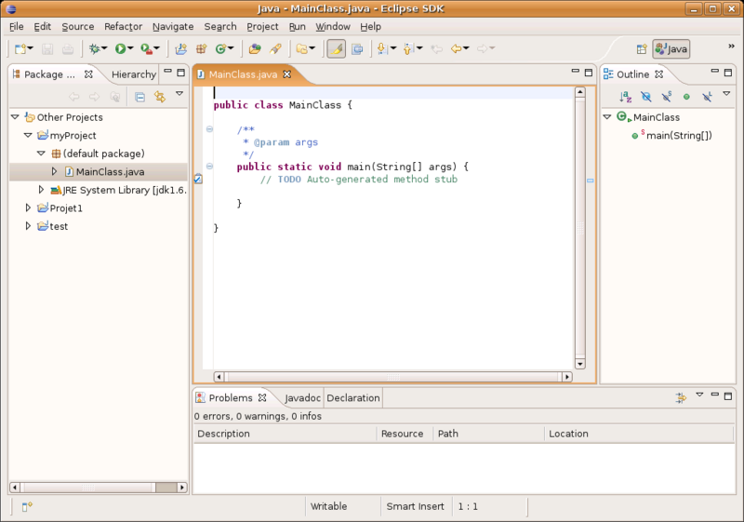
Eclipse IDE

The Eclipse framework targets different usage scenarios, including embedded devices development and enterprise development.

In its simplest form, Eclipse is a framework providing a set of services for building plug-in components and, therefore, all plug-ins are created equal. One of the indispensable components is the Workbench. It consists of perspectives, views and editors. A perspective is a collection of one or more views and editors (e.g. Navigator view, Outline view, Tasks view). It also comes with CVS (Concurrent Versions System) support built-in. Workbench also provides extension points allowing any plug-in to extend the Eclipse user interface by adding new interface functionalities, creating new views, etc.
Every plug-in declares some descriptive information in a manifest XML file called plugin.xml, such as the plugin name, version number, .jar file name, dependencies on other plugins, extension points, etc. An extension point may declare additional specialized XML element types for use in the extensions. This allows the plug-in supplying the extension to communicate arbitrary information to the plug-in declaring the corresponding extension point. The manifest information is used by Eclipse to integrate this plug-in into the framework. The new plug-in can be attached, tested and debugged without having to restart Eclipse.
Various plug-ins with different functionalities already exist or are currently being developed. As an example, the CDT (C/C++ Development Toolkit) plug-in provides support for other programming languages like C/C++. Other plug-ins, such as TPTP (Test & Performance Tools Platform), address software testing, profiling and trace analysis.
Due to the flexibility offered by the robust design of Eclipse, numerous different projects based on Eclipse are currently being developed and are released simultaneously, like the Ganymede version on June 25, 2008 (Ganymede Simultaneous Release Projects). A more detailed list of eclipse based projects is available here.

References
- David Gallardo, Developing Eclipse plug-ins: How to create, debug, and install your plug-in, IBM Developerworks, 2002
- Eclipse documentation: Current release
- Marc Erickson, Working the Eclipse Platform, IBM Developerworks, 2001
- Ganymede Simultaneous Release, Eclipse, 2008
- List of Eclipse projects, Wikipedia

Intel VTune

VTune Performance Analyzer
VTune Performance Analyzer is an application profiler for systems based on Intel processors. It supports all language compilers (C, C++, Fortran) that follow industry standards (ELF, STABS and DWARF). Java and mixed Java are also supported. The Graphical User Interface (GUI) is based on Eclipse.

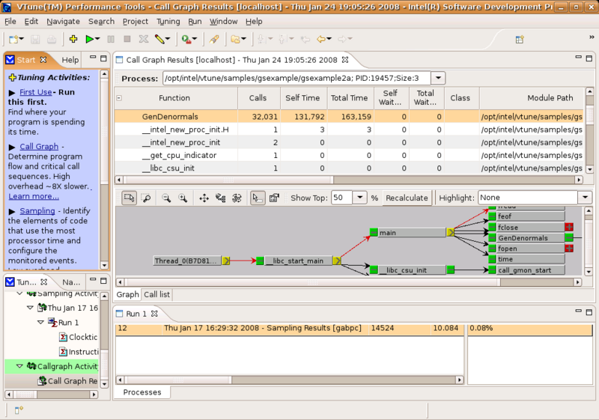
VTune Snapshot
The VTune analyzer searches for symbol information in the binary file it launches. If it cannot find this information, VTune disassembles the code and provides static analysis of the basic blocks in the code. VTune can collect information through two methods: sampling and profiling.

Sampling
VTune conducts non-intrusive sampling and doesn't instrument the binary code. Instead, at regular intervals, it interrupts the processor and collects samples of instruction addresses, one per interrupt. This procedure stops when the application ends, when the specified duration is over, or when sampling is manually stopped using the ActivityController. VTune stores 32 bytes per sample in a user-configurable sampling buffer. When the buffer is full, VTune suspends sampling temporarily to write the data to the disk. By default, the collected sampling information is stored in the $HOME/.VTune directory. The sampling collector has different options that can be configured by the user such as the sampling interval, the sampling buffer size, the delay before sampling starts, the conditions to stop sampling (i.e. sampling time, maximum samples to collect, etc.).
Event-based sampling can be specified to identify low level performance problems such as cache misses and misdirected branches. By default, the Clockticks and Instructions Retired events are pre-selected. Different processors support different events. VTune can determine the ones that are supported by the processor used (vtl -help -c sampling). Data collected can be filtered and visualized in three different views: process view, module view and hotspot view.
Hotspots indicate sections of code within a module that took a long time to execute. The hotspot view can display hotspots of active functions or active source files in the module. The information can be filtered by process id, CPU number and module name.

Profiling
Call Graph profiling is used to determine the program flow and the critical path in the program. It counts how many times a function calls another function and determines the time spent in each of them. The Call graph uses the binary instrumentation technique to record timing and call sequence information. By default it instruments all Ring 3 modules used by the application and slowing down its execution. For Java and .NET applications, call graph uses Java Virtual Machine Profiling Interface (JVMPI) and .NET Profiling API to collect performance data. VTune stores the collected data in a user-configurable Call Graph buffer having a default size of 16 MiB. When the buffer is full, VTune suspends the profiling temporarily to write the data to the disk. There are three instrumentation levels for the modules that can be configured by the user:
- "all-functions" instrumentation which is only possible if the selected module has debug information,
- "exports" level which is used to instrument functions in the module's export table, and
- "minimal" level which instruments the module but does not collect data. It only reports calls from this “unimportant” module to other “important” modules.
For user executables, only the all-functions and minimal instrumentation levels are possible. Again, data can be visualized in different views such as the process view, thread view, module view, function view, view by call site and the critical path view. The critical path is the most time consuming call sequence.
Some of the VTune Timing Information that can computed are the total time spent in a function, the self time (without the time spent in calls to other instrumented functions), the time spent in a function (with or without its children) while the thread was suspended, etc.

References
- VTune Performance Analyzer Documentation
- VTune Analyzer Help

LTTng Viewer

The Linux Trace Toolkit Next Generation Viewer (LTTV) is a graphical application for viewing and analyzing traces recorded with LTTng. It is being developed mainly at École Polytechnique de Montréal and is released under the GNU GPL.

Description

General characteristics
LTTV is designed to be very modular. Its powerful plug-in system makes it easy to add features.
LTTV is optimized to handle very large traces and has been tested successfully with 15 GB traces.
LTTV is capable of opening several traces at once and merging their data. This makes it possible to view traces of virtual machines and their host simultaneously in order to study problems that involve the interaction between them. In order for this to work correctly, timestamping in all the traces must be consistent.

Graphical interface
The following graphical views are included in the LTTV distribution.

Histogram
This is a graph of the density of events through time. It makes it easy to find periods of high system activity. Filters can be applied so the graph applies only to specific event types.
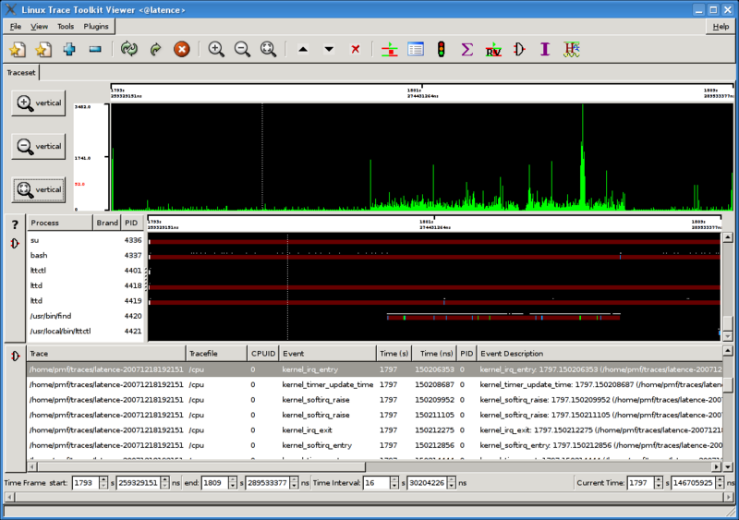
Histogram showing increased activity while find process is running

You've got to be kdiding me it's so transparently clear now!

Resource view
The Resource view displays, in graph form, the state of CPUs, IRQ handlers, SoftIRQ handlers and trap handlers of the system through time.
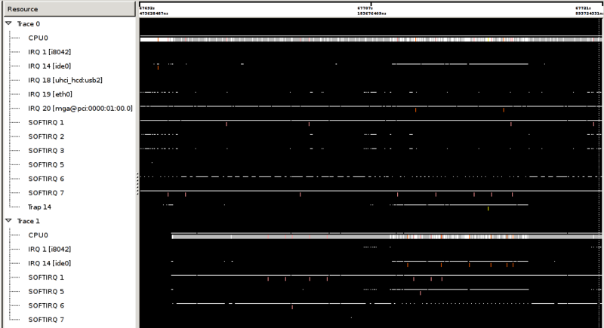
Resource view showing a virtual machine (Trace 1) and its host (Trace 0)
Kudos to you! I hadn't thought of that!

Statistics viewer
The statistics viewer displays various statistics concerning the system's state during the trace.

Interrupts statistics
This plug-in computes a variety of statistics concerning interrupts: frequency, total time in handler, max time in handler.

Text-based output
LTTV also has a number of text-based plug-ins. It is, for instance, possible to output a trace in text form in a one-event-per-line format.

See also
- LTTng Architecture

Tracealyzer

Tracealyzer, by Percepio AB - http://www.percepio.se

QNX Momentics

QNX Software Systems

Company
QNX Software Systems provides different products targeting primarily the embedded systems market. Their proprietary operating system, called QNX Neutrino, is a real-time operating system. As of 12 September 2007, a free license was released for non-commercial use together with the source code of QNX Neutrino. The company also provides a development suite called QNX Momentics which is described briefly later in this document. Other products include middleware for multimedia applications, for acoustic processing, as well as for 2D and 3D graphics rendering.

Kernel Tracing
The instrumented QNX microkernel is equipped with an event-gathering module and runs at 98% of the speed of the regular microkernel. When tracing, system activity is intercepted by generating time-stamped and CPU stamped events to be stored in a circular linked list of small buffers. This allows the data capture program to store the filled buffers to the disk while other available buffers are used to log more events. Kernel activities that generate events are system calls, scheduling activities, interrupt handling, thread/process creation, destruction and state changes.
The instrumented kernel can't flush a buffer or switch to another one within an interrupt. To solve this problem, the instrumented kernel requests a buffer flush when it becomes 70% full. The buffer is composed of 1024 event slots, of 16 bytes each, and most interrupt routines require less than 300 event buffer slots (approximately 30% of 1024 event buffer slots). Most events (simple events) usually fit in a single event buffer slot, but this is not the rule. Events holding too much information (combined events) can consume two or more event buffer slots. In fast mode, only one buffer slot is allocated to all events (combined events will be incomplete).
The traceevent_t structure is 16 bytes long. To represent a combined event, multiple traceevent_t elements are required. The structure includes a 2-bit flag indicating whether the event is simple or combined. Data are written in raw binary format to a device or file for offline processing. The library libtraceparser provides a set of API functions that allow the user to set up a series of callback functions associated with each event, and called when complete buffer slots of event data have been read and assembled from the binary event stream. The libtraceparser API transparently assembles combined events and sorts the events with respect to their timestamps. The timestamp uses only the 32 LSB (least significant bits) of the 64-bit clock to reduce the amount of data in the trace. When this portion rolls over, a control event is issued. A provided tool called traceprinter uses this library and outputs all of the trace events in a human readable format, ordered linearly by their timestamps.

Measurements
The aim of this section is to determine the cost in time per traced event. The benchmark consists of compiling the gcc compiler on a Pentium 4 3.0 GHz processor with 2 GiB of RAM. Only kernel events were traced to avoid losing some events when writing to the tracefile. The compilation generated around 13 million events on average, with an overhead of around 24 additional seconds to finish the test execution. This gives an approximate cost of 1.85 microseconds per event (1620 clock cycles per event).

QNX Momentics Development Suite
The QNX Momentics Development Suite is an Eclipse-based IDE (Integrated Development Environment) for C/C++ and embedded C++ development. It supports three host platforms: Linux, QNX Neutrino, and Windows. It has built-in support for the CVS (Concurrent Versions System) source-control protocol with support for both remote pserver and secure SSH repository access. It provides many tools for trace analysis and application debugging.

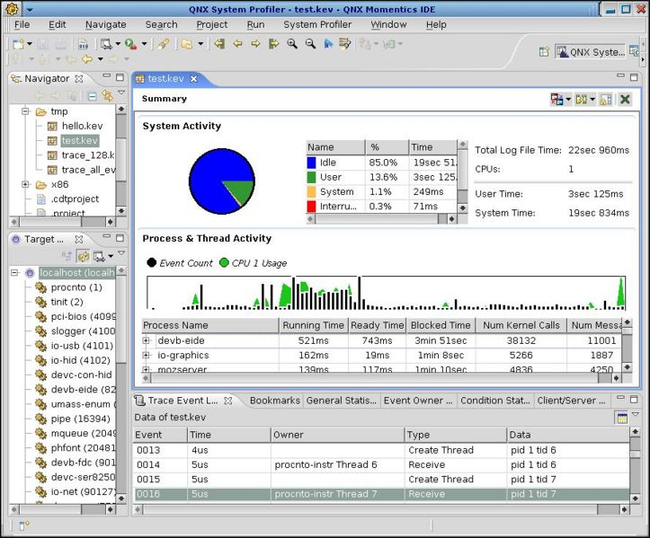
QNX Momentics IDE

Trace Analysis
The System Profiler Perspective, in the QNX Momentics IDE, groups different views for trace analysis. Some of these views are described below:

- The Summary View shows the time spent when the system was idle, was processing interrupts, or was executing kernel code or user code.
- The CPU Activity view shows the total amount of CPU time a thread or a process consumed throughout the period of the trace file or during a selected interval.
- The Timeline view shows the succession of events relative to every process, where the different thread states are shown in different colours.
- The CPU Migration pane displays a chart showing the number of CPU scheduling migrations over time. The count is incremented every time a thread migrates from one CPU to another. Another chart shows the number of messages sent between a client and a server running on two different processors.
- The Bookmarks view can be used to bookmark events of particular interest.
- In the Client/Server CPU Statistics view, the thread running time is divided into self time and imposed time. For instance, if a client X requests a service from server Y, then the time Y consumes is considered an imposed on time. It becomes easier to find which clients are the most demanding and are causing the bottleneck.
- The Overview view has two charts. The first one displays the CPU usage over the period of the trace file, and the second shows the event distribution over time.
- The Trace Event Log view shows all the fields of an event including its number, timestamp, class, type and others.
- The Why Running Tool enables the user to backtrace relevant events leading up to the execution of a selected thread.

Application Analysis Tools
- Memory analysis tools
- Application profiler
- Code coverage

Memory Analysis tools
When a program is launched with the Memory Analysis tools, it uses the debug version of the malloc library (libmalloc_g.so). This library tracks the history of every allocation and deallocation the program does and provides cover functions that validate the corresponding function's parameters before using them. This is used to detect memory leaks and memory errors such as overruns, underruns and freeing the same memory twice. Whenever a memory error is encountered at runtime, the developer can either request a process core dump file, or switch to the debugger view where he can identify the erroneous lines of code.
Offline analysis is also possible. Once the information is available, a graph showing the requested, allocated and freed memory can be displayed in the Memory Analysis perspective. A list of memory errors is also provided showing the type, the pointer, the timestamp, the pid, the tid (thread id) and the memory operation requested.

Application profiler
The main target of the application profiler is to identify highly executed sections of code which are the most eligible candidates for optimization. The Application Profiler provides two types of profiling: Statistical and Instrumented profiling.
In statistical profiling, the tool relies on sampling the running code every millisecond and recording the address being executed. For this type of profiling to be accurate, the program should run for a sufficiently long time. The advantage of this method is that no instrumentation and code recompilation is required, and the profiler can be attached dynamically to a running process on the target system.
In instrumented profiling, the compiler inserts snippets of code into the different functions to report the addresses of the called and calling functions. If the program is to be run on an embedded system, the profiler update interval can be set accordingly. For instance, a low interval would result in continuous, but low, network traffic whereas a long interval may result in forcing the embedded system to buffer a relatively large amount of profiled data.

Code coverage
The code coverage tool in the Momentics IDE is a visual front-end to the gcov metrics generated by the gcc compiler. A list of coverage information is generated showing lines fully covered, not covered and partially covered. The coverage tool also highlights the lines of code that were not executed during the testing phase. Branch coverage is not yet provided by the IDE although this metric is already produced by gcc. Finally, a report can be generated and saved for later analysis or comparison with other reports. For each function, the report contains the number of lines that were not covered, that were partially covered and that were fully covered.

References
- QNX IDE User's Guide
- QNX on Wikipedia

Visualizing System Latency

This article describes the use of heat maps to display latencies.

Description
Visualizing System Latency is an article that shows how heat maps can be used to display I/O latencies. It is written in the perspective of showing millions of I/O access in a medium-sized widget and allowing a user to immediately extract data that would be pertinent.

Heat Maps
Describe a heatmap here.

When to use a heat map
When should you use heat maps? Advantages described here.

When not to use a heat map
When is it not appropriate to use heat maps.

Examples
- Winamp voiceprint analyzer

References
- Brendan Gregg, Visualizing System Latency, Oracle, 2010

WindRiver Workbench

Wind River

Company
Wind River Systems, Inc. is a Software company providing mainly solutions for embedded systems including operating systems such as VxWorks and Wind River Linux, as well as development tools.

Wind River Workbench
Wind River Workbench is an Eclipse-based development suite providing a rich set of tools for software development and debugging. This document describes a few but very important features.
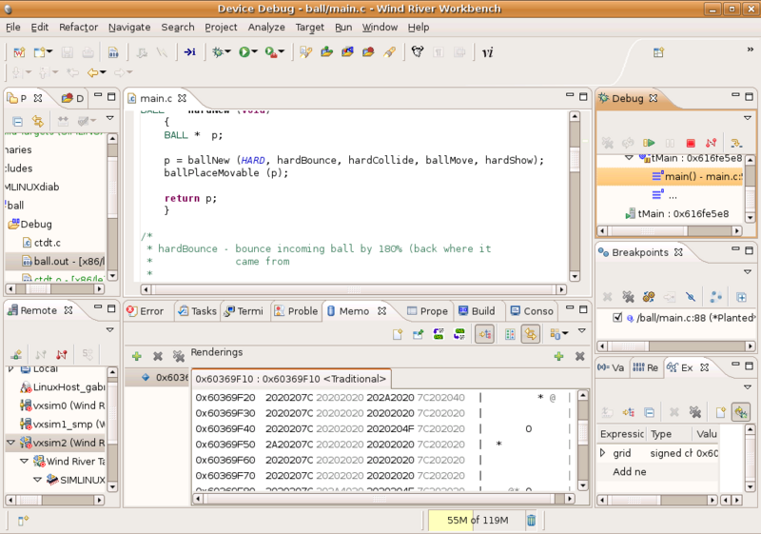
WindRiver Workbench

Target Debugging
The target can be connected with the workbench host for debugging via one of three possible ways:
- A direct connection to the target with an 8250 serial connection using a null-modem cable, or
- via a terminal server with TCP, or
- by Ethernet with UDP.
Once the connection is established, workbench shifts to the Device Debug perspective. Here it is possible to add breakpoints in the kernel code. Once a breakpoint is hit, the Editor inside the perspective will open the corresponding source file. On specific architectures like the IA-32, hardware breakpoints can be set. The normal execution of the program can be interrupted when a specific variable is read or written, or when a specific instruction is read for execution. Breakpoint properties can be saved to a file and imported later on.

System Viewer
The Wind River Workbench System Viewer is used to capture the dynamic interactions of the operating system, device software application and target hardware. It displays graphically the trace data, allowing device software developers to detect anomalous behaviour relatively quickly. The tool is architecture-independent and can be used with VxWorks simulator (for VxWorks 6.x) before hardware is available and with Linux platforms using the Linux Trace Toolkit (LTTng) instrumentation.
Logged events correspond to one of the following kernel activities:
- Semaphore gives and takes,
- Task spawns and deletions,
- Timer expirations,
- Interrupts,
- Message queue sends and receives,
- Watchdog time activity,
- Exceptions,
- Signal activity,
- System calls,
- I/O activity,
- Networking activity,
- Memory allocation, freeing and partitioning, and
- Protection domain activity (for VxWorks 653 only).

Event Log Analysis
The System Viewer provides various graphical ways to make data analysis most effective:
- The Event Graph: The Event Graph displays the succession of events relative to each thread. Holding the mouse over any event will make the event name, time stamp and argument values appear. Icons can help identify events in the graph. Event type filters can be used to considerably reduce the amount of data to analyze.
- The Event Table: The Event Table displays events as rows of information ordered by their timestamps. The columns show the event name, the timestamp, the thread state, the event id, the time difference between current and previous event, and other different event-specific arguments.
- The Memory usage graph displays memory allocation and deallocation resulting from memLib function calls. This graph shows the memory usage versus time. It also shows the addresses of memory blocks that were allocated and then freed.

Sensorpoints
Wind River Workbench diagnostics is a plug-in to Wind River Workbench and provides Sensorpoints technology which can help test software relatively quickly. Sensorpoints are lines of code that can be used to instrument dynamically a running application without having to rebuild the application or reboot the device. Sensorpoints give access to global and local variables within the scope of the function to patch. They can be used to monitor or to interfere with the execution of the application (by injecting specific values in variables). Sensorpoints can also be used to create a trace of global and local variables, function calls, and to timestamp any point in the system to reveal timing problems. They can be disabled when the test is finished.

References
- Wind River Test Management : Sensorpoint and Patchpoint Technology
- Wind River System Viewer, 3.0 – User's guide

Zealcore System Debugger

Zealcore

Company
Zealcore is a Swedish software development company whose main interest is to provide developers with debugging tools to help them “find the last bug”. Its products are targeted to accelerate development and troubleshooting of embedded systems software through instrumentation, trace analysis, profiling and visualization tools.

Products
The three main products of Zealcore are the System Debugger, the Model Replay Debugger and the System Recorder. The System Recorder provides a general framework for recording system data. The currently supported operating systems are VxWorks, Enea OSE and Linux. The System Debugger is a post analyzer and graphical viewer of logged information. It will be described briefly in the next section. The Model Replay Debugger records and displays the behaviour of UML models. It can also check for assertions to help identify model faults.

System Debugger
The System Debugger provides multiple browsers to visualize the logged information in different ways. They are the Timeline Browser, Gantt Chart, Text Browser, Sequence Diagram, State Diagram and the Plot View.
- The Timeline Browser displays the relative logarithmic time distance between events. Different events can be shown with different colours on the timeline. A dynamic legend displays the events colours just for the ones appearing on the timeline. When an event is selected, its occurrence time is shown. The common timebase for the system debugger is time in nanoseconds since the epoch.
- The Gantt Chart displays the scheduling of threads. Every thread execution is drawn horizontally taking into consideration the time it was scheduled in, how long it executed, and the time it was scheduled out.
- The Text Browser displays the events with all of their fields in a human-readable way, one event per line.
- The Sequence Diagram shows processes or objects (actors) as parallel vertical lines, and messages passed between them as horizontal arrows.
- The State Diagram shows for a given actor the model of its recorded behaviour. The current state is marked by a thicker frame and the next state is marked by a dashed arrow together with the transition condition. All of the different views discussed so far are synchronized in time.
- The Plot View draws charts derived from values of a basic search. For instance, if there is an event collecting the actual temperature, then it is possible to plot the temperature versus time.
System Debugger also has a Logmark View that can be used to bookmark events of special interest. Another feature is the ability to define and run assertions. An assertion is created by selecting first an event type, and then adding a constraint on one or more of its fields. As an example, an assertion could state that the temperature variable, which is collected from a specific type of event, is always less than 50 degrees Celsius. After running the created assertion, a view of all the events that violate the specified constraints will be displayed.
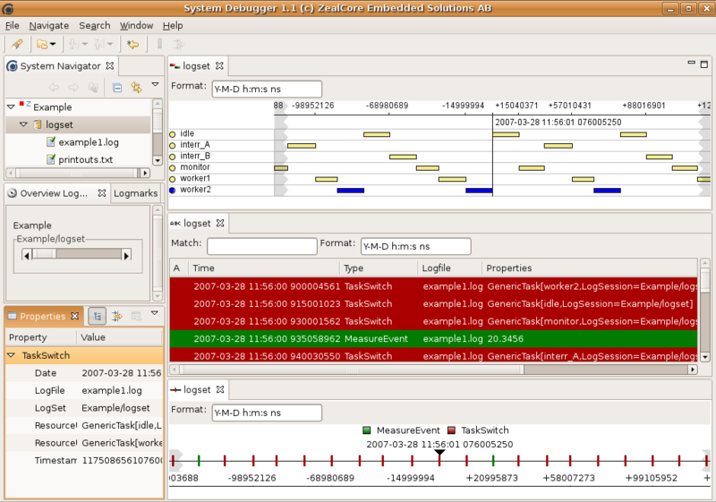
Zealcore System Debugger

Glossary

List of tracing world common terms
- aggregation - updating statistics or other analytical information, based on trace events
- capture - the act of recording event information
- configuration - the set of constraints which determine which events are collected and how they are stored in a trace
- configuration interface - the API used to configure the tracing engine
- control interface - the API used to control the tracing engine
- dynamic tracepoint - a trace point dynamically added, at runtime, to the software being traced
- event - an instruction occurrence or system state transition at a specific point in time
- filters - criteria used to limit the events that are processed or captured
- post-processing - manipulation of the trace data after the trace is collected
- static tracepoint - a trace point statically compiled into the software being traced
- trace buffer - location where trace data are stored at time of capture
- trace log - location where trace data are stored for the long term
- trace time - the time during which the trace is active
  - ie. SystemTap can do aggregation at trace time, while KFT and LTTng do aggregation during post-processing (mostly)
- transfer interface - the API or mechanism used to move the trace data from kernel space to user space (or vice-versa)
- triggers - criteria used to start and stop tracing automatically

Terms to discuss
Here's a list of the term commonly used but somewhat misinterpreted. Sometime, several terms mean the same thing and should be regrouped into a single one.
- State
  - Modelled state
  - Synthetic state
  - Trace state (Declared state vs. inferred state)
- Synthetic event

Sources
- Some terms were taken from the elinux.org Tracing Collaboration Project.

