1. Find the same employee name from your table.
2. Find the employee salary who is in “Mumbai” and Dept.name is “clerk”.
3. Find the dept.no from dept. Table who live in “Mumbai”.
4. Find the employee whose middle name is “kumar”.
5. Find the second highest salary of the employee whose Dept.name is “Clerk”.
6. Find , how many employees work in “Mumbai”?
7. Find all combinations of one employee who gets the chances to match deptno from the dept table.
8. Find the employee salary who earns the greater than the avg salary of a total salary.
9. Create a primary key of a table, insert the data into this attribute. Find how to insert the data in another table from the first table?
10. Find the employee name ,whose surnames are equal.

A1. Select emp_name from emp where emp_name=

A2.Select emp_salary from emp where emp_address="Mumbai" and emp_dsg=(select dept_name from dept where dept_name="clerk");

A3.Select dept_no from dept where dept_name=

(select emp_dsg from emp where emp_address="Mumbai");

A4.Select * from emp where emp_name like '%kumar%';

A5. Select emp_name, Max(emp_salary) AS SECOND_HIGHEST_SAL from

emp where emp_salary < (Select Max(emp_salary) from emp);

A6.Select count(*) from emp where dept_no=(Select dept_no from dept where

dept_location='Mumbai');

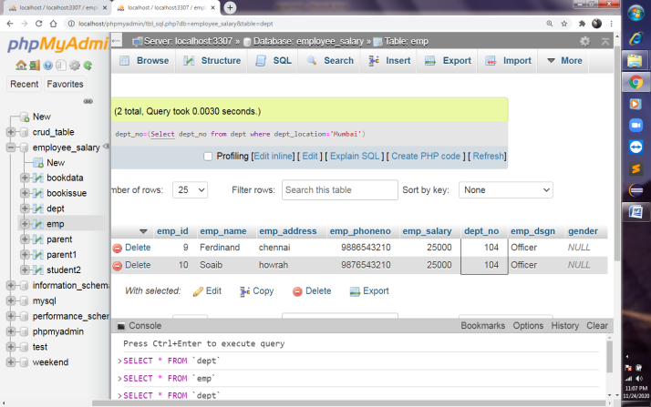

A7.Select * from emp inner join dept on emp.emp_dsgn=dept.dept_no;

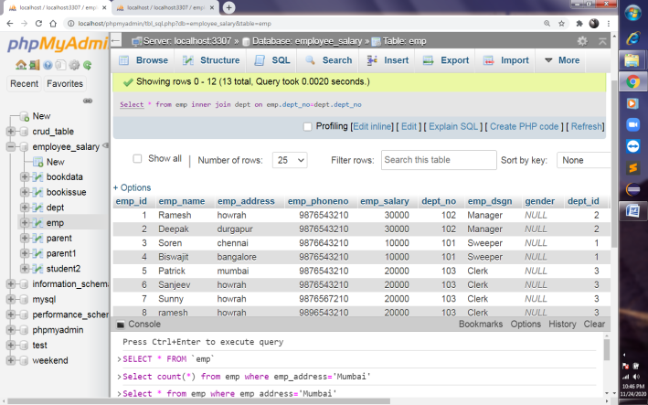

A8.Select emp_salary from emp where emp_salary > (Select avg(emp_salary) from

emp);

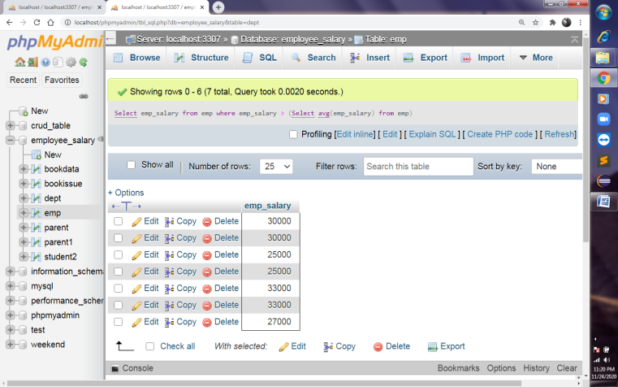

A9.

A10. select substr(emp_name ,instr(emp_name,' ',-1)+1 ) as surname from emp;