Name: __________________________

GCCIS-ISTE-230 Final Practical

1. Write the SQL statements necessary to create a database called 'yourlastname_practical' and implement the following E-R diagram as tables in the database. You will need to implement all appropriate and needed constraints based on the E-R diagram and specifications provided.

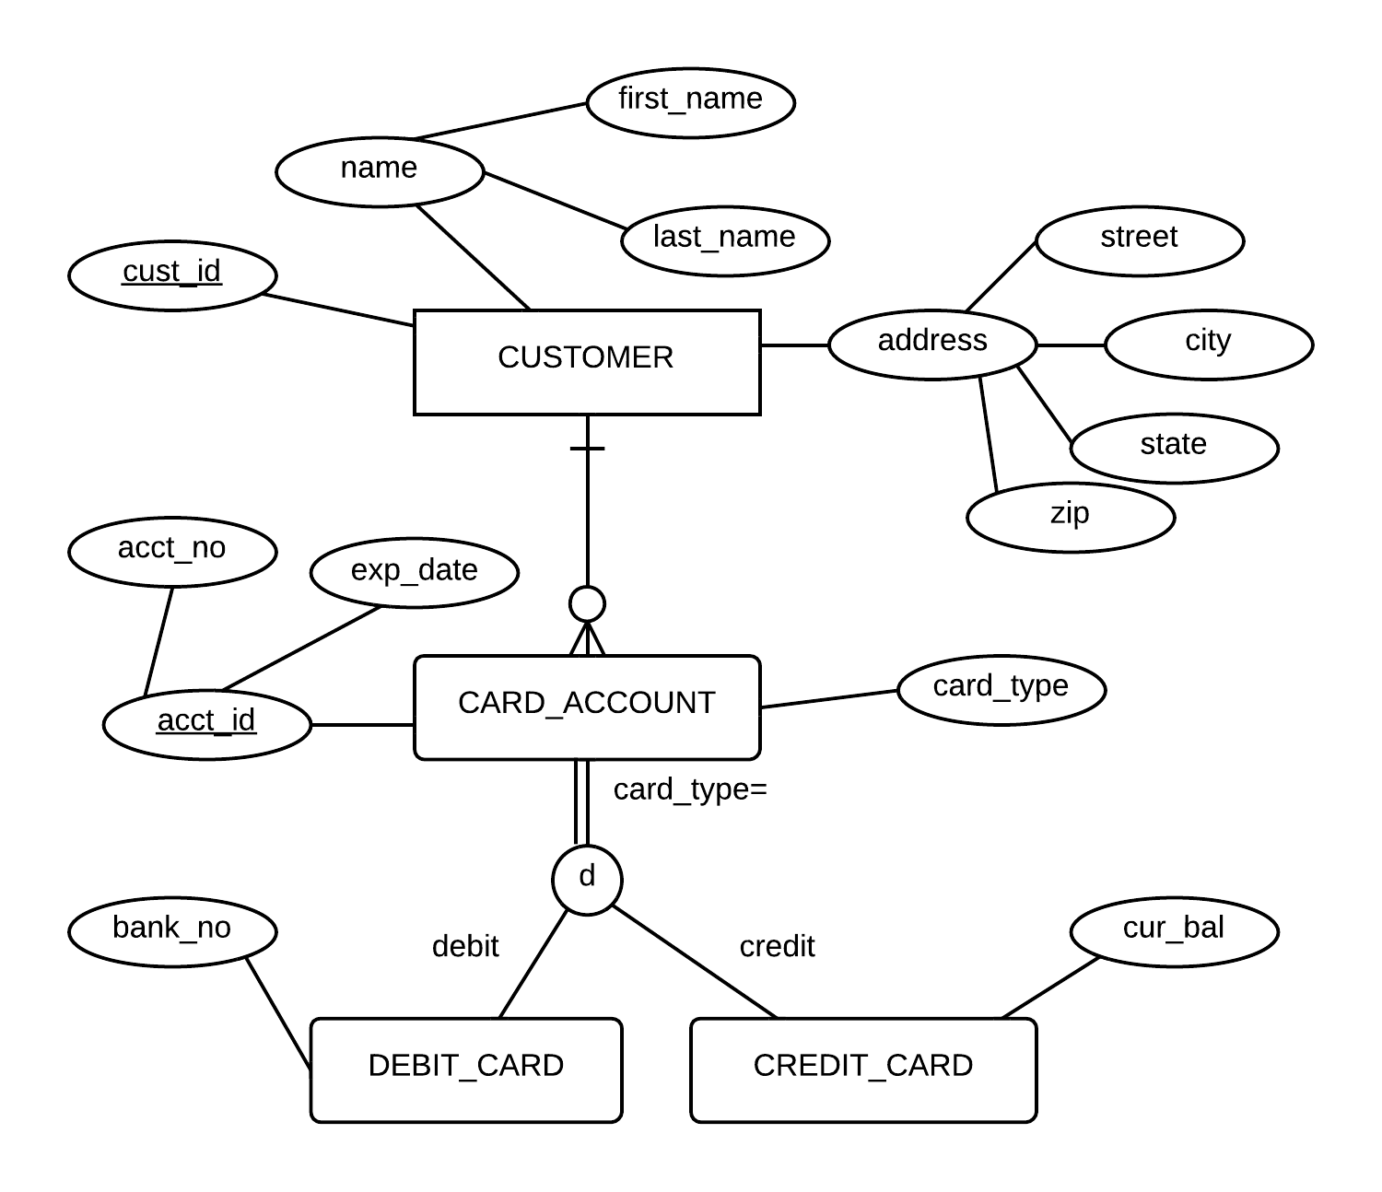

|  |  |
| --- | --- |
| CUSTOMER.custID | Integer values; set it up such that DBMS will automatically determine a value |
| CUSTOMER.state | Exactly 2 characters |
| CUSTOMER.zip | 0<=n<=10 characters |
| CARD_ACCOUNT.acctNo | Exactly 16 characters |
| CARD_ACCOUNT.expDate | Date value |
| CARD_ACCOUNT.cardType | a value is required; only allowed values are 'Debit' or 'Credit' |
| DEBIT_CARD.bankNo | Exactly 9 characters; a value is required |
| CREDIT_CARD.curBal | 7 total digits with 2 of those to the right of the decimal point; value required; 0 is the default value |
| All other attributes | 0<=n<=25 characters |

**If a value of acct_no and/or exp_date is changed or removed from CARD_ACCOUNT, it should also be reflected in DEBIT_CARD and CREDIT_CARD.**

***Make sure to follow camelCase naming conventions (even though the ER Diagram doesn’t!)***

1. Within a transaction add Joe Smith as a customer with an address of 132 Main St., Rochester, NY 14623. Joe Smith will open a card account with 1111111111111111 as the account number, an expiration date of 2014-01-01 and it will be a Credit card. You do not know the number assigned to Joe Smith for his CustomerID, so when you add his card account record, you will need to include as part of the statement a query to determine Joe Smith's customer ID. Do not supply a value for the credit card's current balance, instead rely on the default value.

**The remainder of the practical is based on the JOBS database.**

1. List the companies that are located on a street containing the string 'west'. Case should not impact your results. Duplicate company names should not be displayed (you may not use group by to accomplish this). The case of your output should match the results below.

+------------------------------+

| COMPANY NAME |

+------------------------------+

| AJAX SOFTWARE, INC. |

| CAMERON INDUSTRIES |

| DAVIS-KLEIN SOFTWARE |

| FOCUSED APPLICATIONS, INC. |

| MANHATTAN-MADE SOFTWARE |

| MIDTOWN SOFTWARE DEVELOPMENT |

+------------------------------+

6 rows in set (0.00 sec)

1. List the cities with an 'e', 'o', or 'a' as the second letter of their city name (you must use either the substring or instr function to accomplish this) and have two or more employers in the respective city. Sort them in ascending order by the number of employers and then in descending alphabetical order by the city name. Make sure your headings match what is shown below.

+------------------+---------------------+

| City | Number of Employers |

+------------------+---------------------+

| Colorado Springs | 2 |

| Rochester | 3 |

| Kenmore | 3 |

| New York | 4 |

| Berkeley | 4 |

+------------------+---------------------+

5 rows in set (0.00 sec)

1. Display the company name, division, city, state, and zip code, as shown below for employers that have interviews where the listing has been posted, signified by a ‘y’. Sort records first by zip code in ascending order, then by company name in descending order, and finally by division in ascending order.

+----------------------------------------------------------------------------+

| Employer Info |

+----------------------------------------------------------------------------+

| Nantucket Applications, Inc., RandD, Nantucket, MA 02554 |

| Manhattan-Made Software, Customer Support, New York, NY 10012 |

| Manhattan-Made Software, Payroll, New York, NY 10012 |

| Long Island Apps, Inc., Development, Oceanside, NY 11572 |

| Buffalo Software Assoc., Payroll, Buffalo, NY 14221 |

| PennState Programming, Inc., Management, Pittsburgh, PA 15108 |

| Focused Applications, Inc., Production, Myrtle Beach, SC 29579 |

| Georgia Software Design, RandD, Atlanta, GA 30328 |

| ApplDesign, RandD, Huntsville, AL 35803 |

| Acme Information Source, Customer Support, Cleveland, OH 44234 |

| Mountainside Magic Software, Customer Support, Colorado Springs, CO 80941 |

| Mountainside Magic Software, Management, Colorado Springs, CO 80941 |

| Bay Software Inc., Production, Berkeley, CA 94710 |

| Ajax Software, Inc., Production, Berkeley, CA 94710 |

| Ajax Software, Inc., RandD, Berkeley, CA 94710 |

+----------------------------------------------------------------------------+

15 rows in set (0.00 sec)

1. Write a SQL statement that accomplishes a theoretical relational algebra difference between the state and quarter tables (STATE-QUARTER). Use IN and Subquery.

**+-----------+**

**| statecode |**

**+-----------+**

**| AK |**

**| AL |**

**| AR |**

**| AS |**

**| AZ |**

**| CO |**

**| CT |**

**| DC |**

**| DE |**

**| FL |**

**| FM |**

**| GA |**

**| GU |**

**| HI |**

**| IA |**

**| ID |**

**| IL |**

**| IN |**

**| KS |**

**| KY |**

**| LA |**

**| MD |**

**| ME |**

**| MH |**

**| MI |**

**| MN |**

**| MO |**

**| MP |**

**| MS |**

**| MT |**

**| NC |**

**| ND |**

**| NE |**

**| NH |**

**| NJ |**

**| NM |**

**| NV |**

**| OH |**

**| OK |**

**| OR |**

**| PA |**

**| PR |**

**| PW |**

**| RI |**

**| SC |**

**| SD |**

**| TN |**

**| TX |**

**| UT |**

**| VA |**

**| VI |**

**| VT |**

**| WA |**

**| WI |**

**| WV |**

**| WY |**

**+-----------+**

**56 rows in set (0.00 sec)**

1. For each academic year in the quarter table, list the *average* of the minimum salaries expected rounded to the nearest whole number, and the *minimum* of the minimum salaries expected rounded to the nearest whole number. Make sure that the column headings match those shown below.

+------+------------------------+-----------------+

| Year | Average Minimum Salary | Minimum Offered |

+------+------------------------+-----------------+

| 2019 | 22 | 21 |

| 2020 | 23 | 22 |

+------+------------------------+-----------------+

2 rows in set (0.02 sec)

1. List the state descriptions that contain “or” (**MUST use the instr function to do this)** and the count of the locations desired (from the quarter table) in that state. Be sure to list ALL states even if the count is zero. Make sure your column headings match what is shown below.

+--------------------------+---------------------+

| Description | Number of locations |

+--------------------------+---------------------+

| CALIFORNIA | 1 |

| COLORADO | 0 |

| FLORIDA | 0 |

| GEORGIA | 0 |

| NEW YORK | 3 |

| NORTH CAROLINA | 0 |

| NORTH DAKOTA | 0 |

| NORTHERN MARIANA ISLANDS | 0 |

| OREGON | 0 |

+--------------------------+---------------------+

9 rows in set (0.00 sec)

1. For each quarter, list the full statename, the company name and the division for interviews in locations that match those desired by the student. Hint: what the student wants is stored in the QUARTER table.

Hint: Show the quarter code from quarter. Show the company name and division from employer.

+-------+----------+---------------------------+-------------+------------+

| QTR | State | Company | Division | Date |

+-------+----------+---------------------------+-------------+------------+

| 20201 | NEW YORK | Rochester Software Design | Development | 2020-07-01 |

| 20201 | NEW YORK | Long Island Apps, Inc. | Development | 2020-08-11 |

| 20204 | NEW YORK | Buffalo Software Assoc. | Payroll | 2021-04-22 |

+-------+----------+---------------------------+-------------+------------+

3 rows in set (0.00 sec)

1. You noticed an inconsistency in the EMPLOYER table. Change the Company name "Rochester Application Software" to "Rochester Software Design".

Note: This question will change the database and may alter the output seen if previous tasks are rerun.

This table is not the output of the question, just verification that it worked. You only need to write the SQL to make the change in this table.

mysql> SELECT companyname, address, zipcode

-> FROM employer

-> WHERE companyname LIKE "rochester%";

+---------------------------+-----------------+---------+

| companyname | address | zipcode |

+---------------------------+-----------------+---------+

| Rochester Software Design | 16 Broad Street | 14621 |

| Rochester Software Design | 16 Broad Street | 14621 |

+---------------------------+-----------------+---------+

2 rows in set (0.00 sec)