Platform devices
Actually, we should have said pseudo platform device, since this section concerns devices that sit on pseudo platform buses. When you are done with the driver, you will have to feed the kernel with devices needing that driver. A platform device is represented in the kernel as an instance of struct platform_device, and looks as follows:
struct platform_device {
const char *name;
u32 id;
struct device dev;
u32 num_resources;
struct resource *resource;
};
When it comes to the platform driver, before driver and device match, the name field of both struct platform_device and static struct platform_driver.driver.name must be the same. The num_resources and struct resource *resource field will be
covered in the next section. Just remember that, since resource is an array,
num_resources must contain the size of that array.
Resources and platform data
At the opposite end to hot-pluggable devices, the kernel has no idea of what devices are present on your system, what they are capable of, or what they need in order to work properly. There is no auto-negotiation process, so any information provided to the kernel would be welcome. There are two methods to inform the kernel about the resources (irq, dma, memory region, I/O ports, buses) and data (any custom and private data structure you
may want to pass to the driver) that the device needs which are discussed as follows:
Device provisioning - the old and depreciated way
This method is to be used with the kernel version that does not support device tree. With this method, drivers remain generic, and devices are registered in board-related source files.
Resources
Resources represent all the elements that characterize the device from the hardware point of view, and which the device needs, in order to be set up and work properly. There are only six types of resources in the kernel, all listed in include/linux/ioport.h, and used as flags to describe the resource's type:
#define IORESOURCE_IO 0x00000100 /* PCI/ISA I/O ports */
#define IORESOURCE_MEM 0x00000200 /* Memory regions */
#define IORESOURCE_REG 0x00000300 /* Register offsets */
#define IORESOURCE_IRQ 0x00000400 /* IRQ line */
#define IORESOURCE_DMA 0x00000800 /* DMA channels */
#define IORESOURCE_BUS 0x00001000 /* Bus */
A resource is represented in the kernel as an instance of struct resource:
struct resource {
resource_size_t start;
resource_size_t end;
const char *name;
unsigned long flags;
};
Let us explain the meaning of each element in the structure:
- start/end: This represents where the resource begins/ends. For I/O or memory regions, it represents where they begin/end. For IRQ lines, buses or DMA channels, start/end must have the same value.
- flags: This is a mask that characterizes the type of resource, for example
IORESOURCE_BUS.
- name: This identifies or describes the resource.
Once one has provided the resources, one needs to extract them back in the driver in order to work with them. The probe function is a good place to extract them. Before one goes further, let's remember the declaration of the probe function for a platform device driver: int probe(struct platform_device *pdev); pdev is automatically filled by the kernel, with the data and resource we registered earlier. Let's see how to pick them.
The struct resource embedded in struct platform_device can be retrieved with the platform_get_resource() function. The following is the prototype of platform_get_resource:
struct resource *platform_get_resource(structplatform_device *dev, unsigned int type, unsigned int num);
The first parameter is an instance of the platform device itself. The second parameter tells what kind of resource we need. For memory, it should be IORESOURCE_MEM. Again, please have a look at include/linux/ioport.h for more details. num parameter is an index that says which resource type is desired. Zero indicates the first one, and so on. If the resource is an IRQ, we must use int platform_get_irq(struct platform_device * pdev, unsigned intnum), where pdev is the platform device, and num is the IRQ index within the resource (in case there is more than one). The whole probe function which we can use to extract the platform data which we registered for our device can look as follows:
static int my_driver_probe(struct platform_device *pdev)
{
struct my_gpios *my_gpio_pdata = (struct my_gpios*)
dev_get_platdata(&pdev->dev);
int rgpio = my_gpio_pdata->reset_gpio;
int lgpio = my_gpio_pdata->led_gpio;
struct resource *res1, *res2;
void *reg1, *reg2;
int irqnum;
res1 = platform_get_resource(pdev, IORESSOURCE_MEM, 0);
if((!res1)){
pr_err(" First Resource not available");
return -1;
}
res2 = platform_get_resource(pdev, IORESSOURCE_MEM, 1);
if((!res2)){
pr_err(" Second Resource not available");
return -1;
}
/* extract the irq */
irqnum = platform_get_irq(pdev, 0);
pr_info("\n IRQ number of Device: %d\n", irqnum);
/*
* At this step, we can use gpio_request, on gpio,
* request_irq on irqnum and ioremap() on reg1 and reg2.
* ioremap() is discussed in chapter 11, Kernel Memory Management
*/
[...]
return 0;
}

Platform data
Any other data whose type is not a part of the resource types numerated in the preceding section fall here (for example, GPIO ). Whatever their type is, the struct platform_device contains a struct device field, which in turn contains a struct platform_data field. Usually, one should embed that data in a structure and pass it to the platform_device.device.platform_data field. Let's say, for example, that you declare a platform device that needs two gpios number as platform data, one irq number, and two memory regions as resource. The following example shows how to register platform data along with the device. Here, we use platform_device_register(struct platform_device *pdev) function, which one uses to register a platform device with the platform core:
/*
* Other data than irq or memory must be embedded in a structure
* and passed to "platform_device.device.platform_data"
*/
struct my_gpios {
int reset_gpio;
int led_gpio;
};
/*our platform data*/
static struct my_gpiosneeded_gpios = {
.reset_gpio = 47,
.led_gpio = 41,
};
/* Our resource array */
static struct resource needed_resources[] = {
[0] = { /* The first memory region */
.start = JZ4740_UDC_BASE_ADDR,
.end = JZ4740_UDC_BASE_ADDR + 0x10000 - 1,
.flags = IORESOURCE_MEM,
.name = "mem1",
},
[1] = {
.start = JZ4740_UDC_BASE_ADDR2,
.end = JZ4740_UDC_BASE_ADDR2 + 0x10000 -1,
.flags = IORESOURCE_MEM,
.name = "mem2",
},
[2] = {
.start = JZ4740_IRQ_UDC,
.end = JZ4740_IRQ_UDC,
.flags = IORESOURCE_IRQ,
.name = "mc",
},
};
static struct platform_devicemy_device = {
.name = "my-platform-device",
.id = 0,
.dev = {
.platform_data = &needed_gpios,
},
.resource = needed_resources,
.num_resources = ARRY_SIZE(needed_resources),
};
platform_device_register(&my_device);

In the preceding example, we have used IORESOURCE_IRQ and IORESOURCE_MEM in order to inform the kernel about what kind of resource we provided. To see all other flag types, have a look at include/linux/ioport.h in the kernel tree. In order to retrieve the platform data we registered earlier, we could have just used
pdev->dev.platform_data (remember the struct platform_device structure), but it is recommended to use the kernel-provided function (which does the same thing, admittedly):
void *dev_get_platdata(const struct device *dev)
struct my_gpios *picked_gpios = dev_get_platdata(&pdev->dev);

Where to declare platform devices?
Devices are registered along with their resources and data. In this old and depreciated method, they are declared a separate module, or in the board init file in the arch/<arch>/mach-xxx/yyyy.c, which is arch/arm/mach-imx/mach-imx6q.c in our case, since we use a UDOO quad based on an i.MX6Q from NXP. The function platform_device_register() lets you do that:
static struct platform_device my_device = {
.name = "my_drv_name",
.id = 0,
.dev.platform_data = &my_device_pdata,
.resource = jz4740_udc_resources,
.num_resources = ARRY_SIZE(jz4740_udc_resources),
};
platform_device_register(&my_device);

The name of the device is very important, and is used by the kernel to match the driver with the same name.

Device provisioning - the new and recommended way
In the first method, any modification will necessitate rebuilding the whole kernel. If the kernel had to include any application/board-specific configurations, its size would incredibly increase. In order to keep things simple, and separate devices declarations (since they are not really part of the kernel) from the kernel source, a new concept has been introduced: the device tree. The main goal of DTS is to remove very specific and never-tested code from kernel. With the device tree, platform data and resources are homogenous. The device tree is a hardware description file and has a format similar to a tree structure, where every device is represented with a node, and any data or resource or configuration data is represented as the node's property. This way, you only need to recompile the device tree when you make some modifications. The device tree forms the subject of the next chapter, and we will see how to introduce it to the platform device.
Devices, drivers, and bus matching
Before any match can occur, Linux calls the platform_match(struct device *dev, struct device_driver *drv). Platform devices are matched with their drivers by means of strings. According to the Linux device model, the bus element is the most important part. Each bus maintains a list of drivers and devices that are registered with it. The bus driver is responsible for devices and drivers matching. Any time one connects a new device or adds a new driver to a bus, that bus starts the matching loop. Now, suppose that you register a new I2C device using functions provided by the I2C core (discussed in next chapter). The kernel will trigger the I2C bus matching loop, by calling the I2C core match function registered with the I2C bus driver, to check if there is already a registered driver that matches with your device. If there is no match, nothing will happen. If a match occurs, the kernel will notify (by means of a communication mechanism called netlink socket) the device manager (udev/mdev), which will load (if not loaded yet) the driver your device matched with. Once the driver loads, its probe() function will immediately be executed. Not only does I2C work like that, but every bus has its own matching mechanism that is roughly the same. A bus matching loop is triggered at each device or driver registration. We can sum up what we have said in the preceding section in the following figure:
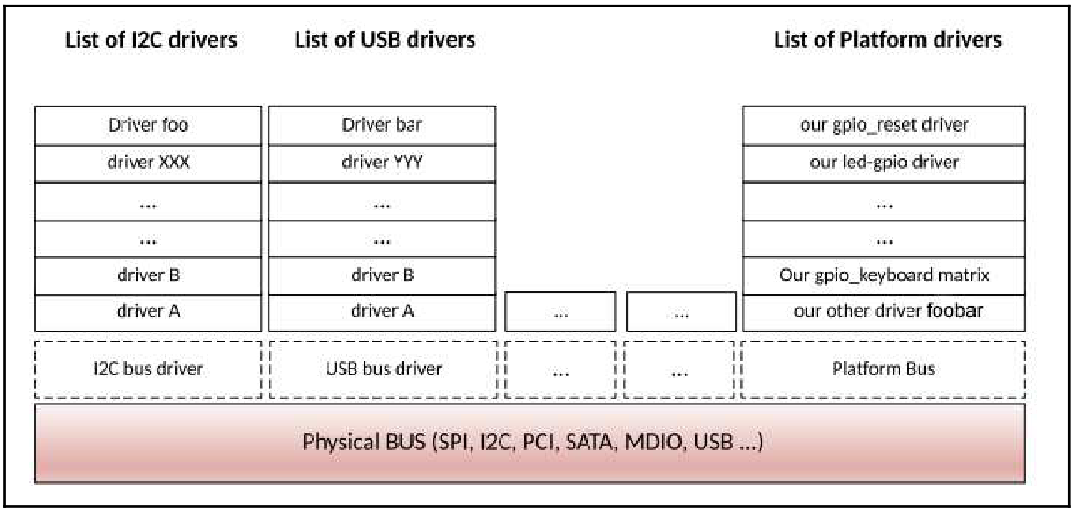
Every registered drivers and devices sit on a bus. This makes a tree. USB buses may be children of PCI buses, whereas MDIO buses are generally children of other devices, and so on. Thus, our preceding figure changes as follows:
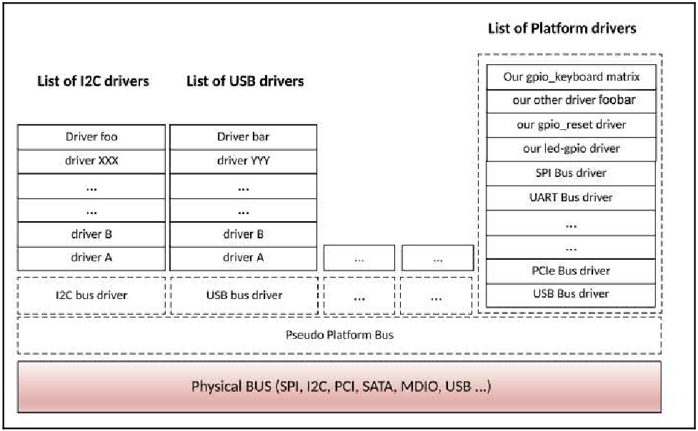
When you register a driver with the platform_driver_probe() function, the kernel walks through the table of registered platform devices and looks for a match. If any, it calls the matched driver's probe function with the platform data.
How can platform devices and platform drivers
match?
So far, we have only discussed how to fill different structures of both devices and drivers.But now we will see how they are registered with the kernel, and how Linux knows which devices are handled by which driver. The answer is MODULE_DEVICE_TABLE. This macro lets a driver expose its ID table, which describes which devices it can support. In the meantime, if the driver can be compiled as a module, the driver.name field should match the module name. If it does not match, the module won't be automatically loaded, unless we have used the MODULE_ALIAS macro to add another name for the module. At
compilation time, that information is extracted from all the drivers in order to build a device table. When the kernel has to find the driver for a device (when a matching needs to be performed), the device table is walked through by the kernel. If an entry is found matching the compatible (for device tree), device/vendor id or name (for device ID table or name) of the added device, then the module providing that match is loaded (running the
module's init function), and the probe function is called. The MODULE_DEVICE_TABLE macro is defined in linux/module.h:
#define MODULE_DEVICE_TABLE(type, name)
The following is the description of each parameter given to this macro:
- type: This can be either i2c, spi, acpi, of, platform, usb, pci or any other bus which you may find in include/linux/mod_devicetable.h. It depends on the bus our device sits on, or on the matching mechanism we want to use.
- name: This is a pointer on a XXX_device_id array, used for device matching. If we were talking about I2C devices, the structure would be i2c_device_id. For SPI device, it should be spi_device_id, and so on. For the device tree Open Firmware (OF) matching mechanism, we must use of_device_id.
For new non-discoverable platform device drivers, it is recommended not to use platform data anymore, but to use device tree capabilities instead, with OF matching mechanism. Please do note that the two methods are
not mutually exclusive, thus one can mix these together.
Let's get deeper into the details for matching mechanisms, except for the OF style match which we will discuss in Chapter 6, The Concept of Device Tree.
Kernel devices and drivers-matching function
The function responsible for platform devices and driver-matching functions in kernel is defined in /drivers/base/platform.c as follows:
static int platform_match(struct device *dev, struct device_driver *drv)
{
struct platform_device *pdev = to_platform_device(dev);
struct platform_driver *pdrv = to_platform_driver(drv);

/* When driver_override is set, only bind to the matching driver */
if (pdev->driver_override)
return !strcmp(pdev->driver_override, drv->name);

/* Attempt an OF style match first */
if (of_driver_match_device(dev, drv))
return 1;

/* Then try ACPI style match */
if (acpi_driver_match_device(dev, drv))
return 1;

/* Then try to match against the id table */
if (pdrv->id_table)
return platform_match_id(pdrv->id_table, pdev) != NULL;

/* fall-back to driver name match */
return (strcmp(pdev->name, drv->name) == 0);
}
We can enumerate four matching mechanisms. They are all based on the string compare. If we have a look at platform_match_id, we'll understand how things work underneath:
static const struct platform_device_id *platform_match_id(
const struct platform_device_id *id,
struct platform_device *pdev)
{
while (id->name[0]) {
if (strcmp(pdev->name, id->name) == 0) {
pdev->id_entry = id;
return id;
}
id++;
}
return NULL;
}

Now let's have a look at the struct device_driver structure we discussed in Chapter 4, Character Device Drivers:
struct device_driver {
const char *name;
[...]
const struct of_device_id *of_match_table;
const struct acpi_device_id *acpi_match_table;
};
I intentionally removed fields that we are not interested in. struct device_driver forms the basis of every device driver. Whether it is an I2C, SPI, TTY, or other device driver, they all embed a struct device_driver element. OF style and ACPI match OF style is explained in Chapter 6, The Concept of evice Tree. The second mechanism is an ACPI table-based matching. We'll not discuss it at all in this book, but for your information, it uses struct acpi_device_id. ID table matching This match style has been for a long time, and is based on the struct device_id structure. All device id structures are defined in include/linux/mod_devicetable.h. To find the right structure name, you need to prefix device_id with the bus name whom your device driver seats on. Examples are: struct i2c_device_id for I2C, struct platform_device_id for platform devices (that don't sit on a real physical bus), spi_device_id for SPI devices, usb_device_id for USB, and so on. The typical structure of a device_id table for a platform device is as follows:
struct platform_device_id {
char name[PLATFORM_NAME_SIZE];
kernel_ulong_t driver_data;
};
Anyway, if an ID table is registered, it will be walked through whenever the kernel has run the match function to find a driver for an unknown or new platform device. If there is a match, the probe function of the matched driver will be invoked, and given as a parameter a struct platform_device, which will hold a pointer to the matching ID table entry that originated the match. The .driver_data element is an unsigned long, which is sometimes casted into pointer addresses in order to point to anything, just like in the serial- imx driver. The following is an example with platform_device_id in drivers/tty/serial/imx.c:
static const struct platform_device_id imx_uart_devtype[] = {
{
.name = "imx1-uart",
.driver_data = (kernel_ulong_t)
&imx_uart_devdata[IMX1_UART],
},
{
.name = "imx21-uart",
.driver_data = (kernel_ulong_t)
&imx_uart_devdata[IMX21_UART],
},
{
.name = "imx6q-uart",
.driver_data = (kernel_ulong_t)
&imx_uart_devdata[IMX6Q_UART],
},
{
/* sentinel */
}
};
The .name field must be the same as the device's name you give when you register the device in the board specific file. The function responsible for this match style is platform_match_id. If you look at its definition in drivers/base/platform.c, you'll see:
static const struct platform_device_id *platform_match_id(
const struct platform_device_id *id,
struct platform_device *pdev)
{
while (id->name[0]) {
if (strcmp(pdev->name, id->name) == 0) {
pdev->id_entry = id;
return id;
}
id++;
}
return NULL;
}

In the following example, which is an excerpt from drivers/tty/serial/imx.c in kernel sources, one can see how the platform data is converted back into the original data structure, just by casting. That is how people sometimes pass any data structure as platform data:
static void serial_imx_probe_pdata(struct imx_port *sport,
struct platform_device *pdev)
{
struct imxuart_platform_data *pdata =
dev_get_platdata(&pdev->dev);
sport->port.line = pdev->id;
sport->devdata =
(structimx_uart_data *) pdev->id_entry->driver_data;
if (!pdata)
return;
[...]
}
pdev->id_entry is a struct platform_device_id, which is a pointer to the matching ID table entry made available by the kernel, and whose driver_data element is casted back to a pointer on the data structure. Per device-specific data on ID table matching In the previous section, we have used platform_device_id.platform_data as a pointer. Your driver may need to support more than one device type. In this situation, you will need specific device data for each device type you support. You should then use the device id as an index to an array that contains every possible device data, and not as a pointer address anymore. The following are detailed steps in an example:
- We define an enumeration, depending on the device type that we need to1 support in our driver:
enum abx80x_chip {
AB0801,
AB0803,
AB0804,
AB0805,
AB1801,
AB1803,
AB1804,
AB1805,
ABX80X
};
- We define the specific data-type structure:
struct abx80x_cap {
u16 pn;
boolhas_tc;
};
- We fill an array with default values, and depending on the index in device_id, we can pick the right data:
static struct abx80x_cap abx80x_caps[] = {
[AB0801] = {.pn = 0x0801},
[AB0803] = {.pn = 0x0803},
[AB0804] = {.pn = 0x0804, .has_tc = true},
[AB0805] = {.pn = 0x0805, .has_tc = true},
[AB1801] = {.pn = 0x1801},
[AB1803] = {.pn = 0x1803},
[AB1804] = {.pn = 0x1804, .has_tc = true},
[AB1805] = {.pn = 0x1805, .has_tc = true},
[ABX80X] = {.pn = 0}
};
- We define our platform_device_id with a specific index:
static const struct i2c_device_id abx80x_id[] = {
{ "abx80x", ABX80X },
{ "ab0801", AB0801 },
{ "ab0803", AB0803 },
{ "ab0804", AB0804 },
{ "ab0805", AB0805 },
{ "ab1801", AB1801 },
{ "ab1803", AB1803 },
{ "ab1804", AB1804 },
{ "ab1805", AB1805 },
{ "rv1805", AB1805 },
{ }
};
- Here we just have to do the stuff in the probe function:
static int rs5c372_probe(struct i2c_client *client,
const struct i2c_device_id *id)
{
[...]
/* We pick the index corresponding to our device */
int index = id->driver_data;
/*
* And then, we can access the per device data
* since it is stored in abx80x_caps[index]
*/
}

Name matching - platform device name matching
Now-a-days most platform drivers do not provide any table at all; they simply fill the name of the driver itself in the driver's name field. But the matching works because, if you look at the platform_match function, you will see that at the end the match falls back to name matching, comparing the driver's name and the device's name. Some older drivers still use that matching mechanism. The following is name matching from sound/soc/fsl/imx-ssi.c:
static struct platform_driver imx_ssi_driver = {
.probe = imx_ssi_probe,
.remove = imx_ssi_remove,
/* As you can see here, only the 'name' field is filled */
.driver = {
.name = "imx-ssi",
},
};
module_platform_driver(imx_ssi_driver);

To add a device that matches this driver, one must call platform_device_register or platform_add_devices, with the same name imx-ssi, in the board-specific file (usually in arch/<your_arch>/mach-*/board-*.c). For our quad core i.MX6-based UDOO, it is arch/arm/mach-imx/mach-imx6q.c.

