**INFO 6205**

**Program Structures & Algorithms**

**Fall 2020**

**Assignment No 4**

* **Task**
* For weighted quick union, store the depth rather than the size; (https://github.com/tracy626/INFO6205/blob/master/src/main/java/edu/neu/coe/info6205/union_find/WQU.java)
* For weighted quick union with path compression, do simpler one-pass variant (path-halving) alternates, make every other node in path point to its grandparent. (https://github.com/tracy626/INFO6205/blob/master/src/main/java/edu/neu/coe/info6205/union_find/WQUPC2.java)
* For both of these, also, benchmark them. (https://github.com/tracy626/INFO6205/blob/master/src/main/java/edu/neu/coe/info6205/util/Benchmark_Timer.java)
* **Output**
* Weighted Quick Union (store with depth):

Number of sites n = 10

union (4, 1)

union (1, 4)

union (5, 7)

union (9, 1)

union (5, 2)

union (0, 8)

union (6, 4)

union (2, 7)

union (2, 1)

union (8, 6)

union (1, 0)

union (5, 0)

union (5, 5)

union (1, 1)

union (5, 7)

union (7, 0)

union (7, 6)

union (1, 7)

union (1, 1)

union (4, 7)

union (4, 3)

WQU:

count: 1

parents: [5, 4, 5, 5, 9, 5, 9, 5, 0, 5]

depths: [1, 2, 1, 1, 2, 0, 2, 1, 2, 1]

Initiate with 10 sites and generate 21 connections

* Benchmark of Weighted Quick Union (store with depth):

2020-10-12 19:26:39 INFO Benchmark_Timer - Begin run: Weighted Quick Union (Store Size) with 5 runs

Initiate with 10000 sites and generate 58500 connections

Initiate with 10000 sites and generate 50902 connections

Initiate with 10000 sites and generate 45497 connections

Initiate with 10000 sites and generate 52350 connections

Initiate with 10000 sites and generate 40449 connections

Initiate with 10000 sites and generate 47409 connections

Initiate with 10000 sites and generate 45769 connections

Average time of connect 10000 sites by Weighted Quick Union is 5.4 ms

2020-10-12 19:26:39 INFO Benchmark_Timer - Begin run: Weighted Quick Union (Store Size) with 5 runs

Initiate with 20000 sites and generate 97760 connections

Initiate with 20000 sites and generate 107280 connections

Initiate with 20000 sites and generate 94895 connections

Initiate with 20000 sites and generate 116870 connections

Initiate with 20000 sites and generate 88274 connections

Initiate with 20000 sites and generate 103411 connections

Initiate with 20000 sites and generate 93340 connections

Average time of connect 20000 sites by Weighted Quick Union is 8.8 ms

2020-10-12 19:26:39 INFO Benchmark_Timer - Begin run: Weighted Quick Union (Store Size) with 5 runs

Initiate with 40000 sites and generate 253267 connections

Initiate with 40000 sites and generate 196571 connections

Initiate with 40000 sites and generate 265894 connections

Initiate with 40000 sites and generate 191104 connections

Initiate with 40000 sites and generate 232166 connections

Initiate with 40000 sites and generate 234765 connections

Initiate with 40000 sites and generate 242127 connections

Average time of connect 40000 sites by Weighted Quick Union is 32.2 ms

2020-10-12 19:26:39 INFO Benchmark_Timer - Begin run: Weighted Quick Union (Store Size) with 5 runs

Initiate with 80000 sites and generate 433119 connections

Initiate with 80000 sites and generate 427897 connections

Initiate with 80000 sites and generate 449222 connections

Initiate with 80000 sites and generate 571460 connections

Initiate with 80000 sites and generate 454066 connections

Initiate with 80000 sites and generate 443735 connections

Initiate with 80000 sites and generate 587140 connections

Average time of connect 80000 sites by Weighted Quick Union is 75.2 ms

2020-10-12 19:26:40 INFO Benchmark_Timer - Begin run: Weighted Quick Union (Store Size) with 5 runs

Initiate with 160000 sites and generate 925883 connections

Initiate with 160000 sites and generate 885718 connections

Initiate with 160000 sites and generate 1223522 connections

Initiate with 160000 sites and generate 1086319 connections

Initiate with 160000 sites and generate 1241024 connections

Initiate with 160000 sites and generate 958188 connections

Initiate with 160000 sites and generate 923118 connections

Average time of connect 160000 sites by Weighted Quick Union is 118.8 ms

* Weighted Quick Union with Path Compression (one-pass variant):

Number of sites n = 10

union (4, 4)

union (2, 9)

union (6, 0)

union (4, 6)

union (1, 2)

union (3, 7)

union (6, 2)

union (5, 2)

union (3, 7)

union (7, 9)

union (1, 3)

union (9, 1)

union (6, 8)

WQUPC:

count: 1

parents: [6, 6, 6, 6, 6, 6, 6, 3, 6, 6]

sizes: [1, 1, 1, 2, 1, 1, 10, 1, 1, 1]

Initiate with 10 sites and generate 13 connections

* Benchmark of Weighted Quick Union with Path Compression (one-pass variant):

2020-10-12 19:28:49 INFO Benchmark_Timer - Begin run: Weighted Quick Union with Pass Compression (one-path variant) with 5 runs

Initiate with 10000 sites and generate 46523 connections

Initiate with 10000 sites and generate 64880 connections

Initiate with 10000 sites and generate 49098 connections

Initiate with 10000 sites and generate 50305 connections

Initiate with 10000 sites and generate 63903 connections

Initiate with 10000 sites and generate 47185 connections

Initiate with 10000 sites and generate 42390 connections

Average time of connect 10000 sites by Weighted Quick Union is 5.4 ms

2020-10-12 19:28:49 INFO Benchmark_Timer - Begin run: Weighted Quick Union with Pass Compression (one-path variant) with 5 runs

Initiate with 20000 sites and generate 98031 connections

Initiate with 20000 sites and generate 99108 connections

Initiate with 20000 sites and generate 97626 connections

Initiate with 20000 sites and generate 103900 connections

Initiate with 20000 sites and generate 102686 connections

Initiate with 20000 sites and generate 132601 connections

Initiate with 20000 sites and generate 96589 connections

Average time of connect 20000 sites by Weighted Quick Union is 10.2 ms

2020-10-12 19:28:49 INFO Benchmark_Timer - Begin run: Weighted Quick Union with Pass Compression (one-path variant) with 5 runs

Initiate with 40000 sites and generate 199198 connections

Initiate with 40000 sites and generate 200569 connections

Initiate with 40000 sites and generate 197352 connections

Initiate with 40000 sites and generate 217554 connections

Initiate with 40000 sites and generate 197141 connections

Initiate with 40000 sites and generate 201074 connections

Initiate with 40000 sites and generate 206677 connections

Average time of connect 40000 sites by Weighted Quick Union is 17.0 ms

2020-10-12 19:28:49 INFO Benchmark_Timer - Begin run: Weighted Quick Union with Pass Compression (one-path variant) with 5 runs

Initiate with 80000 sites and generate 504812 connections

Initiate with 80000 sites and generate 525677 connections

Initiate with 80000 sites and generate 437987 connections

Initiate with 80000 sites and generate 514159 connections

Initiate with 80000 sites and generate 399747 connections

Initiate with 80000 sites and generate 459034 connections

Initiate with 80000 sites and generate 516475 connections

Average time of connect 80000 sites by Weighted Quick Union is 45.6 ms

2020-10-12 19:28:49 INFO Benchmark_Timer - Begin run: Weighted Quick Union with Pass Compression (one-path variant) with 5 runs

Initiate with 160000 sites and generate 1002378 connections

Initiate with 160000 sites and generate 917658 connections

Initiate with 160000 sites and generate 1094267 connections

Initiate with 160000 sites and generate 1103098 connections

Initiate with 160000 sites and generate 877551 connections

Initiate with 160000 sites and generate 921784 connections

Initiate with 160000 sites and generate 1003802 connections

Average time of connect 160000 sites by Weighted Quick Union is 92.2 ms

* **Conclusion**
* Weighted Quick Union with Path Compression (one-pass variant):

Running time is about T = 1.7 x 10-7 x N1.15 s, N is the input number of sites to union and the final count of components is 1.

* For Weighted Quick Union stored with depth

Running time is about T = 2.5 x 10-7 x N1.15 s, N is the input number of sites to union and the final count of components is 1.

* **Evidence to support**
* Weighted Quick Union with Path Compression (one-pass variant):

Running time is about *a N b* with *b* = lg ratio.

19882.1 x 10-3 = *a* x 102400001.15

*a* = 1.7 x 10-7

Running time is about 1.7 x 10-7 x N1.15 seconds.

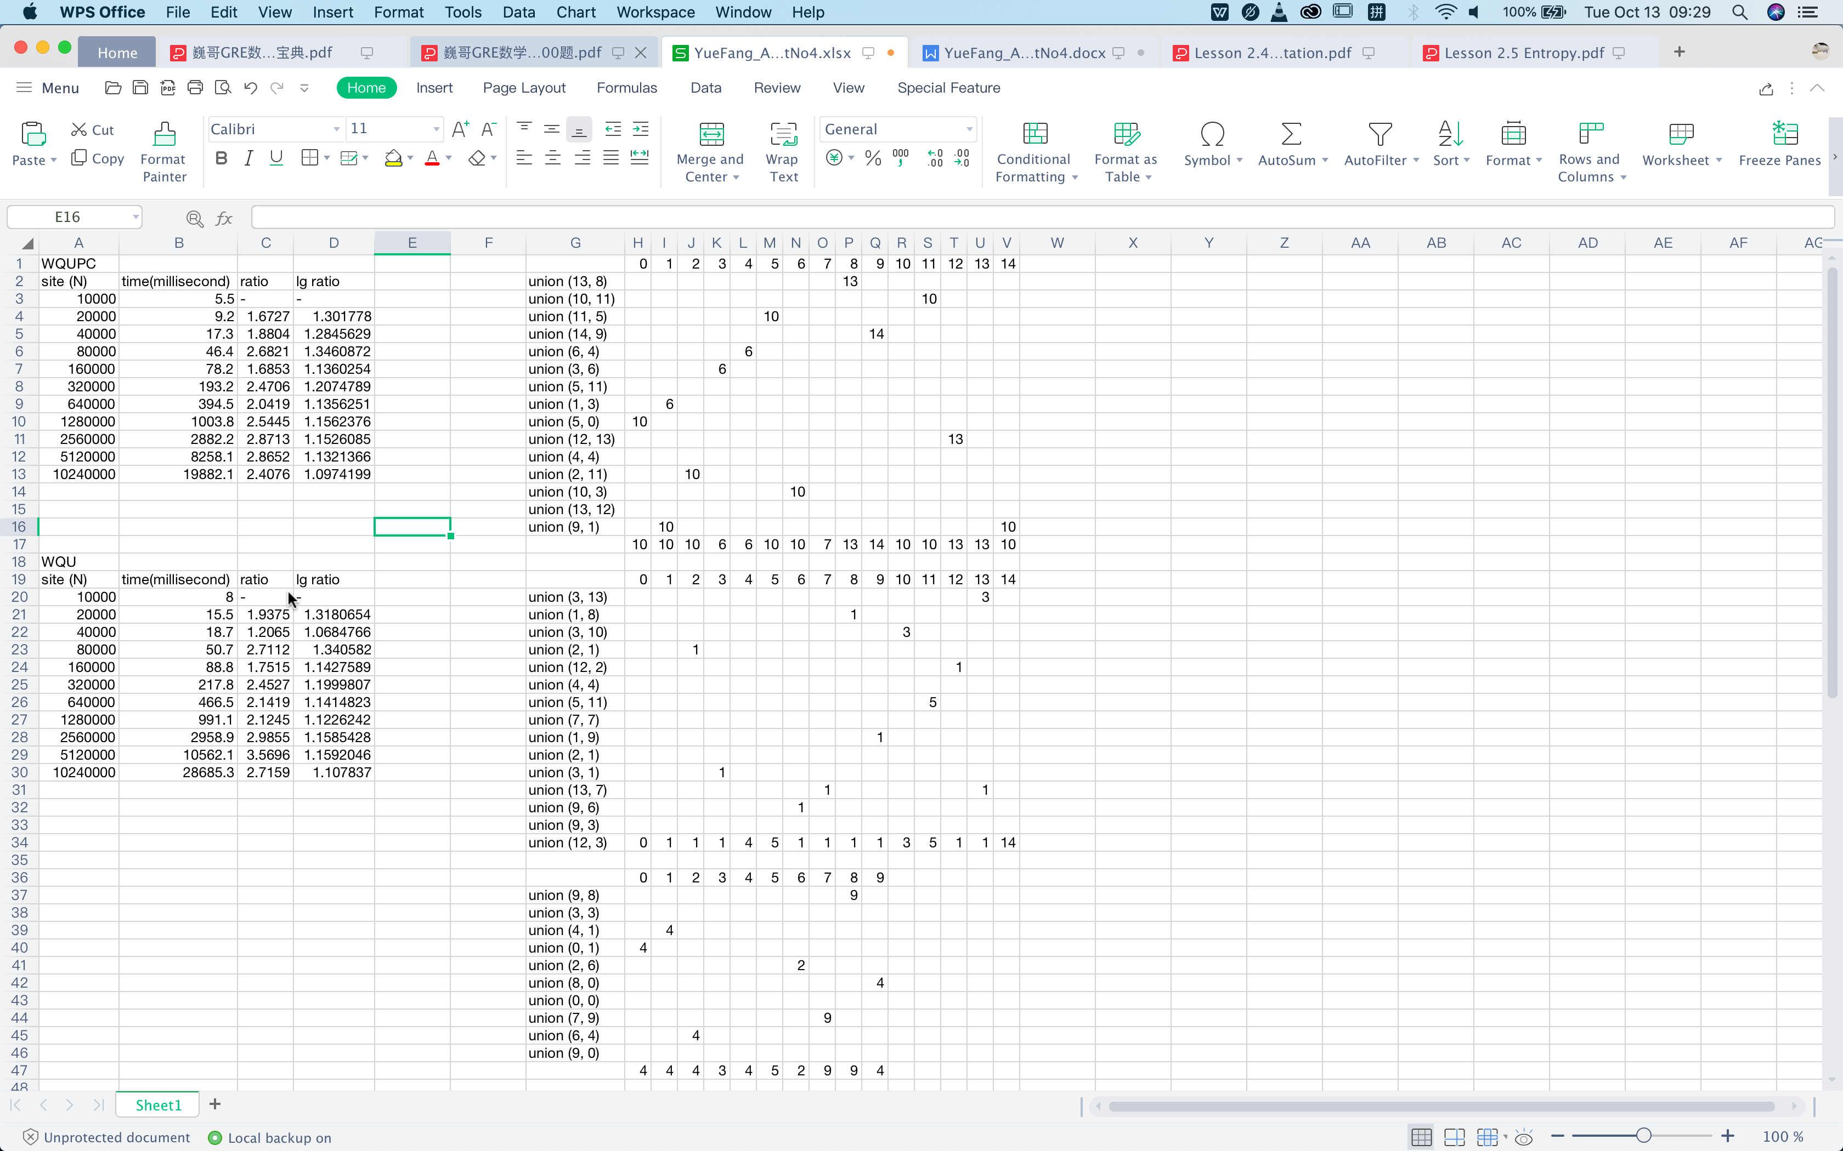

* For Weighted Quick Union stored with Depth:

Running time is about *a N b* with *b* = lg ratio.

28685.3 x 10-3 = *a* x 102400001.15

*a* = 2.5 x 10-7

Running time is about 2.5 x 10-7 x N1.15 seconds.



* **Screenshot of Unit test passing**
* Union Test of Weighted Quick Union:

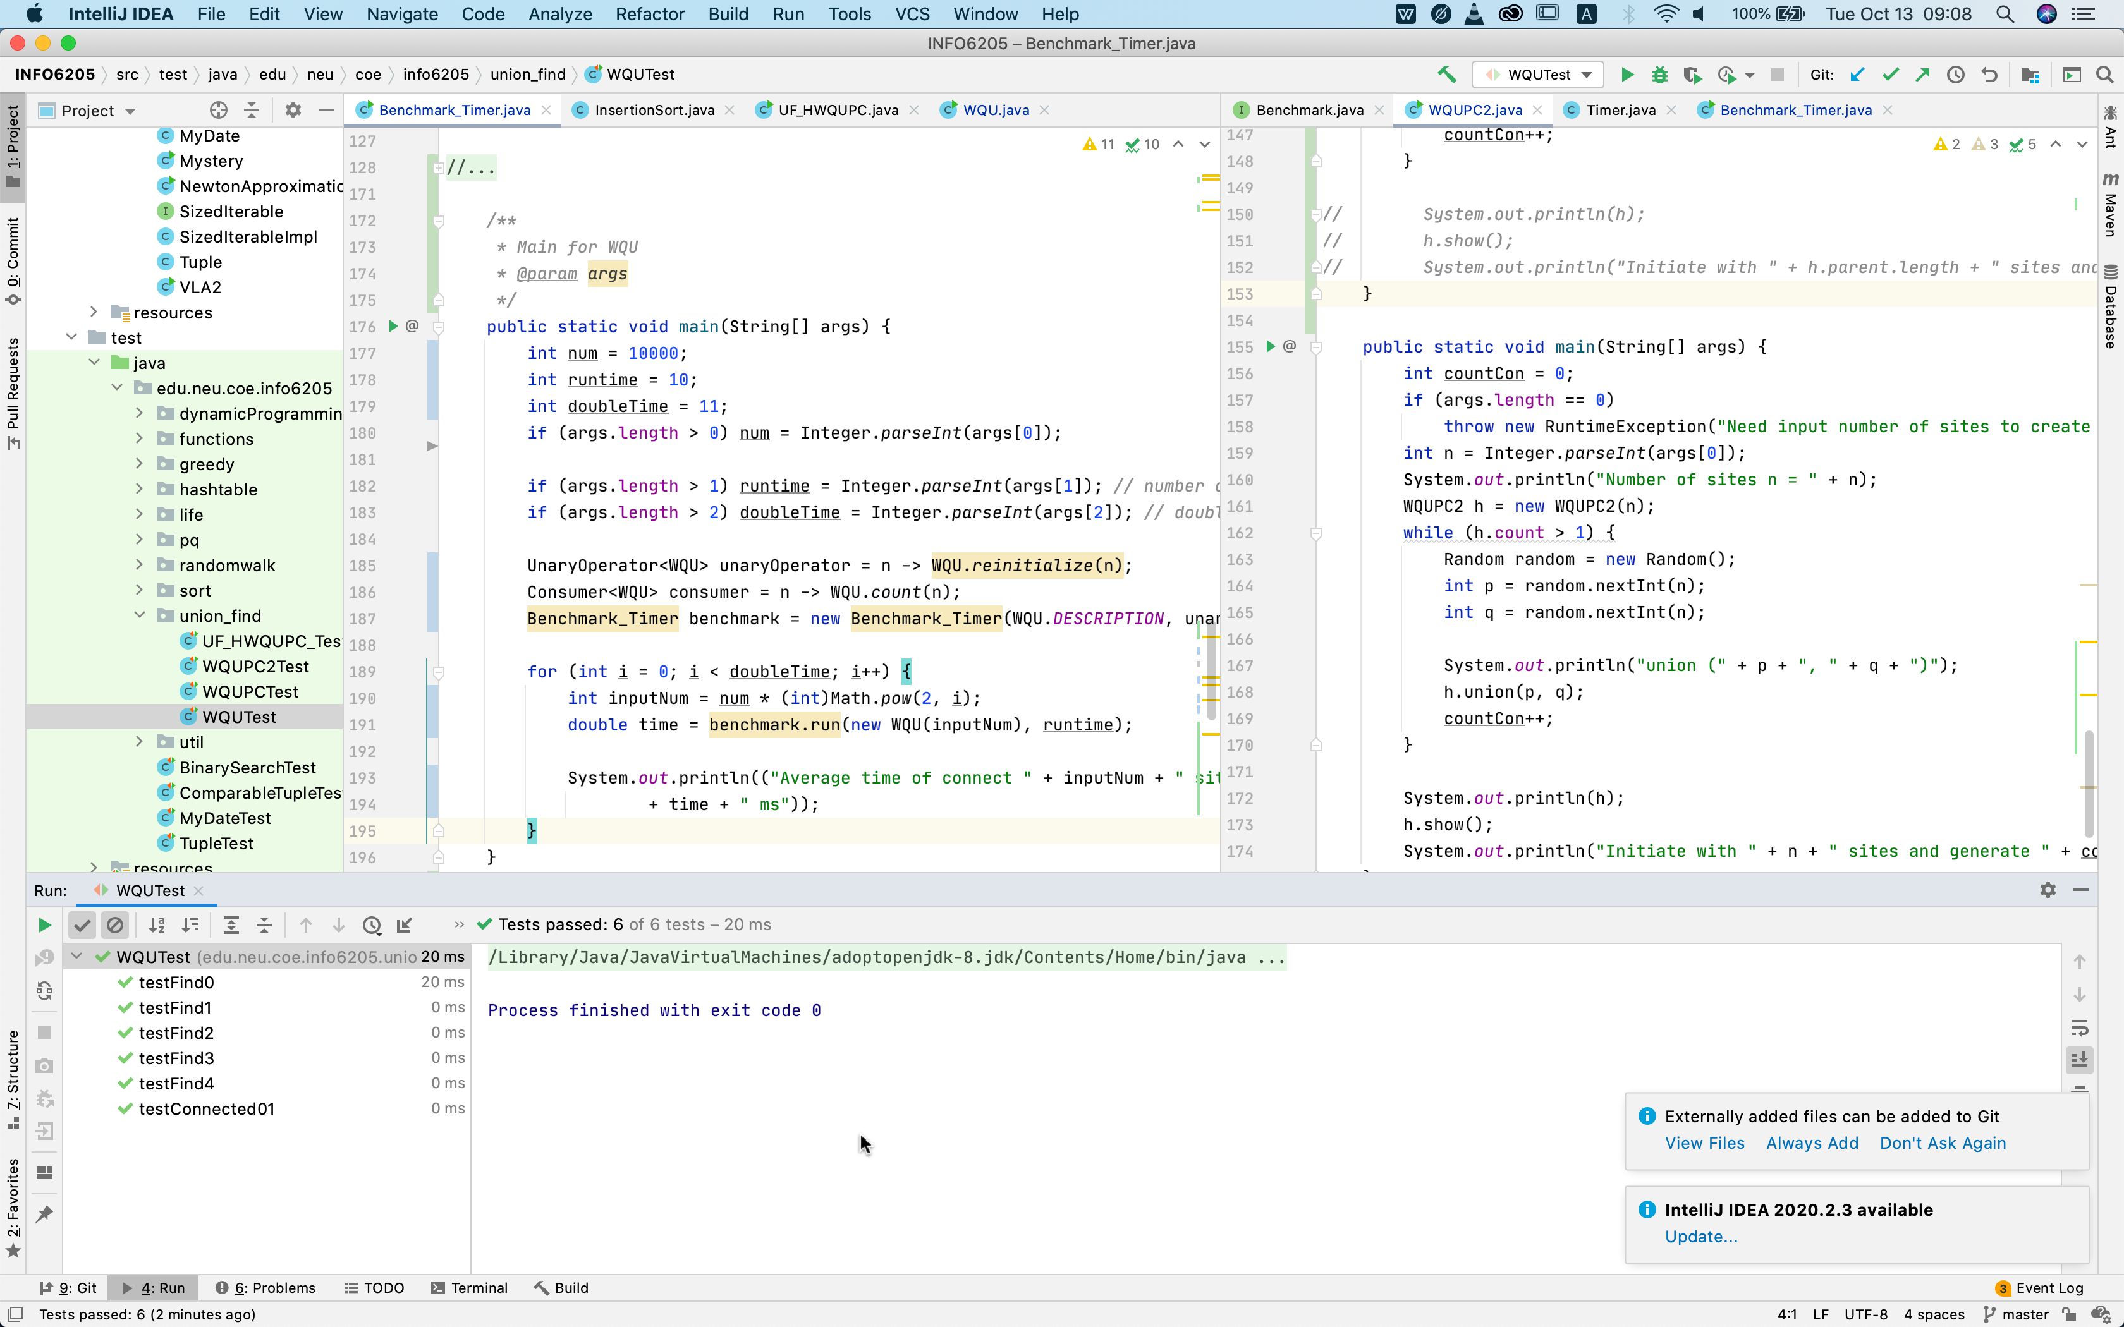

* Union Test of Weighted Quick Union with Path Compression:

