**INFO 6205**

**Program Structures & Algorithms**

**Fall 2020**

**Assignment No 3**

* **Task**
* Implement height-weighted Quick Union with Path Compression.
* Using UF_HWQUPC, generates random pairs of integers and union.
* Get the number of connections and draw conclusion on the relationship between number of sites to union and number of pairs generated.
* **Output**

UF_HWQUPC:

count: 2

path compression? true

parents: [0, 27, 27, 27, 27, 27, 27, 27, 27, 27, 27, 27, 27, 27, 27, 27, 27, 27, 27, 27, 27, 27, 27, 27, 27, 27, 27, 27, 27, 27, 27, 27, 27, 0, 27, 27, 27, 27, 27, 27, 27, 27, 27, 27, 27, 27, 27, 27, 27, 27]

heights: [2, 1, 1, 1, 1, 1, 1, 1, 4, 1, 2, 1, 2, 1, 1, 5, 2, 2, 1, 1, 1, 1, 2, 1, 1, 2, 1, 48, 1, 1, 1, 1, 1, 1, 1, 2, 1, 4, 1, 2, 1, 1, 1, 1, 1, 1, 2, 1, 1, 1]

Initiate with 50 sites and generate 80 connections

UF_HWQUPC:

count: 1

path compression? true

parents: [25, 25, 25, 25, 25, 25, 25, 25, 25, 25, 25, 25, 25, 25, 25, 25, 25, 25, 25, 25, 25, 25, 25, 25, 25, 25, 25, 25, 25, 25, 25, 25, 25, 25, 25, 25, 25, 25, 25, 25, 25, 25, 25, 25, 25, 25, 25, 25, 25, 25, 25, 25, 25, 25, 25, 25, 25, 25, 25, 25, 25, 25, 25, 25, 25, 25, 25, 25, 25, 25, 25, 25, 25, 25, 25, 25, 25, 25, 25, 25, 25, 25, 25, 25, 25, 25, 25, 25, 25, 25, 25, 25, 25, 25, 25, 25, 25, 25, 25, 25]

heights: [1, 1, 1, 1, 1, 20, 4, 2, 1, 1, 1, 1, 2, 1, 1, 2, 1, 1, 1, 1, 1, 1, 3, 1, 1, 100, 1, 1, 1, 1, 8, 1, 3, 1, 1, 1, 2, 1, 1, 1, 1, 2, 1, 1, 2, 1, 1, 1, 2, 1, 1, 1, 1, 1, 6, 1, 1, 4, 1, 2, 2, 1, 1, 1, 1, 1, 2, 1, 1, 3, 1, 2, 1, 2, 1, 1, 1, 1, 1, 10, 1, 1, 8, 1, 4, 1, 1, 1, 1, 1, 1, 1, 1, 1, 1, 4, 1, 4, 1, 1]

Initiate with 100 sites and generate 278 connections

* **Conclusion**

Number M of connections generated to a set of N objects is about N1.16 = M

* **Evidence to support**

Tables of number of connections (M), number of objects (N), calculate the ratio of M/N and log of M base on N.

The result of lg ratio is approximately 1.16 when N comes bigger as shown in the table.

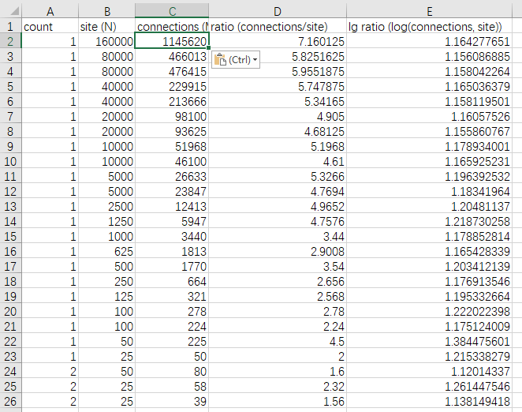

* **Screenshot of Unit test passing**

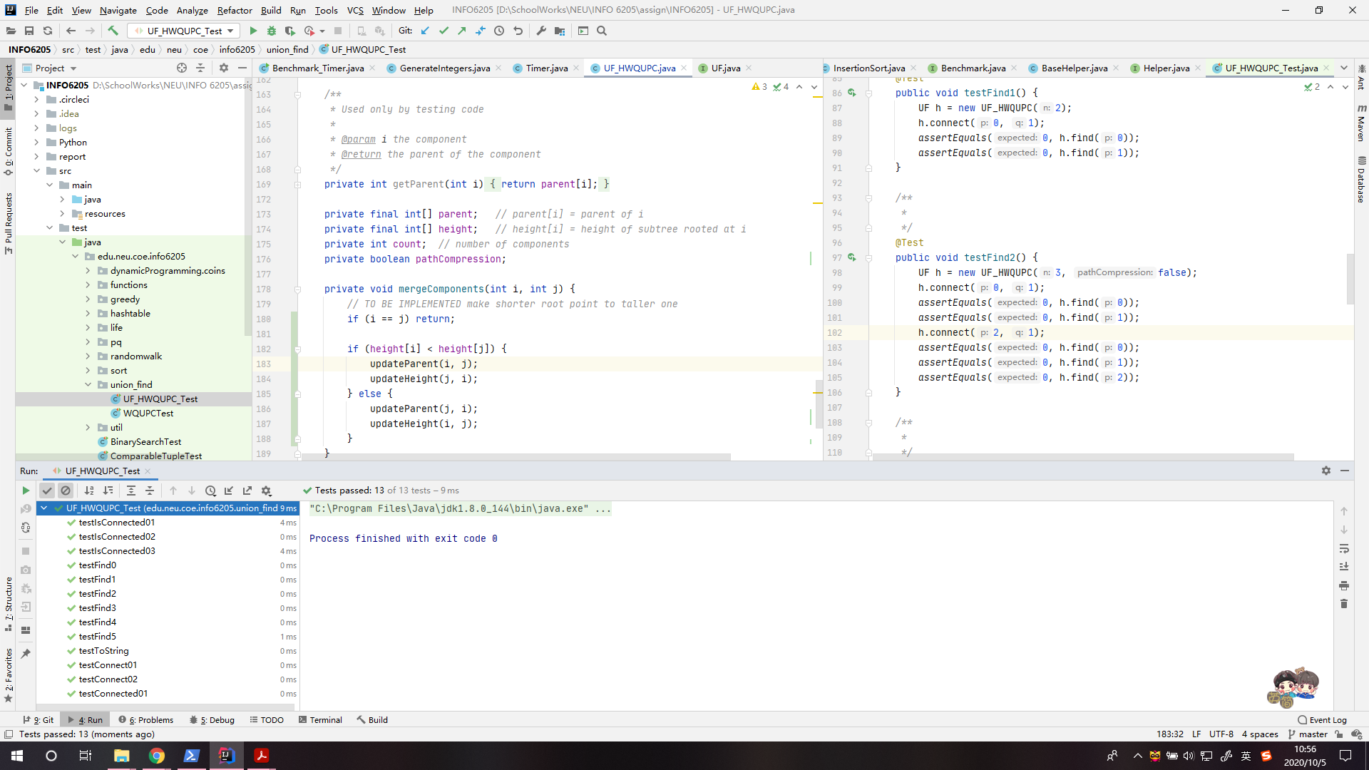UF_HWQUPC_Test: