**INFO 6205**

**Program Structures & Algorithms**

**Fall 2020**

**Assignment No 5**

* **Task**

Figure out the efficacy of the parallelizing merge sort, based on experiments of different array size, different number of threads and the cutoff determination.

* **Output**

Degree of parallelism: 15

The size of the array: 1000000

cutoff：20000 10times Time:902ms

cutoff：40000 10times Time:607ms

cutoff：60000 10times Time:544ms

cutoff：80000 10times Time:510ms

cutoff：100000 10times Time:423ms

cutoff：120000 10times Time:400ms

cutoff：140000 10times Time:320ms

......

* **Conclusion**

· For different array size:

Keep the cutoff the same number, if the array is smaller the average sort time will be shorter than the larger array.

· For different number of threads sorting parallel:

Within larger thread pool the average time is smaller (CPU of the machine used to do the experiments has 8 cores).

· For different cutoff:

In the experiments, when the ratio of cutoff and array size come to (012, 0.18) (approximately), the sort time seems to be smaller.

* **Evidence to support**

· For different number of threads:

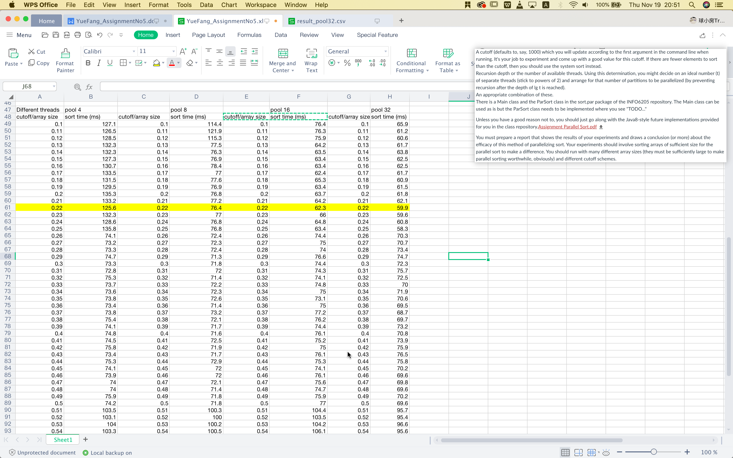

· For different array size & different cutoff:

