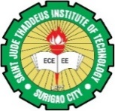
St. Jude Thaddeus Institute of Technology
Borromeo Street, Surigao City, Surigao del Norte, Philippines
Contact Nos.: 0917 105 8462 / 0917-105-3772
Email Add: sjtit1973@gmail.com / sjtit1977@sjtit.edu.ph
www.sjtit.edu.ph

PROJECT IN TM-2

Submitted by:
Alcero, Jann Wendyllyn C.
BSCA 1-B

Submitted to:
Ms. Jeany V. Senarillos
Instructor

PRELIM TOPICS

MIDTERM TOPICS

QUIZZES

