e1. Download github and install.

2. If you do not have an account please register for a github account.
Send your github account name to hammond@tamu.edu to get access to the repository.

3. Once you have access to the repository, open the github application on your computer, click the coursesketch repository and click “clone to computer”. Make sure to note the location that it is installed.

if you have a mac then you will have an easy life using github
if you have windows and you are struggling using github then you can download other git clients or if you are advance you just the command line. (something that will probably happen at least once because the windows interface sometimes breaks)

4a. Download intillij (latest version):
and install it (this is done by moving it the location you want to put it and open it)
If it does not open chances are that the sdk is not installed
google “java sdk 7” and follow the instructions to download it and install it.

When you open intillij for the first time it should look like this
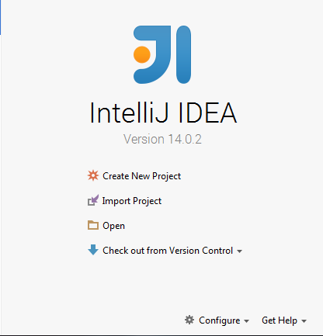
From this page we import the project

5. IMPORT PROJECT

On this page click import project

It should bring you to a file viewer. Find the coursesketch folder select it and press next
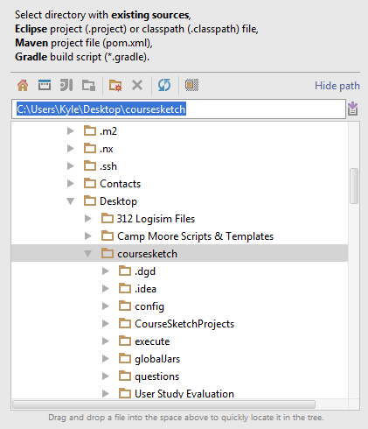
Here you select import project from external model and select maven.
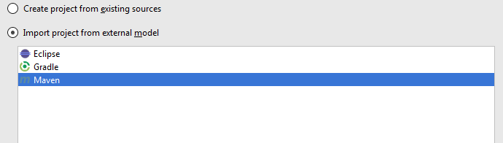

Click next till you find this screen
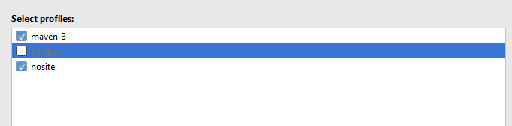

Click next till you find this screen: NOTE it may be blank
If it is blank press the + button and select the jdk you installed earlier (or install it now) The location of it is different for different operating so google “jdk location <OS>”
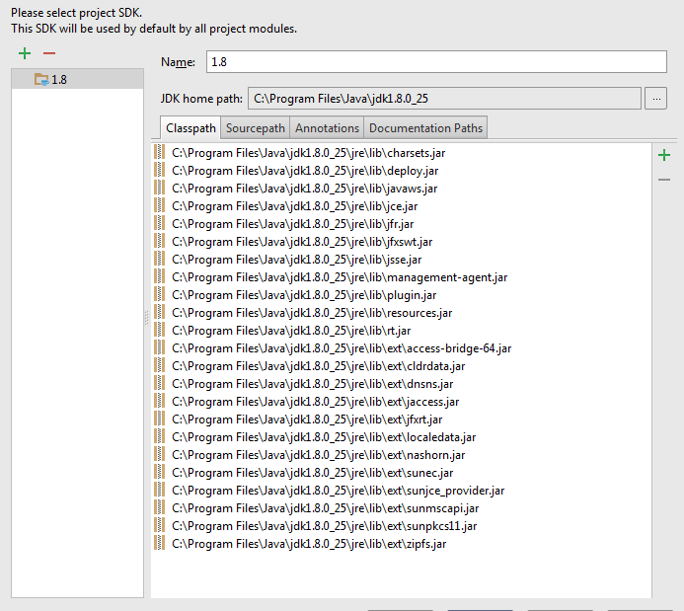
press next till you are done. It should show this on the left hand side.
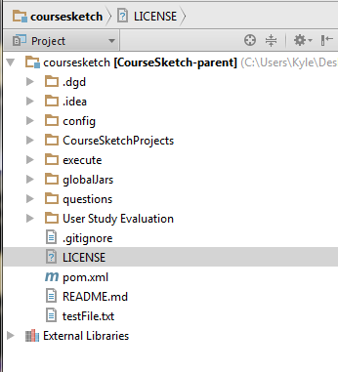

6. Download google app engine (python)
https://developers.google.com/appengine/downloads

7. IMPORT APPLICATION into Google App Engine
after downloading open up google app engine launcher (it may be various places depending on the operating system)

After opening up we go to file and add an existing application
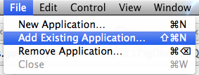
Navigate to course sketch and select “coursesketchwebclient”
click ok
after adding it should show a line in the launcher

9. Download and run mongodb
(http://docs.mongodb.org/manual/installation/)
You only have to run mongodb and the second half of the guide focuses on testing so you do not need to worry about

10. Download maven
if you have a package manager use that, if you are using windows then we have a script that should set it up for you. This can be found in the config section of course sketch.

If not windows (and no package manager):
google “install maven <OS>”
after it is installed you should be able to run:
mvn -v
and it should not throw any errors

the next thing you have to do is set the JAVA_HOME variable.
Mac
http://stackoverflow.com/a/26456579/2187510
Then
/usr/libexec/java_home -v '1.7*' Or 1.8* if you installed Java 8 instead

Windows
(something with variables MATT PLEASE FIX)

11. Download protobuf
We are currently using version 2.6
google “protobuf download 2.6”
then follow instructions

8. RUNNING APPLICATION
select the application and click the run button (should be an arrow)
after the browse button is available click browse.
(on a mac you may have to click on the launcher to have it redraw and enable the button)

To make the application point to a local server navigate to coursesketchwebclient then edit index.html (as a text file)

Running servers locally:

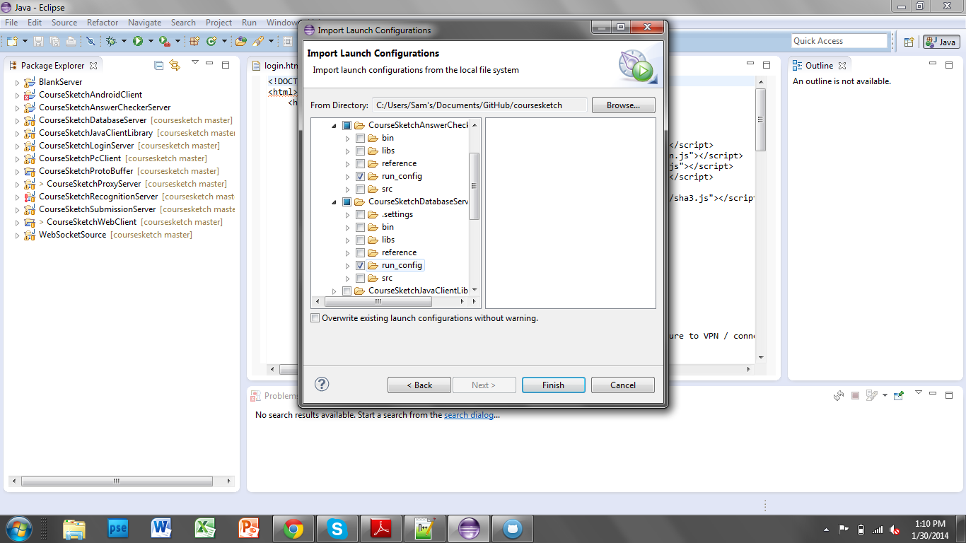

CREATING YOUR OWN LAUNCH CONFIGS

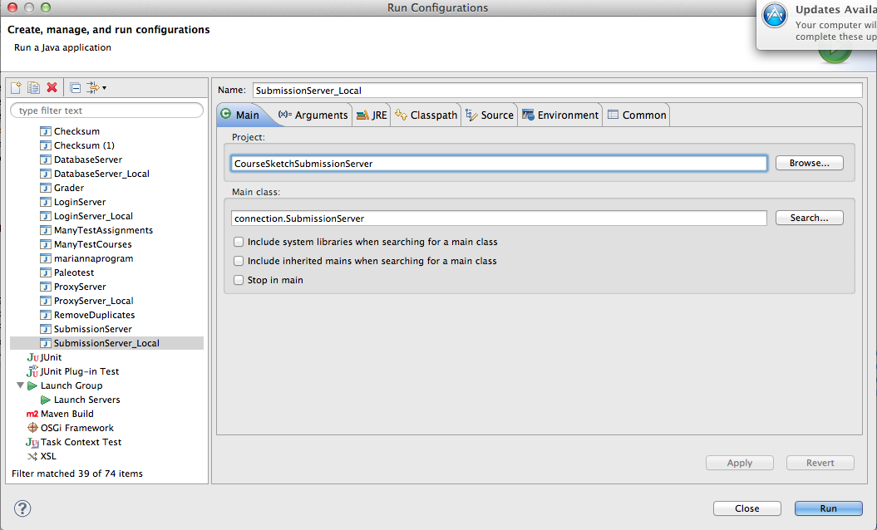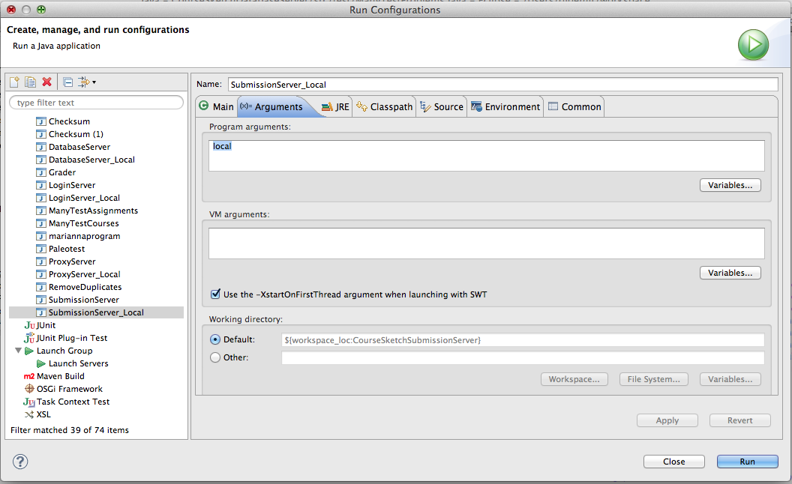

Run order:

LOGIN
DATABASE
SUBMISSION
ANSWER CHECKER
PROXY

