**1. Download github and install.**

**2. If you do not have an account please register for a github account.**

Send your github account name to [hammond@tamu.edu](mailto:hammond@tamu.edu) to get access to the repository.

**3. Clone**

Once you have access to the repository, open the github application on your computer, click the coursesketch repository and click “clone to computer”. **Make sure to note the location that it is installed.**

if you have a mac then you will have an easy life using github

if you have windows and you are struggling using github then you can download other git clients or if you are advance you just the command line. (something that will probably happen at least once because the windows interface sometimes breaks)

**4 Download intillij (latest version):**

and install it (this is done by moving it the location you want to put it and open it)

If it does not open chances are that the sdk is not installed

google “java sdk 7” and follow the instructions to download it and install it.

When you open intillij for the first time it should look like this

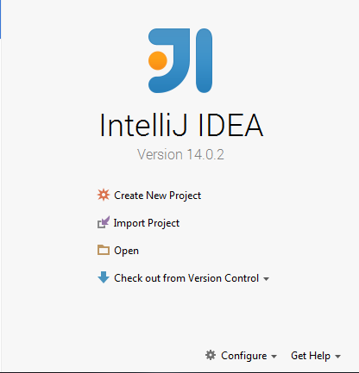

From this page we import the project

**5. IMPORT PROJECT**

**On this page click import project**



It should bring you to a file viewer. Find the coursesketch folder select it and press next

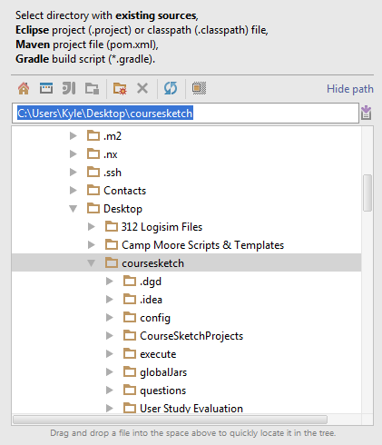

Here you select import project from external model and select maven.

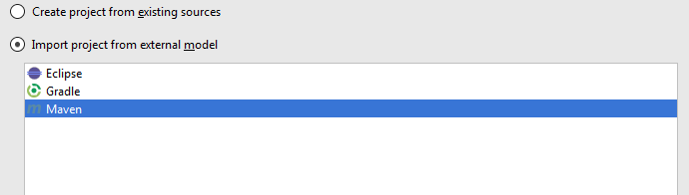

Click next till you find this screen

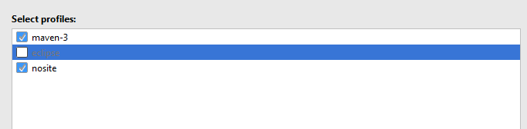

Click next till you find this screen: NOTE it may be blank

If it is blank press the + button and select the jdk you installed earlier (or install it now) The location of it is different for different operating so google “jdk location <OS>”

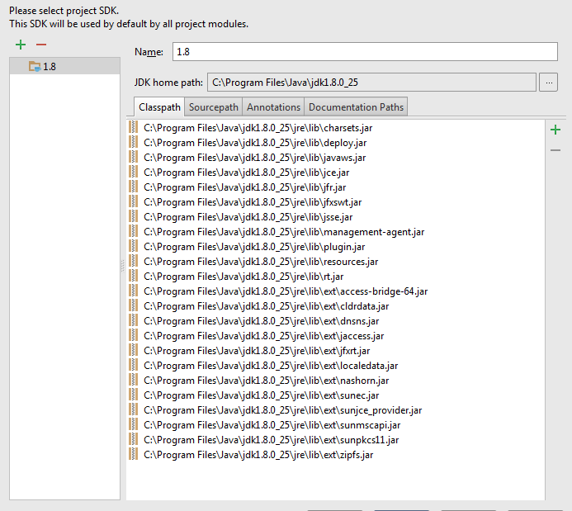

press next till you are done. It should show this on the left hand side.

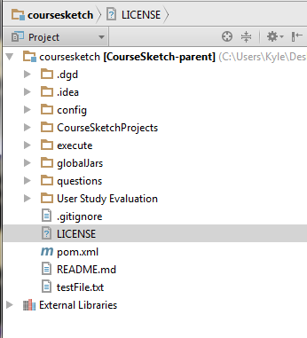

**6. Download google app engine (python)**

<https://developers.google.com/appengine/downloads>

**7. IMPORT APPLICATION into Google App Engine**

after downloading open up google app engine launcher (it may be various places depending on the operating system)

After opening up we go to file and add an existing application

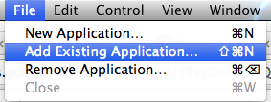

Navigate to course sketch -> CourseSketchProjects and select “coursesketchwebclient”

click ok

after adding it should show a line in the launcher

**8. RUNNING google app engine**

select the new application and click the run button (should be an arrow)

after the browse button is available click browse.

(on a mac you may have to click on the launcher to have it redraw and enable the button)

**9. Download and run mongodb**

(<http://docs.mongodb.org/manual/installation/>)

After you have installed it you only have to run mongodb (stop after step #2) and the second half of the guide focuses on testing so you do not need to worry about.

**10. Download maven**

if you have a package manager use that, if you are using windows then we have a script that *should* set it up for you. This can be found in the config section of course sketch.

If not windows (and no package manager):

google “install maven <OS>”

after it is installed you should be able to run:

**mvn -v**

and it should not throw any errors

the next thing you have to do is set the JAVA_HOME variable.

**Mac**

<http://stackoverflow.com/a/26456579/2187510>

Then

/usr/libexec/java_home -v '1.7*' Or 1.8* if you installed Java 8 instead

**Windows**

(something with variables MATT PLEASE FIX)

**11. Download protobuf**

We are currently using version 2.6

google “protobuf download 2.6”

then follow instructions

**12. Compiling servers**

On a mac open up terminal

change directory till you are inside course sketch:

On windows go to github and select the course sketch repo. Then open a terminal (it should open in the directory of CourseSketch)

Both:

$ mvn clean install -Dsmart -Dnosite

**Different possible errors:**

can not compile to target version 1.7: It means your JAVA_HOME is not set to the correct version (probably running 1.6) point it to 1.7 or 1.8 (which ever one you have)

JAVA_HOME is not defined: You never set the path for java home (needs to be found)

you have X number of checkstyle errors: Everything worked! you are good!

Can not find binary for protoc: it means protobuf is either in the wrong spot or was never installed correctly.

**13. Additional Setup**

**Import settings**

Import settings for intillij (this helps with auto formatting)

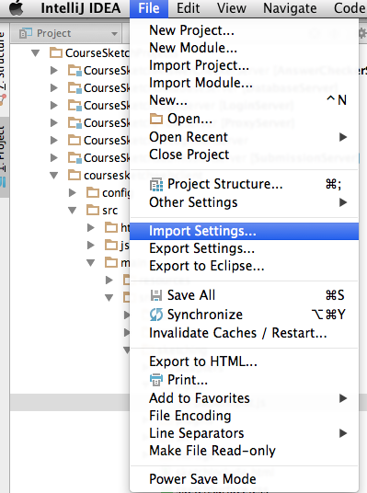

Choose the eclipse settings

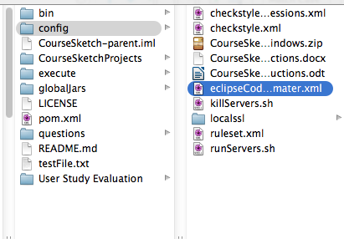

**Install checkstyle**

go to help -> find actions

then type plugins

then click browse repositories

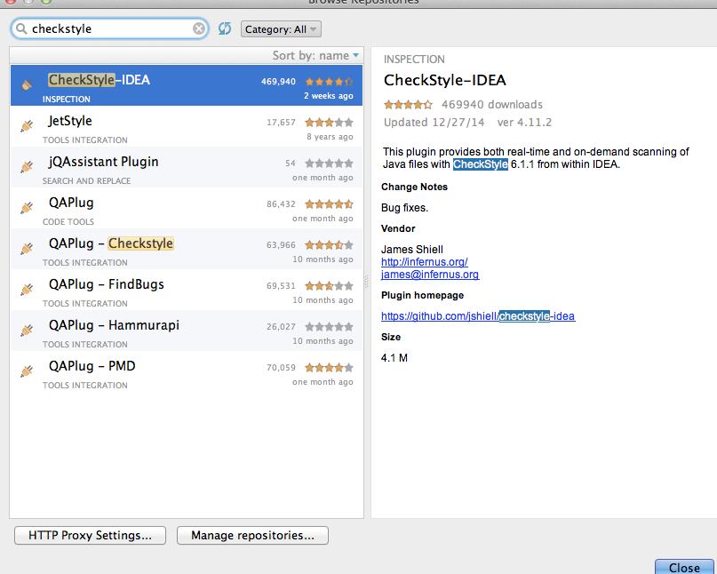

Now go to other settings

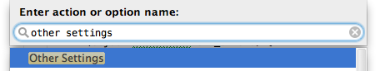

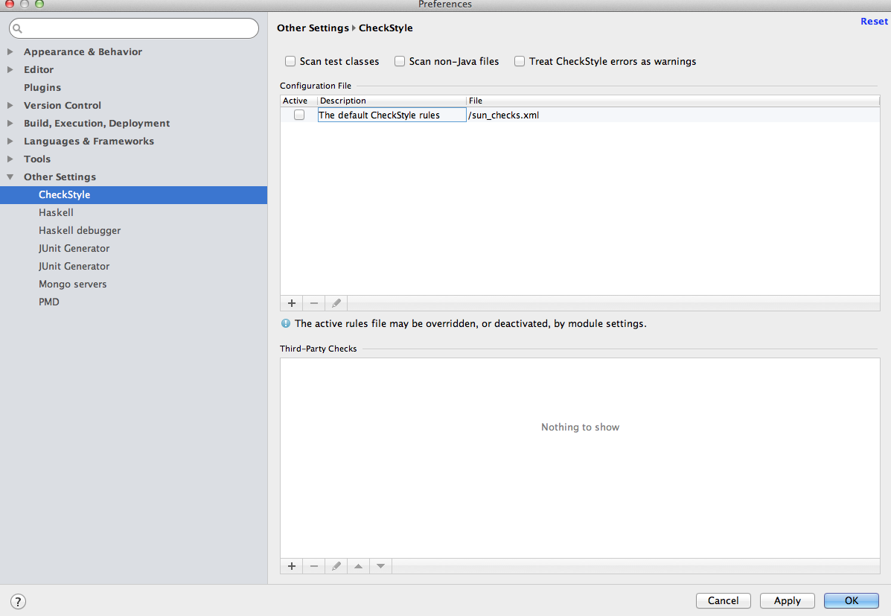

After you are at this page under “Configuration File” click the +

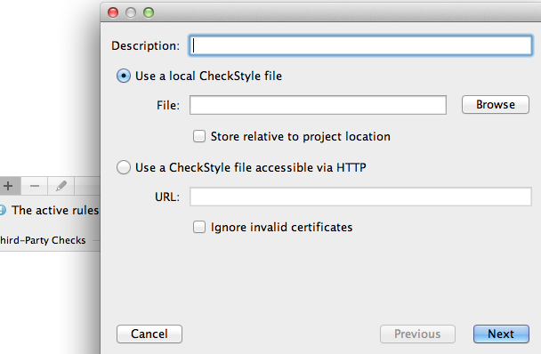

Click browse and find the file under config -> checkstyle.xml

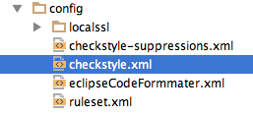

Add a description and click next then finish

And select the newly added line. And click Apply



**Install Multirun**

same process as above with installing checsktyle

go to plugins and browse repository but type “Multirun” instead

(this is the plugin webpage)

<https://plugins.jetbrains.com/plugin/7248?pr=idea>

When you add a new configuration you can create a multirun configuration that runs multiple run configurations (A lot of this is explained in running the application)

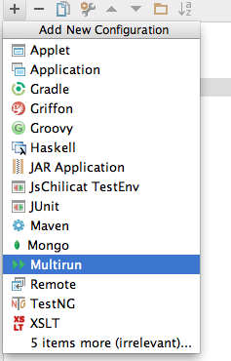

Here is what my run configuration looks like yours should end up looking very similar:

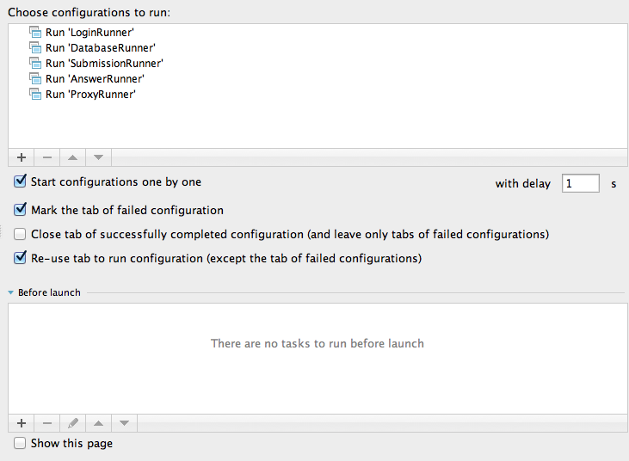

**14: RUNNING COURSE SKETCH**

App Engine

make sure google app engine is running (see #8)

Mongodb

Open up the terminal

type:

**mongod**

mongodbshould now be running

Servers

you have to create a launch configuration (select the down arrow next to the play arrow)

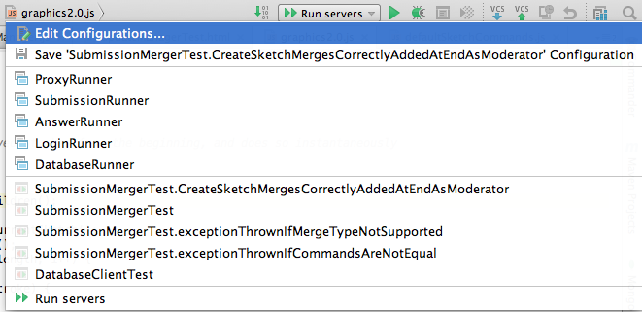

Click edit configurations

After the window pops up click the + button and choose “Application”

It should pop up with a blank configuration

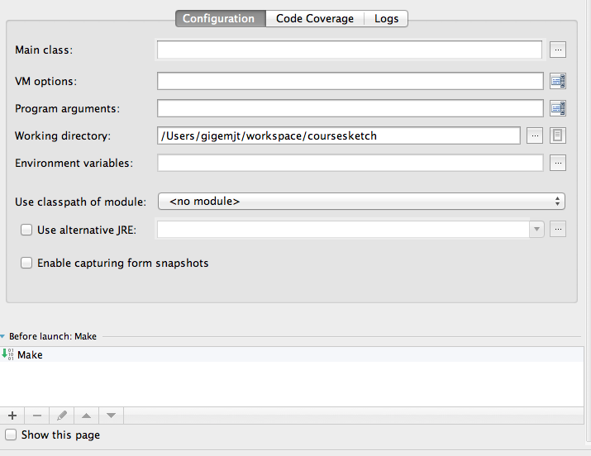

Fill it out and a couple of additional configurations for each server:

**Proxy**

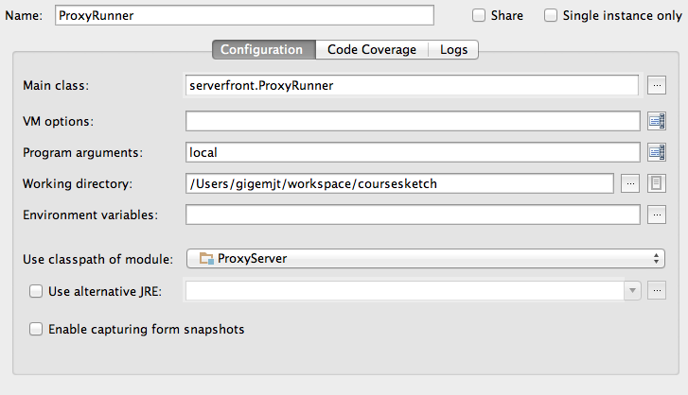

**Submission**

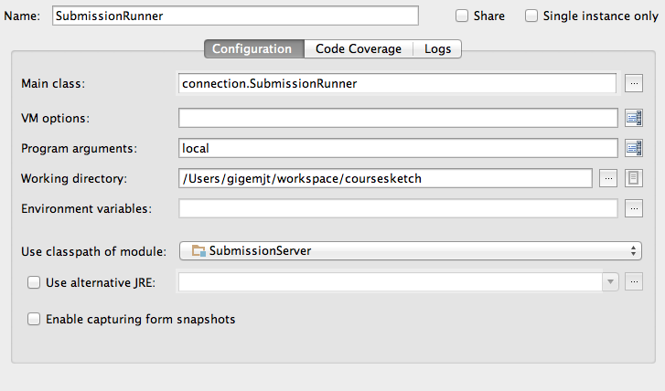

**Answer checker**

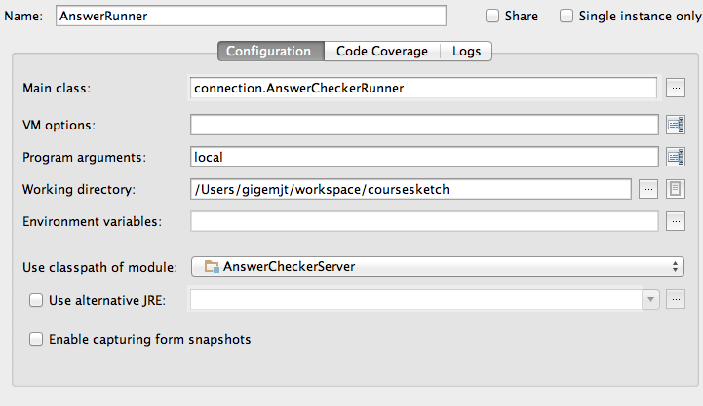

**Login Server**

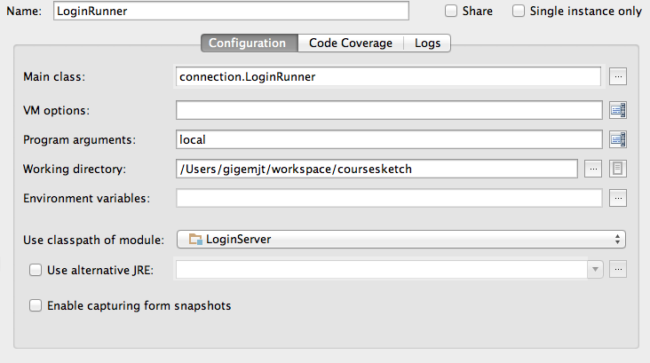

Database Server

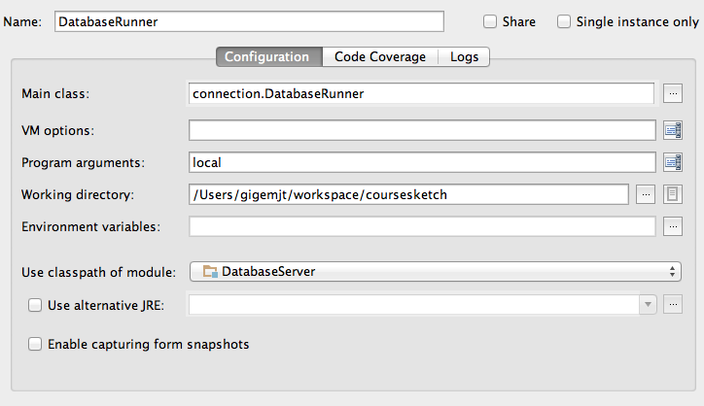

Run order:

LOGIN

DATABASE

SUBMISSION

ANSWER CHECKER

PROXY

Or install multirun (above in addtional setup)

**15: FINAL SETUP**

good news if you made it this far you are setup. please feel free to look at the code or follow any additional instructions you are given

**LEGACY EXPLANATIONS**

Eclipse view (very similar to intillij view)

