

CS 320 Course Project - Software Design Document

for

Would You Rather?

Prepared by Tracy Hotchkiss

Group Name: Team 21

|  |  |  |
| --- | --- | --- |
| Tracy Hotchkiss | 011619865 | tracy.hotchkiss@wsu.edu |
| Kelly St.Onge | 011376758 | kelly.stonge@wsu.edu |
| Brian Hong | 011708122 | wenle.hong@wsu.edu |
| Lane Koistinen | 011707400 | lane.koistinen@wsu.edu |
|  |  |  |
|  |  |  |

|  |  |
| --- | --- |
|  |  |
| Date: | 11/19/2020 |
|  |  |
|  |  |
|  |  |

Content

Contents ii

1 Introduction 1

1.1 Project Overview 1

1.2 Definitions, Acronyms and Abbreviations 1

1.3 References and Acknowledgments 2

2 Activity Diagram(s) 3

2.1 Main Page Activity Diagram 3

3 Class Diagram(s) 4

3.1 Main Program Class Relations Diagram 4

4 Behavioral Diagram(s) 6

4.1 Behavior Sequence Diagram 1- User Clicks Generate Question 6

4.2 Behavior Sequence Diagram 2 - User Clicks About Page 6

4.3 Behavior Sequence Diagram 3 - User Clicks Stats Page 7

4.4 Behavior Sequence Diagram 4 - User Choice Selection………………………………………………8

Appendix A - Group Log 9

# Introduction

## Project Overview

The Would You Rather project is a web app that presents hypothetical would you rather questions for users to choose from. With user interaction, statistics are updated with each decision. In the WYR main page activity diagram, when the user initially comes to the site, a random WYR question is fetched and displayed. The site waits until the user answers the question, where after answering, its statistical information is updated and displayed. The user is then given the option of wanting another random WYR question, if yes the process repeats to a new random question, if not the process is not repeated. In the WYR class diagram, the main intersecting class is the gameplay class. This class connects to the player, global statistics, WYR question, and option statement classes. The class diagram shows a set of components and their relationships that illustrates the static implementation view of the WYR system. The WYR sequence diagrams show the sequence of messages exchanged between the objects needed to carry out the functionality of the gameplay. The component WYR behavioral sequence diagrams are the User Clicks Generate Question, User Clicks About Page, User Clicks Stat Page and the main Behavior Diagram.

## Definitions, Acronyms and Abbreviations

*DB - Database*

*WYR - Would You Rather*

## References and Acknowledgments

Section 2

1. “PlantUML Web Server,” PlantUML.com.

Available:

http://www.plantuml.com/plantuml/uml/TP3FYeD03CRlynJ1q-w2hx0ex7N1AgMKraFGL0EQgJEnujjtAXRQqjwItvSlVv9uHQTZtnbbxGXs-np-aGKoREWeQQLyOPtXZx5ns1lpzVCDSVmBKKx3I5u15y_c5hELo2nYviYJw3if5J-HUwNRSurAK2Wg1rxvbHUjdPuednv6YzMM70ptNX1ICG31UfZ9bv-tfCxJMYYsX72LIKZgy8Wh

Section 3

1.“PlantUML Web Server,” PlantUML.com

Available:

http://www.plantuml.com/plantuml/png/ROy_2y8m4CLtFyLnOw65EZf8jux-SH37QtlQO9f8SaNyzbuC51J7Uu_VZtTD50eoJtQ5BKqCUqilGC02eRHybN8BMEkTSWw06orXf0Y0FqHTLGaAvZOkL6jzHnPEGcAYc3vcllTEWkbcuGZY_wZKC_YdIvginVFb28UPLU9TNa7n7XNyAZ9RBF1QWzqZLPyDFB6JJAS9P9mQ6dQ3_ly6

Section 4.

1. “PlantUML Web Server,” PlantUML.com. [Online].

Available:

http://www.plantuml.com/plantuml/png/LP31IiH038RlUOgGauA5zjf3MUo0NWgTzI0UOpkuWzrfdSaglhtfTB7iBV0dNxxaa8IZNCuJy21pHEed_dMHa1Fs5Gnpa3XFIDTYkaPT2oCBltDoIAR6rxTZOHvpP61HeX_yma6GElO1U_vmERJbRNhaCCvdj1UNnCy1VxoSyDcFemlu8YnfcwfWrVFVB4wjzbfnq5T5OyiQgPtyy9dmoGKNDVo74jYoQBgstkTK7xgsQDISLFqkPeq7JElAUzeR3O1PyHbXgnsnEbdTt5UAC3uj-ZRSCFXrSyqfNxEX2GukZFhjFm00. [Accessed: 17-Nov-2020]

1. “PlantUML Web Server,” PlantUML.com. [Online].

Available:

http://www.plantuml.com/plantuml/png/LP2nRWCX38Ptdi9Ypy2D6Q9KTEXo4gHFu09ghHAuWgzLtxucZNIvpSBVn__3kJCsNgzPOU3QGBkClwbfm0xEg50Bjvf1tuTyNyrMBU9He0KBWxvWYVKAVasTgHRu8Vw05uen5NXbv7wplDbRJszrPN3udlxNanejw1ivIVWsYwUSEPoyEOAscS9dXvkhbPVZsHutLfgfsGex2Nj9NwCHF0Hjv8Zpq-7angtFr1Tv-OuyfnBbP_u0. [Accessed: 17-Nov-2020].

1. “PlantUML Web Server,” PlantUML.com. [Online].

Available: http://www.plantuml.com/plantuml/png/LS_13e8m30RW-vwYsPq3SkD0CFDAClG9wbpCucIu5XFVtg94yDRawv-_ROanytIF2Xsd3Df6VFci0GbigLmQEAS8UXdYGfrHe-I22oCE37f_JXE3nQl_SB_xvnFZLYirjuKdifUITPx1baNJLpLe4uEx4SnHqgglYgOpzReh5wZEBBj7_vWyCVnwlW5RYXq2ZVBJrbe_NEJbDm00. [Accessed: 17-Nov-2020].

1. “PlantUML Web Server,” PlantUML.com. [Online].

Available: http://www.plantuml.com/plantuml/png/XP7FJeGm4CRlynIJdlJ0WGqd3cGZFNY0IEiJZD34HhPWEwlnxIrb5JIQlJNzVTzyy-SOc3oVJoDGpvD7qOtqORn02jZbq4-E_JIYk3p62sfh68ZfYO918KjyPEAGoRi49SonfktjJ8vHQ7B3T49rDe7jvF3TyZFUss4mRlKbayf_kXxc9CuJRFvaXyJqzRHzJ07BfFQDsCG1jtVCXoxFAfMNAEhHzYy1lti05KbJRke6cgngwzrFM__hFwn-lLDhq8iVeAspIaP7wl2ckHMRHlwcEbAGIqIgfufTmJYNAhAgMzAb3NEy8lfr5QzVgmXf2t0qReW7_mG0. [Accessed: 17-Nov-2020].

# Activity Diagram(s)

## Main Page Activity Diagram

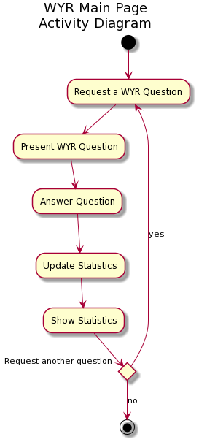

This activity diagram depicts the flow of control for the main page of the WYR system. On the main page, the user requests a question. Then, a question is presented by the system and the user is prompted to answer it. After the question is answered, the system adds the user input to its existing database and shows the percentage of people answering each choice to the user. The user then has the decision of requesting another question and repeating the process.

# Class Diagram(s)

## Main Program Class Relations Diagram

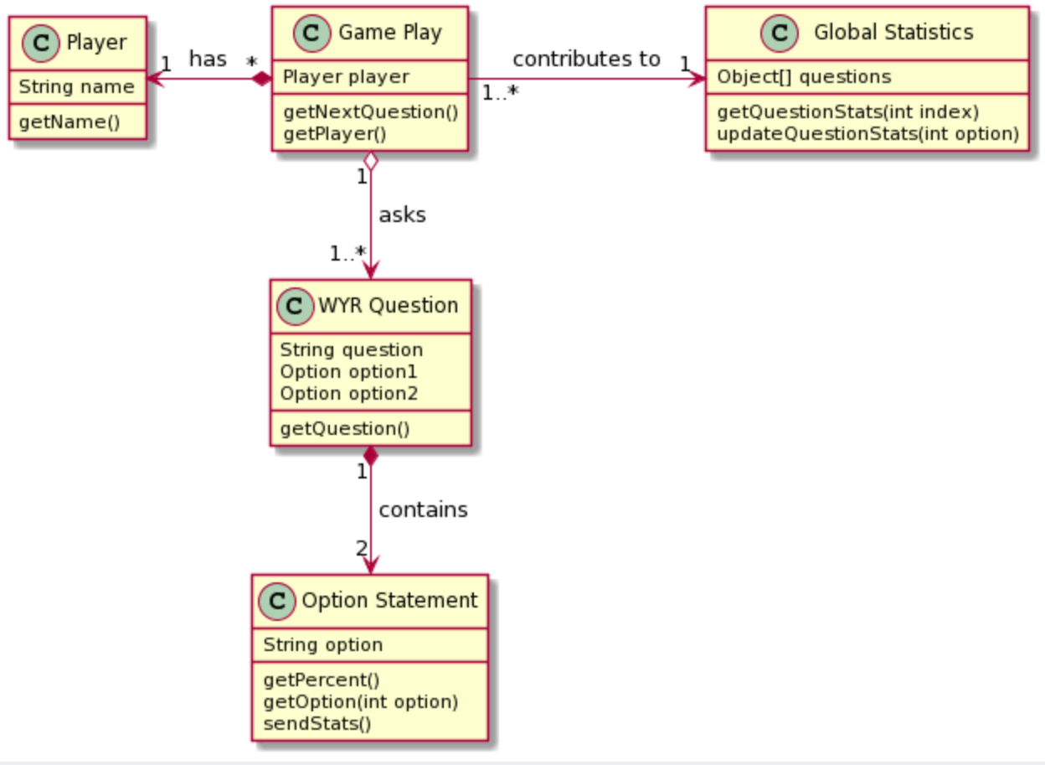

|  |  |
| --- | --- |
| **Class** | **Description** |
| Game Play | The Game Play class manages the progression of a certain game, including the selection of questions and the associated player. |
| Player | A small amount of information is maintained about a user when they start a game play, including their name. This basic profile does not transcend an individual Game Play. |
| Global Statistics | This class manages the data gathered from all gameplays. This class is used primarily in the statistics page. |
| WYR Question | The WYR Question class holds the question string and references to two options. |
| Option Statement | Option statement holds the answer string and contains associated statistics for individual questions and updates global statistics using the player answer. |

# Behavioral Diagram(s)

## Behavior Sequence Diagram 1- User Clicks Generate Question

This sequence diagram describes visually the sequence of events when the user selects the option to generate a question. The user starts on the main page and clicks “Generate Question”. A controller that handles mouse click events requests a random question and its associated stats from the WYR database. A new page is activated, and this page displays the random question with the statistics hidden.

## Behavior Sequence Diagram 2 - User Clicks About Page

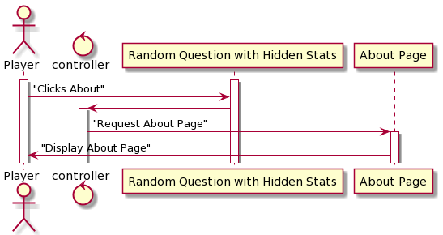

This sequence diagram describes visually the sequence of events when the user selects the option to visit the “Stats Page”. The user clicks on the “Stats Page” option and the controller handles the mouse click. The controller requests the “Stats Page” and a new page is displayed with all random questions and their associated statistics.

## Behavior Sequence Diagram 3 - User Clicks Stats Page

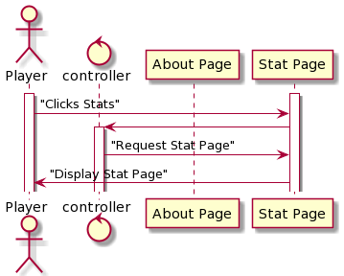

This sequence diagram describes visually the sequence of events when the user selects the option to visit the “Stats Page”. The user clicks on the “Stats Page” option and the controller handles the mouse click. The controller requests the “Stats Page” and a new page is displayed with all random questions and their associated statistics.

## Behavior Sequence Diagram 4 - User Choice Selection

This sequence diagram describes visually the sequence of events when the user selects one of the two options provided after generating a question. Depending on the option that the user clicks, the controller sends a request to update the stats of that question to include the user response. The data is updated to a new page that now displays the question with its stats.

Appendix A - Group Log

Meeting Minutes

--Meeting 10/6/2020

Team Present:

Tracy Hotchkiss

    Lane Koistinen

    Kelly St.Onge

    Brian Hong

Assign Team Lead - Tracy Hotchkiss

Project Web App Ideas

* Pachinko Fake Gambling Site
* Wine Venue Database
* Where to Poo
* Math formula solver
* Word unscramble
* 21 questions?
* Would You Rather?

“Would You Rather?” Project ideas:

* Rank controversial/worst ideas
* Come up with good questions
* Allow user to submit questions
* About page

Discuss Project Ideas

* Project must be a web application
* Has a landing page which helps a user to understand what the application is about
* Besides the landing page, it has multiple other pages
* It has some data to maintain/manipulate

The Web App Idea that we have chosen is the Would You Rather? Database

* This Database will present the user with random would you rather questions
* The user will be prompted for their answer
* Answers will be stored and stats will be available such as favorite choices or least favorites

SRS Document Plan: Going forward we will discuss and assign different sections of the document to each member of the team. As a team we will go over each section and review and edit as needed before finalizing.

To do for next meeting:

MainPage/Introduction, Update Appendix B - Tracy Hotchkiss

1.1 - Brian Hong

1.2 - Kelly St.Onge

1.3 - Lane Koistinen

--Meeting 10/13/2020

Team Present:

Derived from Discord Team Chat

The professor responded back to our project idea. It looks like we don't need to do the submit questions database. Just having the site that will produce the predefined sentences randomly and then saving and storing the stats is sufficient

Team members have reviewed the work done for the Introduction and sections 1.1 - 1.3 and provided feedback via the SRS Team 21 google doc

We have decided for now not to plan on adding item 3 of the introduction until it is clear if there will be sufficient time to do so as per the professor’s response this is not required.

To Do for next meeting:

Team members will review the next set of sections to get an idea of content to discuss for next meeting.

Team members will start thinking on which section they would like to write next.

Sections to review:

Sections: 2.1-2.4

Sections 1.1 - 1.3 will be updated on the master SRS document by Tracy.

--Meeting 10/15/2020

Team Present:

    Lane Koistinen

    Kelly St.Onge

    Brian Hong

We reviewed a little from section 2.1, we will review further at our next meeting.

We have decided to cut the meeting short and make the next one longer to discuss and review what we’ve written for the SRS so far. We each selected a part of section 2.

To do for next meeting:

2.1 - Brian Hong

2.2 - Brian Hong

2.3 - Kelly St.Onge

2.4 - Kelly St.Onge

2.5 - Lane Koistinen

2.6 - Lane Koistinen

SRS Document update/2.7 - Tracy Hotchkiss

--Meeting 10/20/2020

Team Present:

    Tracy Hotchkiss

    Lane Koistinen

    Kelly St.Onge

    Brian Hong

Reviewed comments and suggestions for changes to make to section 1.

Updated these sections in comments to reflect suggestions for edit.

Discussed assumptions and dependencies.

To do for next meeting:

All team members will review section 2 and comment suggestions.

3.1.1 - Tracy

3.1.2 - Tracy

3.1.3 - Brian

3.1.4 - Brian

3.2 - Kelly

3.3.1 - Lane

--Meeting 10/27/2020

Team Present:

Tracy Hotchkiss

Brian Hong

Lane Koistinen

Reviewed comments and suggestions for changes to make to section 2 and 3.

Updated suggested edits and comments.

Discussed how the database will be stored in regards to section 3.1.3

Discussed minimum system requirements

Discussed assumptions and dependencies

Discussed design and implementation constraints

To do for next meeting:

4.1 - Brian

4.2 - Lane

4.3 - Kelly

1.4-1.6, Appendix B - Tracy

Update document Final edit is due Friday Nov. 6th - Tracy

--Meeting 11/05/2020

Team Present:

Derived from Discord Team Chat

Discussed Section 5, Appendix A, 4.3, and 2.1

Document is ready for final review and submission by team

--Meeting 11/10/2020

Team Present:

Derived from Discord Team Chat

Discussed:

Project Milestone 2 - Due date is 11/20/2020

Step 3 of Milestone 2 is complete

Github - <https://github.com/tracyhotchkiss/Team_21>

Assign and discuss step 2 of Milestone 2

Created googledoc and sent invites to team gmail addresses. [Team_21_SDD](https://docs.google.com/document/d/1gxy_nGomtJkc8hjfa3VufzuyWPMh5oB0u-I0vEXAYcA/edit)

To Do for next meeting:

Section 1 - Kelly

Section 2 - Brian

Section 3 - Lane

Section 4 - Tracy

--Meeting 11/17/2020

Team Present:

Derived from Discord Team Chat

Discussed:

Diagrams, references, and reviewed work done.

Milestone 2 Document ready for review to turn in.