Screen Interface Document

Purpose
This document is designed to list the hierarchy of the Upper / Lower Consoles. This document contains a diagram representing the classes and/or rule-sets which will ultimately create the screen to be displayed for the bowlers. The code structure will be shared between the Uppers and Lowers. Additionally, some mock-up screens are contained in this document which will demonstrate some examples of how the layout will appear.

Screen Interface
The diagram below shows how the code interfaces will be designed in order to efficiently manage a dynamic screen environment. All bowling centers and bowlers will have different data-sets that they will want presented to them. Additionally, they may all want different layouts of the same data. This design is meant to allow the most flexibility to accommodate the majority of all users.
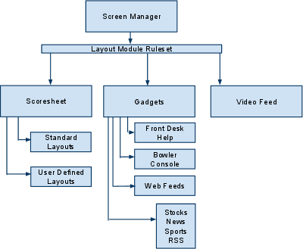

Screen Examples
This section of the document gives some basic examples of how the consoles might be presented to the users.
