Console Interface Document

For

The OpenBowling Project
Version 0.xx
Prepared by Eric Koski

Mar. 01, 2010

Revision History
Name | Date | Reason For Changes | Version
Eric Koski | 03/01/2010 | Original Release | 0.01
Eric Koski | 03/09/2010 | Added formatting | 0.02

Console Interface Document

Purpose
This document is designed to list the hierarchy of the upper / lower consoles. This document contains a diagram representing the classes and/or rule-sets which will ultimately create the screen to be displayed for the bowlers. The code structure will be shared between the Uppers and Lowers. Additionally, some mock-up screens are contained in this document which will demonstrate some examples of how the layout will appear. As development occurs, it may be discovered that some of the layout examples presented below are not feasible due to hardware restrictions or other factors.

Console Interface
The diagram below shows how the code interfaces will be designed in order to efficiently manage a dynamic screen environment. All bowling centers and bowlers will have different data-sets that they will want presented to them. Additionally, they may all want different layouts of the same data. This design is meant to allow the most flexibility to accommodate the majority of all users.
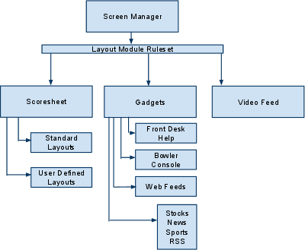

QT GUI / Layout Classes
This section of the document is intended to plan out the classes available in QT which will help to implement the console design. Additional research is required for this section, as only a limited amount of QT research has been done at this time. The current version of QT is at 4.6. The QT SDK can be acquired at the following link: QT SDK
QGraphicsLayout – This class will allow ensure that the layout of the console items is consistant across different screen resolutions. At this time, it seems logical to have different layouts designed in XML, which can then be parsed by the QXml* classes. Additionally, it may be a good strategy to create a simple tool which allows drag-n-drop functionality where users can design their layouts visually. Afterward, the tool can create an XML file for the user so no knowledge of XML is necessary for creating layouts. Lastly, some logic needs to be present to prevent layouts that make the screens illegible. That is to say, limit the number of different items that can be presented on the screen at any given time. Also, certain items should have a minimum size limit. Conversely, some should have a maximum size limit.

QGraphicsProxyWidget – In some cases, a layout may not be the answer to how the console should be presented. The QGraphicsProxyWidget allows any type of QWidget to be embedded into a QGraphicsScene. This will be useful for places where the console layout may require a picture-in-picture style. The XML file referenced in the QGraphicsLayout section should distinguish between true-layout and embedded-layout styles.

QGLWidget – This class will be used for all OpenGL widgets used in the console

QGraphicsView – This class creates a “view port” of a scene. Much like the window of a house allows a person inside of the house to see outside. The person inside the house can only see a section of the outside even though there is much more beyond the boundaries of the window. The QGraphicsView coordinates are integer based. Convenience functions are provided to translate coordinates between QGraphicsView, QGraphicsScene, and QGraphicsItem.

QGraphicsScene – This class is the scene which is to be displayed to the user. In the analogy presented in the QGraphicsView section above, the QGraphicsScene would be the “outside”. The QGraphicsScene can be as large or small as desired. The QGraphicsScene coordinates are floating point. Convenience functions are provided to translate coordinates between QGraphicsView, QGraphicsScene, and QGraphicsItem.

QGraphicsItem – This class represents an item contained in a QGraphicsScene. Convenience functions are provided to translate coordinates between QGraphicsView, QGraphicsScene, and QGraphicsItem.

Console Examples
This section of the document gives some basic examples of how the consoles might be presented to the users.
