# **Intervention report**

# **Nina Carducci**

# **I - Lighthouse Score**

## **Lighthouse score before optimization**

**Desktop**

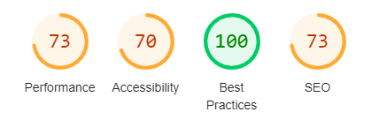

**Mobile**

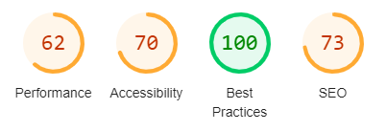

## **Lighthouse score after optimization**

**Desktop**

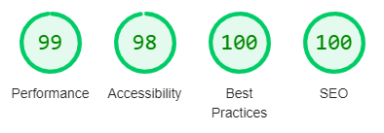

**Mobile**

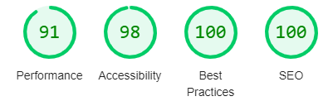

# **II - Details of optimizations and interventions made:**

## **1 - Images**

The project originally contained 15 images with a total size of 29.44 MB. All images (except Instagram Icon) were resized and converted from PNG or JPG to the next-gen format of AVIF. The Instagram image was changed to a font awesome icon to reduce overall website image size. After the modifications, the total weight of the images is 0.577 MB, a gain of 98%.

**2 – Lazy loading**

Lazy loading was added to all images not immediately onscreen such as the second and third carousel images and the gallery images. The order of carousel images was changed to allow a smaller image to load first.

**3 – Minification**

The minified version of bootstrap.bundle.min.js & bootstrap.min.css files were used to reduce code size and allow the website to load faster.

## **4 – Title & Description**

Added a title and description in the head section to improve SEO:

<title>Nina Carducci</title>

<meta name="description" content="Professional Photographer Home Page">

**5 – Social Media**

Social media OpenGraph meta tags were added for sites such as Facebook and X (formerly Twitter). Previews below:

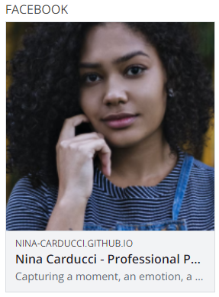

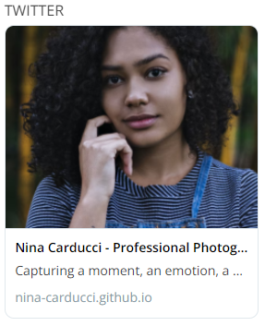

**6 – Schema.org microdata**

Local information provided by the client was added to the website and Schema.org microdata SEO tags were added.

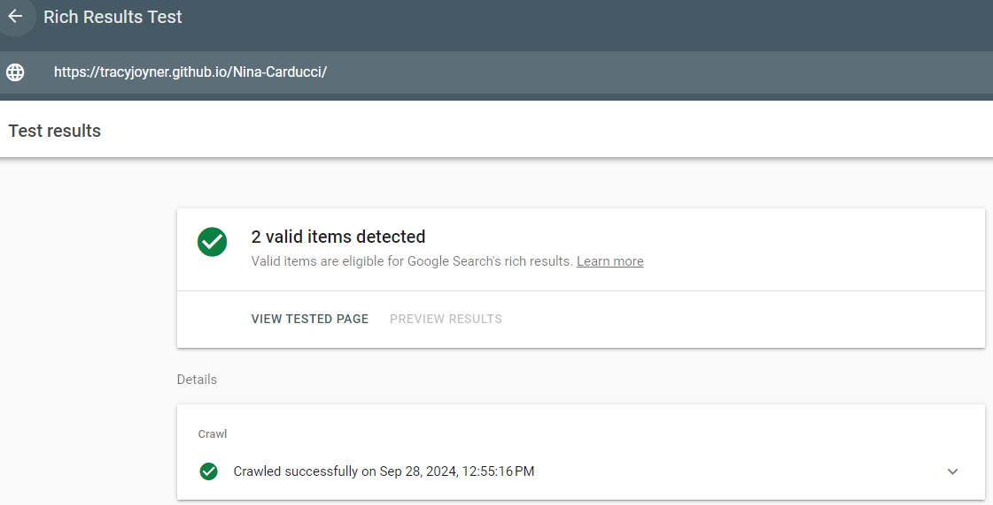

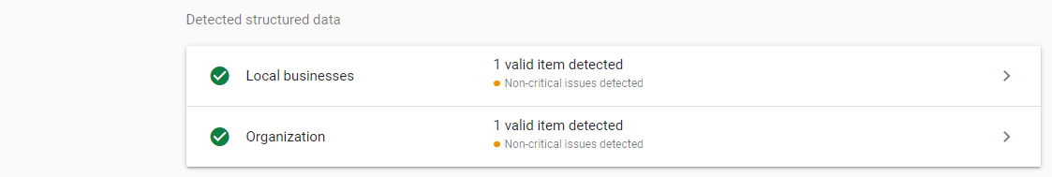

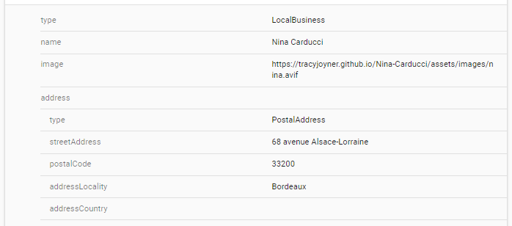

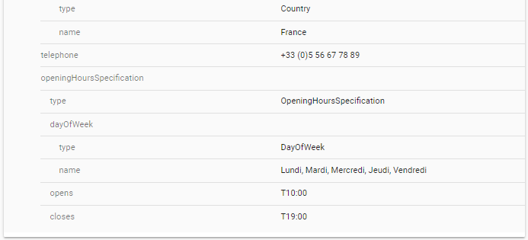

**III - Site accessibility**

## 

## **Accessibility before optimization**

## 

## **Accessibility after optimization**

## 

## **Details of Accessibility Changes made:**

**1 – Labels**

Added “alt” elements to images, “for” elements to form labels, “aria-label” elements to previous/next buttons in the carousel and to the Instagram link for screen readers.

## **2 - Language**

Added lang="fr" to the html element for screen readers to correctly interpret the text.

**3 – Color contrast**

Kept filter button text black to keep sufficient color contrast between the text and the background color of gold.

# **IV - Details of additional work carried out at the customer's request**

## **1 – Debug previous/next buttons**

The customer stated: “The gallery’s previous and next image navigation doesn’t work. " I debugged the previous/next navigation buttons and added the +1/-1 to the code for clicking on the button that allows the user to move to the previous or next image. If it is the first/last image, clicking the previous/next button does allow the user to go to the end/beginning of the image gallery appropriately

## **2 – Debug filter background issue**

The customer stated: “When you change filters to display images, the selected category is not visible. The category should normally have a gold background. The same as the default filter. " I added the correct class value to the css file allowing the selected filter button to retain the gold background color.

**V - Acceptance log**

Details of functions debugged and their status:

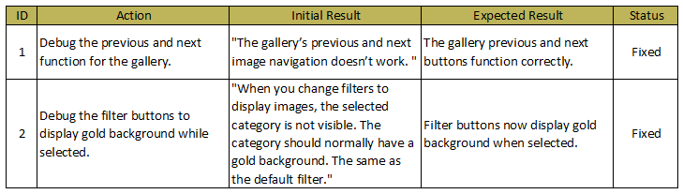

# **Appendices**

## **Full Lighthouse audit reports**

Lighthouse-Report-Desktop-After.pdf

Lighthouse-Report-Mobile-After.pdf

## **Full PageSpeed Insights reports**

PageSpeed-Insights-Desktop-After.pdf

PageSpeed-Insights-Mobile-After.pdf