**Computer Organization**

**Architecture diagram:**

**The architecture is basically same as the picture given in CO_Lab_2.pdf. The only different is we add a Mux_Shift to determine ALU input should be rsdata_o or shamt when handling the sra instruction.**

**Moreover, we add two output, se_o and shift_o, for Decoder, which represent the signal control for sign_extend and Mux_Shift respectively.**

**Detailed description of the implementation:**

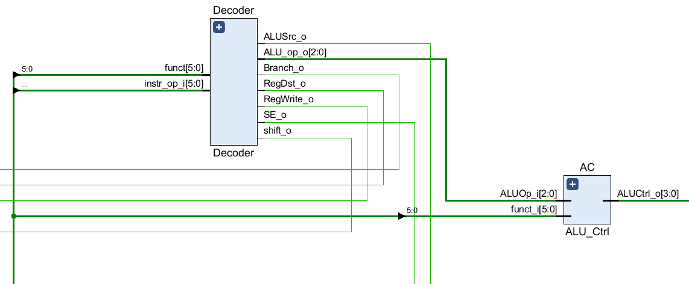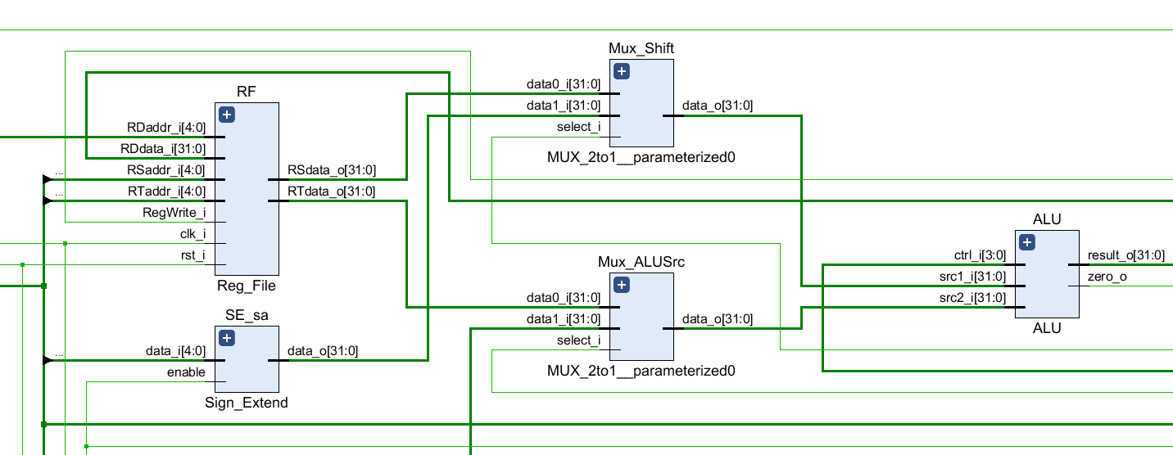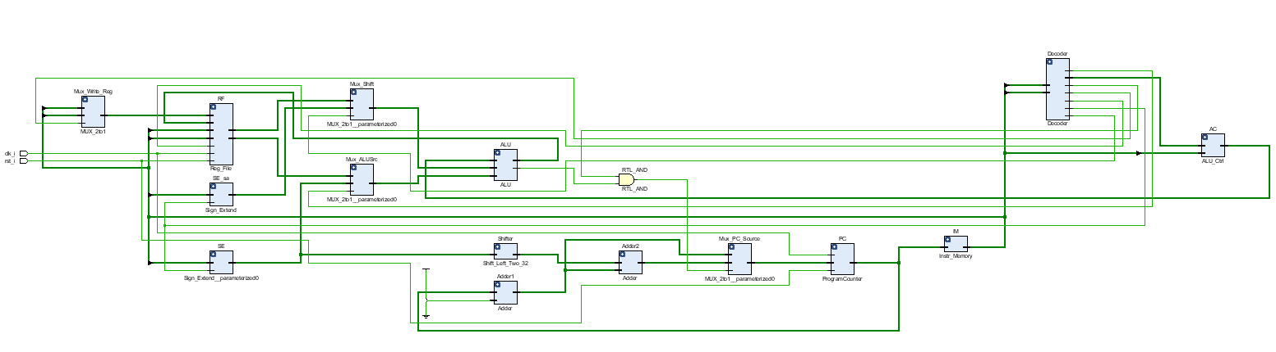

**Decoder Design**

|  |  |  |  |  |  |  |  |  |  |
| --- | --- | --- | --- | --- | --- | --- | --- | --- | --- |
|  | **Op** | **Func** | **ALUSrc** | **Branch** | **RegWrite** | **RegDst** | **Signed** | **Shift** | **ALUOp** |
| **addu** | 000000 | 100001 | 0 | 0 | 1 | 1 | x | 0 | 010 |
| **addi** | 001000 | - | 1 | 0 | 1 | 0 | 1 | 0 | 010 |
| **subu** | 000000 | 100011 | 0 | 0 | 1 | 1 | x | 0 | 010 |
| **and** | 000000 | 100100 | 0 | 0 | 1 | 1 | x | 0 | 010 |
| **or** | 000000 | 100101 | 0 | 0 | 1 | 1 | x | 0 | 010 |
| **slt** | 000000 | 101010 | 0 | 0 | 1 | 1 | x | 0 | 010 |
| **sltiu** | 001011 | - | 1 | 0 | 1 | 1 | 0 | 0 | 110 |
| **beq** | 000100 | - | 0 | 1 | 0 | x | 1 | 0 | 001 |
| **sra** | 000000 | 000011 | 0 | 0 | 1 | 1 | x | 1 | 010 |
| **srav** | 000000 | 000111 | 0 | 0 | 1 | 1 | x | 0 | 010 |
| **lui** | 001111 | - | 1 | 0 | 1 | 0 | 1 | 0 | 011 |
| **ori** | 001101 | - | 1 | 0 | 1 | 0 | 0 | 0 | 100 |
| **bne** | 000101 | - | 0 | 1 | 0 | x | 1 | 0 | 101 |

**ALUCtrl Design**

|  |  |  |
| --- | --- | --- |
| **ALUOp** | **Func** | **ALUCtrl** |
| **000** | - | 0010 |
| **001** | - | 0110 |
| **010** | 100001 | 0010 |
| 100011 | 0110 |
| 100100 | 0000 |
| 100101 | 0001 |
| 101010 | 0111 |
| 000011 | 1000 |
| 000111 | 1000 |
| **011** | - | 1001 |
| **100** | - | 0001 |
| **101** | - | 1010 |

**Problems encountered and solutions:**

* **Problem: Failed when implementing sra (result_o = $signed(src2_i) >>> src1_i)**
* **Solutions: It turned out to be that not only src2_i should be signed but also the result_o itself, so we declared result_o as signed then fixed.**

**Lesson learnt (if any):**

* **Understand how to distribute control code to functions through decoder and ALUcontrol.**
* **Understand how a simple single cpu works**