**Computer Organization**

**Architecture diagram:**

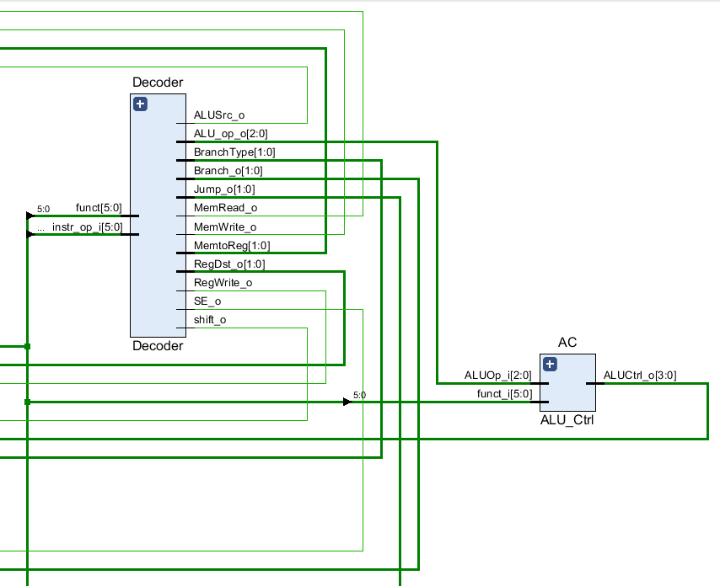

**We add some control signals for Jump and**

**lw/sw instructions, and also we change some**

**2_to_1_MUX to 3_to_1_MUX for the jr and**

**jal instructions.**

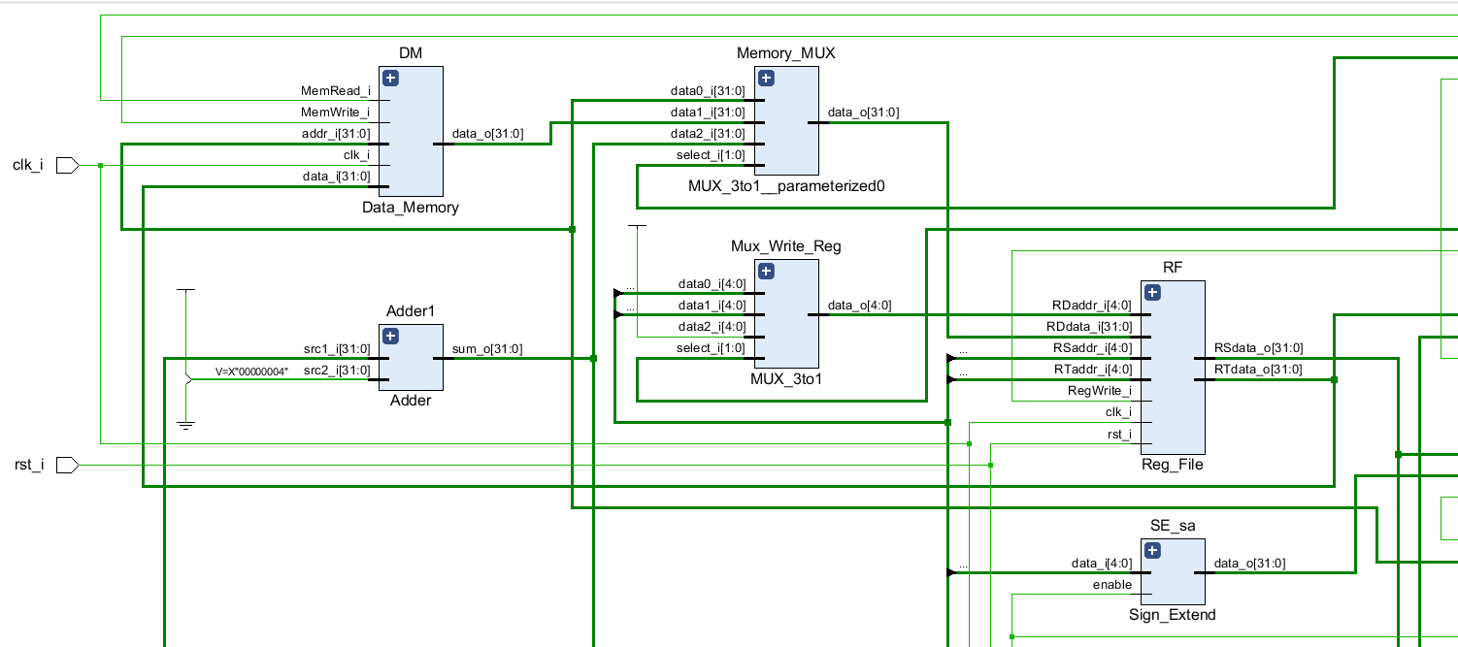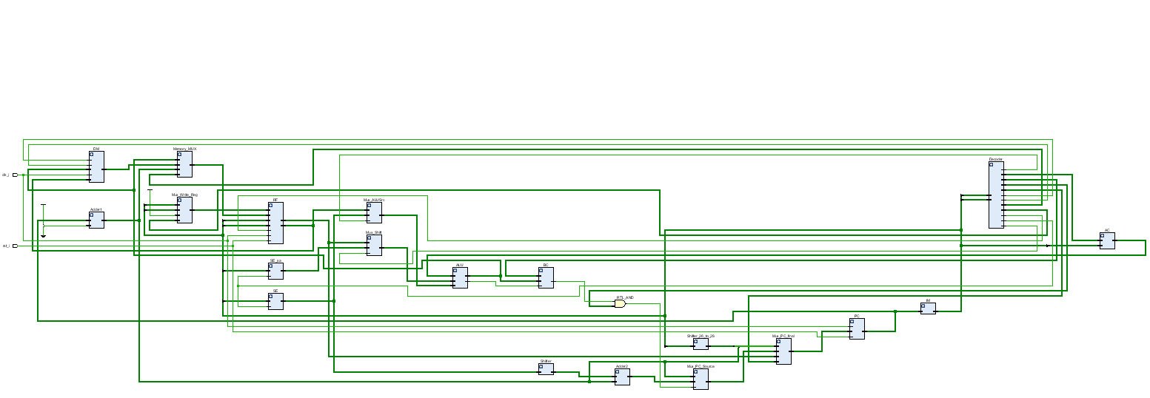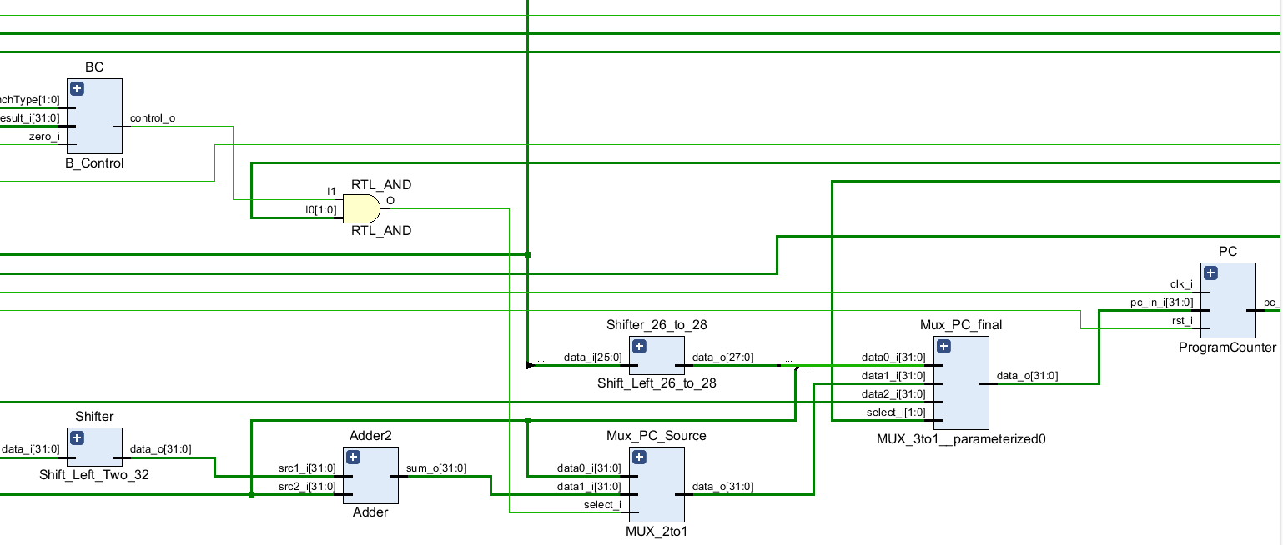

**Detailed description of the implementation:**

**Problems encountered and solutions:**

**Lesson learnt (if any):**