1. Puzzle Problem 1:
   1. Locate a calculator in good working order and power it on.
   2. Clear any totals displayed on the screen to zero (0)
   3. Enter the first homework grade.
   4. Press the + key.
   5. Repeat steps c and d for each subsequent homework grade up to grade and including grade ten (grade 2 through 10).
   6. Press the = key.
   7. Press the / (division) key.
   8. Enter the total number of grades (grade count), in this case 10.
   9. Press the = key.
   10. The displayed result is the average of the 10 grades entered.
2. Puzzle Problem 2:
   1. Obtain a sheet of paper and a writing instrument, appropriately sized to accommodate the alphabet written in a single line twice on the sheet.
   2. Use the writing instrument to write the alphabet from A to Z in a single line at the top of the sheet of paper.
   3. On the line directly below, write the alphabet beginning with the letter E. When Z is reached, continue filling out the line by writing the letters A through D.
   4. On the next line, write the message you intend to send.
   5. Use the first line-alphabet to find the first letter of the message you want to send.
   6. Find the letter directly below the intended letter in the second line.
   7. Write this letter on the next blank line on the page.
   8. Repeat steps f and g for each remaining letter in the message.
   9. When finished, this line represents the secret code for the Caesar Cipher.
3. Puzzle Problem 3: ANSWER- “PUZZLES ARE FUN,”
   1. Obtain a sheet of paper and a writing instrument, appropriately sized to accommodate the alphabet written twice in a single line on the sheet. Place a vertical line after you have reached Z in the first alphabet and before A in the second alphabet.
      1. i.e. ABCDEFGHIJKLMNOPQRSTUVWXYZ|ABCDEFGHIJKLMNOPQRSTUVWXYZ
   2. Begin a numbered list below the alphabets line, numbered 1 to 25.
   3. Place the tip of your writing instrument on the first letter of the cipher message as it appears in its second occurrence (after the vertical line) in the alphabets you wrote.
   4. Move your writing instrument one position to the left and write the letter in that position on line one in the numbered list.
   5. Repeat steps C and D for all the letters in the cipher message.
   6. Place the tip of your writing instrument on the first letter of the cipher message as it appears in its second occurrence (after the vertical line) in the alphabets you wrote.
   7. Move your writing instrument two positions to the left and write the letter in that position on line two in the numbered list.
   8. Repeat steps F and G for all the letters in the cipher message.
   9. Continue this process for all the numbered lines in your list, three positions for line 3, four positions for line 4… through twenty-five positions for line 25.
   10. Check the numbered list you created with the shifted solutions for a plain text message.
   11. The line number of the readable plain text message is the shift size.
       1. i.e. The readable message appears in line 3 “PUZZLES ARE FUN”, so the shift size is 3.
4. Puzzle Problem 4:
   1. Logically segment the chalk board so that the 1st position will contain a counter of the number of grades that have been received (0-9).
   2. The 3 remaining positions will be used to record the sum of the homework grades.
   3. Request the first 2 grades from my brother and mark 2 in the first position on the board, and the sum of the 2 grades in the remaining spaces (this is likely all 3 spaces unless little Timmy is failing all his assignments miserably).
   4. For each subsequent grade relayed, the first position is incremented by 1 and the sum is updated with the new grade total.
   5. This is adequate for up to 10 grades under 100 points each. When the last grade is received, divide the sum (last 3 positions) by the count (first position) to get the average of all grades.
5. Puzzle Problem 5:
   1. 46
      1. Step 0 says to Print N- output is “15”
      2. Step 1 says if N equals 1, stop. N equals 15, so move to step 2. - output remains “15”
      3. Step 2 says if N is even, divide it by 2. N is not even, so move to step 3- output remains “15”
      4. Step 3 says if N is odd, triple it and add 1. 15 is odd so 3\*15=45, 45 +1=46- output is “46”
      5. Step 4 says Go to step 0- output remains “46”
6. Puzzle Problem 6:
   1. 10
      1. Step 0 says to Print N- output is “6”
      2. Step 1 says if N equals 1, stop. N equals 6, so move to step 2. - output remains “6”
      3. Step 2 says if N is even, divide it by 2. N is even, so 6/2=3- output is “3”
      4. Step 3 says if N is odd, triple it and add 1. 3 is odd so 3\*3=9, 9 +1=10- output is “10”
      5. Step 4 says Go to step 0- output remains “10”
7. UML class:

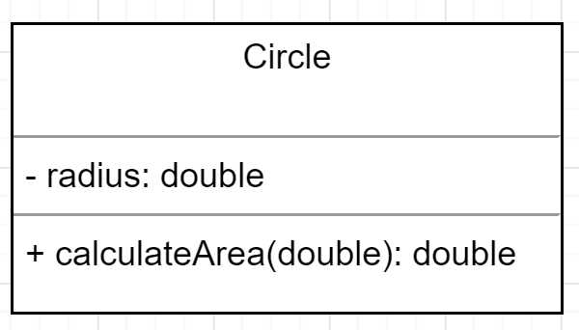

1. UML Triangle:
   1. 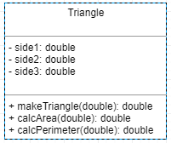
2. Shapes Java code:

